90529A

Level 3 Practical Music, 2005
90529 Demonstrate developed aural skills through
competent transcription and notation of music
Credits: Two

There are TWO questions in the Question Booklet.
You will be given three minutes to read and prepare before the audio recording begins to play. Read the questions and listen carefully to the instructions on the audio recording.
For copyright reasons, the score extract are not reproduced here.
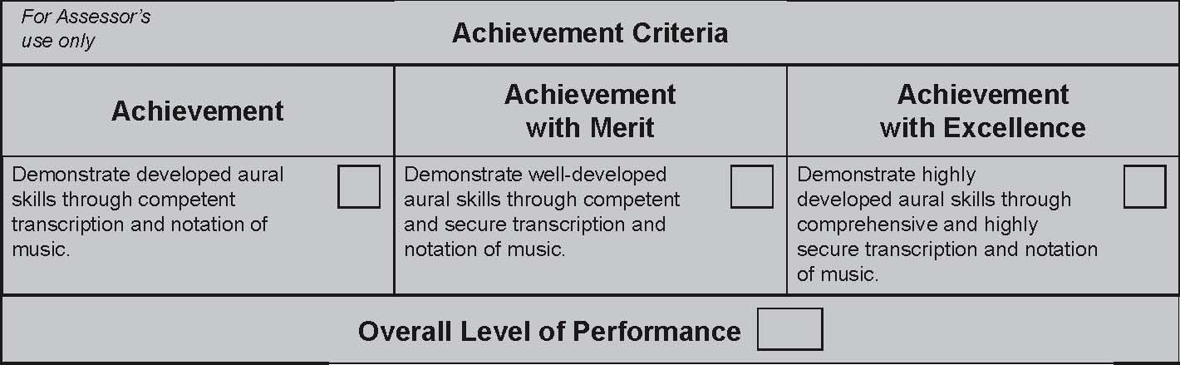

© New Zealand Qualiﬁcations Authority, 2005
All rights reserved. No part of this publication may be reproduced by any means without the prior permission of the
New Zealand Qualiﬁcations Authority.

