3
90496

Level 3 Music Studies, 2005
90496 Describe elements of music through listening

Credits: Four

There are FOUR questions in this examination. Answer ALL questions in this booklet.
You will be given three minutes to read and prepare before the audio recording begins.
Read the questions carefully.

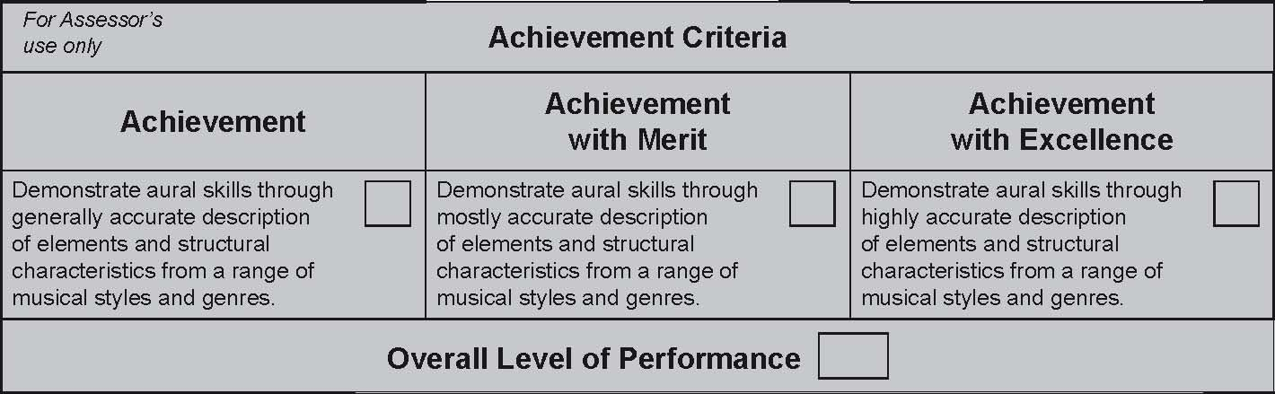

© New Zealand Qualiﬁcations Authority, 2005
All rights reserved. No part of this publication may be reproduced by any means without the prior permission of the
New Zealand Qualiﬁcations Authority.
You are advised to spend one hour answering the questions in this examination.
You may ﬁnd this list of elements and structural characteristics useful when answering some questions:
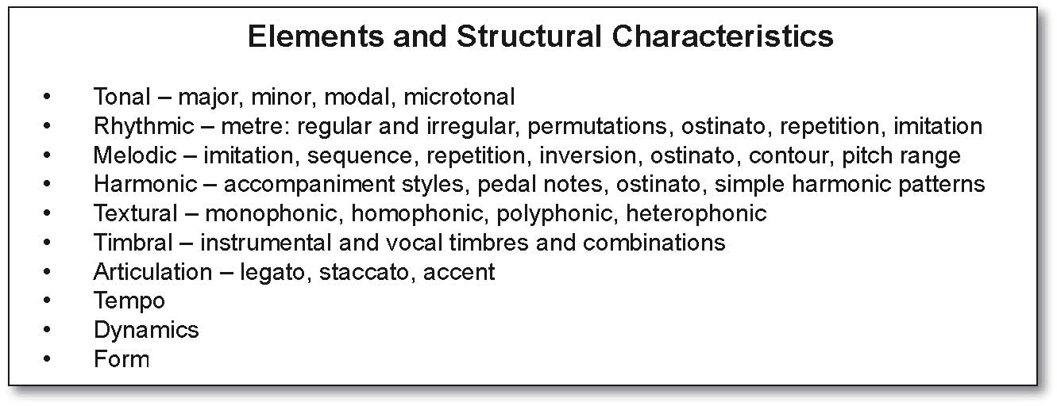
QUESTION ONE
You will hear three extracts from Variations Serieuses by Felix Mendelssohn. The music is in theme and variation form.

Listen to the ﬁrst extract from the beginning of the work. This is 40 seconds long. It will be played TWICE with a pause of 10 seconds between playings. Answer (a), (b) and (c).
(a) Describe the opening tonality of the music.

(b) Identify the type of texture.

(c) Name the type of cadence that is heard at the end of this extract.


Listen to the second extract, which is 60 seconds long. This will be played TWICE with a pause of 20 seconds between playings. Answer (d).
(d) (i) The mood in this extract is different to the mood of the ﬁrst extract. Describe this mood by listing TWO appropriate words.
Mood / Character:

(ii) Describe how the tonality, tempo and dynamics help to create the mood / character in this extract. Make ONE point for each element.

Tonality:

Tempo:

Dynamics:


Listen to the third extract of music, which is 90 seconds long. This will be played THREE TIMES with a pause of 20 seconds between playings. Answer (e).
(e) The music increases in intensity as it progresses through three variations. Describe how this is achieved.
Refer to all of the elements listed below in your answer. Write ONE relevant point for each.

Rhythm:
Tempo:
Dynamics:
Articulation:
Texture:

QUESTION TWO
You will hear three extracts of music from Naseby by Anna Grifﬁths. The text comes from a poem by James K. Baxter:
Unchanging mountain scars carry their mane of snow, |  | (line 1)
So for a thousand years the yellow broom will blow |  | (line 2)
When the great wave is spent |  | (line 3)
And the earthquake broods no longer, |  | (line 4)
And iron armament |  | (line 5)
Has fed an ocean hunger. |  | (line 6)
When, darkness on their breast |  | (line 7)
Lover by lover lie, |  | (line 8)
And soldier calm at rest knows not his enemy |  | (line 9)
Then the dark peaks will hold |  | (line 10)
Their peace beyond our knowing, |  | (line 11)
While over sunken gold |  | (line 12)
The yellow broom is blowing. |  | (line 13)
The poem will now be read.


Listen to the ﬁrst extract, from the beginning of the work to the end of line 3. This is 40 seconds long. It will be played THREE times with a pause of 20 seconds between playings. Answer (a), (b) and (c).
(a) What type of vocal ensemble is this extract written for?
(b) What is the tonality of this extract?
(c) The texture changes from one line to another in this extract.
  - (i) Describe the texture of line 1 and of line 3.
  - (ii) What evidence from the musical setting supports your answer in (i)?
  - Line 1:
  - (i)
  - (ii)
  - Line 3:
  - (i)
  - (ii)


Listen to the second extract from later in the music. This is 30 seconds long. It will be played TWICE with a pause of 20 seconds between playings. Answer (d).
(d) The mood in this extract has changed from the opening. Identify TWO ways that the musical elements contribute to this change of mood.
- (1)

- (2)


You will now hear the second half of the music, a setting of lines 7–13. This is 90 seconds long and it begins with the music you have already heard as Extract Two. It will be played as follows:
- the whole of the extract ONCE with a pause of 30 seconds;
- lines 7–9 TWICE with a pause of 30 seconds between playings;
- lines 10–13 TWICE with a pause of 30 seconds between playings;
- the whole extract TWICE with a pause of 30 seconds between playings.

(e) A feature of this music is word painting, where the meaning of certain words / phrases are emphasised by using appropriate structural characteristics or compositional devices.
In the chart below, indicate how the meaning of lines 7–13 is communicated by analysing and describing speciﬁc characteristics and / or compositional devices that are used in the music. Write at least ONE point for each line.
Line Features / Compositional devices used

LINES 7–9
When, darkness
on their breast
Lover by lover lie,
And soldier calm
at rest knows not
his enemy

LINES 10–13
Then the dark
peaks will hold
Their peace
beyond our
knowing,
While over
sunken gold
The yellow broom
is blowing.
QUESTION THREE
You will hear three extracts of music from Pony Express by Locomotiva.

Listen to the ﬁrst extract from the opening of the work. This is 50 seconds long and will be played TWICE with a pause of 20 seconds between playings. Answer (a), (b) and (c).
(a) These four instruments are heard in this extract:
- voice
- bass
- drum kit (hi-hat)
- various electronic sounds.

  - List the order in which they first enter:
1. 2. 3. 4.

(b) A compositional device is used in the bass. What is it?

(c) Complete the four-beat rhythm that is heard in the bass. The ﬁrst two beats have been given.


You will now hear a short 30 second extract from the end of the work. This will be played TWICE with a pause of 20 seconds between playings. Answer (d).
(d) A four-note melodic riff is repeatedly heard. It has an upper and a lower part. Notate the pitch only (in semibreves) of both parts. Do not include the rhythm. The ﬁrst notes of the riff for each part are given.
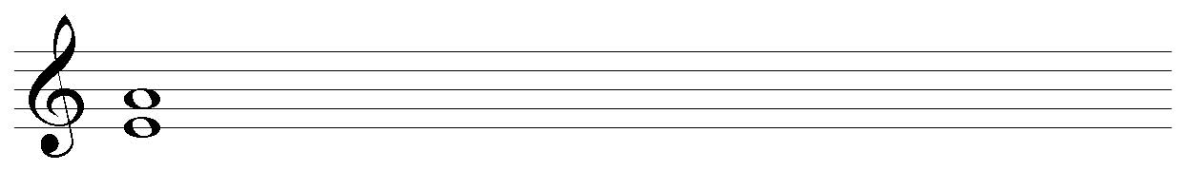

You will now hear the whole work, which is 6 minutes long. It will be played ONCE only. Answer (e).
(e) What features in this piece of music make it different from most popular music forms heard on commercial radio stations? Refer to FOUR elements / structural characteristics in your answer.
(1)
(2)
(3)
(4)

QUESTION FOUR
You will hear three extracts of music from a ﬁlm soundtrack.

Listen to the ﬁrst 25 second extract from the opening of the soundtrack. This will be played TWICE with a pause of 20 seconds between playings. Answer (a) and (b).
(a) Name the interval formed between the ﬁrst two notes of the melody.

(b) What is the tonality throughout this music?


You will now hear a continuation of Extract One for 90 seconds. This will be played THREE times with a pause of 30 seconds between playings. Answer (c).

(c) This extract can be divided into three sections according to the addition of new instruments.

Refer to the table on page 9.

Analyse the SECOND and THIRD sections by making bullet points on timbre, texture, tessitura (how high or low the music is), compositional devices identiﬁed and mood / effect. The number of bullet points required for each aspect is indicated in the table.

The beginning of the second and third sections will be indicated by a voiceover as the music plays.
The ﬁrst section has been completed as an example of how to answer the question.


You will now hear a short 40 second extract which will be played TWICE, with a pause of 30 seconds between playings. Answer (d) and (e).
(d) A repeated four-note melodic motive is heard in the middle strings. Write the pitch only (using semibreves) on the stave provided. The ﬁrst pitch has been given:

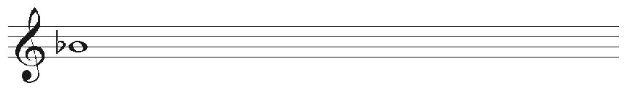

(e) The tension of the music builds up during this extract.

(i) What THREE elements contribute to this build in tension?

- Write ONE comment for each element to support your answer.
Element 1:

Comment:

Element 2:

Comment:

Element 3:

Comment:

