90493Q
3

Level 3 Art History, 2005
90493 Explain a theory and its role in art

Credits: Four


There are FOUR questions in this paper. Answer all parts of ONE question.
 | Achievement Criteria
Achievement | Achievement with Merit | Achievement with Excellence
Outline a theory related to art. | Explain how the theory inﬂuences the development of artworks. | Evaluate the signiﬁcance of the theory in the art of a particular artist, period or movement.
Demonstrate how the theory is applied in artworks.

© New Zealand Qualiﬁcations Authority, 2005
All rights reserved. No part of this publication may be reproduced by any means without the prior permission of the
New Zealand Qualiﬁcations Authority.

You are advised to spend 40 minutes answering your selected question.
INSTRUCTIONS
The following twelve areas of study are used for this external assessment:
i. | Fourteenth-century Italian Painting
ii. | Fifteenth-century Italian Painting
iii. | Italian Renaissance Sculpture
iv. | High Renaissance and Mannerism
v. | Venetian Art
vi. | Northern Renaissance Art
vii. | Cubism and Abstraction 1900–1930
viii. | Fauvism and Expressionism
ix. | Dada and Surrealism
x. | Architecture: Modernism to Postmodernism
xi. | Modern American Art
xii. | Modern New Zealand Art

There are FOUR questions in this paper. Choose ONE question and answer all parts of the question.
You may answer your selected question with reference to any areas you have studied.
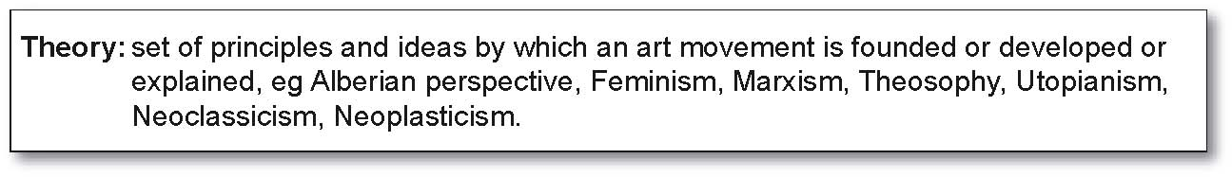
Either:

QUESTION ONE
Theory: Behavioural, eg Utopian, Freudian, Humanist, Feminist, Ethnic.
(a) Name a behavioural theory that has inﬂuenced art. Outline the principles of this theory and show how these are reﬂected in the art of ONE artist you have studied.
(b) Explain how this theory has inﬂuenced at least TWO speciﬁc art works by your chosen artist.

(c) Including reference to the period in which your chosen artist worked, evaluate the importance of this theory on the development of this artist’s style.

Or:

QUESTION TWO
Theory: Technical, eg Colourist, Perspectival, Constructivist, Functionalist, Automatist, Spatial.

(a) Name and outline a technical theory or set of ideas and demonstrate the application of this theory in the art of ONE artist you have studied.

(b) Choose at least TWO art works by your selected artist and explain how each has been inﬂuenced by this theory.

(c) Critically explore the extent to which this theory was the major inﬂuence on the art of your selected artist.

Or:
QUESTION THREE
Theory: Political, eg Capitalist, Socialist, Marxist, Fascist, Secular.

(a) Name a political theory and outline its main principles. Demonstrate the application of these principles in the art of a movement you have studied.

(b) Explain how this theory has inﬂuenced the development of at least TWO art works from your selected movement.

(c) Evaluate the extent to which this theory was the major factor in shaping the art that distinguishes your chosen movement.

Or:
QUESTION FOUR
Theory: Spiritual / Philosophical, eg Christian, Theosophical, Existentialist, Neoplatonist.

(a) Outline the main principles of a spiritual / philosophical theory or set of ideas and describe the inﬂuence of this theory on a period or movement you have studied.

(b) Select TWO art works from your chosen period or movement and explain how each has been inﬂuenced by this theory.

(c) Evaluate the extent to which this theory was the distinctive feature of the art of your selected period or movement.

