9 0 4 9 6
Level 3 Music Studies, 2004
90496 Describe elements of music
through listening

Credits: Four

You should answer ALL the questions in this booklet.
You will be given three minutes to read and prepare before the examination begins.
You may wish to answer questions in pencil ﬁrst. You should go over your answers in ink before
handing in this examination. Answers in pencil will NOT be eligible for reconsideration.
If you need more space for any answer, use separate manuscript and lined pages and clearly number the question.
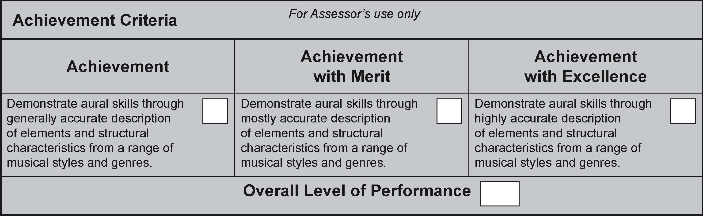
© New Zealand Qualifications Authority, 2004
All rights reserved. No part of this publication may be reproduced by any means without the prior permission of the New Zealand Qualifications Authority.
You are advised to spend one hour answering the questions in this examination.
QUESTION ONE
You will now hear FOUR extracts of music.

Listen to the ﬁrst extract. This will be played TWICE with a gap of 10 seconds between playings. Answer (a) and (b).
- (a) What type of ensemble is playing this work?

- (b) Describe the metre of the music.


Listen to the second extract. This will be played THREE times with a gap of 20 seconds between playings. Answer (c).
(c) Identify THREE compositional devices (rhythmic, melodic, harmonic or structural) used in this extract of music and describe how they are used.


Listen to the third extract. This will be played THREE times with a gap of 20 seconds between playings. Answer (d).
  - (d) Describe how the texture density and type begins and changes throughout this repeated section of music.



  - Listen to the fourth extract. This is the whole piece of music. This will be played THREE times with a gap of 45 seconds between playings. Answer (e).

  - (e) Describe how unity and variation are maintained in this piece of music. Refer to at least FIVE of the elements and structural characteristics listed below to support your answer:
• rhythm
• melody
• tonality
• harmony
• texture
• timbre
• articulation
• dynamics.

QUESTION TWO
You will now hear TWO extracts of music from Folk Jazz by Nathan Haines.

Listen to the ﬁrst extract, which is from the opening of the work. This will be played FOUR times with a gap of 30 seconds between playings. Answer (a), (b) and (c).
(a) Describe the instrument playing the opening solo at the start of this extract.

(b) How does the role of the instrument change after it has played the opening solo?
(c) After the entry of the drums and electric guitar, the bass guitar introduces a four-bar repeated idea and then the instrument from question (a) reappears.

What is the relationship between the bass guitar and the instrument in (a)?


Listen to the second extract. This will be played TWICE with a gap of 30 seconds between playings. Answer (d).
- Describe TWO ways in which the music of the second extract differs from the ﬁrst extract.


Now listen to both extracts played one after the other TWICE. There will be a gap of one minute between playings. Answer (e).
(e) (i) Describe the roles of each instrument in this music.
(ii) How important is timbre / tone colour in this music? Give reasons for your answer.
(iii) How do texture and harmony give both unity and variety to this music?

QUESTION THREE
You will now hear music from Body and Mind by Deho Mone. This is a traditional work from the Bauls, a Bengali religious group.

Listen to the ﬁrst extract, which is from the opening of the work. This will be played THREE times with a gap of 30 seconds between playings. Answer (a) and (b).
(a) What is the tonality (eg major) of this music?
(b) (i) Describe the sound sources and list the order in which they enter.
(ii) What is the overall texture and the roles of the instruments?
Overall texture:
Roles of the instruments:

Listen to the second extract, which consists of the opening and a continuation of the music. This will be played THREE times with a gap of one minute between playings. Answer (c).
(c) Using the headings in the table below, describe the differences between the opening of the work and the way the music continues. Make at least ONE key point per heading.

Listen now to Extract 3, which is a longer extract from the opening of this work. This will be played TWICE with a gap of one minute between playings. Answer (d).
(d) This music has been described as ‘energetic’, ‘happy’, ‘joyous’ and even ‘trance-like’. How does the music reﬂect these descriptions?
Refer to at least THREE of the elements and structural characteristics listed below to support your answer:
• tempo
• rhythmic
• melodic
• timbral.

QUESTION FOUR

You will now hear TWO extracts from Quem Queritis, an arrangement of a medieval Irish work that
commemorates the death of Jesus Christ.

EXTRACT 1

Listen to the first extract, from the opening of the work. This will be played THREE times, with a gap of 20 seconds between playings. Answer (a), (b) and (c).

(a) What is the texture of the music?

(b) Describe the tonality of the music.

(c) Map out the pitch contour or shape of ONE statement of the theme on the stave given below, using note-heads only. A key signature and the first pitch, Eb, is given.

EXTRACT 2

Listen to the second extract, which is a longer statement of the opening of the work. This will be
played FOUR times with a gap of 30 seconds between playings. Answer (d) and (e).

- Describe how the opening statement of the Alleluia theme, heard three times, is changed or transformed for a following three times.

(e) Devise a graphic score of this extract of music, using the outline on page 9, to describe the following elements and structural characteristics of the music:

• textures – eg monophonic

• relationships between the various parts – this will be indicated by where you place things in the score

• pitch levels – this is indicated on the left-hand side of the page

• melodic contour of the voices – indicate with curving lines

• timbres/voices – label these, eg sopranos.

You may make notes on your graphic score as appropriate. The beginning has been started for you, and the time, in seconds, is indicated at the top of the graphic score to assist you.

