2
9 0 4 4 8
Level 2 Te Reo Mäori, 2004
90448 Tuhituhi i te reo o öna wheako whaiaro
Credits: Six
You should answer both tasks in this booklet.
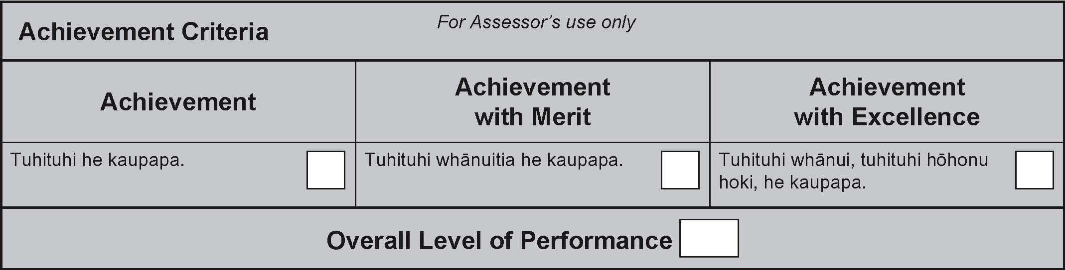

© New Zealand Qualiﬁcations Authority, 2004.
All rights reserved. No part of this publication may be reproduced by any means without the prior permission of the
New Zealand Qualifications Authority.
.
You are advised to spend 75 minutes answering the questions in this booklet.
TE KAI A TE RANGATIRA
INSTRUCTIONS:
1. There are TWO writing tasks in this examination.
For TÜMAHI TUATAHI you must write one essay-length answer in TE REO MÄORI.
For TÜMAHI TUARUA you must write two paragraph-length answers in TE REO MÄORI.

2. Carefully read through all instructions and topics before you begin working.

3. As a guide: Tümahi Tuatahi 40–45 minutes
Tümahi Tuarua 30–35 minutes

4. Ensure that your work is legible (clearly written and easy to read).

5. For high achievement, ensure your answers fit these descriptors:
• relevant to the topic, and answering all aspects of the question
• written in correct Mäori
• containing a wide range of vocabulary and language structures
• well set out, with a logical and coherent flow of ideas
• interesting and/or informative to the reader
• where applicable, containing original thoughts, ideas or opinions.

TÜMAHI TUATAHI: Tuhinga Roa
Write a passage of 200–250 words (1¹/₂ – 2 pages) in length, on ONE of the following topics:
EITHER:
A Tuhi Pakiwaitara
Write an interesting story based on the series of illustrations below. Don’t forget to give your story a title.
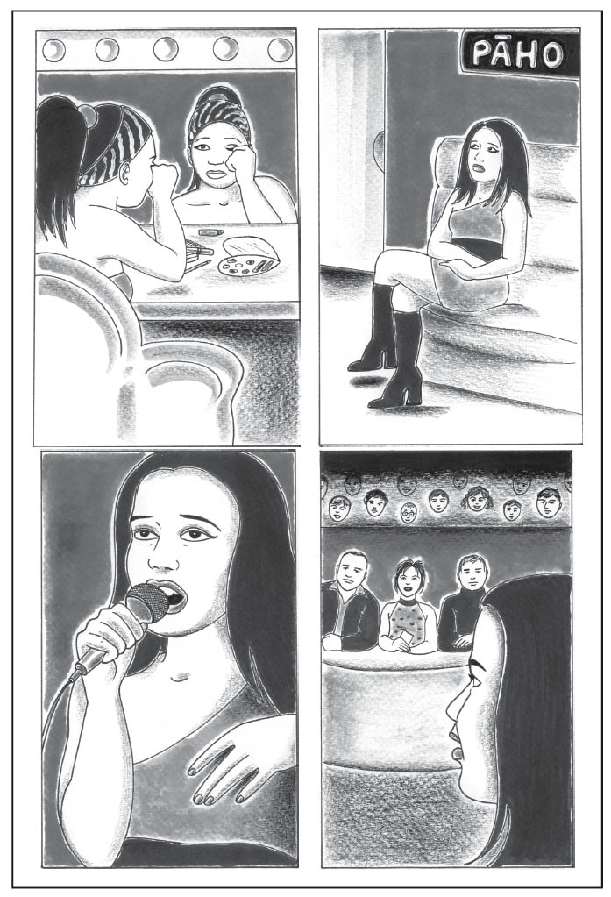

OR:
B Tangata Rongonui
You are the host of a new Mäori television series that profiles the achievements of famous New Zealanders. You are interviewing one of these people for your show.
Choose a New Zealander who is well known at a national level and write the dialogue (körero) between yourself and your guest.
You may choose to include the following ideas:
• a summary of his/her life
• circumstances of his/her background
• family, home, occupation, other interests
• an explanation of why this person is famous
• lessons or advice he/she has for young people, or for everyone.

Remember: your answer must be a conversation between two people in front of a television audience.
KUPU ÄWHINA
oranga life
pükenga skills
painga qualities
mahi ngahau interests
toanga achievements
akoranga lessons
moemoeä dreams
taumahatanga difficulties
kaiwhakaatu presenter
umanga occupation

OR:
C He Tuhinga Taupatupatu
‘Me whakauru ngä tauira katoa o te kura tuarua e ako ana i te reo Mäori ki te mahi Kapa Haka. Nä te mea he whai tikanga te reo me öna tikanga kia haere ngätahi.’

‘Kapa Haka should be compulsory for all secondary school students studying Te Reo Mäori,
because language and culture are intertwined.’

Your essay should present your arguments either for or against this suggestion, as if you were our preparing for a debate.

Your answer should fully explain your ideas, and the reasons why you would argue either for or against this suggestion, using examples and wider observations to illustrate your points.

Indicate your choice for Tümahi Tuatahi by circling the letter of the topic:
A B C
You may plan your answer here:

Write your answer here:

TÜMAHI TUARUA: Whakamärama Kupu
Choose TWO of the words listed below.
Write a paragraph that defines, explains and discusses each word you have chosen.
Each paragraph should be 50–100 words in length.

NGÄ KUPU

harakeke
hoko
manaaki
mökai
rorohiko

Kupu Tuatahi:
You may plan your answer here:

Write your answer on separate paper.
Kupu Tuarua:

You may plan your answer here:

Write your answer on separate paper.

