9 0 3 1 7
Level 2 Science, 2004

90317 Use physics to describe the operation of technological devices, and to solve problems

Credits: Four

You should answer ALL questions in this booklet.

Show ALL working.

Achievement Criteria |  | For Assessor’s use only
Achievement |  | Achievement  with Merit |  | Achievement  with Excellence
Identify physics principles/concepts in the operation of technological devices. |  | Explain physics principles/concepts in the operation of technological devices. |  | Analyse physics principles/concepts in the operation of technological devices.
Solve problems by substituting data into given formulae, or through directed use of graphs or diagrams. |  | Solve problems by selecting formulae from a given list, or by drawing graphs or diagrams. |  | Solve problems requiring a two-step solution using formulae, graphs or diagrams.
Overall Level of Performance (all criteria within a column are met) 

© New Zealand Qualifications Authority, 2004
All rights reserved. No part of this publication may be reproduced by any means without the prior permission of the New Zealand Qualifications Authority.

Formulae that may be useful:
Use correct units and sensible rounding in solving problems.

You are advised to spend 45 minutes answering the questions in this booklet.

Part A: The Telescope

Figure 1 shows a photo of a telescope. This telescope has a large lens (called the ‘objective lens’) at the front and this forms an image at the other end of the telescope tube. The observer then looks through a small lens (the ‘eyepiece’) next to the image to get a magnified view of it.
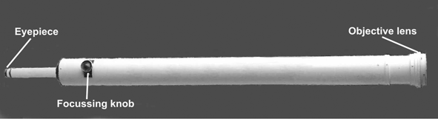
Figure 1.
A telescope is normally described by its aperture (the diameter of the objective lens) its focal length and its focal ratio. These three characteristics are related according to the following equation:

QUESTION ONE

The telescope in Figure 1 has an aperture of 0.10 m and a focal ratio of 15. Show by calculation that the focal length of its objective lens is 1.5 m.

QUESTION two

The light rays from very distant objects such as stars and planets can be considered to be parallel.

(a) How far from the lens is the image for a very distant object viewed through the telescope in Figure 1.

(b) Draw a ray diagram showing the paths through the telescope of two light rays from a very distant object.

QUESTION THREE

The position of the eyepiece can be changed for objects at different distances as shown in Figures 2 and 3. One of these photographs (Figure 2 or 3) shows the 1.5 m focal length telescope focussed on a very distant object and the other photograph shows it focussed on an object only 20 m away.

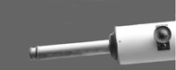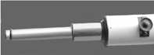
Figure 2. Figure 3.

(a) Calculate the position of the image in the telescope for an object 20 m away.

(b) Using your results for questions TWO (a) and THREE (a), which Figure, 2 or 3, shows the telescope focussed on the object 20 m away?

(i) The telescope focussed on an object 20 m away is shown in Figure ___.
(ii) Justify your answer.

QUESTION FOUR

The magnification of a telescope is changed by using eyepieces of different focal lengths and can be calculated using the following equation:
where f_{obj} = focal length of objective lens

f_{eye} = focal length of eyepiece
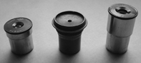
Figure 4.

Use this equation to calculate the magnification of the telescope (focal length of its objective lens is 1.5 m) when an eyepiece of focal length 15 mm is used.

QUESTION FIVE

Astronomers sometimes replace the eyepiece with a camera body (with the camera lens removed) so that photographs can be taken. Describe the nature of the image formed on the film.
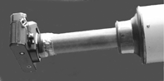
Figure 5.

QUESTION SIX

When the telescope is pointed high up, the eyepiece is low down and awkward to look through. In this position, if the eyepiece could be inserted at right angles to the tube it would be much more comfortable for viewing.

Apply the principles of reflection and refraction to identify and explain how the image can be viewed through an eyepiece at right angles to the tube. Complete the diagram, Figure 6, to show how the rays can be focussed into the eyepiece.
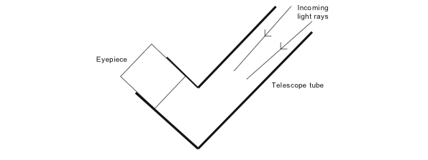
Figure 6.

Part B: The Ladder

QUESTION SEVEN

Calculate the work done by a person, whose weight is 700 N, when they climb up a ladder to a height of 4 m.

QUESTION EIGHT

Explain the relationship between the work done by the person and the energy gained as they climb the ladder.

QUESTION NINE

Describe what would happen to the energy gained if the person was to fall off the ladder.

Part c: The Lift

QUESTION ten

Tall buildings use lifts (or ‘elevators’) to transport people up and down.

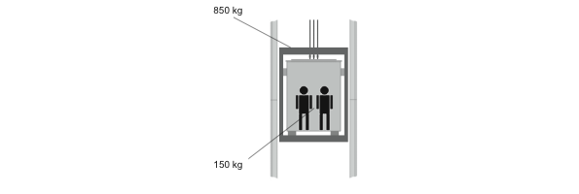

(a) A lift of mass 850 kg carries two passengers of total mass 150 kg. The lift and its passengers travel up a total distance of 120 m. Calculate the increase in gravitational potential energy of the lift and the passengers.
(The gravitational field strength g, is 10 N kg^{–1})

(b) The lift travels at a constant speed of 4 m s^{–1}. Calculate the power that is being developed.

QUESTION eleven

The cables that raise and lower the lift are also connected to a counterweight which hangs on the other side of a pulley. The counterweight weighs the same as the lift when it is carrying an average number of people. It goes down when the lift goes up (and up when the lift goes down).

[For copyright reasons, this resource cannot be reproduced here. See below.]

http://science.howstuffworks.com/elevator3.htm
The graph below shows how the gravitational potential energy of the lift and its passengers changes as the lift goes down.
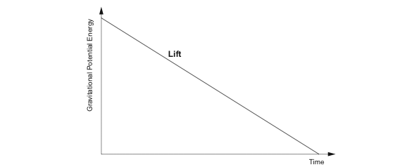
Figure 9.

(a) In Figure 9 above, draw the graph that shows how the gravitational potential energy of the counterweight changes during this time.

(b) Discuss the purpose and advantages of the counterweight to the lift operation.

