9 0 3 1 6

Level 2 Science, 2004

90316 Describe New Zealand’s geological history and processes, and the nature and life cycle of stars

Credits: Four

You should answer ALL the questions in this booklet.

Show ALL working.

Achievement Criteria |  | For Assessor’s use only
Achievement |  | Achievement  with Merit |  | Achievement  with Excellence
Describe geological processes related to New Zealand’s geological history. |  | Explain geological processes related to New Zealand’s geological history. |  | Apply knowledge of geological processes to explain in detail New Zealand’s geological history.
Describe how stars are classified and describe their life cycles. |  | Link star types and their characteristics to their life cycles. |  | Explain links between the nature and life cycles of stars.
Overall Level of Performance (all criteria within a column are met)

© New Zealand Qualifications Authority, 2004
All rights reserved. No part of this publication may be reproduced by any means without the prior permission of the New Zealand Qualifications Authority.

You are advised to spend 45 minutes answering the questions in this booklet.

PART A: NEW ZEALAND’S GEOLOGICAL HISTORY

QUESTION ONE: ROCKS OF THE SOUTHERN ALPS

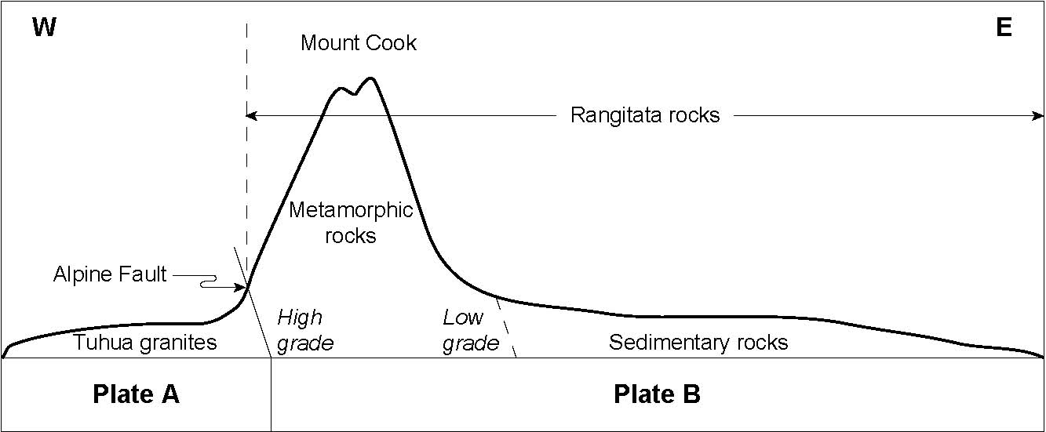

Figure 1. Cross section of the Southern Alps

(a) Name the two plates, shown in Figure 1, separated by the Alpine Fault and describe their motion relative to each other.

Plate A
Motion relative to Plate B

Plate B
Motion relative to Plate A

The Tuhua granites are some of New Zealand’s oldest rocks.

(b) Explain why New Zealand’s oldest rocks are on the west side of New Zealand.

Formation of the Southern Alps rock types



Glen Coates, The Rise and Fall of the Southern Alps, Canterbury University Press, Christchurch, 2002.

Figure 2. Processes involved in the formation of New Zealand 150 million years ago

(c) Describe the processes responsible for the formation of the:

(i) Submarine fan

(ii) Seamounts

(d) Explain the formation of the Rangitata rocks in New Zealand and their relationship to plate tectonics.

(e) Explain the role of the Kaikoura Orogeny in placing the Rangitata rocks into their present position, as shown in Figure 1.

QUESTION TWO: ICE AGES IN THE SOUTHERN ALPS

Much of the Southern Alps show evidence of major ice ages. These ice ages were a time of increased erosion of the rocks.

(a) Describe one effect of an ice age on New Zealand’s landscape.

(b) Explain how ice ages increased the rate of erosion of the Southern Alps.

(c) Discuss what effects the Kaikoura Orogeny would have had on the last ice age.

PART B: STARS

The Hertzsprung-Russell Diagram below shows a number of stars, most of which are easily seen in our skies. Their positions in this diagram are plotted according to two of their characteristics:

• brightness in terms of our Sun’s brightness

• spectral type, which is another way of describing the stars’ surface temperatures.

[For copyright reasons, this resource
cannot be reproduced here. See below.]

Hertzsprung-Russell Diagram
Based on diagram from “Space Encyclopedia” by Heather Couper & Nigel Henbest

QUESTION THREE

Proxima Centauri is the closest star to our Sun. Proxima Centauri is shown on the Hertzsprung-Russell diagram opposite. Describe the features of this star.

Two other stars that occur on the Hertzsprung-Russell Diagram are Achernar and our Sun. The table below compares some more characteristics of Achernar and our Sun.

Characteristics | Sun | Achernar
Mass (Suns) | × 1 | × 6
Size (Suns) | × 1 | × 12
Colour | Yellowish-white | Blue
Surface Temperature
Spectral Type

Use the Hertzsprung-Russell Diagram to complete this table for the Surface Temperature and Spectral Type of both stars.

QUESTION FIVE

The spectral type and colour of a star depends on its surface temperature. Describe how a star’s surface temperature determines the star’s colour. Compare Achernar with our Sun in your description.

QUESTION SIX

Achernar is one of the bright stars always visible at night in our southern skies. It is a Main Sequence star and so is our Sun.

Discuss how Main Sequence stars are formed.

QUESTION SEVEN

Stars at one end of the Main Sequence have a longer life than those at the other end. (You may want to use Achernar and our Sun as examples.)

Discuss how mass and temperature affect a star’s life.

QUESTION EIGHT

At different stages in their lives, stars burn different fuels by a process of nuclear fusion. These fuels are:

• helium
• hydrogen
• iron
• carbon and oxygen
• none (a star may not be burning any fuel at all but just slowly cooling down).

In the table below write the correct fuel next to its star type.

Star Types | Fuels
Main Sequence
Red Giant
Super Giant
Supernova
White Dwarf

QUESTION NINE

Our Sun and Achernar are single stars that are not massive enough to explode as supernovae. They will end their lives as White Dwarf stars. However, White Dwarfs cannot have masses greater than 1.4 times the Sun’s mass. The Sun is already below this limit, but Achernar is not.

Explain the processes and/or events that must happen to Achernar before it can become a White Dwarf.

