9 0 3 1 5
Level 2 Science, 2004

90315 Describe naturally occurring organic mixtures and the production of derived consumer products

Credits: Four

You should answer ALL the questions in this booklet.

A Periodic Table is printed on page 2 of this booklet.

Show ALL working.

Achievement Criteria |  | For Assessor’s use only
Achievement |  | Achievement  with Merit |  | Achievement  with Excellence
Describe organic compounds, and the composition and uses of  naturally occurring organic mixtures. |  | Link the composition of naturally occurring organic mixtures and the derived consumer products to their uses. |  | Explain the usefulness of naturally occurring organic mixtures and the derived consumer products in terms of their properties.
Describe key steps in the production of consumer products from naturally occurring organic mixtures. |  | Link the key steps in the consumer production process to the properties of the naturally occurring organic mixtures involved. |  | Explain the purpose of individual steps in the consumer production process.
Overall Level of Performance (all criteria within a column are met)
© New Zealand Qualifications Authority, 2004
All rights reserved. No part of this publication may be reproduced by any means without the prior permission of the New Zealand Qualifications Authority.

You are advised to spend 45 minutes answering the questions in this booklet.

Question One: Organic compounds

(a) Complete the following table with the name or structure of each compound.

Name | Structure
Ethanol | (i)
(ii) | 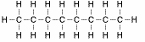
Pentene | (iii)
(iv) | 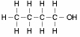
Butanoic acid | (v)

(b) Give the name and structure of the straight-chained alkane with 7 carbon atoms.

Name | Structure

Question TWO: Crude oil

(a) Describe how crude oil differs from refined oil.

(b) Not all crude oils are the same. Give reasons for the differences between crude oils.

(c) Discuss what makes petrol one of the most useful vehicle fuels.

Question Three: biogas as natural gas

The breakdown of sewage wastes releases large amounts of methane.

(a) Why is methane the simplest hydrocarbon?

(b) Balance the equation for the burning of methane in excess oxygen.

CH₄ + O₂        CO₂ + H₂O

(c) Explain the process by which methane is produced from raw sewage.

Question FOUR: plants and alcohol

Alcohol can be produced by the fermentation of plant material.

(a) Complete the following word equation for fermentation.

Plant sugars + ________  ________ + ________

(b) Describe one chemical use of alcohol.

(c) Explain the process that produces alcohol from plants.

(d) Beer and wine are both produced by fermentation of plant material. Beer has about 30% of the alcohol content of wine.

Discuss how the differences in the fermentation process account for the different levels of alcohol in beer and wine.

Question FIVE: the refining of crude oil

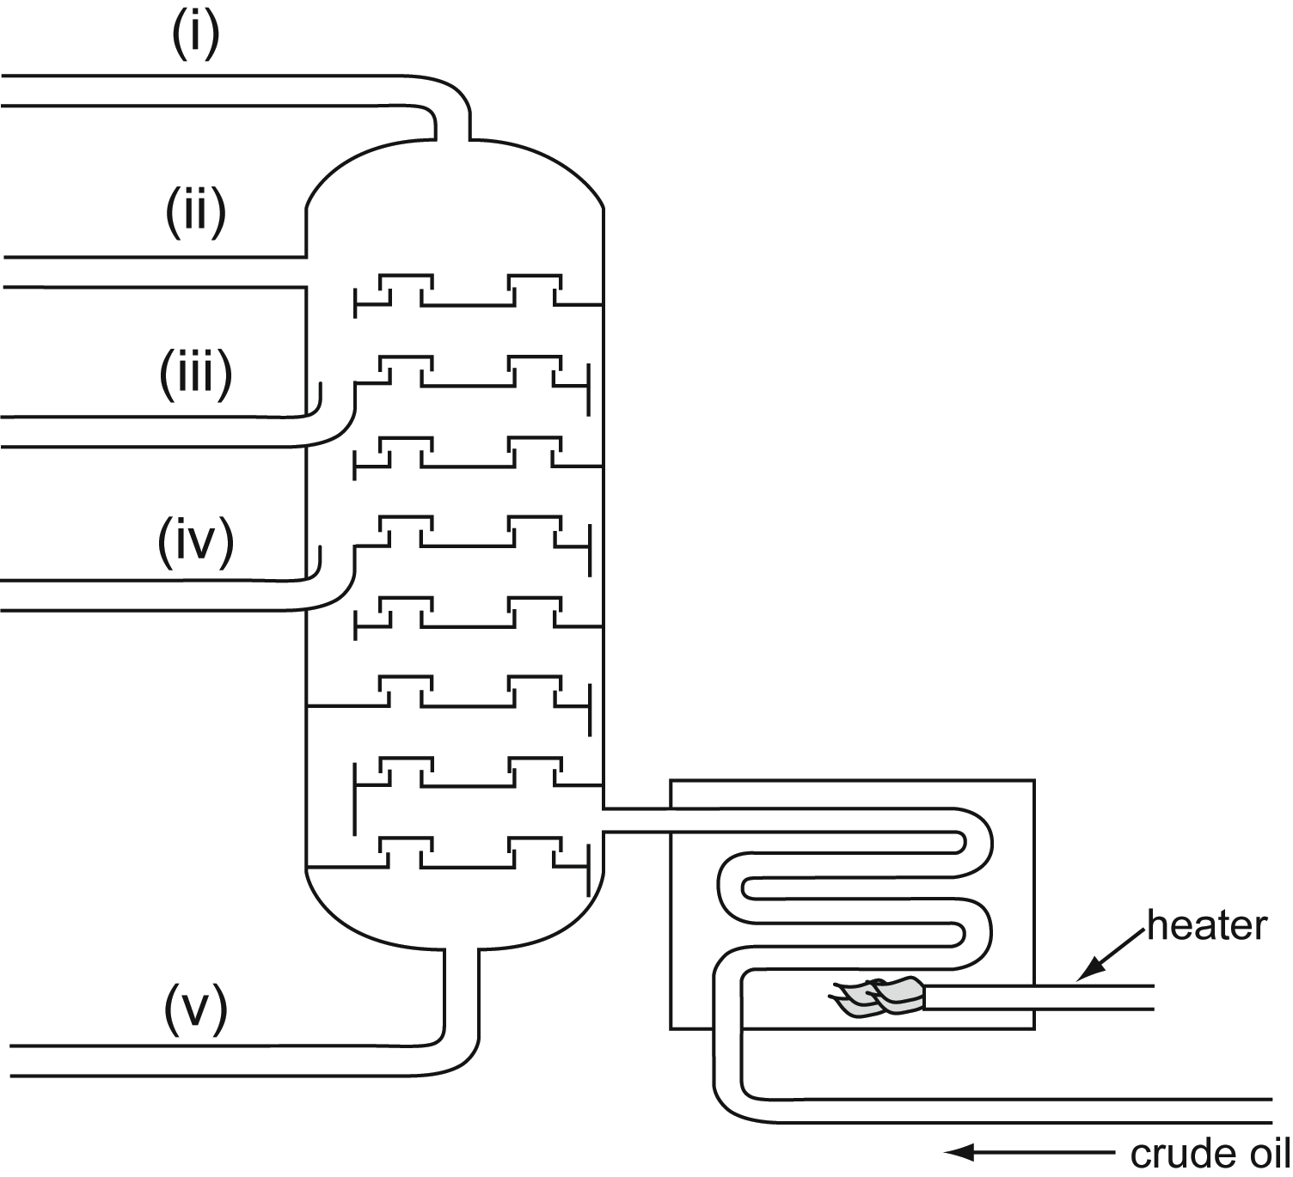
Diagram of a fractional distillation column.

(a) During fractional distillation, the heater heats the crude oil. Why is the crude oil heated to 450°C?

(b) List, in order, from the shortest carbon chain to the longest carbon chain, the products produced from the above refinery.

Products are petrol, oil, av-gas, methane, tar.

Shortest carbon chain length
(i)
(ii)
(iii)
(iv)
(v)

Longest carbon chain length
To increase the amount of petrol obtained from crude oil, the process of ‘cracking’ is carried out.
(c) Explain what ‘cracking’ does to the crude oil to get more petrol.

(d) Give the name and formula of the main waste product from cracking.

Name | Formula

(e) This waste product is used to make a key polymer. Name the key polymer and draw its structure.

Name | Structure

(f) Discuss the conditions necessary for ‘cracking’ to occur.

