9 0 2 3 6
Level 2 Economics, 2004
90236 Explore issues using economic concepts and statistical data
Credits: Six

You should answer ALL the questions in this booklet.

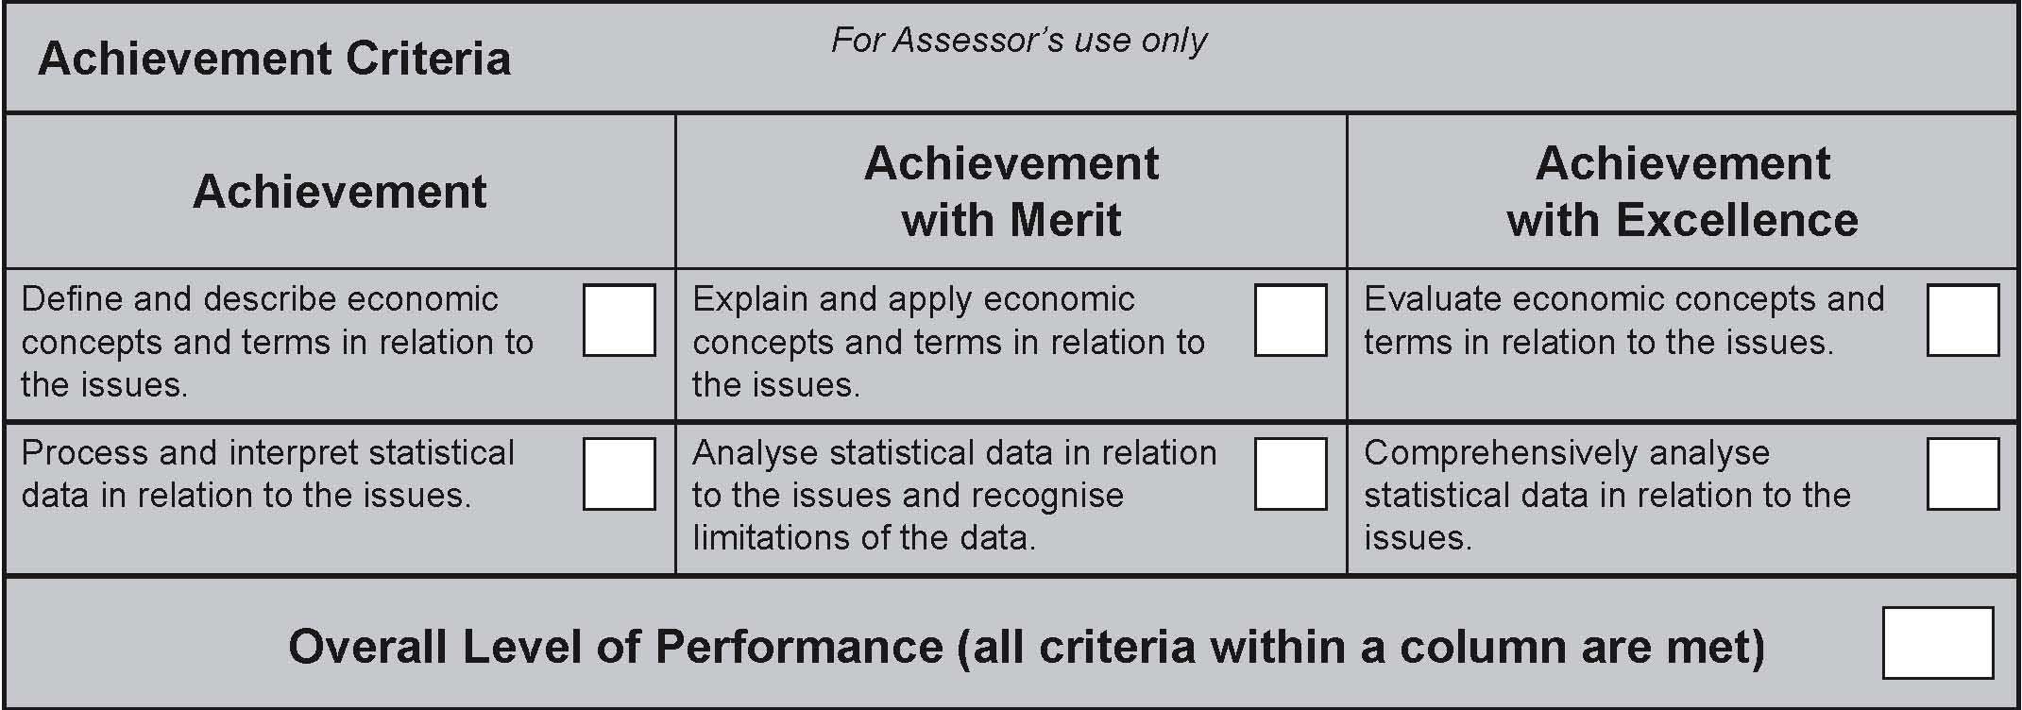
© New Zealand Qualiﬁcations Authority, 2004.
All rights reserved. No part of this publication may be reproduced by any means without the prior permission of the
New Zealand Qualifications Authority.
You are advised to spend 60 minutes answering the questions in this booklet.

PART A
QUESTION ONE
  - (a) (i) Describe the difference between an onshore service and an offshore service.

  - (ii) Identify ONE example of each of:

  - (1) an onshore service

          - (2) an offshore service

  - (b) A quota is a form of protectionism.

  - (i) Deﬁne quota in the context of international trade.

    - (ii) Give ONE reason why a quota might be used by the government as a form of protectionism.

  - (c) A tariff is another form of protectionism.

  - (i) Deﬁne tariff in the context of international trade.

  - (ii) Explain why a tariff might be preferred to a quota as a form of protectionism.

QUESTION TWO
  - (a) (i) Identify TWO examples of income.

  - (1)

  - (2)

  - (ii) Identify TWO examples of wealth.

  - (1)

  - (2)

- (b) Describe the difference between equity and equality.

  - (c) (i) Explain a situation where incomes could be equal but inequitable.

  - (ii) Explain a situation where a system of taxation could be unequal but equitable.

QUESTION THREE
(a) (i) Describe ONE cause of a price rise in a particular market.
  - (ii) Describe ONE cause of a general price rise.

- (b) Deﬁne deﬂation.

- (c) For each period on the table below, identify whether the percentage change in the general price level represents inﬂation or deﬂation and, where appropriate, also disinﬂation. Some periods require more than one answer. Write your answer in the space provided.

Time Period  (year ended) | % Change in General Price Level | Inﬂation or Deﬂation (and where appropriate, also Disinﬂation)
Jun 2003 | 0 | No Inﬂation
Sep 2003 | 2.3
Dec 2003 | 1.6
Mar 2004 | 2.4
Jun 2004 | 0.2
Sep 2004 | – 0.7

QUESTION FOUR
(a) Economic growth can be measured by changes in real income, productive capacity and net social welfare. Identify one strength and one weakness for each measure.
Measure | Strength | Weakness
(i) Changes in real income
(ii) Productive capacity
(iii) Net social welfare

(b) Choose the measure above that you think is the best indicator of economic growth. Give a reason for your choice.
Measure:
Reason:

PART B
QUESTION ONE
Refer to the table below to answer this question.
Balance of Payments
Quarter ended June 2003

Major Components | NZ$(million)
Exports | 7 627
Imports of services | 2 446
Outﬂow of current transfers | 258
Income from foreign investment in NZ | 2 296
Imports | 7 216
Exports of services | 2 290
Inﬂow of current transfers | 320
Income from NZ investment abroad | 545
(www.stats.govt.nz)
(a) | (i) | Calculate the Balance on Goods | $________ m surplus or deﬁcit (circle one)
 | (ii) | Calculate the Balance on Services | $________ m surplus or deﬁcit (circle one)
 | (iii) | Calculate the Current Account Balance | $________ m surplus or deﬁcit (circle one)

(b) Give an example of an item that would be included in:

- Exports of services

(ii) Income from NZ investment abroad

(c) Give ONE reason why income from foreign investment in NZ is such a large amount.

(d) Identify ONE limitation of the data used to calculate the balance of payments.

QUESTION TWO
Assume a household buys only the quantities of goods described in the table below.

Item Purchased | Quantity Purchased | Price ($) Year 1 | Price ($) Year 2 | Price ($) Year 3
Bread | 6 | 2.20 | 2.40 | 2.60
Cheese | 1 | 7.00 | 7.50 | 8.00
Milk | 3 | 2.40 | 2.50 | 2.60

(a) Use the table provided below to calculate the rate of inﬂation in Year 2 and Year 3. Year 1 is the base year.
Year | Total Spending ($) | Price Index | Rate of Inﬂation (%)
1 |  | 1000
2
3

(b) Describe what is indicated by the rate of inﬂation you calculated for Year 2.

(c) The Consumer Price Index (CPI) is a weighted price index. Describe what is meant by
weighted.

(d) Explain why the CPI is not a suitable indicator for a business to use when predicting its costs
for the following year.

QUESTION THREE
(a) Use the data in the table below to calculate the Gross Domestic Product (GDP) per capita.

GDP ($m) | Population (million) | GDP per capita ($)
81 700 | 3.85

(b) Describe what is indicated by the ﬁgure you calculated in (a).

- (c) Describe what GDP measures.

- (d) Identify TWO limitations of using GDP data to compare the standard of living between countries.

QUESTION FOUR
Refer to the table below to answer this question.
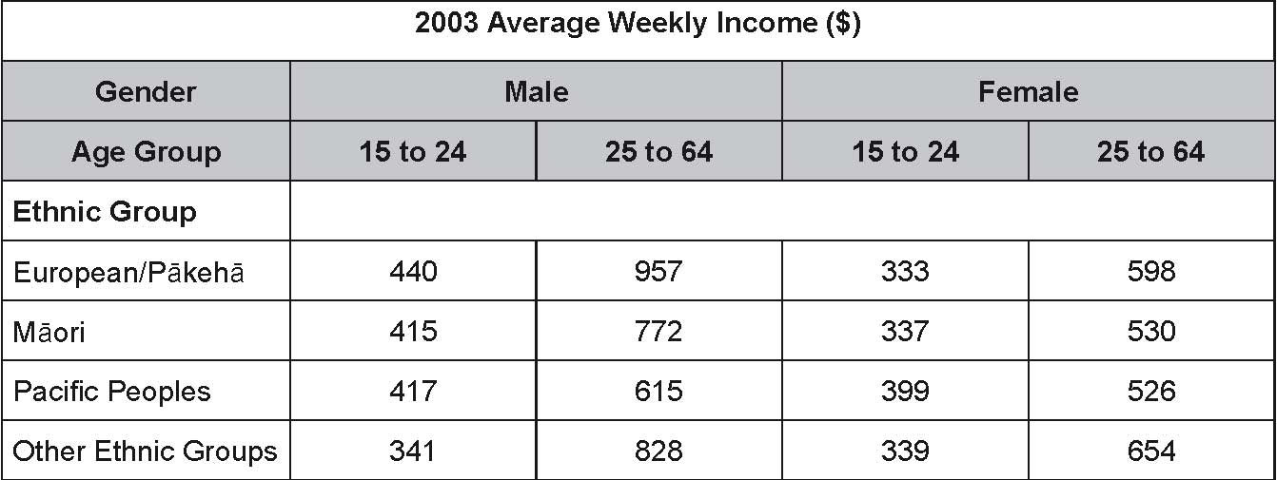
(www.stats.govt.nz)

(a) (i) Calculate the range of average weekly incomes in the female 15 to 24 age group.

(ii) Identify the ethnic group that has the greatest difference between male and female earnings in the 15 to 24 age group.

(b) In the female 15 to 24 age group, Paciﬁc Peoples have the highest average weekly income, but in the female 25 to 64 age group, Paciﬁc Peoples have the lowest average weekly income. Suggest an economic reason that explains why this change might occur.

(c) Identify ONE reason why statistics related to average weekly incomes may not be a good indicator of the standard of living.

PART C
Economic and Financial Forecasts
Annual average % change | 2002 | 2003f | 2004f | 2005f
Private consumption | 4.4 | 5.4 | 4.6 | 2.0
Business investment | 5.3 | 10.5 | 8.2 | 5.3
Exports | 5.8 | -0.1 | -0.3 | 4.1
Imports | 8.6 | 9.6 | 6.9 | 4.1
GDP | 4.4 | 3.6 | 3.3 | 2.0

End of year |  |  | 2002 |  | 2003 |  | 2004f |  |  | 2005f
OCR |  |  | 5.75 |  | 5.0 |  | 5.5 |  |  | 5.5
TWI |  |  | 56 |  | 65.5 |  | 63.7 |  |  | 58.4
f | = | forecast |  |  |  |  |  |  | (www.westpac.co.nz)

The data in the tables above illustrates a range of economic relationships. Refer to the data to identify the following relationships, and provide an explanation for each relationship. Note that the ﬁgures in the upper part of the table are % changes from the previous year, while the ﬁgures in the lower part are at the rates at the end of each year.
(a) Private Consumption and the OCR.
Relationship:
Explanation for relationship:

(b) Business Investment and the OCR.
Relationship:
  - Explanation for relationship:
- (c) Exports and the TWI.
Relationship:
Explanation for relationship:

(d) Imports and the TWI.
Relationship:
  - Explanation for relationship:
- (e) Referring only to the data provided, explain the factors that would have contributed to the forecast fall in the rate of economic growth between 2002 and 2003.

