90317

Level 2 Science, 2003
90317 Use physics to describe the operation of
technological devices, and to solve problems

Credits: Four

You should answer ALL the questions in this booklet. Show ALL working.
Formulae that you may find useful are given on page 2.
For Assessor’s use only
Achievement Criteria
Achievement |  | Achievement  with Merit |  | Achievement  with Excellence
Identify physics principles/ concepts in the operation of technological devices. |  | Explain physics principles/ concepts in the operation of technological devices. |  | Analyse physics principles/ concepts in the operation of technological devices.
Solve problems by substituting data into given formulae, or through directed use of graphs or diagrams. |  | Solve problems by selecting formulae from a given list, or by drawing graphs or diagrams. |  | Solve problems requiring a two-step solution using formulae, graphs or diagrams.
Overall Level of Performance (all criteria within a column are met)

© New Zealand Qualifications Authority, 2003
All rights reserved. No part of this publication may be reproduced by any means without the prior permission of the New Zealand Qualifications Authority.

You are advised to spend 45 minutes answering the questions in this booklet

Formulae that may be useful:
W = Fd p = mv T = Fd^ P = E E _{k} = ½ mv²

E_{p} = mgΔh E_{p} =½kx² F = kx
= X100
work input
S_{i}S_{o} = f₂
H_{o} f S_{o} d_{o}
M = H₁ = S_{o} = f = d₁
t
Efficiency = work output
d₁
1
+
d₂
1
=
f
1
Part A: The Camera
QUESTION ONE

The lens of a camera focuses light onto a film.

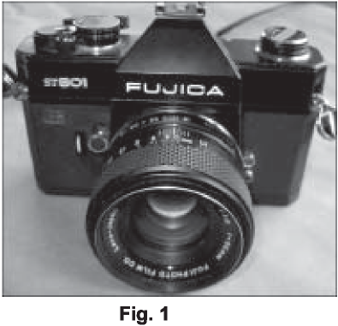

- What shape of lens is used in a camera so that an image is formed on the film?

- Describe the nature of the image formed on the film by the camera lens.

- The lens in the camera shown in Fig. 1 on page 2 has a focal length of 55 mm. The amount of light entering a lens is controlled by the aperture. In Fig. 2, the lens is set on an ‘f-stop’ (or ‘focal ratio’) equal to 11. The focal ratio of a lens is defined as
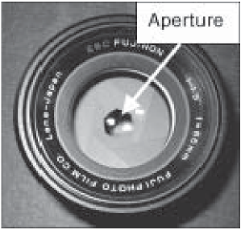
focal ratio = ½
where f = focal length
a = diameter of the aperture
Fig. 2
Calculate the diameter of the aperture at this setting.

- In Fig. 3, the lens is focused on an object a very long distance away, normally referred to as
‘infinity’, •.
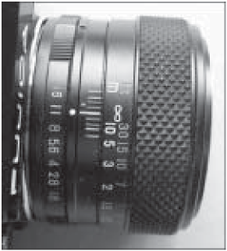
Fig. 3

Draw an accurate diagram in the box below to show how two light rays from ‘infinity’ pass through the lens and onto the film. Label the focal length.
Position of lens


- In Fig. 4, the lens is focused on an object only 0.45 m away. You will notice that the lens is now further away from the camera body (and the film).
Discuss, with the help of ray diagram(s) drawn in the boxes below, why the lens must be further away to form an image on the film when the object is this close to the camera.
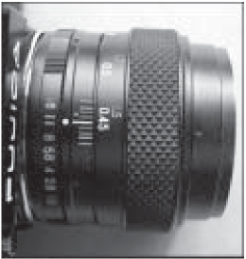
Fig. 4




- When the camera lens in Fig. 4 is focused on an object 455 mm from it, what is the distance of the image on the film from the lens?
Calculate this showing clearly the formula you have selected and all working required to obtain your result. Give correct units and use sensible rounding in your answer.
(NOTE: f = 55 mm)
QUESTION TWO

A common type of camera is the single lens reflex (SLR), which enables the user to see exactly the same view that the film will by allowing the light to pass through the same lens. This is accomplished by a flat (‘plane’) mirror that flips up out of the way when the photograph is taken. Fig. 5 below shows the light path when the mirror is in position for the view finder, but the mirror is not shown on the diagram.
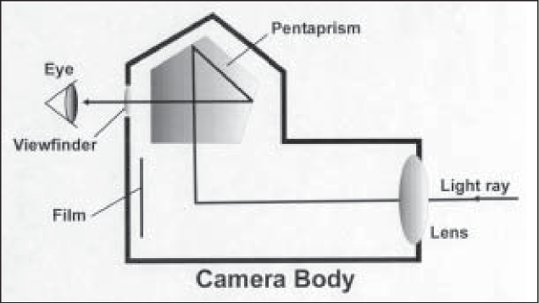
Fig. 5
- (i) On Fig. 5, accurately draw the flat mirror so that it will reflect the light ray up into the pentaprism along the path shown.
(ii) What angle does this flat mirror make with the incoming light ray?
- Use a property of reflection to explain the mirror’s correct position and angle.

- Discuss how a light ray can be reflected totally inside a piece of glass with no reflective coating on its surface. Include a description of the conditions that must apply for this to occur. You may like to draw a diagram in the box below to help your answer.


Part B: The Rocket
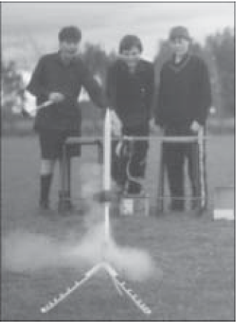
Model rocketry is an exciting hobby. Model rockets can be built from kits or from scratch. They are powered by specially made rocket motors that contain real rocket propellant (fuel and oxidiser). The motors look something like fireworks.

QUESTION THREE

- Chemical potential energy in the propellant is converted into other forms of energy while the rocket fuel burns. Describe the main energy changes that occur during the flight of the rocket.

- The rocket motor cuts out before the rocket reaches its maximum height. Explain what happens to the net energy of the rocket after the motor cuts out but while it is still moving upward.

- A particular rocket travels a vertical distance of 45 m while the motor is firing. The motor’s thrust (6 N) is doing work on the rocket over this distance and is calculated by using the formula W = Fd. Calculate this work giving correct units and using sensible rounding in your answer.

- Calculate the mean height the rocket will go, ignoring air friction.
The mass of the rocket is 42 g. Give correct units and use sensible rounding in your answer.

