90236

Level 2 Economics, 2003
90236 Explore issues using
economic concepts and statistical data

Credits: Six

You should answer ALL the questions in this booklet.

For Assessor’s use only
Achievement Criteria
Achievement |  | Achievement  with Merit |  | Achievement  with Excellence
Define and describe economic concepts and terms in relation to the issues. |  | Explain and apply economic concepts and terms in relation to the issues. |  | Evaluate economic concepts and terms in relation to the issues.
Process and interpret statistical data in relation to the issues. |  | Analyse statistical data in relation to the issues and recognise limitations of the data. |  | Comprehensively analyse statistical data in relation to the issues.
Overall Level of Performance (all criteria within a column are met)

© New Zealand Qualifications Authority, 2003
All rights reserved. No part of this publication may be reproduced by any means without the prior permission of the New Zealand Qualifications Authority.
You are advised to spend 60 minutes answering the questions in this booklet.
PART A
QUESTION ONE

Describe the difference between regional trade and international trade. Use appropriate examples.

QUESTION TWO
Two friends, Latai and Hania, decide to pick fruit in the school holidays to earn some money. They get paid $2.50 for each container they pick. Hania picks 25 containers a day, while Latai only picks 15. Latai is very careful to pick only ripe fruit and she often helps other pickers carry their containers to the weighing shed. When they get paid, Latai is annoyed that her pay is much less than Hania’s.

Define the concepts of equality and equity, and identify ONE example of EACH using the information above.

Equality
Definition:
Example:
Equity
Definition:
Example:

QUESTION THREE

- Define disinflation.
In a conversation with Hania, Latai tells her that New Zealand’s CPI rose about 3% over the last year or so. Hania knows that an increase in the CPI means that prices are rising, yet she is wondering why the price of kumara at her local supermarket has fallen.

- Explain to Hania how the CPI can rise even though the price of kumara is falling.

QUESTION FOUR

- Classify the following people as frictional, cyclical or structural unemployed. Use each term only once.
Frictional, Cyclical or Structural Unemployed
- Sione is a professional rugby player who is looking for a job over the summer period.
- Regan used to work in a carpet factory until the company bought a new machine that replaced the job he was doing.
- Louise was a salesperson for a clothing business but has just lost her job due to a downturn in the economy.

- Explain whether an increase in frictional unemployment or an increase in structural unemployment would be of more concern to the Government.

QUESTION FIVE

- Define gross domestic product (GDP).

- Explain why real GDP is a better measure of a country’s economic well-being than nominal GDP.
PART B
QUESTION ONE
Unemployment Rates for Mäori and Non-Mäori,
by Age and Sex, 1996

Source: Statistics New Zealand, Census of Population and Dwellings, 1996
Graph 1

- From Graph 1 above, identify ONE significant trend or observation.

- Give ONE reason why the trend identified in (a) above might exist.

- Explain ONE limitation of unemployment data as measured by the census.

QUESTION TWO

- Complete the table below by calculating real GDP for 2000 and 2001. Round your answer to the nearest whole number.
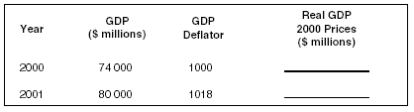

- In which quarter was New Zealand’s growth rate the highest?
- Identify ONE quarter when New Zealand’s real GDP fell.
- Identify ONE quarter that best indicates when the New Zealand economy was in recession.
Latai and Hania are arguing over whether New Zealand or Samoa is the better place to live. Latai comes from Samoa and is arguing that even though New Zealand has a higher real GDP per capita, this does not mean that it is a better place to live. Hania disagrees.

(c) Explain to Hania TWO limitations of real GDP per capita as a measure of a country’s economic well-being.
(1)
(2)

QUESTION THREE

- Complete the table below by calculating the inflation rate for 2001 and 2002. Round your answer to 1 decimal place.

Year CPI Inflation Rate 2000 1000
2001 1035
2002 1065

- Explain ONE limitation of the CPI as a measure of inflation.

QUESTION FOUR

- Complete the table below by calculating the trade balance for the years ended December 2001 and 2002.
Year ended | Exports  $(million) | Imports Trade Balance  $(million) $(million)
December 2001 | 32 670 | 31 682
December 2002 | 31 026 | 32 355
Source: Statistics New Zealand

- Study Table 1 below and answer the questions that follow. New Zealand’s Main Export Destinations
Year ended June
$(million)
Exports by country |  | 2000 |  |  | 2001 |  | 2002^{P}
Australia |  | 5 | 528 |  | 6 | 083 | 6 327
United States of America |  | 3 | 733 |  | 4 | 651 | 4 922
Japan |  | 3 | 382 |  | 4 | 314 | 3 733
United Kingdom |  | 1 | 542 |  | 1 | 538 | 1 580
Republic of Korea |  | 1 | 1 80 |  | 1 | 386 | 1 465
People’s Republic of China |  |  | 766 |  | 1 | 126 | 1 436
Germany |  |  | 646 |  |  | 843 | 828
All merchandise exports |  | 26 | 111 |  | 32 | 000 | 32 333
P = 2002 figures are provisional
Source: Statistics New Zealand
Table 1

- Which export destination is the most significant for New Zealand?

- Which export destination has grown the fastest over the time shown? Justify your answer.

- Study Graph 3 above. If the current trend for the trade-weighted index continues, explain how this will impact on New Zealand’s trade balance.
PART C
QUESTION ONE

Read the three different definitions of full employment shown below. Evaluate TWO of the definitions by discussing their strengths and weaknesses, and then draw a conclusion about which definition is most useful. Clearly indicate which definitions you have chosen.
Definition 1 | Definition 2 | Definition 3
Full employment occurs when | Full employment occurs when | Full employment occurs when
all people who are willing and | the number of job | there is a politically acceptable
able to work are working. | advertisements equals the number of unemployed. | level of unavoidable unemployment.

The first definition I have chosen is:
Strengths:
Weaknesses:
The second definition I have chosen is:
Strengths:
Weaknesses:

Conclusion

QUESTION TWO
Use the appropriate graph below to comprehensively analyse the possible relationship between:
EITHER
Real GDP and the Unemployment Rate (Graph 4)
OR
Real GDP and the Balance on Goods and Services (Graph 5).

You will need to:
- explain the expected relationship between each pair of variables
- discuss the extent to which the data in the graph supports the relationships you have explained
- discuss reasons why the data matches or does not match the expected relationship you have explained in (a).

Percentage Change in Real GDP and the Balance on Goods and Services
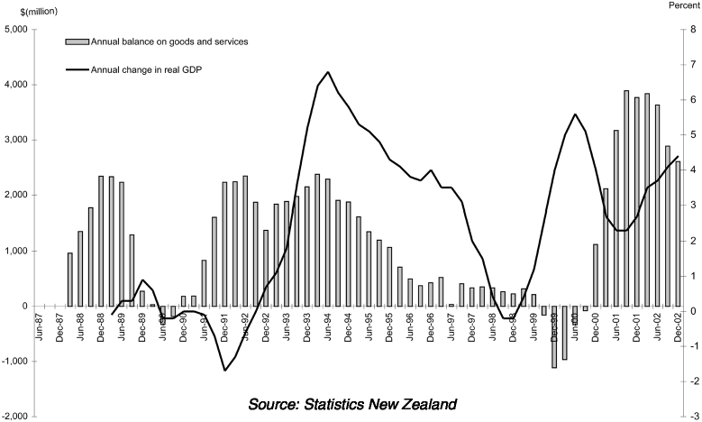
Graph 5

The relationship I have chosen is Real GDP and the:

- Explanation of the expected relationship:

- Extent to which the data in the graphs supports the expected relationship:

- Reasons why the data matches or does not match the expected relationship you have explained in (a):

