University of KwaZulu-Natal,
Science Foundation Programme, Westville Campus

Science Foundation Physics, PHYS001 November, 2005 Examination
Internal Examiners External Examiner
Mr A Archary Dr V Couling
Mr Y P Latchmanan
Dr J Govender

Question One (20 Marks)

Each of the following 10 multiple choice questions has four alternatives. Choose the best alternative that will make the question correct and then ring the letter corresponding to this choice.

  - A square mat has dimensions 20 cm x 20 cm. The area of the mat in, in m², is …
- 0,0040 m²
- 0,040 m²
- 0, 40 m²
- 400 m² (2)

  - The following diagram shows a glass cylinder containing water.
The radius of the cylinder is 6 cm, and the height of the water is 8 cm.
8,0 cm

When a steel ball is placed into the cylinder, the water level rises by 1 cm. The volume of
the steel ball is …..
- π cm³
- 9π cm³
- 36π cm³
- 9x36π cm³ (2)

  - A crane lifts a load upwards from the ground.
The accompanying graph shows how the
Resultant
Force
Time
resultant force on the load varies with time.
From the graph we can conclude that…
- the load has a constant acceleration
followed by a constant velocity
- the load has a changing velocity
followed by a constant velocity
- the load has a changing acceleration
followed by a constant velocity
- the load has a changing acceleration
followed by a constant acceleration (2)

  - The diagram shows a car pulling a trailer.
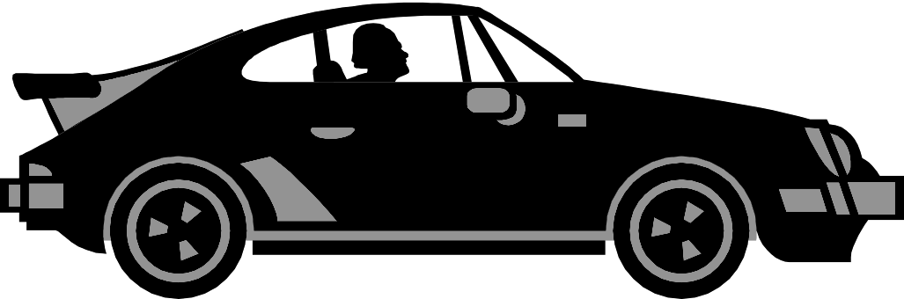
trailer

The force exerted by the trailer on the car is …..
- less than the force exerted by the car on the trailer, and is directed to the left.
- equal to the force exerted by the car on the trailer, and is directed to the right.
- less than the force exerted by the car on the trailer, and is directed to the right.
- equal to the force exerted by the car on the trailer, and is directed to the left. (2)

  - The weight of a communication satellite on the ground is x. When the satellite is vertically above the surface of the earth, at a height which is equal to the radius of the earth, then its weight will be …… (2)
- ¼ x B. ½ x C. x D. 2 x

  - Two cars travelling at a constant velocity of 60 km.h⁻¹ in opposite directions are alongside each other at some instant.
60 km.h⁻¹
60 km.h⁻¹

After travelling for 1 hour, both cars turn left, and continue for another 1hour now traveling with a constant velocity of 80 km.h⁻¹. How far apart are the cars from each other after the 2 hours of traveling?
- 120 km
- 160 km
- 200 km
- 280 km (2)

1.7 Two charged spheres exert an electrostatic force of F on each other. If the charge
on each sphere is doubled and the distance between them is halved, then the new
force will be:
A. F
B. 2F
C. 4F
D. 16F (2)

1.8 When charging an electroscope positively by induction …
A. the disc of the electroscope is touched by a positive rod.
B. the disc of the electroscope is touched by a negative rod.
C. a positive rod is brought close to the disc of the electroscope.
D. a negative rod is brought close to the disc of the electroscope. (2)

  - Three identical bulbs X, Y and Z are connected as shown in two different circuits.
X
Y
Z

The batteries in both circuits are identical and have no internal resistance.
Which one of the following statements concerning the brightness of the bulbs and the
accompanying reasoning is correct?
- X will be brighter than both Y and Z since it has more current flowing through it.
- X will be brighter than both Y and Z since the potential difference across it is more
than the potential difference across Y and Z.
- All the bulbs will be equally bright since the potential difference across each of them
is the same.
- Bulbs Y and Z will be brighter than X since more current flows through their circuit.
(2)

  - Two resistors P and Q are connected in parallel to a battery of negligible internal
resistance as shown below:
P
Q
S
When switch S is opened…..
- the current in P becomes larger
- the total resistance of the circuit becomes larger
- the potential difference across P becomes smaller
- the potential difference across P becomes larger (2)

Question Two (40 Marks)

  - The following table shows how the acceleration (a) of a trolley varies with changes in the resultant force (Σ F) acting on the trolley.

Σ F,  in N | 12 | 20 | y | 30
a,  in m.s⁻² | x | 5 | 6 | z

Determine the values of x, y and z that will correctly complete the table. (6)
x =
y =
z =

  - In each of the following diagrams a box is acted upon by 3 forces of magnitude 15 N,
12 N and 30 N each, acting in the same plane in the directions shown. Use the given
diagram to draw in the direction of the acceleration. (6)

(a)
12 N
15 N
30 N

(b)
12 N
15 N
30 N

(c)
12 N
15 N
30 N

2.3 The diagram shows three pieces of cord being used to suspend a light fitting from the ceiling. All the cords are in the same plane.

A
50⁰
45⁰
C
B

If the tensions in cord A and B are 60 N and 75 N respectively, and cord B is vertical, use components to calculate
    - the tension in cord C;
    - the weight of the light fitting. (7)

  - In the following diagram (Figure (a)) a 60 kg crate is placed on a plane which is inclined at 36⁰ to the horizontal. The coefficient of static friction between the crate and the inclined plane is 0,25 while the coefficient of kinetic friction is 0,20.
36⁰
Figure (a)
Figure (b)

    - Use Figure (b) to draw all the forces acting on the crate. Label the forces. (4)

    - Use appropriate calculations to determine whether the crate will
(i) remain at rest or (ii) move with constant velocity down the plane or (iii) accelerate down the plane. (7)

  - Two heavy mass pieces are connected by a light rope which passes over a set of frictionless pulleys as shown in the diagram below.
41 kg
89 kg

Determine the tension in the rope. (10)

Question Three (18 Marks)

  - A boy pulls a sled with a force of 24 N along a horizontal surface at a constant speed. His pull makes an angle of 45⁰ with the horizontal.
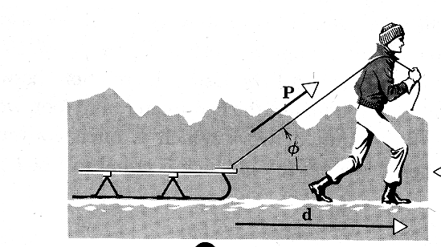
45⁰
24 N

    - Find the work done by the boy if he pulls the sled over a distance of 30 m. (3)

    - Determine the frictional force acting on the sled. (3)

  - A bowling ball of mass 5,0 kg is released from rest at point A and moves along the
frictionless track ABC. Point A is 2,0 m above the level of the ground.
A
B
C
2 m
D

3.2.1 Calculate the height at point B, if the speed of the ball at this point is 2,0 m.s⁻¹. (6)

The track from C to D is horizontal and of length 1,5 m. Because this portion of the track is rough, the ball comes to a stop at D.

3.2.2 Calculate how long it takes for the ball to travel from C to D. (6)
Question Four (24 Marks)

4.1 The diagram shows the electric field lines associated with two small oppositely charged
spheres X and Y placed near each other. A and B are two points in the electric field.
BY
AX
X
Y

4.1.1 Which of the two spheres is negatively charged? (1)

4.1.2 Explain, in terms of the electric field lines, why the electric field is not
uniform. (2)

4.1.3 Which of the two points A and B is at the higher potential? Briefly explain. (3)

The charge on one sphere is − 60 μC and the charge on the other is + 60 μC.

4.1.4 How many electrons were added or removed from each sphere to obtain this
charge? (2)

4.1.5 If the spheres are situated 10 cm apart, determine the electric field intensity at a
point P midway between the spheres. (5)

    - Calculate the magnitude and direction of the electrostatic force exerted on a −3,5 nC point charge placed at the point P. (3)

4.2 Two identical pith balls each carrying equal charges −Q are attached to silk threads and suspended from a common point. The pith balls repel each other and come into equilibrium, as shown in the diagram below.

60⁰
60⁰
A
B

The angle made by each thread with the horizontal is 60⁰ and the length of the threads is
40 cm each. If the mass of each pith ball is 10 g, determine the charge Q. (8)
Question Five (40 Marks)

  - Four identical light bulbs A, B, C and D are connected to a battery of negligible internal resistance as follows:
A
C
B
D

5.1.1 State which bulb ( or bulbs ) will glow the brightest. Give a reason for your answer. (3)
5.1.2 If bulb B burnt out, which bulb ( or bulbs ) will now glow the brightest? Explain why. (3)

  - In the circuit diagram below, the current I₃ through the 15 Ω resistor is 2 A.
I₁
I₂
I₃
15 Ω
10 Ω

Determine the value of the current I₁. (5)

5.3 Find the equivalent resistance, in terms of R, of the following network:
R
R
2R
2R
2R
3R
(6)

5.4 The circuit diagram below consists of three batteries of negligible internal resistance:

ε₃
ε₂ = 24 V
1 Ω
4 Ω
2 Ω
2 Ω
R
I₁ = 2 A
I₃ = 1 A
I₂
ε₁ = 10 V

Use Kirchoff’s laws to determine:
5.4.1 the current I₂; (2)
5.4.2 the resistance R; (5)
5.4.3 the emf ε₃. (5)

5.5 The diagram shows a 12 V battery having an unknown internal resistance connected to a light bulb of resistance 5 Ω and two resistors of resistance 15 Ω and 10 Ω each. The ammeter reads 1 A.
12 V, r
5 Ω
10 Ω
15 Ω
1 A

5.5.1 Find the total external resistance of the circuit. (4)

5.5.2 Calculate the internal resistance of the battery. (3)

5.5.3 Find the heat generated in the 15 Ω resistor in 2 minutes. (4)

Question 6 (8 Marks)

Heat conduction takes place through a cylinder of length ℓ and cross sectional area A, whose ends are maintained at a temperature of T₁ and T₂ respectively, with T₂ > T₁.

ℓ
A
T₁
T₂

The amount of heat flow per unit time, Q/t, is directly proportional to the difference in temperature between the ends of the cylinder. The heat flow per unit time is also directly proportional to the cross sectional area of the cylinder and inversely proportional to the length of
the cylinder.
  - If the proportionality constant is given by k, find an equation relating Q/t with the quantities A, ℓ, T₁ and T₂. (2)

  - Use your equation to determine the SI units of k (which is called the thermal conductivity). (2)

  - The value of k depends on the type of material used to make the cylinder. The table below shows some values of k for three different substances.

Substance | k (SI units)
A | 380
B | 0,84
C | 0,09

Identify the substances A, B and C as either glass, copper or wood, and briefly
explain how you arrived at your answer. (4)

