Question One (10 marks)

Circle only the letter that is next to the correct answer for each of the following:

1.1 A natural number which is not prime and greater than one is called:

A Even number B Odd number
C composite number D undefined

1.2 The surface area of a closed cylinder (in terms of radius r, diameter d and height h) is given by the
formula:

A $π$$\text{dh}+2{πr}^{2}$ B $π$$\text{dh}+{πr}^{2}$
C 2$π$$\text{dh}+2{πr}^{2}$ D 2($π$$\text{dh}+2{πr}^{2}$)

1.3 Simplify: $−(−3x^{2})^{3}$ =

A $−9x^{5}$ B $−9x^{6}$
C $−\text{27}x^{5}$ D $\text{27}x^{6}$

1.4 If P = { 0,1,2}, then the total number of sub-sets is:

A 4 B 6
C 8 D { }

1.5 Simplify: $\left|2−7\right|+2^{−1}$

A 7.5 B -7.5
C 5.5 D -5.5

Question Two (26 marks)

2.1 Consider the following sets :
E, universal set of whole numbers less than 12;
A, set of integers between 0 and 10 that are multiples of 3;
B, set of prime numbers greater than 0 and less than 11;
C, set of odd numbers greater than 2 and less than or equal to 11.
2.1.1 List the elements of sets A, B and C.

A =

B =

C = (3)

    - Draw a Venn diagram, showing all the sets given above, and put the elements in their
correct places

(3)

    - $n\left(B ∩ C\right)$ = (1)

    - Determine ${\left(B∪C\right)}^{′}$ and illustrate your answer on the number line below:

(3)
______________________________________________________________

2.2 Solve for x if :
$\frac{n^{x}\text{.} n^{\frac{3}{x}}}{n^{7 − x} } = 1$ (4)

2.3.1 Sketch the graph of $f(x) = {\left(\frac{1}{5}\right)}^{x}$ on the set of axes below. (2)

y

x

2.3.2 If g is a reflection of f about the line $y = x$, determine the equation of g. (2)

2.4 Prove that : ${\text{log}}_{b}a = \frac{{\text{log}}_{c}a}{{\text{log}}_{c}b}$. (3)

2.5 Solve for m: $2{\text{log}}_{4}m + {\text{log}}_{m}4 = \text{log}\text{1000}$ (5)

Question Three (16 marks)

3.1 Solve the following system of equations:

x - 2y + z = 2
2x + y + 3z = - 1
3x - 6 y + 3z = 6 (6)

3.2 Solve for x : $\frac{x^{2} + x − \text{12}}{5 − x}$$< 0$
and write your answer in set builder notation. (6)

3.3 The instruction for mixing a certain type of concrete is 1 part cement, 2 parts sand, and 3 parts
gravel. If there are 4 m${}^{3}$ of sand how much cement and gravel should you mix with this sand? (4)

Question Four: ( 17 marks)

4.1 Solve: $\left| 2x−3 \right| > 5\text{.}$ (4)

4.2 Express $−2<x<3$ in the form $\left| \text{ax}+b \right|<c\text{.}$ (3)

4.3.1 Sketch the graph of f on the set of axes provided below.

$f(x)=\begin{aligned}\left\{\left| x \right|−2, x<2 | \right.\end{aligned}$ (6)

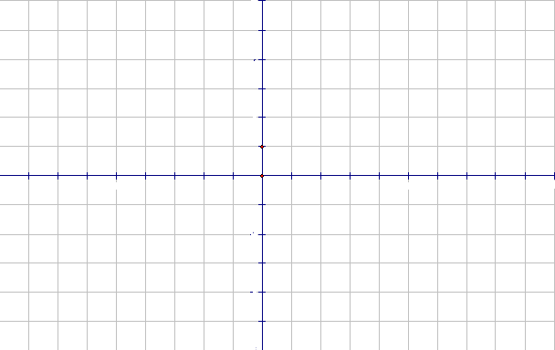

4.3.2 Write down the range and domain of f in set-builder notation. (4)

Question Five : (29 marks)

5.1 Given: $f(x)=\begin{aligned}\left\{{\left(x−1\right)}^{2}−4 , x>0 | \right.\end{aligned}$

5.1.1 Sketch the graph of $f$. (4)

5.1.2 Use the graph to find $\underset{x → 0}{\text{lim}}f(x)$. Justify your answer. (2)

5.2 Given: $f(x)=−3x^{2}$. Determine $f '(x)$ from first principles. (5)

  - Consider: $f(x)=x^{8}−\frac{2}{\sqrt{x}}$ and $g(x)=\left(x^{\text{12}}−3x^{−2}\right) \left(x^{\text{12}}+3x^{−2}\right)$ Determine:
5.3.1 $f^{}(x)$ (3)

5.3.2 $D_{x}[g(x)]$ (3)

5.3.3 Determine the equation of the tangent to the curve of f at x = 1. (4)

5.4 A rectangular container which is open at the top, is to be made from a square metal sheet which is 24 m x 24 m in dimension. The container is made by cutting out equal squares from each corner of the sheet and turning up the sides. Find the volume of the largest container that can be made this way. (8)

Question Six (39 marks)

6.1 If $\text{tan}\text{18}\text{°=}m$ then determine each of the following in terms of m.
6.1.1 cos $\text{144}°$ (5)

6.1.2 cot $\text{216}°$ (5)

6.2 Simplify without using a calculator:
$\frac{(1−{\text{cos}}^{2}\text{10}°)\text{sin}\text{810}°\text{tan}(−\text{225}°)}{\text{sec}\text{240}°{\text{sin}}^{2}\text{190}°}$ (6)

6.3 In the diagram below, P is a point on the terminal arm of $θ$ .

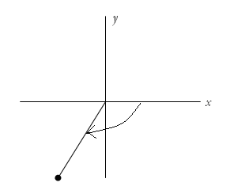$θ$$P(−1, −\sqrt{3})$

6.3.1 Evaluate $\text{tan}θ$. (1)

6.3.2 Hence, without using a calculator, determine
$θ$ if $θ∈R\text{.}$ (3)

6.4 Consider $f(θ)=3\text{sin}2θ, −\frac{π}{2}≤θ<\frac{π}{2}$ and $g(θ)=1−\text{cos}θ, −\frac{π}{2}≤θ<\frac{π}{2}$.
6.4.1 Sketch the graph of f and g on the set of axes provided below. (5)

6.4.2 Write down the range of $y=f\left(θ+\frac{π}{8}\right)$ using interval notation. (2)

6.5 Determine the general solution (in radian measure) of the equation :
$2{\text{sin}}^{2}θ=−\text{sin}2θ\text{.}$ (6)

  - Prove the identity :
$\frac{2{\text{sin}}^{2}x}{2\text{tan}x−\text{sin}2x}=\text{cot}x\text{.}$ (6)

Question Seven : (15 marks)
  - A number has two digits whose sum is 11. A second number can be obtained from the original
number by reversing the digits. The difference between the numbers is 9. Determine the original
number. (5)

7.2 Study the diagram given alongside carefully.
$h$
- It is a circular wooden solid with square hole drilled
down the length, $h$, as shown in the diagram.
- Each side of the square hole drilled is $\frac{h}{4}$.
- The length of the solid is equal to the diameter of the solid.

$$h$$

7.2.1 Show that the volume of the solid in terms of $π$ and $h$ $\frac{h^{3}}{\text{16}}(4π−1)$ (4)

7.2.2 Determine the total surface area of the solid in terms of $π$ and $h$.
The end
Hint: this means inside and out. (6)

