UNIVERSITY OF KWAZULU-NATAL
EXAMINATIONS: January 2007

SUBJECT, COURSE & CODE |  | BIOL001 – FOUNDATION BIOLOGY THEORY
DURATION | 3 HOURS |  | TOTAL MARKS | 150

INTERNAL EXAMINERS | S. Shaik, B. Keke, P. Seaman, N. Kirby, J. White, Dr J. Kioko
EXTERNAL EXAMINER | Dr. E. Dempster

CANDIDATES ARE REQUESTED, IN THEIR OWN INTERESTS, TO WRITE LEGIBLY

THIS PAPER COMPRISES FOURTEEN (14) PAGES. ENSURE YOU HAVE ALL OF THEM.

ANSWER ALL QUESTIONS.

Question 1: Multiple Choice Questions

Answer the following questions by writing the correct letter in your answer book.

  - During gastrulation all of the following occur except:
- Cell division slows down and the cells start to migrate to different positions in the embryo.
- Cells are rearranged to lay the foundation for the structure of the animal.
- Subgroups of cells differentiate into organs and organ systems.
- The blastula is converted into a multilayered gastrula.
- Cells usually form three germ layers.

  - In dicotyledonous plants,
- stomata occur more frequently on the lower leaf surface to minimize water loss.
- long, thin, flexible petioles allow leaves to flutter in the wind to maximize gas exchange.
- stomata occur more frequently on the upper leaf surface to maximize gas exchange.
- long, thin, flexible petioles allow leaves to flutter in the wind to minimize water loss.
- A and B only.

  - Which one of the statements about primary plant products is false?
- They are transported around the plant through phloem from source to sink.
- They may prevent infections.
- They are transported to roots and developing fruits in summer.
- They may be converted into insoluble starches and stored as food reserves.
- They make up the endosperm in seeds to feed the growing embryo.

  - Which of the following is an example of differentiated cells/tissues?
- cambium
- stem cells
- apical meristems
- malpighian layer
- keratinized cells

  - The shell of a turtle provides protection from predators. Which one of the following helps to explain how the turtle shell may have evolved from the smaller scales of an ancestral lizard?
- Ancestral lizards had no variation in the size and shape of their scales.
- Ancestral lizards produced identical offspring through sexual reproduction.
- Ancestral lizards produced bigger, stronger scales in response to a decrease in the population of their predators.
- Ancestral lizards with bigger, stronger scales were better able to escape predators and reproduced more frequently than those with small scales.
- Predation pressure selected for bigger, stronger scales, producing shells in one or two generations.

1.6 Which one of the following is true about plants?
- Plants are multicellular; chemosynthetic and have choroplasts.
- The haploid sporophyte generation produces spores.
- Both gymnosperms and angiosperms have xylem vessel elements.
- Cycads are regarded as the most primitive group of gymnosperms because they have no strengthening tissue.
- Mosses and ferns inhabit shady, moist environments because they require water for fertilisation.

  - Primary tissues in plants arise from:
- the procambium.
- the protoderm.
- the ground meristem.
- the vascular cambium.
- A, B and C.

  - The diagram below shows sedimentary rock strata at the bottom of an ocean.
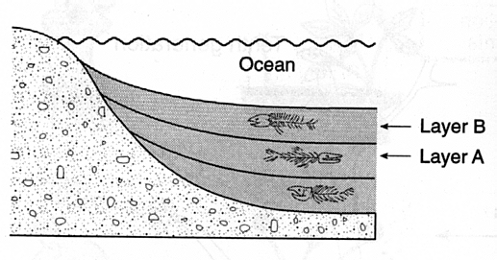
Layer C

Layer B

Layer A
A study of the closely related fossils in layers A, B and C can:
- give information about evolutionary changes over time.
- prove that the species in layer C evolved from the species in layer A.
- show that the fossils in layer C were formed before those in layers A and B.
- prove that species A is extinct.
- show that the species in layer A was more abundant than the species in layer B.

  - Which of the following are found in all prokaryotic cells?
- cell wall, cell membrane.
- cell membrane, plastids.
- cell membrane, mitochondria.
- nucleus, cell membrane.
- DNA, vacuoles.

  - When a person has an open wound their blood forms a clot. This is due to the action of:
- red blood cells.
- neutrophils.
- platelets.
- basophils.
- lymphocytes.

1.11 Which of the following statements is true?
- Tertiary consumers feed only on herbivores.
- The first trophic level is always occupied by plants.
- Energy is lost from one trophic level to the next only in undigested material.
- In all trophic levels, the amount of biomass is determined by the amount of available energy.
- Detritivores break down dead organic matter and waste only from the first trophic level.

1.12 Which one of the following makes the epidermis of the skin relatively tough and water resistant?
- fibroblasts
- collagen fibres
- keratin
- melanin
- elastin fibres

  - Which one of the following types of epithelium is composed of one layer of cells only?
- squamous epithelium in mammalian skin.
- stratified cuboidal epithelium of salivary glands .
- stratified cuboidal epithelium lining the bladder.
- pseudostratified epithelium in the trachea.
- none of the above.

1.14 Which one of the following is true of the protists?
- eukaryotic; with little or no tissue differentiation.
- prokaryotic; unicellular or multicellular.
- eukaryotic; with protection for the developing embryo.
- prokaryotic; heterotrophic or autotrophic.
- prokaryotic; some colonial.

1.15 In which one of the following situations will osmosis occur from A to B?
A. cell A cell B

selectively permeable cell
membranes
Ψת = -1900kPa

Ψת = -1500kPa

Ψ_{p} = 600kPa
Ψ_{p} = 700kPa

freely permeable cell walls

B. cell A cell B

selectively permeable cell
membranes
Ψת = -2000kPa

Ψת = -1800kPa

Ψ_{p} = 800kPa
Ψ_{p} = 900kPa

freely permeable cell walls

C. cell A cell B

selectively permeable cell
membranes
Ψ = -1200kPa
Ψת = -1700kPa

Ψ_{p} = 600kPa
Ψ_{p} = 800kPa

freely permeable cell walls

D. cell A cell B

selectively permeable cell
membranes
Ψ = -900kPa
Ψת = -1800kPa

Ψ_{p} = 700kPa
Ψ_{p} = 900kPa

freely permeable cell walls

E. cell A cell B

selectively permeable cell
membranes
Ψ = -1000kPa
Ψת = -2000kPa

Ψ_{p} = 800kPa
Ψ_{p} = 1000kPa

freely permeable cell walls
30 marks

Section B: Short answer questions
Answer all these questions.

Question 1
Refer to Figure 1 (on the next page) and the dichotomous key below, and answer the questions that follow.

KEY:

- seeds absent …………………….. 2
seeds present ………………………4

- true roots present …………………. Dryopteris cristata
true roots absent …………………. 3

- vascular system simple …………… Selaginella selaginoides
vascular system absent …………... Dicranum scoparium

- seeds naked ………………………… Pinus pinaster
seeds enclosed in an ovary ………..5

- stem with spines ……………………. Opuntia lagunae
stem without spines …………………Lithops gracilidelineata

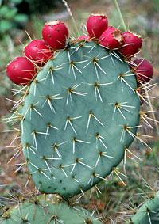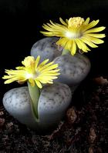
reproductive organ
A
B

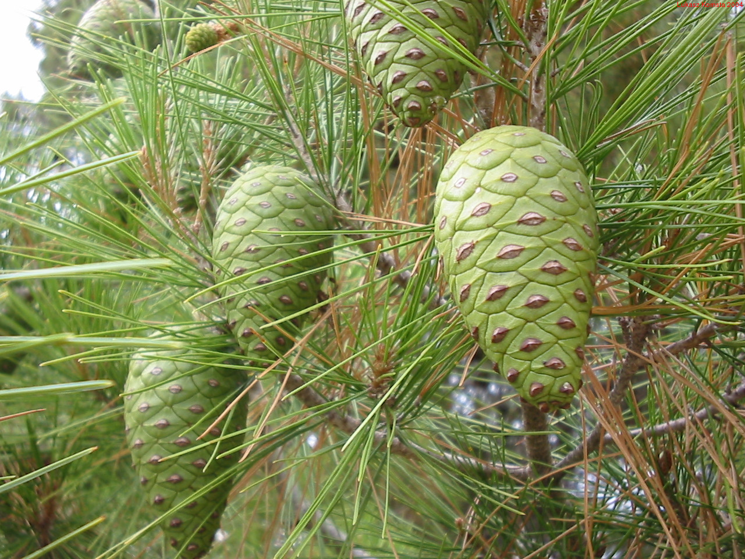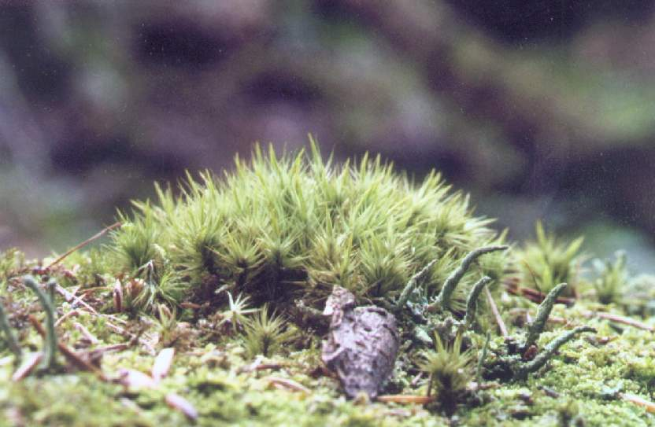
reproductive organ
short adult plants anchored by rhizoids
C
D

Sporangia with spores
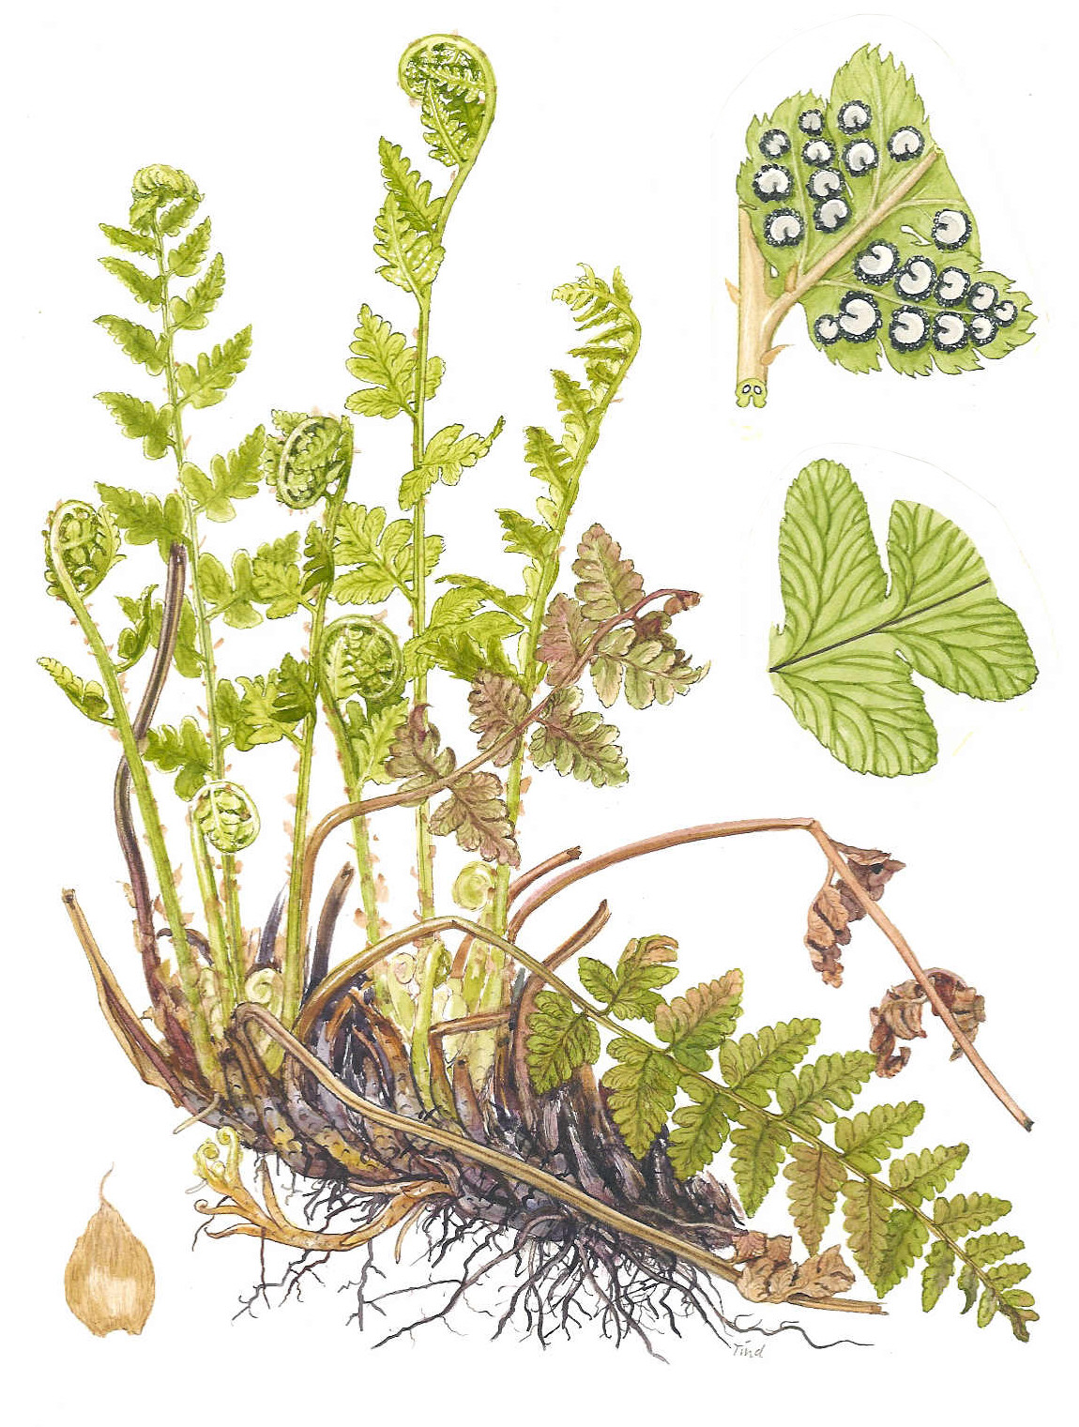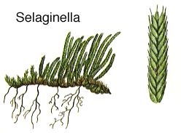
rhizoids
Sporophylls with sporangia and primitive phloem and xylem tracheids
E
F
Figure 1

1.1 a. Using the key above, identify organisms B and E by giving their binomial names. (2)
b. Explain why the binomial name is preferred to the common name when classifying organisms. (1)
c. Consider the reproductive organs of organisms B and C. Which of these two plants would have a more advanced method of pollination? Explain your answer. (4)
d. Explain why organism D cannot grow very tall (3)
e. What feature does organism E have that makes it better adapted to the terrestrial environment than organism F. Explain your answer. (2)
f. Organisms A and B are found in dry environments. Describe and explain any two stomatal adaptations these plants are likely to have. (4)
g. By referring to the theory of natural selection explain how the stomatal arrangement of plants inhabiting a dry environment may have evolved. (3)

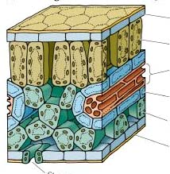

A
B
C

1.2a. Briefly describe and explain what will happen to A, B and C when light first strikes the leaf in the morning (4)
b. Three gases move through the leaf at C that play a role in the primary metabolic process of the plant. Name these gases and briefly describe the role of each. (6)
c. Water moves up from the roots to the leaves with the help of several forces. Describe these forces and explain how they move water up a tall plant. (6)
35 marks

Question 2
Study figures A to F below and answer the questions that follow:

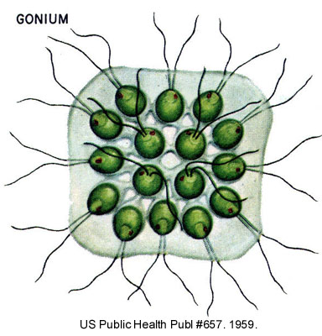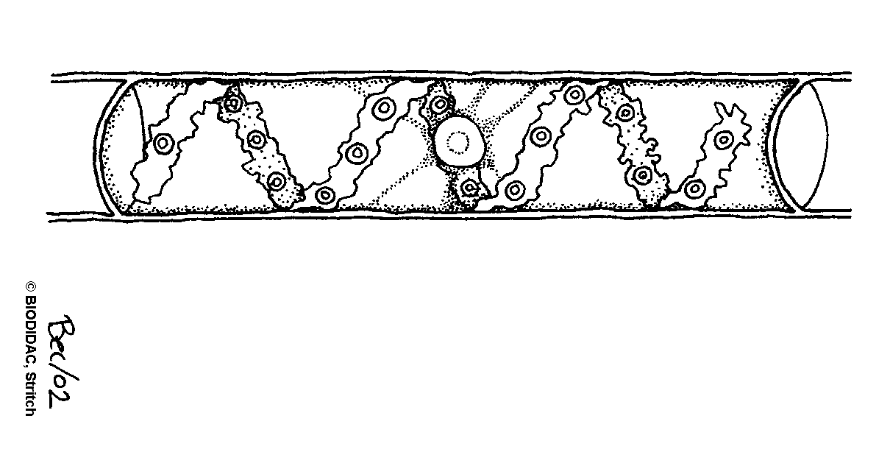

A
B
5µm
25µm
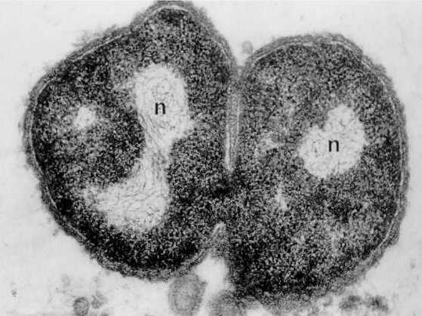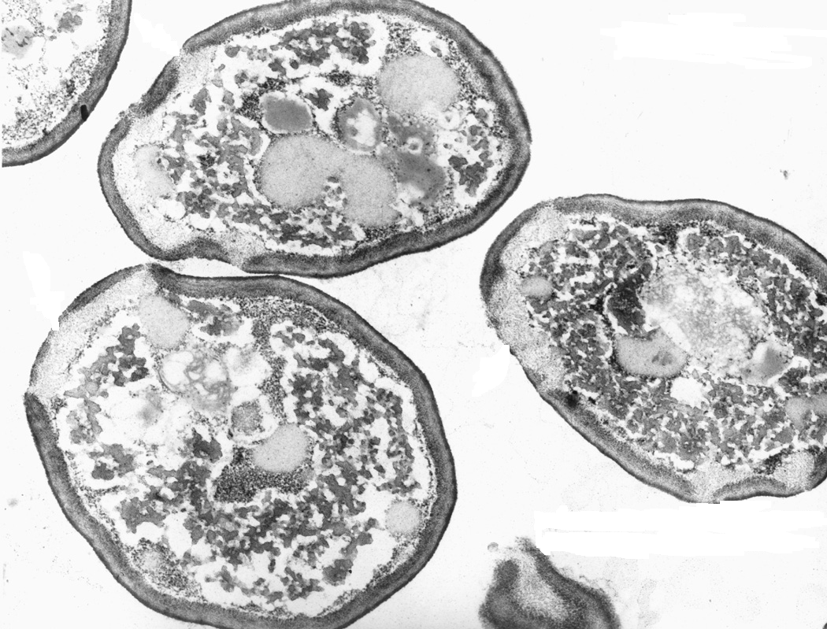
C
D
200nm
15µm
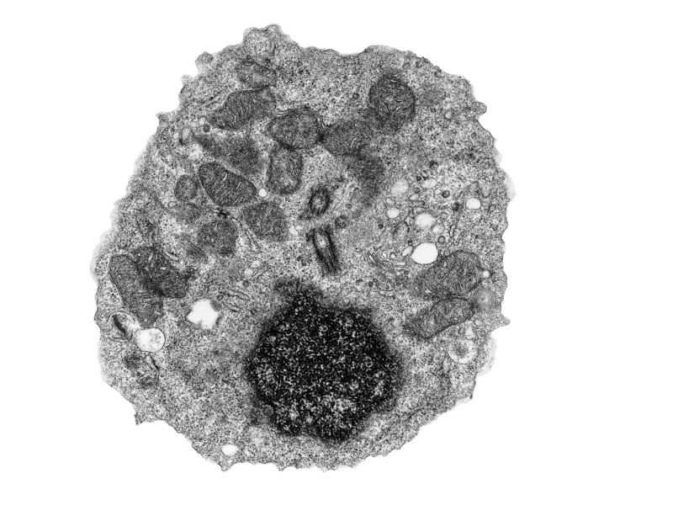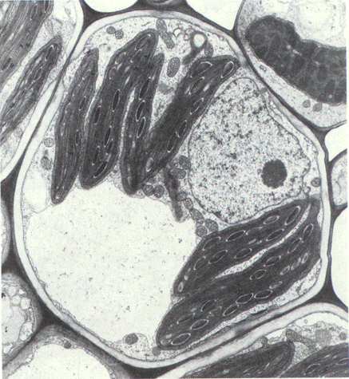
E
F
1µm
2µm

2.1 Both A and B are algae.
a. Explain how the shape of organism B would be suited for its survival. (2)
b. Organism B is multicellular. Give two reasons why this organism would be particularly successful
in its environment. (2)
c. Organism A is colonial. Describe how this arrangement of cells could be used to explain the evolution of multicellularity. (3)
2.2 Consider the bacterial cell, C.
a. Is it prokaryotic or eukaryotic? (1)
b. Give two visible reasons for your answer in 2.2.a. (2)
c. Describe the economic and ecological role played by bacteria. (3)
d. The cell division in C does not allow for variation which is the basis for natural selection and
evolution. Explain one advantage and one disadvantage this could possibly have for C. (4)
2.3 Consider cells D, E and F. Cells in D have cell walls made of chitin.
a. To which Kingdom do cells D belong? (1)
b. What mode of nutrition is shared by cells D and cell E? What does this feature suggest in terms
of the origin of these two cell types? (2)
c. Name two observable characteristics that separate cells in E and F into different Kingdoms. (2)
d. To which of the cells from A to E are cells in F most closely related? Give a reason for your
answer. (2)
24 marks

Question 3
Questions 3.1 to 3.3 are based on the diagrams below showing different stages in animal embryonic development:
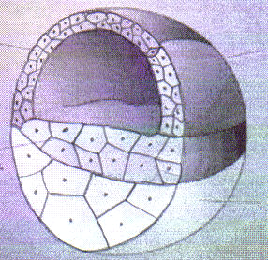
1A
2
31
42
53
64

A B C D

3.1 Describe and explain the role of mitosis and meiosis leading up to the formation of structure C. (4)
3.2 Which of the stages (A to D) represented above would have genetic material identical to B? Explain your answer. (3)
3.3 Structure D is the blastula of a frog. Which numbers in D will become the germ layer that will
eventually give rise to:
a. tissues with a non-living extra-cellular matrix (1)
b. the lining of the circulatory system (1)

3.4 Stem cells transplanted from human embryos can relieve the symptoms of many diseases.
a. Why might stem cells from a human embryo be particularly useful for replacing diseased or
damaged cells? (2)
b. Why do you think some people oppose using human embryonic stem cells. (2)
c. In humans, what alternative, less controversial source of cells can doctors use to treat diseases? (1)
3.5 A young lady was recently diagnosed with leukaemia (a disease in which abnormal white blood cells are over produced and displace erythrocytes, lymphocytes and platelets). Doctors think that her best chance of recovery is a bone marrow transplant. Do you agree? Explain. (3)
17 marks

Question 4
The amount of energy the body is able to get from food can be measured in kilocalories (kCal). Thus the number of kilocalories consumed in a given time can be used to measure the metabolic rate. Study Figure 1 below which shows the metabolic rate of an adult human and an American alligator (a reptile) of the same mass (80kg), measured during one day at Ta = 20ºC. The metabolic rate was measured while the human and alligator were carrying out their normal daily activities. Answer the question that follows:

0
200
400
600
800
1000
1200
1400
1600
1800
Human
Alligator
Type of animal
Metabolic rate
(kCal/day)
Figure 1. Metabolic rates of a human and an alligator in a single day

4.1 Describe and explain the difference in the metabolic rate of these two animals. (4)

Study figure 2 below and answer the questions that follow:

Figure 2. Metabolic rate (BMR) of two animals (A and B) at a range of ambient temperatures (Ta)

4.2 a Which animal (A or B) has a better chance of survival in a cold environment? Explain your
answer. (3)

b. Give an example of such an animal and describe one physical characteristic it may have to
survive in these cold conditions. (2)

4.3 If animal A was a small desert mammal (30g) why would it most likely show nocturnal activity? (2)

4.4. a. Describe and explain one similarity and one difference between the TNZ of animal B and a
camel. (3)
b. Explain how camels achieve their TNZ. (3)
17 marks

Section C: Essay questions
Write any TWO (2) of the following essays. Each essay should be about one page in length.

1. The colonization of the terrestrial environment by living organisms resulted in the evolution of diverse
forms of life. Describe and explain three adaptations each that seedless nonvascular plants, arthropods, amphibians and reptiles evolved to survive on land. (15)

2. Discuss the ecological role of the producers, primary consumers, detritus feeders and decomposers in
a marine ecosystem. Explain why the amount of available energy decreases at each trophic level when moving through the food chain from producers to decomposers. (15)

3. The integumentary system is crucial for the normal life of a terrestrial mammal. Discuss this statement. (15)

4. Life on earth is very diverse. These life forms all originated from simple unicellular organisms that lived in
the oceans. Write an essay in which you:
- describe the conditions on the early earth and the evolution of the first prokaryotes
- discuss the significance of the evolution of photosynthetic autotrophs
- describe the evolution of eukaryotic cells (15)

5. Membranes contribute to the efficient functioning of both plant and animal cells. Discuss this statement
by describing the role of membranes in:
- compartmentalisation
- selective permeability
- surface area
- the nucleus, mitochondria and dictyosome (15)

