UNIVERSITY OF KWAZULU-NATAL
EXAMINATIONS: NOVEMBER 2008

SUBJECT, COURSE & CODE |  | BIOL199 and BIOL099 – FOUNDATION BIOLOGY THEORY
DURATION | 3 HOURS |  | TOTAL MARKS | 150

INTERNAL EXAMINERS | B. Keke, N. Kirby, P. Seaman, S. Shaik, J. White
EXTERNAL EXAMINER | Prof. D. Mycock

CANDIDATES ARE REQUESTED, IN THEIR OWN INTERESTS, TO WRITE LEGIBLY

THIS PAPER COMPRISES FOURTEEN (14) PAGES. THERE IS ALSO ONE (1) APPENDIX.

ENSURE YOU HAVE ALL PAGES

ANSWER ALL QUESTIONS IN YOUR ANSWER BOOKS

Section A: Multiple Choice Questions
Answer the following questions in your answer book by writing the letter of your choice. Please note that negative marking will be used in this section.

- Evolution is:
  - The gradual change in the characteristics of population and species over time.
  - The genetic adaptation of a population of organisms to its environment over time.
  - Based on changes in the environment and is therefore a continuous process.
  - Only A and C are correct.
  - A, B and C are correct. (2)

- Which gas was NOT present in large amounts in the early atmosphere of Earth?
  - Ammonia
  - Methane
  - Carbon monoxide
  - Oxygen
  - Water vapour (2)

    - The size to which a cell can grow is limited by its:
- Location.
- Number of organelles.
- Function.
- Surface area.
- All the above. (2)

  - During DNA replication, if a base pairs up incorrectly, the DNA ______ will read the correct sequence and the DNA ________ will repair the mistake.
    - polymerase and helicase.
    - helicase and ligase.
    - ligase and polymerase.
    - polymerase and ligase.
    - ligase and helicase. (2)

Questions 5 to 10 are based on the following research:

The conservation officer in the Kruger National Park wanted to know the population sizes of different antelope in the Park for management purposes. To do this he carried out a survey: he counted how many of each different type of antelope he saw between 6am and 10am and again between 2.00pm and 6 pm on 10 consecutive days whilst walking along a set pathway. This pathway was randomly selected from aerial maps. He collected his data in spring in 2007 and 2008. Table 1 provides averages for each type of antelope counted.

Table 1.
Antelope species | Mean number of individuals counted in 24 hours
 | 2007 | 2008
Damaliscus dorcas | 30 | 11
Damaliscus lunatus | 30 | 30
Cephalophus natalensis | 13 | 20
Ourebia ourebi | 15 | 22
Aepyceros melampus | 300 | 450
Hippotragus equinus | 5 | 7
Hippotragus natalensis | 3 | 3

  - Which of the following null hypotheses that were set at the beginning of this research should be rejected?
    - The population numbers of Damaliscus lunatus have not changed.
    - The population size of Damaliscus dorcas has not decreased.
    - Numbers of Aepyceros melampus have increased in the past two years.
    - Hippotragus natalensis numbers remained stable.
    - In 2007, there was no difference in the size of Damaliscus populations (2)

  - Which of the following types of graph would be most appropriate to present the findings of this research?
    - Line graph.
    - Pie chart.
    - Histogram.
    - Bar graph.
    - None of the above. (2)

  - The dependent variable in the above set of data is:
      - Different species of antelope.
      - The number of antelope counted.
      - The method of counting antelope.
      - The year in question.
      - The Kruger National Park. (2)

  - Which of the following were controlled variables in the research?
        - Time of day when sampling was done, researcher.
        - Number of days sampling took place, species of antelope.
        - Time of year, Kruger National Park.
        - Sampling method, year.
        - All of the above except D. (2)

  - What sampling strategy did the researchers use?
          - Quadrat.
          - Line transect.
          - Repeated sampling.
          - Random sampling.
          - B, C and D. (2)

  - What valid conclusions can be drawn from the research?
            - All antelope populations increase in size at the same rate.
            - There is a need to conserve some species of antelope more than others.
            - There is no need to monitor the numbers of Aepyceros melampus.
            - Some antelope species are hunted more than others.
            - B, C and D. (2)

TOTAL FOR SECTION A: 20 MARKS
Section B: Short Answer Questions
Answer all of these questions

Question 1
Study the diagrams below and answer the questions that follow:

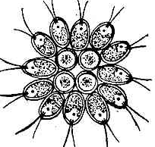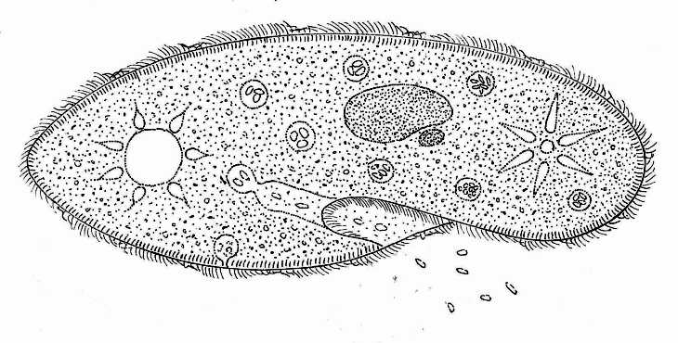
A
B
C
D
E
F
cilia
nuclei
contractile
vacuole
oral groove
food vacuole
pores
connected by plasmodesmata
nucleus squashed in corner
Mag. 1500X
Mag. 8000X
Mag. 2000X
chloroplast

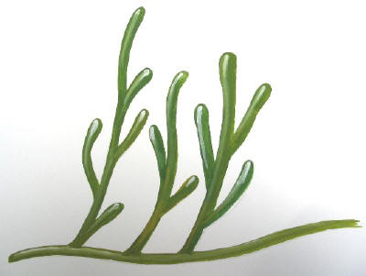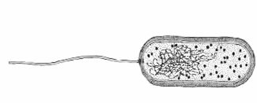

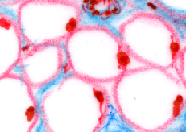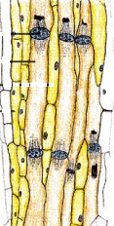

  - Which figure represents a prokaryotic cell? Give a reason for your choice. (2)

  - Which figure represents animal tissue? Give a reason for your choice. (2)

- Which two figures represent algal species? Give reasons for your choice. (3)
- Choose one of these algal species to describe how such organisms may have given rise to multicellularity. (5)

  - By referring to observable features in B explain how this organism is well suited to the environment it lives in. (2)

  - Compare the structure and function of E and F. (4)

18 marks

Question 2
Study the diagram below and answer the questions that follow:
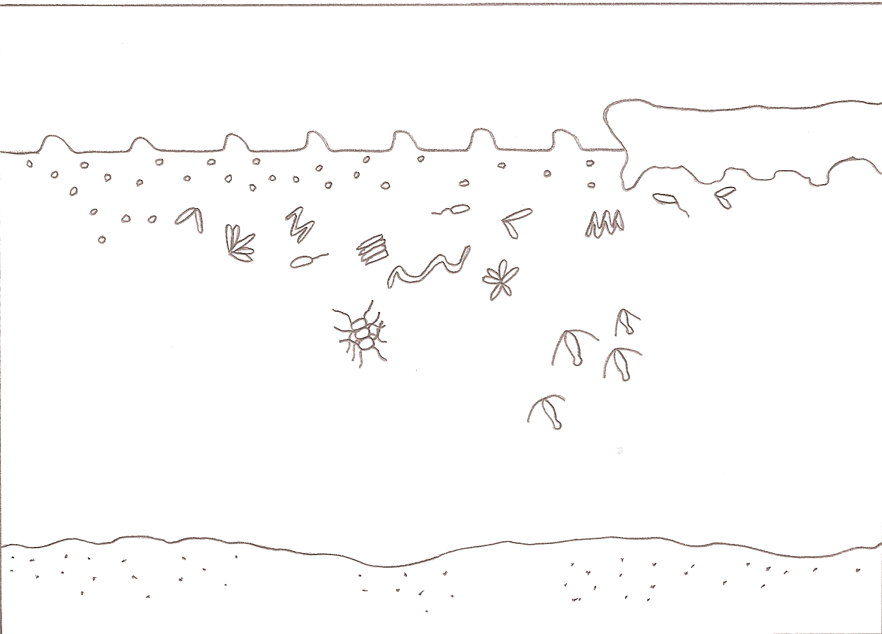

A
B
C
zooplankton
D
E
F
sea water
sea bed
sea ice
6CO₂ + 6H₂O
C₆H₁₂O₆ + 6O₂
CO₂
G
A
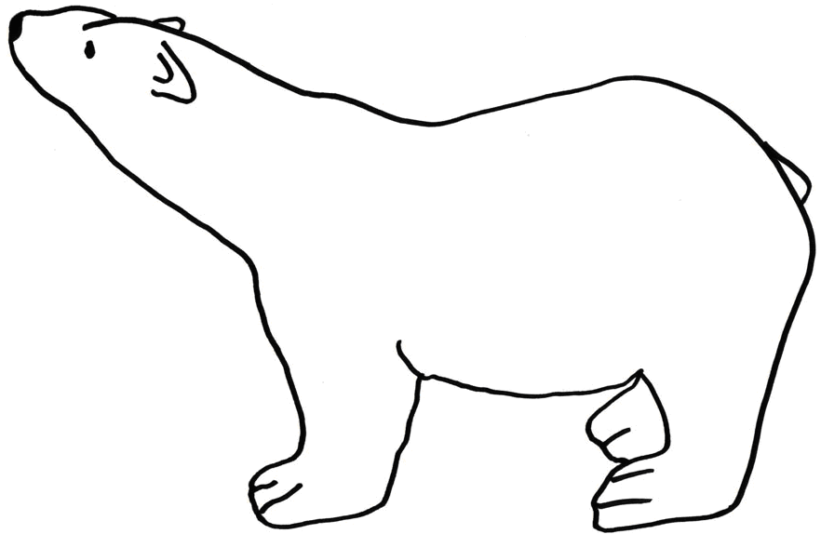

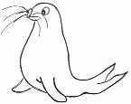

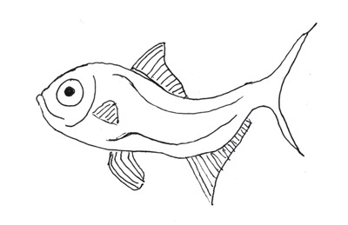

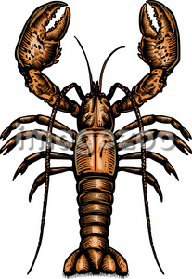

  - Explain the relationship between A, the reaction given in B and the organisms shown in C. (3)

  - Which organisms are likely to have the largest biomass in this ecosystem? Explain your answer.
(3)

  - In Arctic regions populations of organism F tend to be very small. Explain why this is so, by referring to ecological principles. (5)

  - What role do you think will be played by organism G if one of the fish represented by D had to die naturally? What ecological term is given to such an animal? (2)

13 marks
Question 3
Refer to Figure 1 (Appendix 1) and the dichotomous key below, and answer the questions that follow.

Dichotomous key:

1. Organism lives in water………………………………………………………………………………2
Organism does not live in water…………………………………………………………………….4

2. Has tissue differentiation……………………………………..…………......................................3
Has no distinct tissues………………………………………………………………..Ulva capensis

3. Bears flowers…………………………………………..…………....................Eichornia crassipes
Does not bear flowers…….…………………………………………………………Salvinia minima

4. Leaves reduced to spines………………..………………………………………………………….5
Leaves not reduced to spines……………………………………………………..……….............8

- Large flowers attract flies…………………………………………………………Stapelia gigantea
Flowers not large and do not attract flies ………………………………………………………….6

6. Stems produce sticky white latex…………………………………………Euphorbia meridionalis
Plant stems do not produce sticky white latex……………………………………………………7

7. Modified stem branches into smaller segments; stem without ridges……..Opuntia aurantiaca
Modified stem does not branch; stem has ridges……………………………Ferocactus echidne

- Simple leaves with single vein…………………………………………………Selaginella mittenii
True leaves with complex vascular tissue…………………………………………………………9

9. Leaves succulent and fleshy………...…………………………………………………………….10
Leaves not succulent and fleshy.………………………………….………………………………11

- Leaves modified to look like stone, leaf edges are not serrated………………..Lithops salicola
Leaves not modified to look like stone, leaf edges are serrated..………………Aloe wollastonii

11. Seeds protected in cones………………..………………………………………........ Pinus patula
Seeds not protected in cones, seeds in fruit.……………………………..Euphorbia crotonoides

- Using the key above, identify organism J by giving its binomial name. (2)
- Do organisms J and G belong to the same Kingdom? Explain in full, by referring to observable diagnostic features. (3)
- What Division will Organism J belong to? Give one reason for your answer. (2)
- By referring to the key above, name the two organisms that are most closely related to each other. Explain your answer. (3)

- Organisms D, G and I all live in water. In terms of evolutionary trends, is one organism more advanced (or primitive) than the others? Explain as fully as possible. (3)
- Organism E is called a club moss- it is only a few centimeters tall. Ancient relatives of E lived in the Carboniferous period two to three hundred million years ago, and grew to 30 meters or more. Explain why E does not grow very tall, but its ancient relatives were the size of tall trees. (2)
- The ancient relatives of E form the basis of the coal we use today. Explain how this is so. (3)

- Organisms B and I are both covered with many fine, white hairs. What is this modified epidermal tissue called? (1)
- Organism I lives in water. What is the term given to plants living in water? (1)
- Organism B is a xerophyte. By referring to the environments in which organisms B and I live, compare the possible purposes of the fine white hairs. (2)
- Explain why the large flowers of B should “smell like rotting flesh”. (3)

- Explain the term “adaptation”. (2)
- By referring to the theory of natural selection, explain how Organism K has adapted to life in a dry environment. (5)

32 marks

Question 4
Answer the following questions by referring to Figure 2.
Figure 2

  - Who is modern man’s most recent ancestor? (1)

  - What evidence do we have that he existed? (1)

  - Who or what was Australopithecus afarensis? (2)

  - During which period of Earth’s history did Ramapithecus exist? (1)

  - In what way are humans evolving differently from any other mammal? (1)

6 marks

Question 5
Study the diagrams below and answer the questions that follow.
has thick muscular foot

body cavity not lined by peritoneum
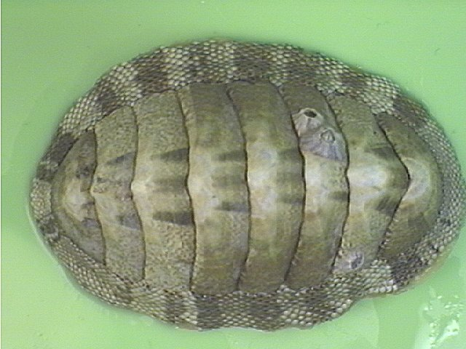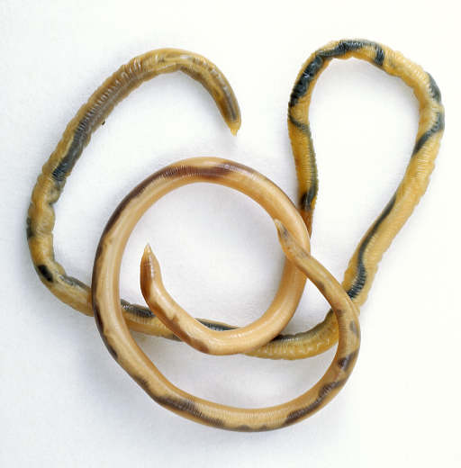
A
B

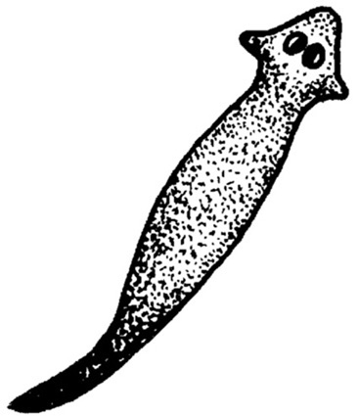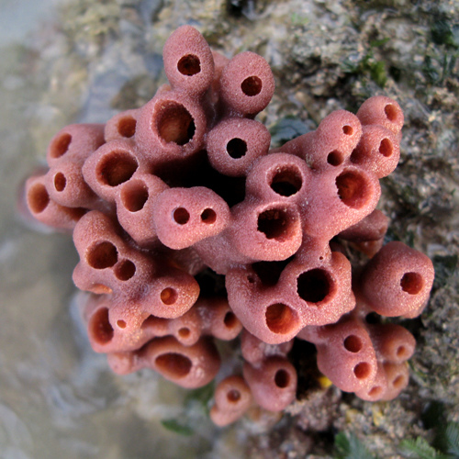
C
D
has sac-like gut

cellular level of organisation

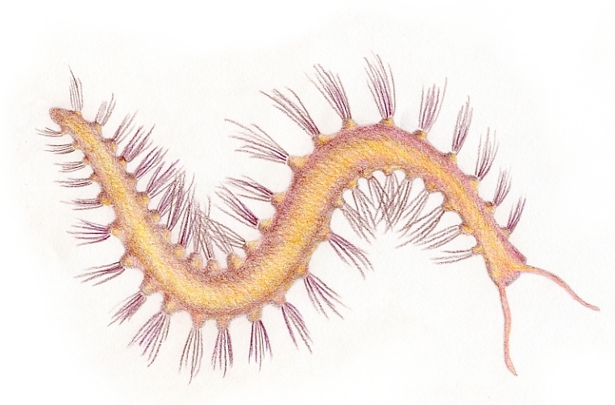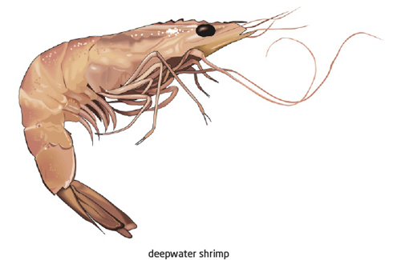
E
F
bristles reinforced with chitin

jointed limbs

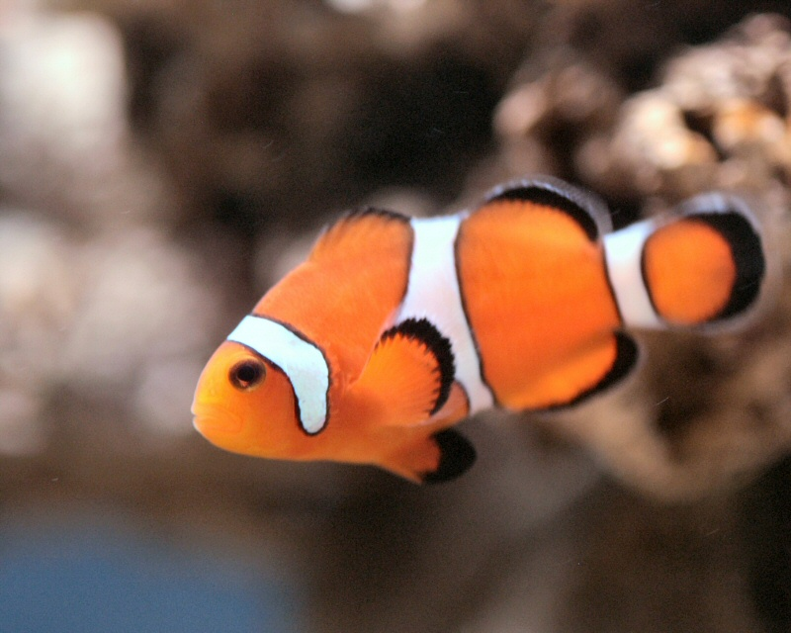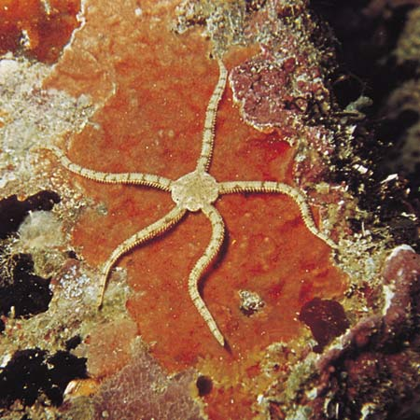
G
H
has bony segments

has tube feet

  - Write down the letter of the animal that …
- has a single entrance to the gut
- has an endoskeleton of ossicles
- has a pseudocoel
- has chaetae on its segments
- is asymmetrical
- has a hard exoskeleton ½ x 6 (3)

  - Write down the letters of the animals on the previous page in order of increasing complexity.
(4)

  - Two lineages of coelomate animals developed from bilateral animals similar to the flatworm. Name these two lineages and write down the letter of one animal belonging to each of these two lineages. (2)

  - By referring to the theory of natural selection explain how the development of jaws in fishes led to better eyesight, bigger brains and the evolution of the integument. (5)

14 marks

Question 6
Use the DNA strand below to answer the questions that follow.

3’ _________T A C G A T G T A G T C____________ 5’ Old DNA strand

  - If a new DNA strand is replicated from the one above during protein synthesis:

- Write in the sequence of bases on the new DNA strand. (1)
- Label the 3’ to 5’ ends of the new DNA strand. (1)
- Write down the mRNA strand transcribed from the new DNA strand. (1)
- Label the 3’ to 5’ end of the mRNA strand. (1)

  - Using the table of genetic codes provided over the page, determine the kind of codons and sequence of amino acids (polypeptide chain) that will be produced from this transcribed mRNA strand. (4)

  - What are the anticodons on the tRNA carrying the amino acids in 6.2 above? (2)
  - Name and explain the role of the enzyme that would have been used for mRNA transcription.
(2)

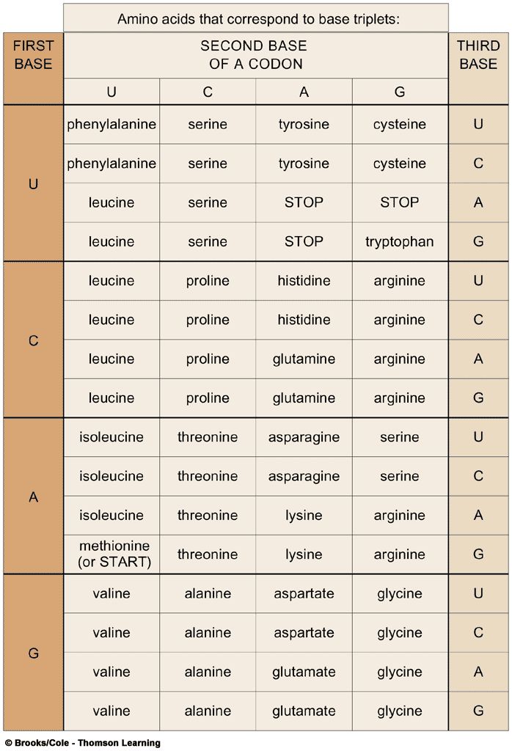

12 marks

TOTAL OF SECTION B: 95 MARKS

Section C: Essay questions
Answer only ONE (1) question in this section.
You should write at least 1 ½ to 2 pages for your essay.

- Two different paleontologists discovered only the fossilized bones of two identical organisms, one along the south east coast of North America and the other along the north west coast of Africa. After many months of research they concluded that these organisms lived during the Ordovician period and had lung-like sacs and jointed fins. Write an essay in which you:
- Discuss what fossilization is,
- Explain how these two organisms became fossils,
- Describe possible sedimentation events that took place during their fossilization and explain how these fossils were probably discovered and dated,
- Discuss reasons for the same fossilized creature to be found in different continents and
- Describe colonization of the terrestrial environment by descendants of these organisms.

Marks
Introduction  Have you used this section to provide a relevant background and introduce the topic i.e. have you discussed what fossilization is? | 3
Content (Body)
1. Have you explained how the two organisms became fossils? | 8
2. Have you described possible sedimentation events that took place during the two organisms’ fossilization and explained how these fossils were probably discovered and dated? | 8
3. Have you discussed reasons for the same fossilized creature to be found in different continents? | 4
4. Have you described colonization of the terrestrial environment by descendants of the fossilized organisms? | 5
Conclusion  Have you used this section to summarize your main points? | 2
General  1. Have you structured the essay correctly? | 1
2. Are the sentences well written? (short and concise) | 1
3. Is the content arranged in a clear, logical sequence? | 1
4. Is the content relevant to the topic? | 2
 | 35

- “The ability of a species to survive depends on its ability to give rise to new individuals of the same type i.e to reproduce”. Write an essay on this statement by:
  - Briefly describing the differences between asexual and sexual reproduction,
  - Explaining what DNA is,(include the role of chromosomes and genes), and the role of DNA replication in reproduction,
  - Describing and explaining how reproduction differs between unicellular and multicellular organisms (use the concepts of mitosis and meiosis) and
  - Discussing the importance of meiosis as a mechanism for genetic variation.

Marks
Introduction  Have you used this section to provide a relevant background and introduce the topic i.e. have you described the difference between asexual and sexual reproduction | 4
Content (Body)
1. Have you explained the role of DNA in cells (including the role of chromosomes and genes) and explained the role of DNA replication in reproduction? | 8
2. Have you described and explained how reproduction differs between unicellular and multicellular organisms (using the concepts of mitosis and meiosis)? | 8
3. Have you discussed the importance of meiosis as a mechanism for genetic variation? | 5
Conclusion  Have you used this section to summarize your main points? | 2
General  1. Have you structured the essay correctly? | 2
2. Are the sentences well written? (short and concise) | 2
3. Is the content arranged in a clear, logical sequence? | 2
4. Is the content relevant to the topic? | 2
 | 35

TOTAL OF SECTION C: 35 MARKS

