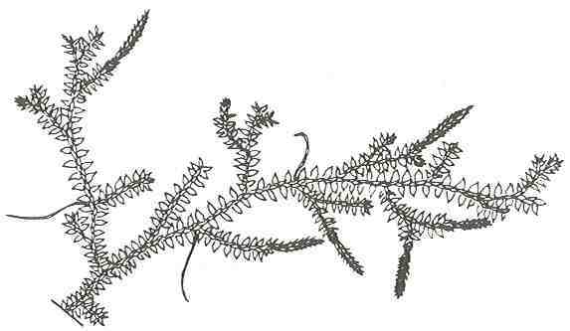
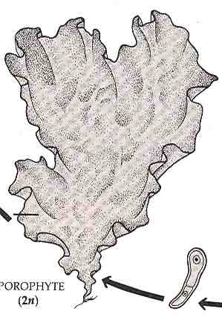
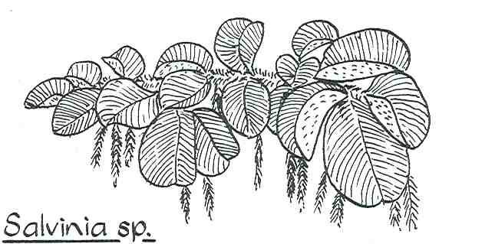
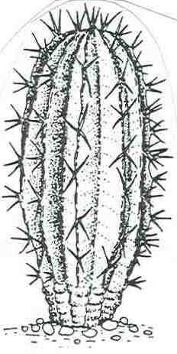
Small spines
Stems
Produce
sticky white fluid (latex)
Swollen leaf base (petiole)

D
water
Simple vascular tissue present in single vein on simple leaves (microphylls)
No true roots (holdfast)
No vascular tissue
water
True leaves covered with many fine white hairs
No flowers or seeds
water
Leaves reduced to spines
Stems produce sticky white fluid (latex)
L
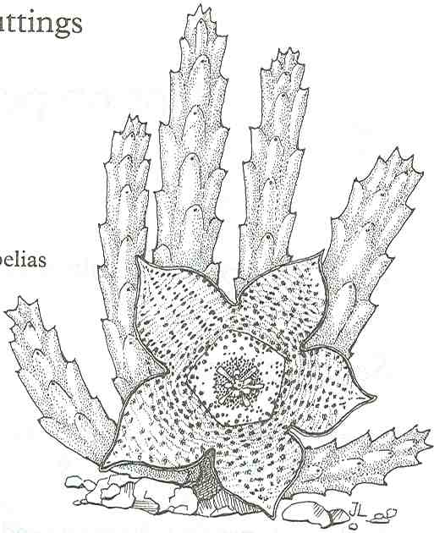
Stems covered with many fine, white hairs
Flower smells of rotting flesh
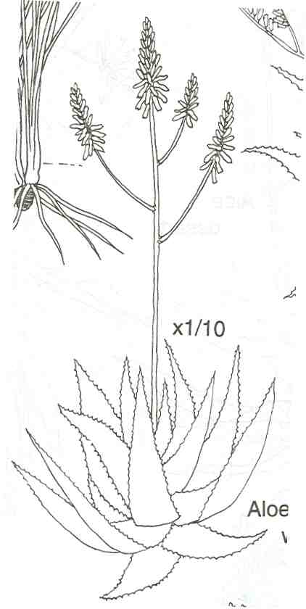

Fleshy leaves have serrated edges

A
B
C
E
I
H
G
F
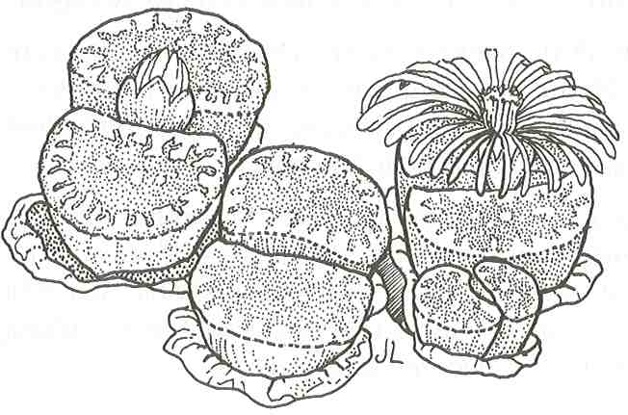
Leaves are succulent and fleshy and look like the stones in its habitat
Floral bud
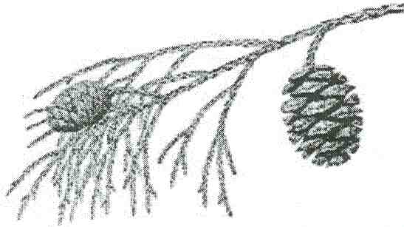
J
Small part of large tree shown
(no flowers)
K
True leaves very small
Figure 1
APPENDIX 1

