UNIVERSITY OF KWAZULU-NATAL
EXAMINATIONS: November 2008

SUBJECT, COURSE & CODE |  | BIOL099; BIOL199 – FOUNDATION BIOLOGY PRACTICAL
DURATION | 3 HOURS |  | TOTAL MARKS | 100

INTERNAL EXAMINERS | B. Keke, N. Kirby, S. Shaik, P. Seaman, J. White
EXTERNAL EXAMINER | Prof. D. Mycock

CANDIDATES ARE REQUESTED, IN THEIR OWN INTERESTS, TO WRITE LEGIBLY

THIS PAPER COMPRISES SIX (6) PAGES AND TWO (2) APPENDICES. ENSURE YOU HAVE ALL OF THEM.

ANSWER ALL QUESTIONS.

Question 1
On the side bench is a range of organisms (A-J). The passage provided below describes the relationship of some of these organisms to each other, in addition to their mode of life. Study the specimens given, and extract the relevant information from the text, to complete the tasks that follow.

A. “Although Crustaceans are a very diverse group of animals, they all characteristically have two pairs of antennae, and at least some of their limbs divided into two branches (biramous). All crustaceans have numerous jointed appendages that are variously adapted for walking, swimming, feeding and reproduction. Members of the Cirripedia differ from the class Malacostraca in that the adults have no walking legs.
Members of the Malacostraca are divided according to whether they have a hard protective covering over the thorax (the carapace) or not. The Amphipoda are a group of very small crustaceans that do not have a carapace. In all amphipods, the body is compressed from the side. Often overlooked because of their size, these animals are abundantly found feeding in decomposing seaweed on sandy beaches.
The decapods all have five pairs of walking legs- some swim with modified feathery, abdominal appendages; others are bottom dwellers whose legs are adapted for walking. The Anomura includes hermit crabs and mole crabs. The former of these (for example Clibanarius virescens) is well known for living in empty mollusc shells. Mole crabs such as Emirita austroafricana differ from these hermit crabs in that they do not rely on shells for protection, but are able to escape danger by being able to bury very quickly into the sand with their spade like legs.
The true crabs (the Brachyura) include species such as Grapsus grapsus, the Natal rock crab which can be seen scurrying across the entire rocky shore above the water level, feeding on fresh algae and small animals, and clinging to the rocks to avoid being washed away by breaking waves. Their
colouration (similar to the rock on which they move about) gives them some protection from predators. Fiddler crabs, for example Uca urvillei, differ from other true crabs in that the nipper on one of the first legs is greatly enlarged. Fiddler crabs, like mole crabs live in burrows on the sandy shore.”

  - Complete the branching diagram given (Appendix 1) to illustrate the classification hierarchy of the 10 organisms on the side bench.
- Fill in the missing information on the taxonomic groups. (5)
- Fill in the letter of each specimen from the side bench in the spaces provided in the boxes at the bottom of the branching diagram. Give the organism’s common name in the spaces provided. (8)
- Provide the diagnostic features (a – k) that were used to classify the organisms. Write these features a to k in your answer books. (List two for a.) (6)
- Hand in the branching diagram with your answer book.

- What diagnostic features do all crustaceans share? (2)
- At what taxonomic level are the sessile Crustaceans separated from those that are not sessile?
(1)
- What diagnostic features do mole crabs and fiddler crabs have in common? (1)
- Give the binomial name for Specimen E. (1)
- Describe the relationship between Specimen E and Specimen C. (1)

  - Draw a cladogram showing the probable evolutionary relationship between organisms A to E. (4)

  - The organisms in each zone of the Rocky shore are specifically adapted to the environmental conditions that they experience. Carefully examine Specimens G and J, paying particular attention to how their structure is adapted to their mode of life and habitats.
- Where on the rocky shores would you expect to find Specimens G and J? Explain your answer by referring to the text, and by relating the organisms’ adaptive features to the environmental conditions that these organisms experience. (6)
- What effect will Global warming will have on organisms like G and J? (2)

37 marks

  - B. After storms and unusually high seas along the East coast of Kwa-Zulu Natal, large amounts of plant debris (organic waste) and seaweed have been washed up onto the beaches along the coast line. At most beaches, this debris is decomposing quickly, but at Umkomaas this does not appear to be happening. The storms damaged pipelines carrying toxic sewerage at Umkomaas and the beach there is badly polluted. Wanting to know why the debris on the beach at Umkomaas was not decomposing quickly, a scientist performed the following investigation: Twenty five identical glass containers were filled with sterilized beach sand; 500 grams of fresh seaweed were added to each container. One hundred amphipods were placed into each of the 30 containers. Five containers were moistened with 1 litre of clean seawater. The remaining containers were treated with sea water contaminated with varying amounts of toxic sewerage. Data are presented in Table 1.

Table 1.
% contamination | Number of amphipods after two weeks
0 | 129 | 139 | 143 | 115 | 121
1 | 111 | 105 | 98 | 100 | 111
10 | 98 | 101 | 104 | 100 | 105
25 | 90 | 87 | 97 | 96 | 90
50 | 22 | 25 | 14 | 18 | 19
100 | 10 | 07 | 11 | 2 | 8

- What observations prompted this investigation? (2)
- By referring to text A, explain why amphipods were the subject of this investigation. (2)
- Suggest a suitable null hypothesis for this investigation. (1)
- List four controlled variables. (2)
- What was the purpose of including 0% contamination? (1)
- Draw a graph to best represent these results. (7)
- What conclusion can you draw from these results? (1)

16 marks

Question 2

  - Prepare a wet mount of specimen B by mounting it in the iodine stain provided. Observe your specimen on high power. Please ensure that a demonstrator has marked your slide before the end of the practical examination. (4)

  - Draw, label and annotate four cells of the specimen. (7)

  - Calculate the real size of one cell in µm. Show your working. (2)

  - What is the magnification of your drawing? Show your working. (2)

15 marks

Question 3
Figure 1 below shows organisms from two different kingdoms. Examine this figure and answer the questions that follow.

X
Y
nucleus
nuclear material
A
B
flagella
chloroplast

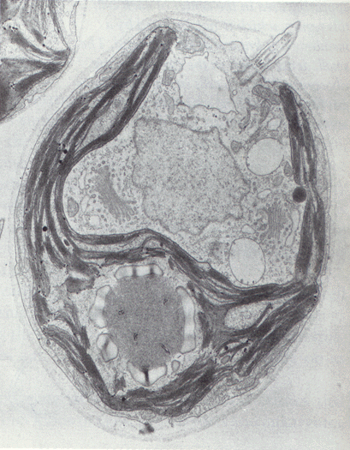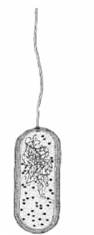
Mag 10 000X
2 μm
Figure 1

  - Name the two kingdoms represented by these two organisms. Give reasons for your answers.
(2)

- Calculate the real length of Organism A using the scale bar. Show your working. (2)
- How many times larger does organism A appear in the micrograph than it is in reality? Show your calculations. (2)

  - Consider the magnification for organism B given in figure 1 and the magnification for organism A calculated in 3.2 b above.
- What does this difference in the magnification tell you about the real sizes of these organisms? Explain your answer. (1)
- Would any of these two organisms be considered more efficient than the other? Explain fully by referring to the differences in the size and structure of the cells. (3)

10 marks

Question 4
Examine Appendix 2 and answer the following questions.

  - Identify and label parts B, C, D and F on the given plan diagram (Appendix 2). Hand in this plan diagram with your answer book. (4)

  - Annotate parts A and E. (5)

  - Provide a heading for your plan diagram. (1)

10 marks

Question 5
On the side bench you will find the following specimens: K L M N O

  - By making careful observations of specimens K and M describe the likely habitats occupied by them and the adaptations they have to make them successful in their particular environment. (6)

  - Specimens L, N and O are all vascular plants with true roots, stems and leaves. However, they are placed in different divisions. Use observable features of these specimens to describe the differences they have that places them in different divisions. (3)

  - Use the differences you have identified in question 5.2 to explain why Specimen L is regarded as belonging to the most primitive group, followed by specimen N and then specimen O the most advanced. (3)
12 marks

