UNIVERSITY OF KWAZULU-NATAL
EXAMINATIONS: JUNE 2008

SUBJECT, COURSE & CODE |  | FOUNDATION BIOLOGY THEORY BIOL O99; BIOL 199
DURATION | 3 HOURS |  | TOTAL MARKS | 100

INTERNAL EXAMINER | B. Keke, N. Kirby, S. Shaik, P. Seaman, J. White
EXTERNAL EXAMINER | Prof. D. Mycock

CANDIDATES ARE REQUESTED, IN THEIR OWN INTERESTS, TO WRITE LEGIBLY

THIS PAPER COMPRISES EIGHT PAGES, ENSURE YOU HAVE ALL OF THEM

ANSWER ALL QUESTIONS

SECTION A: MULTIPLE CHOICE QUESTIONS

Write only the letter of your choice in your answer books.

Questions 1 and 2 refer to the following statement:

A biologist studies the feeding of beetles on a species of plant.

1. The biologist is a/ an:
- entomologist
- ornithologist
- mycologist
- ichthyologist (2)

2. The biologist’s field of study is:
- behaviour
- ecology
- taxonomy
- a and b (2)

3. Which of the following statements is NOT correct?
- The effect of only one variable at a time is tested during the experiment.
- The hypothesis may be proved to be true after testing.
- The hypothesis should explain the observations, be specific, testable and falsifiable.
- A control experiment is set up as a standard against which experimental results may be measured. (2)

4. Which of the following statements is true?
- All living things are made up of many cells.
- The cell organelle is the smallest unit having the properties of life.
- All cells contain genetic material
- A group of cells working together to perform the same function is called an organ. (2)

5. You would expect a cell with an extensive dictyosome to:
- make a lot of ATP
- secrete a lot of material
- move actively
- perform photosynthesis (2)

6. Tissue that has a firm matrix and lacks blood vessels is known as:
- epithelial tissue
- bone
- cartilage
- b and c (2)

7. The cell type that would move sugars in a plant is a:
- tracheid
- vessel element
- fibre
- sieve tube (2)

8. If the amount of DNA present in a somatic cell during G2 is 20 units, how much will be present in each daughter cell immediately following cell division?
- 10 units
- 20 units
- 40 units
- 0 units (only RNA is present) (2)

9. A chromosome that has undergone DNA replication has:
- one chromatid
- two chromatids
- four chromatids
- maternal and paternal chromatids (2)

10. During fertilization in sexual reproduction:
- The zygote receives only half the information needed to make a new individual.
- The zygote receives all the information needed to make a new individual.
- Each gamete receives all the information needed to make a new individual.
- The gametes produced from one parent are all identical to each other, but different to those from the other parent. (2)

20 marks

SECTION B: SHORT ANSWER QUESTIONS
Answer all the questions in this section.

Question 1

Study Figure 1 of Euglena, a fresh water organism. Answer the questions that follow.
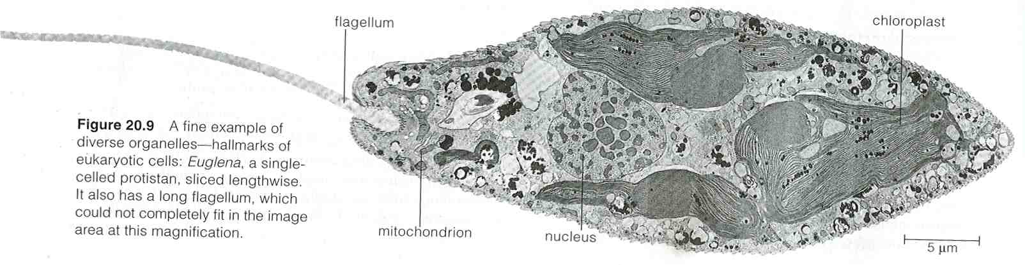
Figure 1

  - a. Is Euglena a multicellular or unicellular organism? Give a reason for your answer by referring to Figure 1. (2)
b. Is Euglena a prokaryote or a eukaryote? Give a reason for your answer. (2)
c. By referring to observable features in Figure 1, explain how Euglena is well suited to the environment it lives in. (2)
d. Give two characteristics of all living organisms that are demonstrated by Euglena in
Figure 1. (2)
e. What term would be used to describe a group of Euglena living in the same fresh water pond? (1)
1.2 Exactly what kind of microscope has been used to produce Figure 1? Explain your answer. (2)
  - a. Use the scale bar to calculate the real length (excluding the flagellum) of Euglena.
Show your calculations. (2)
b. How many Euglena would fit, end to end, across 1 cm? Show your calculations and give your answer to the nearest whole number. (2)
c. How many times larger does this Euglena appear in the micrograph than it is in reality? Show your calculations. (3)
d. Why is Euglena so small? Explain in full. (6)

24 marks

Question 2
Study Figures 2 and 3, and answer the questions that follow.
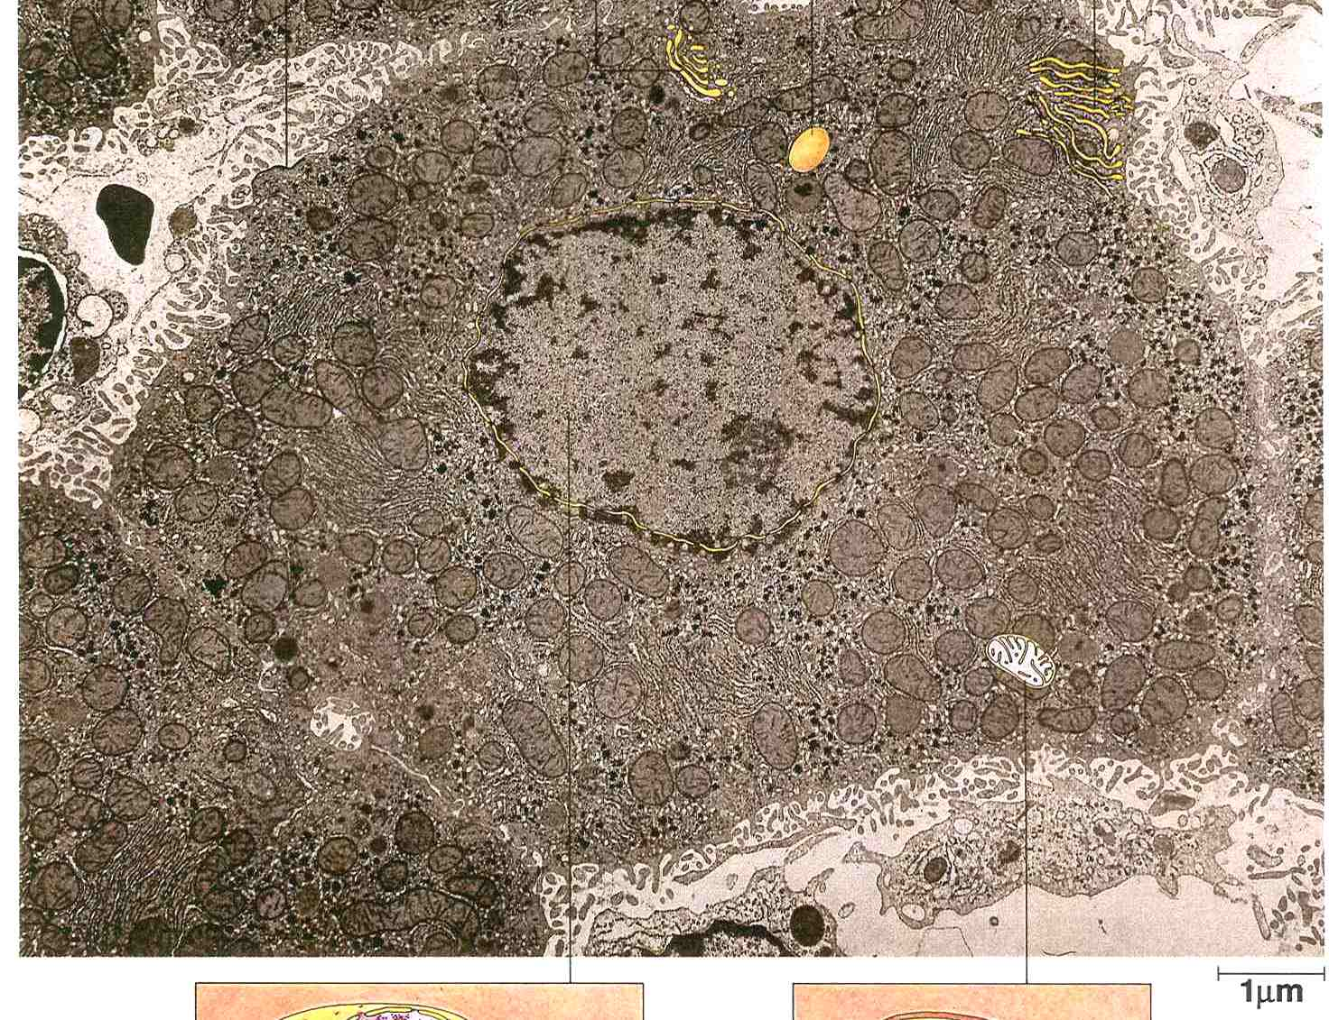

Figure 2

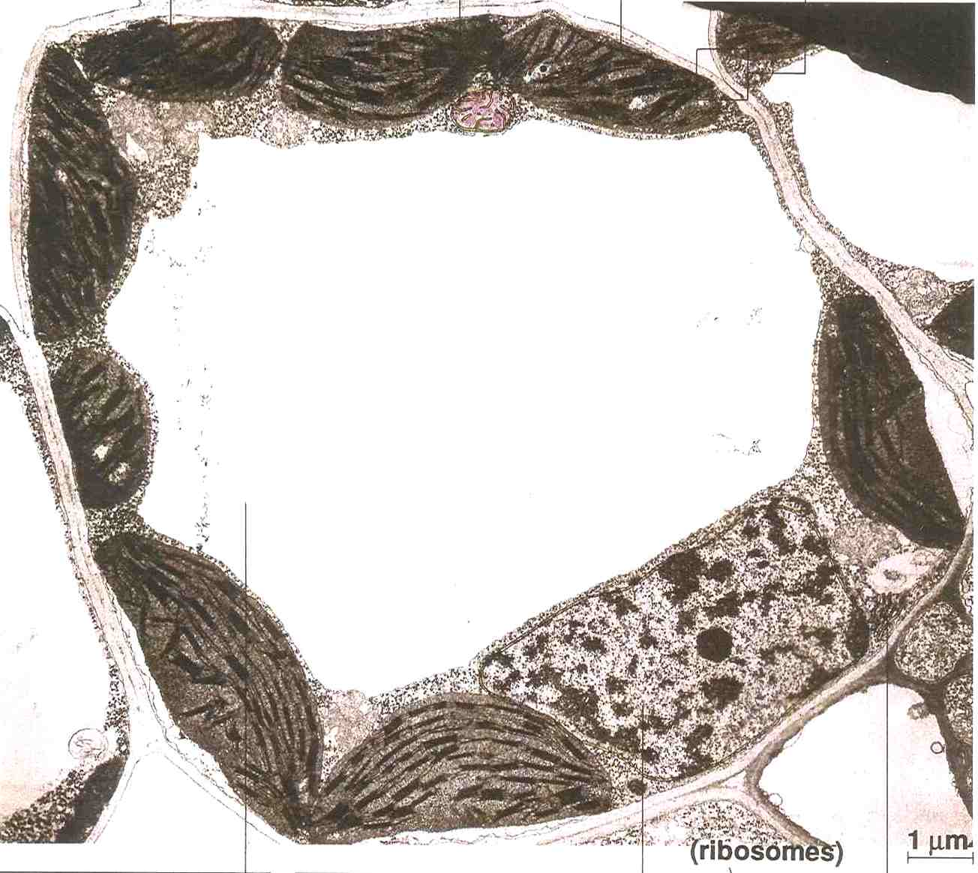

Figure 3

2.1 Which Figure shows cells from a plant? Give three reasons for your answer. (2)
2.2 Which Figure shows the most metabolically active cell? Give two well explained reasons for your answer. (5)
7 marks
Question 3

Study Figure 4 and answer the questions that follow.
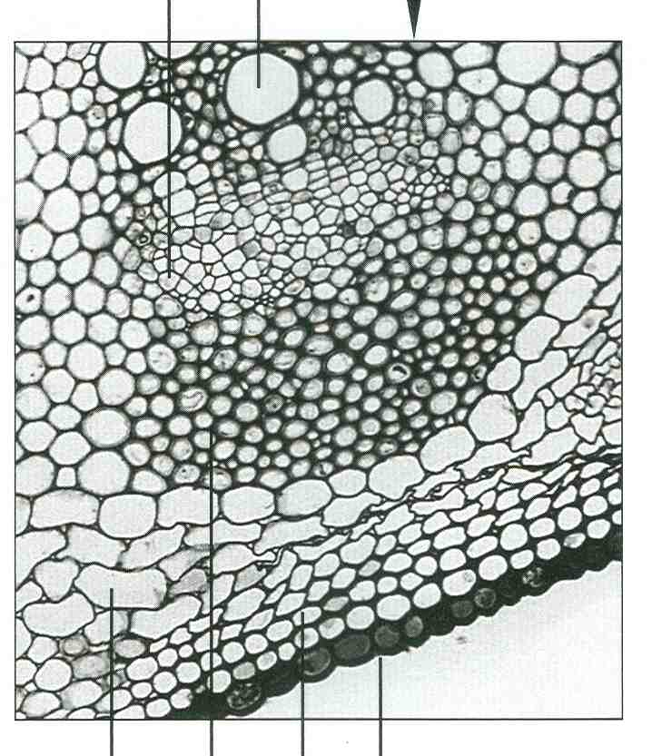
A.
B.
C.
D.
E.
F.

Figure 4

3.1 What level of Life’s hierarchy does Figure 4 represent? (1)
3.2 How are D and F well suited to their functions? Give two well explained reasons for each.(4)
5 marks

Question 4

Study the diagram of translation below and answer the questions that follow:
5
8
6
7
3
2
1
4
C A A A G G U U U A G A C U C C C A A G G A U G A C A
This tRNA has been released from the ribosome
9
10

4.1 Name the following parts:
a. structure 7
b. site 9 (2)

4.2 Fully describe the events that will occur next to join amino acid number 4 to the growing polypeptide chain. End your description when amino acid number 5 is in position to be joined. (Use names and/or numbers to make your description easy to understand). (5)

4.3 What was the anticodon for amino acid 3? (1)

4.4 What is the codon for the 5th amino acid in this chain? (1)

4.5 Give the sequence of the first 3 nucleotides of the DNA template for this polypeptide. (1)

4.6 Explain the consequences of a mutation in the mRNA strand that brings in a different amino acid to the one coded for by the DNA template. (2)
12 marks

Question 5

Read the passage and study the diagram, then answer the questions that follow:

“Species x is a multicellular marine animal which lives firmly attached to rocks on the shore. Males and females are unable to move from their positions. In order to reproduce, they release millions of gametes into the water at the same time. Most of these gametes are lost, but some do meet and fuse to form a new individual. Only a small proportion of these eventually manage to find a suitable habitat and to grow successfully to adulthood”.

Figure 5. Representation of the chromosomes of Species x
(*note: in reality these chromosomes are uncondensed)

5.1 Does Species x reproduce sexually or asexually? Give one reason from the passage and one reason from the diagram to explain your answer. (2)
5.2 Explain one disadvantage for Species x of this type of reproduction. (2)
5.3 Give one advantage of asexual reproduction. (1)
5.4 Which phase of the cell cycle is shown in Figure 5? Give a reason for your choice. (2)
5.5 a. Draw a diagram (similar to Figure 5) to show the appearance of the chromosomes when they are lined up at the equator during the first meiotic division. (2)
- Describe two ways that variation between gametes is ensured during this stage of cell division (drawn in question 5.5a).
You may draw pictures/sketches if this will help your description. (4)
- Why is variation between gametes advantageous for the species? (1)
5.6 The first step in any cell division is DNA replication. Write a paragraph to fully describe how DNA replication occurs. Be sure to mention the roles of the main enzymes and an explanation of why synthesis on the leading and lagging strands differs. (10)
24 marks
Question 6

“The function of an animal tissue is determined by its structure”. Discuss this statement by referring to examples of epithelial and connective tissue that you have studied. (8)
8 marks

