UNIVERSITY OF KWAZULU-NATAL
EXAMINATIONS: JUNE 2008

SUBJECT, COURSE & CODE |  | FOUNDATION BIOLOGY PRACTICAL BIOL099; BIOL199
DURATION | 3 HOURS |  | TOTAL MARKS | 75

INTERNAL EXAMINER | B. Keke, N. Kirby, P. Seaman, S. Shaik, J.White
EXTERNAL EXAMINER | Prof. D. Mycock

CANDIDATES ARE REQUESTED, IN THEIR OWN INTERESTS, TO WRITE LEGIBLY

THIS PAPER COMPRISES FIVE PAGES, ENSURE YOU HAVE ALL OF THEM

ANSWER ALL QUESTIONS

Question 1
- Prepare a wet mount of the onion epidermis. Stain your wet mount with the stain provided. Please ensure that a demonstrator has marked your slide before the end of the practical. (3)
- Draw, label and annotate three cells seen with high power. (8)
- Calculate the real size of one cell in µm. Indicate on your drawing exactly which cell you have used to calculate the real size. Show your working. (2)
- Use the real size you calculated in 1.3 to work out the magnification of your drawing. Show your working. (2)
15 marks
Question 2
Study the figures A to E on the next page and answer the questions that follow:
2.1 Write the letter of the micrograph which shows a:
a. transmission electron micrograph of a prokaryotic cell/s. Explain your answer. (2)
b. scanning electron micrograph of a prokaryotic cell/s . Explain your answer. (2)
2.2 Calculate the real length of the cell in micrograph E (along axis P to Q). Show your working. (2)
2.3 a. In micrograph A, calculate the real length of the cell from X → Y using the scale bar. Show your working. (2)
b. Explain why you would not expect to see a nucleus in every micrograph of this tissue. (1)
2.4 a. Explain why there is such a difference in the sizes of the cells you calculated in 2.2 and 2.3a above. (3)
b. Is any one of these cells more efficient than the others? Give a well explained reason. (3)
15 marks

Question 2
.
B
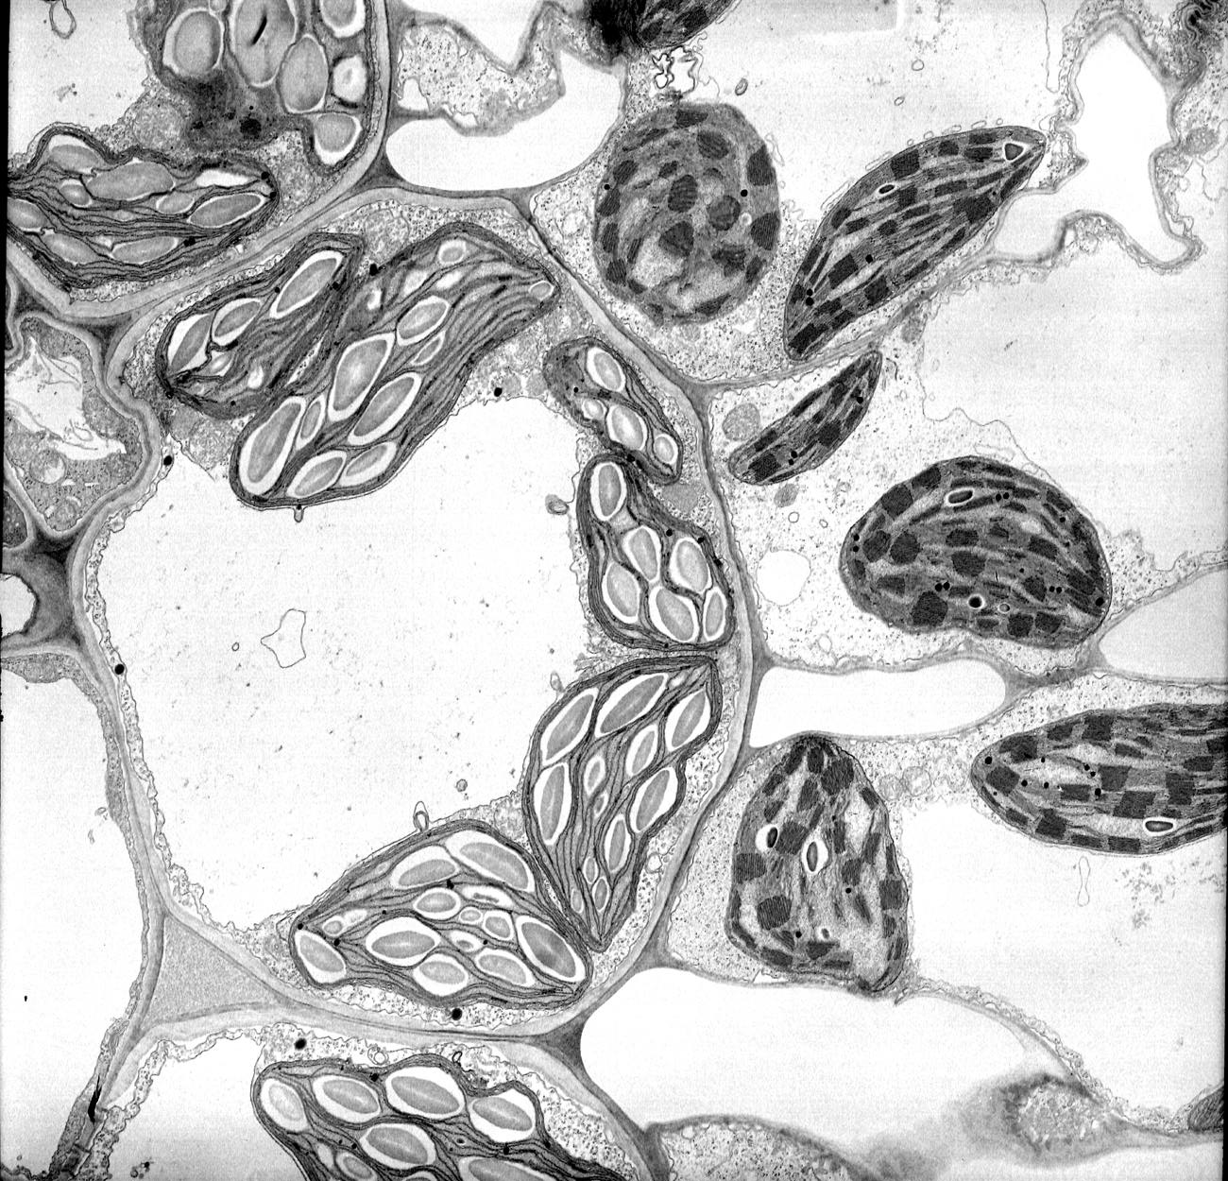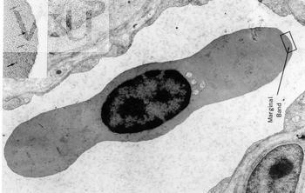
Y
X
A

Mag: 5000X
10 µm
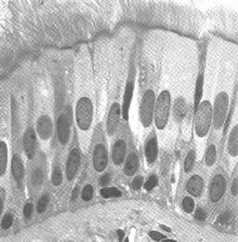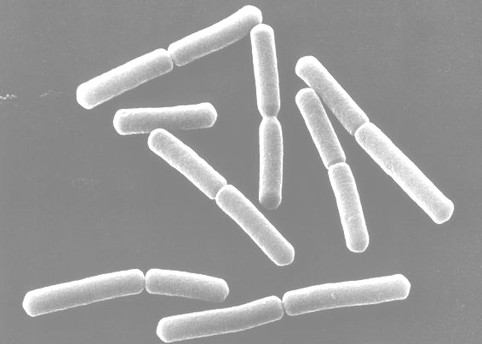
C
D
Mag: 600X Mag: 35000X

P
Q
E

Mag: 56000X
Question 3
- View the prepared slide provided.
- Using the plan diagram provided on page 5, label the parts D. and F on the diagram. (2)
- Provide detailed labels and annotations of the tissues labeled B. and G. (6)
- Give the plan diagram a heading. (2)
- Ensure your student number is on the plan diagram. Detach this page from your question paper and hand it in. 10 marks

Question 4
Land which has been disturbed and damaged by human activities can be returned to health by the growth of indigenous plants. Damaged land will be restored more quickly by planting it with seeds of indigenous plants such as Melicytus ramiflorus.

How effective this repair will be depends on two things: how many seeds germinate (germination percentage) and how quickly the seeds germinate (germination rate). Germination occurs when the young plants begin to develop from the seeds. When these young plants cover the ground they stabilize the damaged land, reducing soil erosion and the invasion of weeds.

The germination of seeds of some plant species has been shown to be influenced by scarification. This is the weakening of the testa (seed coat) which allows water and oxygen to reach the embryo more easily. Acid treatment weakens the testa and can therefore be used in the scarification of seeds.

An investigation was carried out to determine the effect of scarification on the percentage germination of Melicytus ramiflorus. Seeds were harvested and immediately scarified by treating them with concentrated sulphuric acid for different lengths of time. Twenty five identical trays were set up, each with 50 seeds. The seeds in twenty of these trays were placed in concentrated sulphuric acid for different amounts of time. The seeds in the remaining five trays were not scarified. Each tray was given 200 ml of water a day.

The results are given in Table 1.

Table 1 - Influence of scarification time on the percentage germination of Melicytus ramiflorus seeds.

Time (secs) | % Germination
0 | 83 | 91 | 78 | 79 | 84
15 | 59 | 66 | 70 | 62 | 58
30 | 62 | 54 | 64 | 57 | 63
60 | 72 | 73 | 64 | 68 | 63
300 | 58 | 49 | 52 | 50 | 56

4.1 Write a null hypothesis for this experiment. (1)
4.2 Name the independent variable. (1)
4.3 Name three controlled variables mentioned in the text. (3)
4.4 Name one other variable that would need to be controlled in the experiment. (1)
4.5 Why were some seeds not placed in concentrated sulphuric acid? (1)
4.6 Draw a summary table for the information given in Table 1. (6)
4.7 Draw a graph to represent the results shown in the table. (8)
4.8 Describe the trends that can be observed in the graph. (3)
4.9 Should the null hypothesis you wrote in question 4.1 be accepted or rejected? Explain your answer. (1)
4.10 What conclusion can be reached from this experiment? (1)

The scientist then wanted to find out the rate of germination after scarification. This will indicate how quickly the damaged land would be covered by new indigenous plants.

He noticed that there was no difference between the rate of germination of untreated seeds and those scarified for 15, 30 and 60 seconds. However, he observed a significant difference between the germination rate of untreated seeds and those seeds scarified for 300 seconds.
Figure 1 below shows the summarized results.

Figure 1. Effect of scarification for 300s on germination of Melicytus ramiflous seeds

4.11 Determine the following by reading from the graph:
(a) Which germinated first, the treated or untreated seeds? (1)
(b) On what day was the germination percentage of untreated and treated seeds the same? Give the approximate percentage germination. (1)
(c) Determine when the rate of germination was the fastest for treated seeds. (1)
4.12 What conclusion can be reached about the rate of germination as shown in figure 1? Support your conclusion with a brief discussion of the results. (4)
4.13 Do you think that scarification may be useful for repairing damaged land? Explain your answer by referring to the results of both experiments. (2)
35 marks

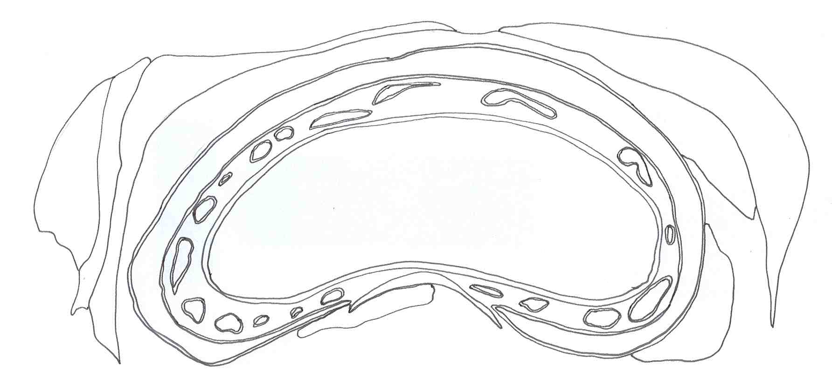
Glandular tissue (may not be visible in section)
B.
A.
E.
D.
C.
G.
F.
H.
I.

