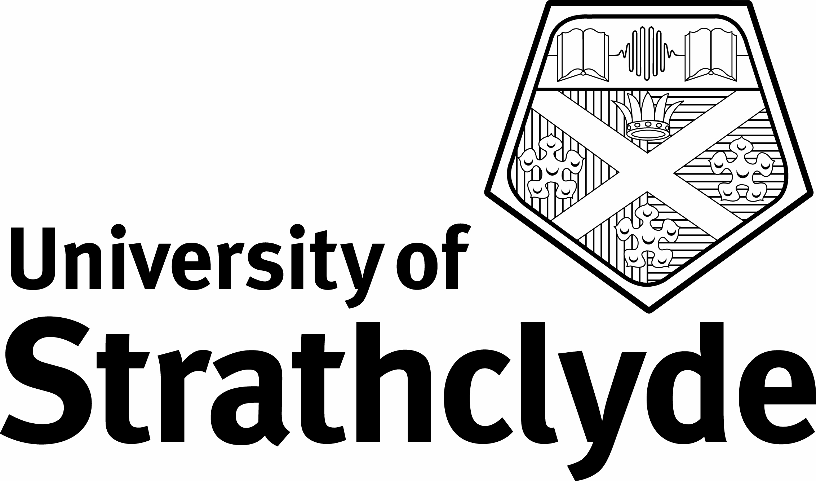

UNIVERSITY OF STRATHCLYDE

Department of Accounting and Finance

Advanced Management Accounting

40425

Tuesday 15th May 2007 9.30am – 11.30am

Time Allowed: 2 hours

ANSWER TWO QUESTIONS

ALL QUESTIONS CARRY EQUAL MARKS

Answer the following questions :

- Using effective arrangement and presentation
- With a clarity of argument
- With clear and concise language
- Demonstrating wide knowledge of literature

The use of calculators is not permitted in this examination

Question 1

Discuss the proposition that management accounting techniques do not need to be either true or fair.

Question 2

Discuss the possible implications of adopting the management control techniques described in the Dominion Swann case study in UK public sector schools.

Question 3

Discuss the usefulness of Kaplan’s suggestion that successful companies have the best management accounting systems in developing management accounting practice.

Question 4

Discuss the future development trajectory of management accounting in the next 20 years.

Question 5

Compare and contrast the concepts of ‘the governable person’ and ‘an economic citizen’ and evaluate their relative contribution to management accounting research.

Question 6

Compare and contrast the usefulness of national and organisational culture in understanding and evaluating management accounting practices.

END OF PAPER

