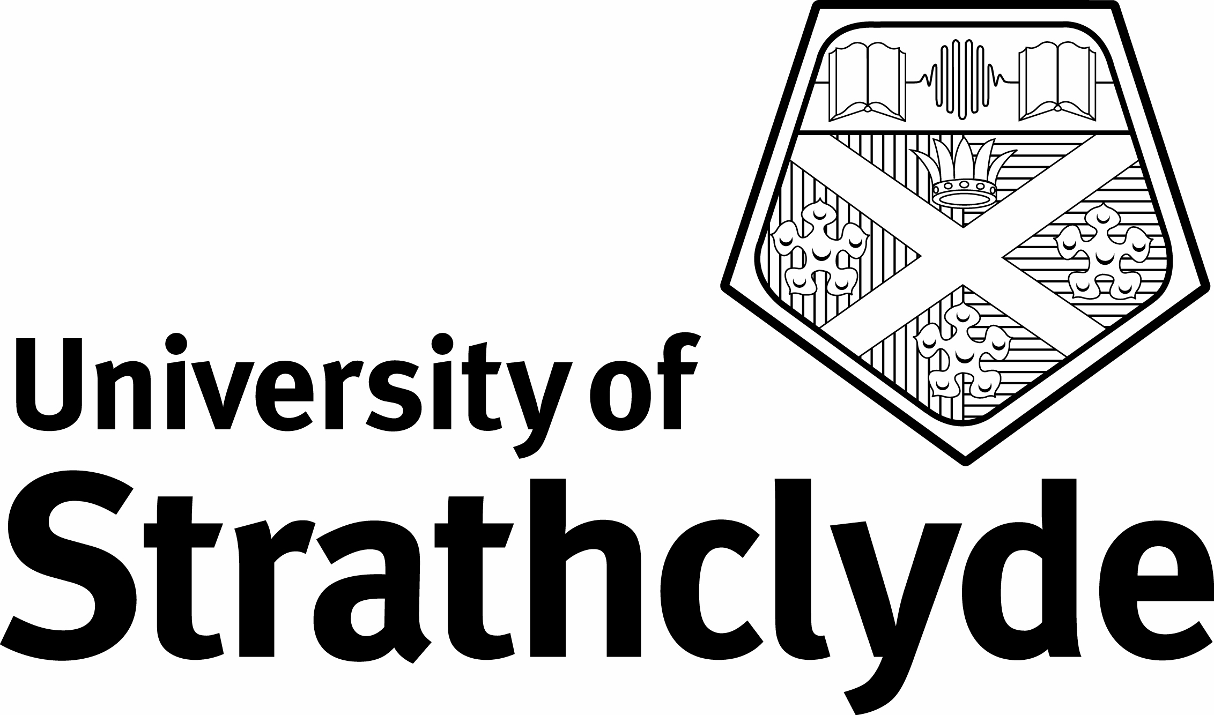

Department of Accounting and Finance

40425 Advanced Management Accounting

Thursday 11th May 2006 | 9.30am – 11.30am 2 hours

ANSWER TWO QUESTIONS

ALL QUESTIONS CARRY EQUAL MARKS

Answer the following questions :

- Using effective arrangement and presentation
- With a clarity of argument
- With clear and concise language
- Demonstrating wide knowledge of literature

The use of calculators is not permitted in this examination

Question 1

Discuss the appropriateness of the following accounting qualities for management accountants and management accounting information. (adapted from UK GAAP).

Question 2

Discuss the key differences in UK Public Sector Management Accounting and management accounting in other profit-oriented organisations.

Question 3

Compare and contrast any two different theoretical approaches that have been used to provide insights into management accounting practices.

Question 4

Discuss how you would clearly differentiate ‘management accounting’ from other management activities.

Question 5

Compare and contrast the management accounting systems at Caterpillar, Kyocera and Dominion Swann, identifying their strengths and weaknesses.

Question 6

Discuss the usefulness of the different accounting research methods in shaping future management accounting practices.

END OF PAPER

