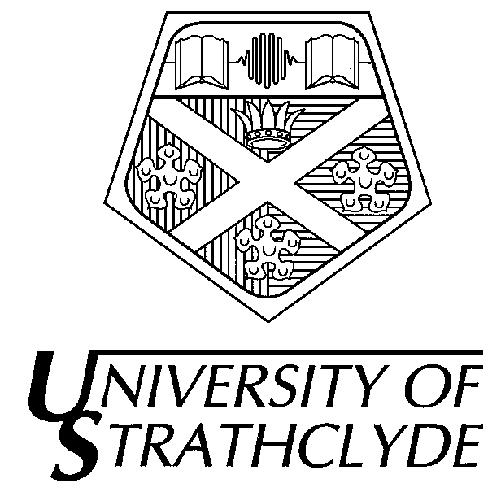

Department of Accounting and Finance

40425 Advanced Management Accounting

Friday 20th May 2005 | 9.30am – 11.30am (2 hours)

THERE ARE SIX (6) QUESTIONS IN ALL

ANSWER TWO QUESTIONS

ALL QUESTIONS CARRY EQUAL MARKS

Answer the following questions :

- Using effective arrangement and presentation
- With a clarity of argument
- With clear and concise language
- Demonstrating wide knowledge of literature

The use of calculators is not permitted in this examination
Answer ANY TWO Questions

Question 1

Discuss the nature of the evolution of management accounting systems since the industrial revolution.

Question 2

Management Accounting Systems should be more appropriately renamed Management Control Systems. Discuss.

Question 3

Cultural issues, for example between countries, styles of management, public and private sector organisations, dictate that management accounting systems cannot be transferred between different organisations. Discuss.

Question 4

Management Accounting has been defined as the process of identification, measurement, accumulation, analysis, preparation, interpretation and communication of financial information used by management to plan, evaluate and control within an organisation and to assure appropriate use of and accountability for its resources. Critically evaluate this definition of management accounting produced by the US Institute of Management Accountants.

Question 5

Discuss the critical factors that will impact upon the effective operation of management accounting systems.

Question 6

Discuss whether Japanese Management Accounting techniques could be usefully applied to UK public sector organisations .

END OF PAPER

