Comparison Between The Trapezium Rule And Simpon’s Rule
Michael R Richards
4th February 2008

Abstract
Integration is used in all aspects of physics; however some definite integrals cannot be evaluated and can only be approximated. Two of the simplest methods of approximating definite integrals are Newton-Cotes formulae i.e. the Trapezium Rule and Simpson’s Rule. Newton-Cotes formulas approximate the integral by breaking the function up into n number of strips whose individual areas can easily be evaluated. For the definite integral $\int_{1}^{\text{10}}{\frac{1}{x}\text{dx}}$ a computer programme was designed in C++ to discover which of these two methods is more accurate. The Trapezium Rule was found to be more accurate with its error being proportional to n⁻⁴ whereas the error associated with the Simpon’s Rule approximation was found to be proportional to n⁻². It was also found that Simpson’s Rule converged on the correct value quicker then the Trapezium Rule and that Simpson’s Rule was more reliable as it still functioned for very large n (above 7,000) whereas the Trapezium Rule began to fail.

Introduction
Integration is one of the key tools in a physicist’s armament; indeed the defining laws of integration were brought about by physicists for physicists. Integration has been used throughout the ages and today almost all aspects of modern physics rely in some way upon it.

Although integration was not formally defined as we know it today until the 17th Century, the processed can be tracked back to ancient Egypt (circa 1800 BC), on the Moscow Mathematical Papyrus^{Ref. 1}. In this paper the scholars of the day used integration to derive a formula for the volume of a pyramidal frustum. The first systematic method for evaluating integrals was documented circa 370 BC, known as the Method of Exhaustion derived by Eudoxus^{Ref. 2}. The method of exhaustion found areas or volumes by dividing the shape into an infinite amount of shapes whose areas or volumes were already known. This method was further developed by Archimedes who famously used it to evaluated the area of a circle; and all around the world many civilisations independently derived similar types of formulas.

The formalisation of integration (as we know it today), came in the 17th Century when Newton and Leibnitz both independently discovered the Fundamental Theorem Of Calculus^{Ref. 3}, a theorem which states integration is the reverse process of differentiation. This theorem for the first time allowed mathematicians to analyse functions over a continuous domain.

However, not all functions can be integrated and their definite integrals need to be approximated possibly using Newton-Cotes formulas ^{Ref. 3}. Two such formulas which approximate definite integrals are the Trapezium Rule and Simpson’s Rule, a programme was made to test which approximation was more accurate for evaluating the definite integral$\int_{1}^{\text{10}}{\frac{1}{x}\text{dx}}$.

Theory
Derivation Of The Trapezium Rule
The Trapezium Rule is a method for approximating the definite integral$\int_{a}^{b}{f(x)\text{dx}}$. In its simplest form it approximates the function f(x) as a “straight” line between the integral interval (a,b) and calculates the area of the trapezium that is created. See Figure 1, below:

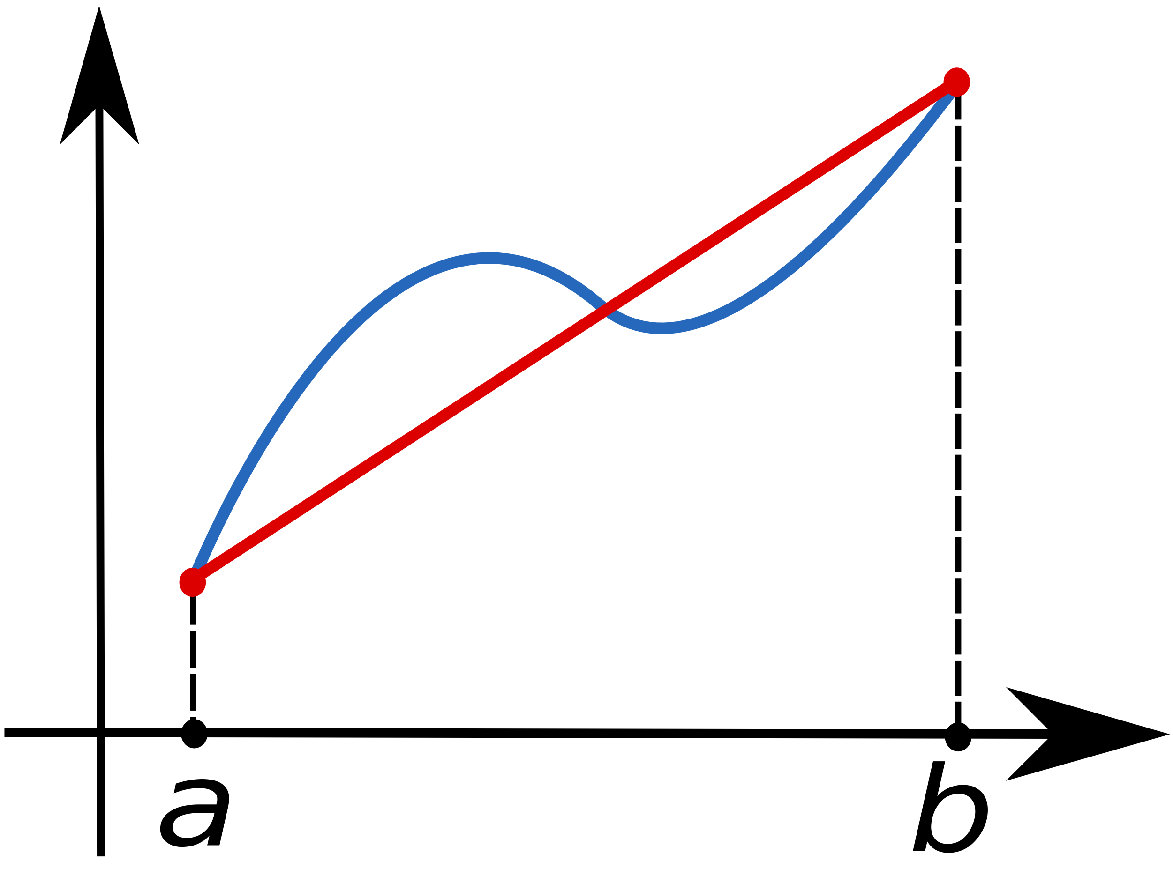
Figure 1: “The function f(x) (in blue) is approximated by the linear function (in red.” ^{Ref. 4}

From Figure 1 above it is clear that the area is approximated by the area of the trapezium which can be worked out by using Equation 1, below:

Equation 1^{Ref. 5}: $\int_{a}^{b}{f(x)\text{dx}≈(b−a)\frac{f(a)+f(b)}{2}}$

However, this simplistic approximation is very inaccurate; it can be made more accurate by subdividing the integral interval into n strips and evaluating and summing the area of the n trapeziums. This can be seen graphically in Figure 2, below:
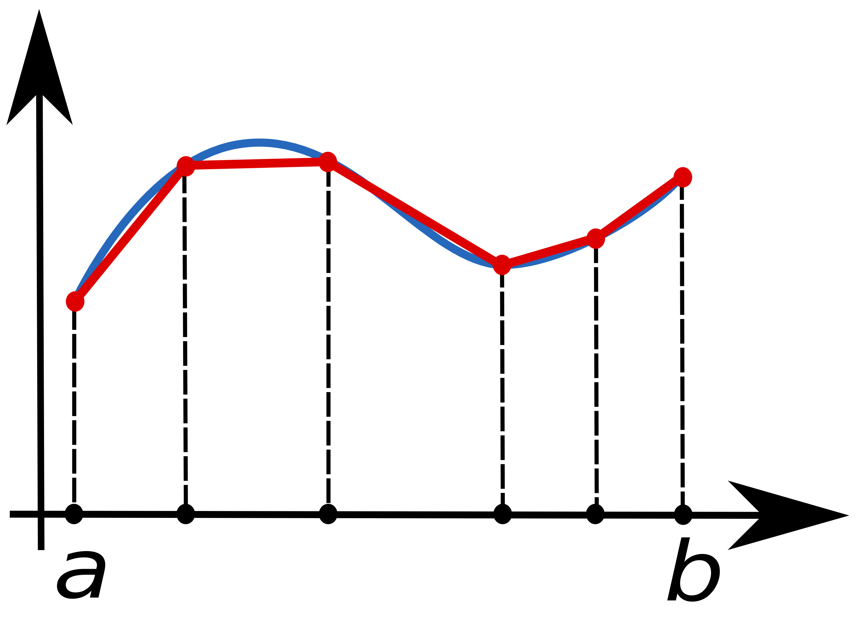
Figure 2: “The definite integral$\int_{a}^{b}{f(x)\text{dx}}$, (where the function f(x) is shown in blue) can be approximated by summing the area of the
trapeziums”.^{Ref. 4}

The area is expressed mathematically in Equation 2, below:
Equation 2^{Ref. 5}: $\int_{a}^{b}{f(x)\text{dx}≈\frac{b−a}{n}\left(\frac{f(a)+f(b)}{2n}+\sum_{i=1}^{n−1}{\left(a+i\frac{b−a}{n}\right)}\right)}$

This can alternatively be written in the form of Equation 3, below:
Equation 3^{Ref. 5}: $\int_{a}^{b}{f(x)≈\frac{b−a}{2n}\left(f(x_{0})+2f(x_{1})+2f(x_{2})+\text{.}\text{.}\text{.}+2f(x_{n−1})+f(x_{n})\right)}$

By defining $δ$ (the strip width) as $\frac{b−a}{n}$ the Trapezium Rule can be written as Equation 4, below:
Equation 4^{Ref. 6}: $\int_{a}^{b}{f(x)≈\frac{δ}{2}}\left(f(x_{0})+f(x_{n})\right)+δ\left(f(x_{1})+f(x_{2})+\text{.}\text{.}\text{.}+f(x_{n−1})\right)$

This form of the Trapezium Rule was used in the programme to compare the accuracy of its approximation relative to Simpson’s Rule.

Derivation Of Simpson’s Rule
Simpson’s Rule is “a more accurate [method of] approximating”^{Ref. 6} the definite integral$\int_{a}^{b}{f(x)\text{dx}}$ which was derived by Thomas Simpson in 1743. However, his rule was “also found 200 years earlier by Johannes Kepler”^{Ref. 3}. Simpson derived his rule by replacing the integrand f(x) with a quadratic function P(x), that is equal to f(x) at a, b and m (where m is midpoint i.e.$\frac{a+b}{2}$). This can be seen graphically in Figure 3, below:
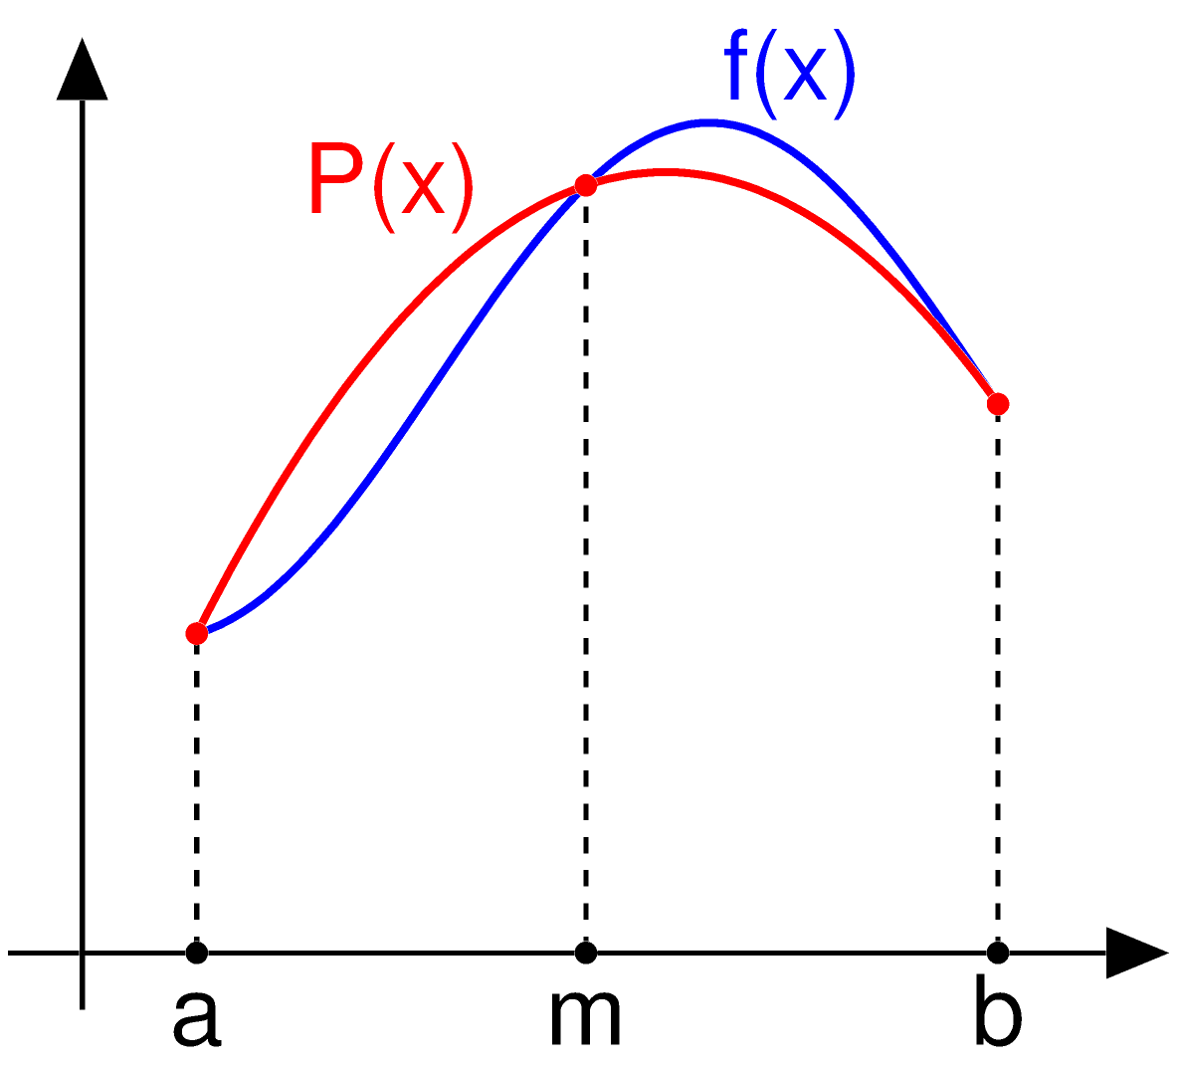
Figure 3: “Simpson’s rule can be derived by approximating the integrand f(x) (in blue) by the quadratic interpolant P(x) (in red)”. ^{Ref. 7}

The equation of the function P(x) can be found using Lagrane polynomial interpolation, this has been done in Equation 5, below:

Equation 5^{Ref. 3}:
$P(x)=f(a)\frac{(x−m)(x−b)}{(a−m)(a−b)}+f(b)\frac{(x−a)(x−m)}{(b−a)(b−m)}+f(m)\frac{(x−a)(x−b)}{(m−a)(m−b)}$

Therefore the area can be approximated by Equation 6, below:
Equation 6: $\int_{a}^{b}{f(x)\text{dx}≈\int_{a}^{b}{P(x)\text{dx}}}$

The integral of the quadratic interpolant can be evaluated, to give the result shown in Equation 7, below:

Equation 7^{Ref. 3}: $\int_{a}^{b}{P(x)\text{dx}=\frac{b−a}{6}\left[f(a)+4f\left(\frac{a+b}{2}\right)+f(b)\right]}$

However, this simplistic approximation is very inaccurate; it can be made more accurate by subdividing the integral interval into n strips and evaluating and summing the area of the n quadratic interpolants. By defining $δ$ (the strip width) as $\frac{b−a}{n}$ and rearranging Equation 7, Simpson’s Rule is given as Equation 8, below:

Equation 8^{Ref. 6}:
$\int_{a}^{b}{f(x)≈\frac{δ}{3}(y_{0}+y_{n})+\frac{4δ}{3}(y_{1}+y_{3}+\text{.}\text{.}\text{.}+y_{n−1})}+\frac{2δ}{3}(y_{2}+y_{4}+\text{.}\text{.}\text{.}+y_{n−2})$

This form of Simpson’s Rule was used in the programme to compare the accuracy of its approximation relative to the Trapezium Rule.

Method
The algorithm created to test which approximation was more accurate for evaluating the definite integral was designed thusly; the user entering the upper and lower integral limits then having the choice of three options, approximating the integral using the Trapezium Rule, approximating the integral using Simpson’s Rule or compare the two methods, respectively. This is represented graphically using the flowchart below:

iopt
++1?
iopt
++2?
iopt
++3?
Output messages
Read double a, b
Keyboard
Output message
Read
iopt
Keyboard
Output
error
Stop
End
Option 1
Actions
Option 2
Actions
Option 3
Actions

Options 1 and Option 2 then asked the user to enter the number of strips for the integration approximation, before using different functions calculate the sum and display it (for the full code see Appendix A).

The function in Option 1 is described by the following flowchart, where the function integrand has already been predefined and h is defined as the strip width.
n = 1

n<=
(n-1)
answer = h*(y + ((1.0/2.0)*(integrand(a) + integrand(b))));

Output answer
y += (integrand((a + (i*h))))

End
Add 1 to n

The function in Option 2 is described by the following flowchart, where the function integrand has already been predefined and h is defined as the strip width.
answer = ((h/3)*(integrand(a)+ integrand(b)))

answer = h*(y + ((1.0/2.0)*(integrand(a) + integrand(b))))

n = 1

n<=
(n-1)
Output answer

End

i%==2?
yodd += integrand(x)

yeven += integrand(x)

Add 1 to n

Option 3 calculated the absolute error in both approximations (for 1 strip up to 10,000 strips), the log of this value and the log of the number of strips used in the approximation. All of this data was streamed to a text file (for the full code see Appendix A).

Results, Errors, Discussion
Using the programme outlined in the method section (full code in Appendix A) the number of strips used in the approximation and the approximation itself were streamed to a text file. For a Newton-Cotes formula we know that the error is in some way related to the number of strips, this relationship is shown in Equation 9, below:

Equation 9^{Ref. 6}: $\left|\text{Error}\right|∝\frac{1}{n^{m}}$ for n>>1
By implementing the laws of logarithms Equation 9 can be rewritten in the form of Equation 10, below:

Equation 10: $\text{log}\left(\left|\text{Error}\right|\right)=−m\text{log}\left(n\right)+\text{log}\left(k\right)$

The programme also calculated the error of each approximation by subtracting the correct value of the definite integral (ln10, this was found by imply the Fundamental Rule Of Calculus) and taking the absolute value of the result. Furthermore the programme also calculated the log of both the absolute error and the number of strips and streamed them to a text file. Equation 10 is of the form$y=−\text{mx}+c$, so by graphing the log of the absolute error against the log of the number of strips a “straight” line should be obtained where the gradient is -m. The resulting graph is figure 4 below:

Figure 4: The log of the absolute error in the definite integral against the log of the number of strips, Simpson’s Rule is in blue and the Trapezium Rule in pink. Although both graphs have a slight curve at the start they become of the form y =- mx + c, so by finding m a relationship for the error can be found.

From figure 4, it is clear that both graphs can be spilt up into at least two distinct parts. Both the Trapezium Rule graph and Simpon’s Rule graph start with an initial curve before becoming a “straight” line. The curve for the Trapezium rule is more pronounced this shows that it takes longer for the Trapezium rule to converge on the correct answer compared to Simpon’s Rule. Linear regression was preformed on both graphs (just the “straight” line section in the middle, from n=1000 to n=7000), both graphs over this range where found to have perfect liner regression i.e. R² = 1, this means that the value calculated for m is highly accurate.

From the linear regression –m for the Trapezium rule was found to be -4.0012 and for Simpson’s rule –m was found to be -1.9989 this suggests that error for the Trapezium Rule is proportional to n⁻⁴ whilst the error in Simpon’s Rule is proportional to n⁻², hence the Trapezium Rule is more accurate for the same value of n.

From Figure 4, it is clear that the Trapezium rule strays from the shape y = -mx + c as n becomes very large and “balloons”. This is because the values the program encounters very small values the log values become more inaccurate.

The only intrinsic errors in this experiment were due to the variable type used in the programme. Throughout the programme the double variable type was used, this was because they are assigned 8 bytes of memory so they can represent “positive or negative numbers in the range of 1.7x10⁻³⁰⁸ to 1.7x10⁺³⁰⁸ with 15 decimal places”^{Ref. 6} which is highly accurate. This means the intrinsic error in the approximation of the integral is given by the order of magnitude of the last digit plus 0.3% of the largest value; hence the largest error will occur for the largest approximation.

Largest approximation is: 2.30258509263728

Largest Error = 1x10⁻¹⁵ + ^{3 x 2.30258509263728} / ₁₀₀
= 6.91 x 10⁻¹⁷

This is an ignorable error, as it is only 3x10⁻¹⁵ % of the approximation.

The error in log the number of strips can be found in the same way with the largest error being 3.0x10⁻¹³.

The error in the error of the approximation of the integral can be worked out by adding the error of the approximation and the error in the correct value in quadrature:

Error in the error of the approximation $\begin{aligned}=\sqrt{6\text{.}\text{91}x{\text{10}}^{−\text{17}}+6\text{.}\text{64}x{\text{10}}^{−\text{17}}} \\ 1\text{.}\text{16}x{\text{10}}^{−8}\end{aligned}$

The error in the log functions can be calculated using equation 11, below:
Equation 11^{Ref. 8}: Error through a log function = $\text{log}(\text{Value}+\text{Error})−\text{log}(\text{Value})$

Error in log absolute error of approximation
= $\text{log}(2\text{.}\text{30258509263728}+1\text{.}\text{16}x{\text{10}}^{−8})−\text{log}(2\text{.}\text{30258509263728})$
= 2.19x10⁻⁹

The error in the log number of strips is similarly found to be 5.17x10⁻³¹

Now the error in m can be evaluated by adding the errors of the log number of strips and log of the error in the approximation in fractional quadrature, the resulting error is 9.05x10⁻¹⁹, this shows us that the values of m calculated are highly accurate.

Conclusions
The programme was successful in comparing the two Newton-Cotes formulas for evaluating the definite integral$\int_{1}^{\text{10}}{\frac{1}{x}\text{dx}}$. It was found the Trapezium Rule was more accurate as its error was proportional to n⁻⁴ whilst the error associated with Simpson’s Rule was proportional to n⁻² (where n is the number of strips). However, it was also found that Simpon’s Rule converged quicker on the answer and was more reliable as the Trapezium Rule broke down for very large n. However, both methods are highly accurate for reasonably large n and both methods could be used to approximate definite integrals in most physical applications.
Bibliography
Ref. 1: Truman State University (Math and Computer Science Division), 1999,
“Mathematics and the Liberal Arts”
Ref. 2: G. L. Huxley, 1980, “The Dictionary Of Scientific Biography, Volume 4”
Ref. 3: M. L. Boas, 2005, “Mathematical Methods In The Physical Sciences”
Ref. 4: http://en.wikipedia.org/wiki/Trapezoidal_rule (2/2/2008)
Ref. 5: R. L. Burden, 2000, “Numerical Analysis, 7th Edition”
Ref. 6: D. Lee, 2007, “First Year Laboratory, Computing Laboratory 2007-8”
Ref. 7: http://en.wikipedia.org/wiki/Simpson%27s_rule (2/2/2008)
Ref. 8: R. Thompson, 2007, “First Year Measurements And Errors”

Appendix A
The Numerical Integration Algorithm In C++
// Integration Tool
#include <fstream>
#include <iostream>
#include <cmath> // Include libaries
using namespace std;

// 1st Function Start
double integrand(double x)
// Type of return value is double, name is integrand, arguments x
{
double y;
y = (1.0 / x);
return y;
} // 1st Function End
// 2nd Function Start
double trapezium(int n, double a, double b)
// Type of return value is double, name is integrand,
{
double h, y=0.0, answer;
h = (b - a) / n; // Strip width=h
for (int i=1; i<=(n - 1); i++) // i=1 increasing by one, until i=(n-1)
{
y += (integrand((a + (i*h))));
// Sum of y-values i.e. y[1] + y[2] + ... y[n-1]
}
answer = h*(y + ((1.0/2.0)*(integrand(a) + integrand(b))));
// +{y[0]+y[n]*(Strip width)} / 2
return answer;
} // 2nd Function End
// 3rd Function Start
double simpson(int n, double a, double b)
// Type of return value is double, name is integrand,
{
double x=a, h, yeven=0, yodd=0, answer; // Values initalised
h = (b - a) / n; // Strip width=h
answer = ((h/3)*(integrand(a)+ integrand(b))); for (int i=1; i<=(n-1); i++)
// i=1 increasing by one, until i=(n-1)
{
x += h;
// x increased by one strip width
if (i%2==0)
// If its the 2nd, 4th, 6th .. (n-2)th term
{
yeven += integrand(x); // Sums the even y values
}
else
// If its the 1st, 3rd, 5th .. (n-1)th term
{
yodd += integrand(x);
// Calcuates odd values, one more term then even values
} }
answer+= (h/3.0)*((2*yeven)+(4*yodd));
return answer;
} // 3rd Function End
int main () // Main function
{
double a, b, Tanswer, Sanswer;
int n, iopt;
cout << "This machine will help you evaluate the integral of 1/x" <<endl;
cout << "Enter the lower integral limit: ";
// Output messages
cin >> a; // Lower integral limit entered
cout << "Enter the upper integral limit: ";
// Output message
cin >> b; // Upper integral limit entered
cout << "If you would like to approximate the integration by the Trapezium Rule press 1: " <<endl;
cout << "If you would like to approximate the integration by Simpson's Rule press 2: " <<endl;
cout << "If you would like to compare the two (results sent to Comparison.txt) press 3: " << endl;
// Output message
cin >> iopt; // Reads input to question
ofstream stream1("Comparison File.txt");
// Numbers will be sent to Comparison File
stream1 << "Number of strips (n)" << "\t" << "Log(n)" << "\t" << "Trapezium Rule Aprxoimation" << "\t" << "Trapezium Rule Error"
<< "\t" << "Log(Trapezium Rule Error)" << "\t" << "Simpson's Rule Aprxoimation" << "\t" << "Absoulte Simpson's Rule Error" << "\t"<< "Log(Simpson's Rule Error)" << endl;
// Titles of the columns
switch (iopt) // Swicth Function Starts
{
case 1: // If 1 use the Trapezium Rule
cout << "Enter the number of strips (must be an integer): ";
// Output message
cin >> n; // Number of strips entered
Tanswer = trapezium (n,a,b);
// trapezium function used to work out the integral
cout << "The intergral using the Trapezium Rule is approx.: " << Tanswer << endl;
// Output message
break;
case 2: // If 2 use Simpson’s Rule
cout << "Enter the number of strips (must be an integer, a multiple of 2 and n>4 ): ";
// Output message
cin >> n; // Number of strips entered
Sanswer = simpson (n,a,b);
// simpson function used to work out the integral
cout << "The intergral using Simpson's Rule is approx.: " << Sanswer << endl;
// Output message
break;
case 3: // Comparison Of Methods
for (int i=4; i<=(10000); i+=2) // i=4, add 2, until i=(10000)
{
n=i;
// Define the number of strips as i
Tanswer = trapezium (n,a,b);
Sanswer = simpson (n,a,b);
stream1 << n << "\t" << log((double)n) <<"\t" << Tanswer << "\t" << (Tanswer - log(10.0)) <<"\t"<< log(Tanswer - log(10.0)) << "\t" << Sanswer << "\t" << fabs((Sanswer - log(10.0))) << "\t" << log(fabs(Sanswer - log(10.0))) <<endl;
// Approximations, Erros etc sent to file

}
break;
default:
cout << "Error in input: Restart and choose 1, 2 or 3" << endl;
// Error Message
exit(99);
} // Swicth function ends
return 0;
} // End of programme

