SCHOOL OF ENGINEERING

MODULAR HONOURS DEGREE

LEVEL 3

SEMESTER 2

1998/99
MANUFACTURING SYSTEMS

Examiners : Mr R Fletcher/Mr H Cather
__________________________________________________________________________
Attempt FIVE questions only. Time allowed 3 hours.
Total number of questions = 8.
All questions carry equal marks.
The figures in brackets indicate the relative weightings
of parts of a question.

1. The development of Group Technology (GT) in the 1970s lead eventually to the philosophy of cellular manufacture.
Discuss the problems that Group Technology was seeking to address. (20)

2. The two products given in the Figure Q2 precedence diagrams are to be assembled on the same multi-model line. Each work element requires special equipment and can thus only be allocated to one workstation.

a) Find a balance on a three station line which will give a reasonable balance for both.
Calculate the balancing loss in each case. (15)

b) Identify any actions which may help to get a better balance. Do not recalculate your cycle times. (5)

QUESTION 2 CONTINUES ON PAGE 3/10

Figure Q2

3. An automatic press is set on an assembly line to press home a part which has been placed in position at an earlier station. (Diagram Figure Q3). The robot gripper can handle two products at a time to allow load and unload in a single movement.

a) Identify a list of inputs and outputs required for safe operation. (5)

b) Identify a list of transport moves, separate load/unload and move functions. (5)

c) Devise a flowchart to perform the initialisation routine to ensure the conditions are as given in the diagram. At any fault condition detected stop the process and call an operator. (10)

QUESTION 3 CONTINUES ON PAGE 5/10

Figure Q 3

4. The unmanned or minimally manned operation of machine tools is now common place in the manufacturing sector. Using machining centres as your example identify the necessary machine and control features. (20)

- The product illustrated in Figure Q5 is a two-part moulding. Discuss six of the options in detail. It is desired to test a limited number of products before committing to full tooling. A quantity of ten would be helpful but one hundred would be preferable.

Discuss the options and make your decisions based on cost, speed and properties. (20)

QUESTION 5 CONTINUED ON PAGE 7/10

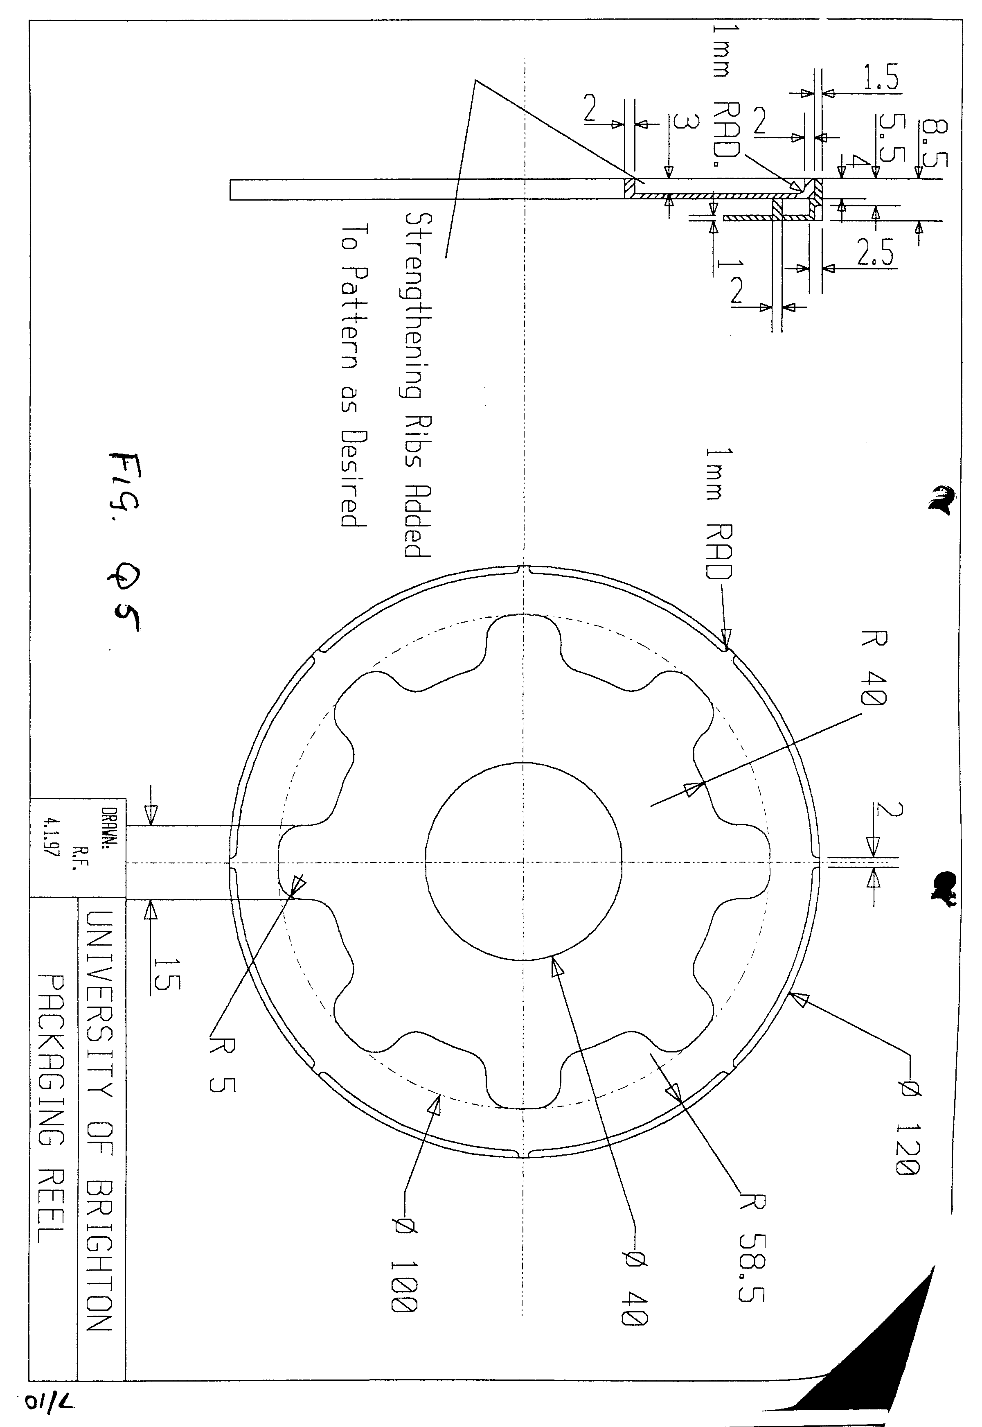

- In automated assembly the design and consistency of the quality of items to be assembled has a major influence on the assembly machine efficiency.

a) Discuss and illustrate action which may be taken to promote efficiency in the areas mentioned. (10)

b) What factors would lead a company to consider automatic assembly? (10)

- The two machines A & B shown in Figure Q7 are in sequence. There is a buffer for a single item between them. The dedicated cell is fed by a conveyor which always has a component ready for machining.

a) Using the given decision table matrix, Figure Q7a, draw up a decision table for the flow of components and minimise it where possible. (15)

b) Identify any assumptions you have made and describe how it may be used to control the cell by computer. (5)

Figure Q7A

- The scanning of product surfaces is now readily available.

a) Discuss the circumstances under which scanning may contribute to manufacture. (7)

b) Explain how can scanning systems can be retrofitted to CNC machines, what types of
probe are used and what features are required of the controller. (8)

c) Non contact laser probes are now available. Discuss the contribution they can make. (5)

