ME 302 1/7

DEPARTMENT OF MECHANICAL & MANUFACTURING ENGINEERING

MODULAR HONOURS DEGREE COURSE

LEVEL 3

SEMESTER 1

1997/98

DYNAMICS AND CONTROL

Examiners: Dr Dave Pearce/Dr Carl Hogg

Attempt FOUR questions only. Time allowed: 3 hours

Total number of questions = 6

All questions carry equal marks.
The figures in brackets indicate the relative weightings
of parts of a question.

The following charts, tables and other special requirements
are supplied:

Graph paper
Mathematical Formulae (B&C)

ME 302 2/7

1. A unity feedback closed-loop position control system operates with an oscillatory performance such that ζ = 0.5 and a settling time of 1.33 seconds.

It is proposed to use a lead/lag network in the forward path to improve the time response to ζ = 0.707 and settling time of 0.8 seconds.

If the original forward path transfer function is F(s) = $\frac{K}{s^{2}+6s+\text{18}}$ and using the root-locus technique.

Determine:

(a) the required compensating lead/lag network to satisfy the desired closed-loop response (12)

(b) a root-locus diagram for the control system (8)

(c) the expected change to steady state performance. (5)

ME 302 3/7

2. (a) A transducer mechanism designed to measure angular velocity is shown in figure Q2. The input, u, to the transducer is an angular velocity (rad s-1) and the output, y, is an angular displacement (rad).
Using the state variables x1 = y and x2 = $\overset{·}{y}$ draw the state variable diagram and formulate the state and output equations. (10)

(b) Assuming the transducer starts from rest and using the data
provided below, calculate a time simulation of the output, y, in steps
of 50 ms for a period of 250 ms when the input, u, experiences
a step input of 1 rad s-1. (15)

Data

k = 3.2 Nm rad-1
C = 0.8 Nms rad-1
I = 0.2 kg m2

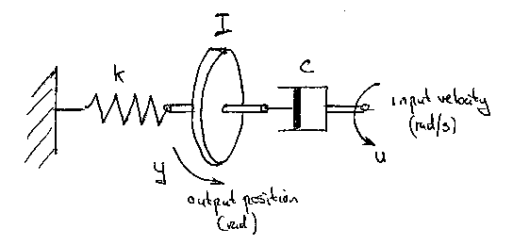

Figure Q2

ME 302 4/7

3. A robot arm used in a car assembly plant is shown in figure Q3. The gripper has three degrees of freedom; two angular, q and a about axes XX and YY respectively and one linear in the radial direction, r, along the arm. The gripper and component are to be considered as a concentrated mass, m, acting at the instantaneous radial distance r.

Determine:

(a) a general equation for the kinetic energy of the component ` (10)

(b) the general expressions for the torques about the axes XX and YY
due to the movement of the component (15)
Lagrange general force equation:

$\frac{d}{\text{dt}}\left({\frac{¶T}{¶\overset{·}{q}}}_{i}\right)−\left(\frac{¶T}{¶q_{i}}\right)=Q_{i}$

where T is the kinetic energy
qi is a generalised co-ordinate
Qi is a generalised force

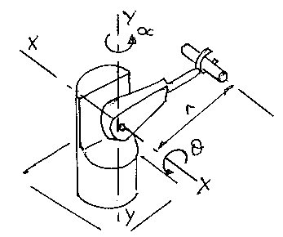

Figure Q3

ME 302 5/7

4. A machine tool when operating at constant speed generates a force
P1 = 100 sin 70t acting in the vertical direction. To reduce the effect from this force acting on the factory floor the machine has been mounted on four isolation pads, shown in figure Q4. It was then subsequently found that the machine tool structure experienced an unsatisfactory vibration in the vertical direction.

(a) Using the data provided below design an auxiliary mass and spring system for the machine to minimise the vibration amplitude. (10)

(b) Determine the magnitude of the force applied to the factory floor from;

(i) using only the vibration isolation pads, and

(ii) using the isolation pads and the auxiliary mass and spring system. (15)

Data

Mass of machine tool = 1000 kg
Isolation pad stiffness = 5 x 105 N m-1
Isolation pad damping = 20 x 103 Ns m-1
Auxiliary mass = 20 kg

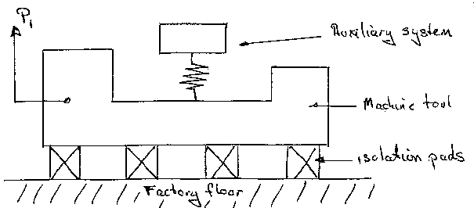
Figure Q4

ME 302 6/7

5. The design of a railway wagon bogie showing the principal masses and
springs is illustrated in figure Q5. Using the data provided below,
determine all the natural frequencies of vibration in the horizontal
direction and verify the modal shapes. (25)

Mode 1 Mode 2 Mode 3

$\begin{aligned}\left[x_{1} | \right]\left[x_{2} | \right] \\ \end{aligned}$ $\begin{aligned}\left[x_{1} | \right]\left[x_{2} | \right] \\ \end{aligned}$ $\begin{aligned}\left[x_{1} | \right]\left[x_{2} | \right] \\ \end{aligned}$

Data

Mass m1 = m3 = 100 kg
Mass m2 = 50 kg
Stiffness k1 = k3 = 10 x 104 N m-1
Stiffness k2 = 5 x 104 N m-1
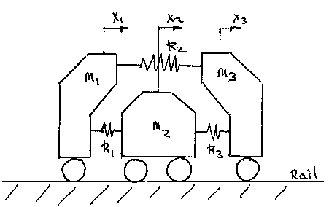

Figure Q5

ME 302 7/7

6. The hydraulic actuator for positioning a flight simulation platform is shown in figure Q6, where the position error supplies oil to the cylinder via a spool-valve. It is to be assumed that the equivalent unity feedback control system has an open-loop transfer function F(s) = $\frac{\text{20}}{s^{3}+\text{13}s^{2}+\text{32}s}$ and the closed-loop state equations are:

$\begin{aligned}\left\{{\overset{·}{x}}_{1} | \right\}\left\{{\overset{·}{x}}_{2} | \right\}\end{aligned}\left\{\right\}=\begin{aligned}\left[0\text{ 1 0} | \right]\left[\text{0 0 1} | \right] \\ \end{aligned}$

(a) Discuss how state feedback signals might be obtained from this
system and used to improve the dynamic performance of the
output. (8)

(b) Using the state equations for the system determine the matrix of state feedback coefficients necessary to generate closed-loop poles at
-8 and -6±j2. (17)

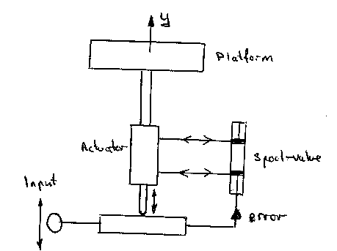
Figure Q6

