ME209 1/7

DEPARTMENT OF MECHANICAL & MANUFACTURING ENGINEERING

MODULAR HONOURS DEGREE COURSE

LEVEL 2

SEMESTER 2

1997/98

EXPERIMENTAL METHODS

Examiners: Mr J A Lomax/Dr D Koshal

This is an Open Book Examination.

Attempt FOUR questions only. Time allowed: 2 hours

All questions carry equal marks. Total number of questions = 5

The figures in brackets indicate the relative weightings of parts of a question.

At the conclusion of the exam you will be asked to hand in your exam script plus one log book for each subject (Dynamics, Materials, Manufacturing, Mechatronics and Thermo Fluids). Ensure that your name and subject is on each log book.

Ensure that any loose log book pages are in the correct logbook and that your name and the subject are recorded on them in the top right hand corner.

The following are supplied:

Linear graph paper
3 cycle Log/Log graph paper

ME209 2/7

1. Mechatronics - MEC23

(a) Analogue input to PC.
Draw neatly on graph paper to scale the wave forms you obtained on the PC monitor when inputting signals at the following conditions, (note the vertical and horizontal scaling):

(i) Low voltage at low frequency (e.g. 1 V at 10 Hz)
(ii) High voltage at high frequency (e.g. 10 V at 600 Hz)
(iii) Justify numerically the number of samples you found in both cases. (9)

(b) Analogue output from PC.
Draw neatly to scale the wave forms you obtained on the oscilloscope when outputting signals from the PC at the following conditions:

(i) Low voltage at low frequency (e.g. 1 V at 10 Hz)
(ii) High voltage at high frequency (e.g. 10 V at 1000 Hz)
(iii) Justify numerically the steps in the wave form you found in both cases. (9)

(c) Aliasing

(i) State the essential point of Shannon's theory
(ii) Explain the phenomena of aliasing that can occur at high frequencies and sketch a graph to demonstrate this
(iii) Explain what tests the user can perform to determine whether a sampled wave form of unknown frequency is aliased or not. (7)

ME209 3/7

2. Dynamics - DYN22

You have been asked to conduct an experiment on an electric servo motor that is to be used in a speed control system. Figure Q2 shows the result obtained for a falling weight test similar to the experiment you conducted in the laboratory when determining the velocity or viscous drag coefficient.

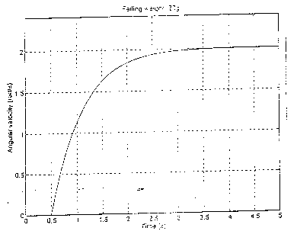

Figure Q2

(a) Using the data given below for the servo motor determine a value
for the velocity drag coefficient (10)

(b) Assuming figure Q2 is that obtained from a first order equation
determine the time constant and value for the moment of inertia of
the servo motor (10)

(c) Describe another engineering problem that involves the solution of
a first order differential equation (5)

DATA for servo motor
Falling weight M = 20 g
Radius at which falling mass acts R = 50 mm
Dry friction torque MF = 7.81*10-3 Nm

ME209 4/7

3. Thermofluids - THF21

(a) The following readings of refrigerant temperature and pressure were obtained from the RC712 refrigeration unit:

T1 = 6°C T2 = 60°C T3 = 30°C T4 = -10°C

P1 = 2.0 bar (absolute) P2 = 8.5 bar (absolute)

(i) Plot the refrigeration cycle on a pressure enthalpy diagram for
refrigerant R134a (figure Q3).

(ii) Determine the specific enthalpy at points 1 to 4 in the cycle.

(iii) Determine the isentropic efficiency of the compressor. (13)

(b) Determine the efficiency with which electrical power (PEL) is converted
to indicated power (PIN) (η = PIN/PEL) using the values of PEL and PIN
obtained in the laboratory class. If the refrigerant unit operates on
the cycle given in section (a) and the electrical power is 0.6 kW,
calculate the indicated power, the mass flow rate of refrigerant, and
the rate of heat transfer in the evaporator. (12)

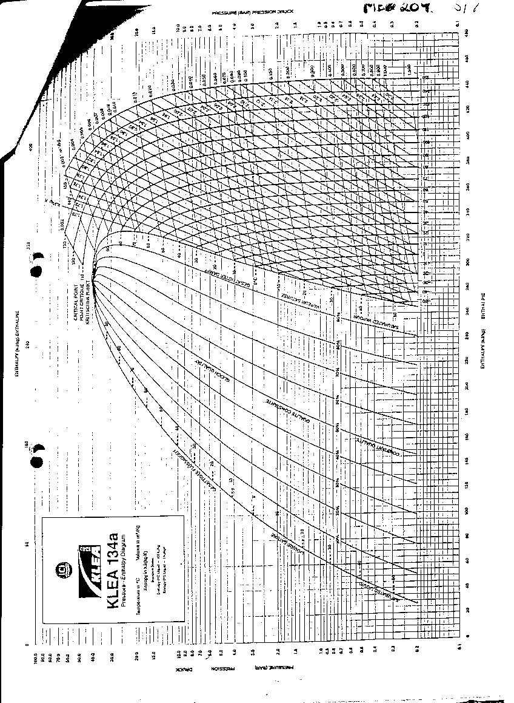
ME209 6/7

4. Manufacturing Engineering - MAN23

Based on the laboratory experiment on the Reflex robot address the following points:

(a) Draw an isometric sketch to show the absolute and relative axis
convention used in this program (5)

(b) (i) Draw neatly the first and last figure that the program in this laboratory produced and show the X and Y axes used.

(ii) Describe the deviations from the intended figure consisting of a circle and its diameter. (5)

(c) Show the modifications needed to the program to produce 4 figures
of 1.5 inches radius at speeds of 2, 4, 6 and 8 inches per sec with 5°
between points on the right hand side and 45° on the left hand side. (10)
(Note : Programme required inputted as inches).

(d) State clearly using line numbers how you would modify the program
in (C) further to cause the robot to draw ellipses with a ratio of 8 to 1
between the largest (Y-axis) and smallest (X-axis) diameters. (5)

ME209 7/7

5. Materials Engineering - MAT22

(a) From your log book using graphs and numerical values summarise the following results for the materials that you tested:

(i) Maximum stress

(ii) Failure stress

(iii) % Elongation to Failure

(iv) Impact strength (6)

(b) Comment on the difference between the elastic recovery and the elongation to failure for each specimen. (3)

(c) Sketch and describe the failed ends of the specimens in each case. (4)

(d) Sketch and describe the fracture pattern obtained from the impact
tests conducted on each specimen. (4)

(e) Describe precisely what factors effect the quality of your results. (4)

(f) What is the effect of the strain-rate and the glass transition
temperature on the results you obtained? (4)

