ME206 1/9

DEPARTMENT OF MECHANICAL & MANUFACTURING ENGINEERING

MODULAR HONOURS DEGREE COURSE

LEVEL 2

SEMESTER 2

1997/98

MANUFACTURING ENGINEERING

Examiners: Dr D Koshal/Mr H Cather

Attempt FIVE questions only Time allowed : 3 hours

All questions carry equal marks. Total number of questions = 8

The figures in brackets indicate the relative weightings of parts of a question.

ME206 2/9

1. (a) You are the quality control manager of a machine shop, which produces batches of components on a fully automated machines at high speed. Your inspector has advised you that he has been monitoring a new machine's production, by taking samples of 10 components, at random intervals and measuring their diameter. These components are supposed to be 60.00 mm nominal diameter. You have calculated that the standard deviation for this parent population is 0.186. Using the information, produce a Mean chart, to enable the inspector to monitor the machine when full production commences. (10)

(b) Discuss what other types of charts are required and explain how
they will assist to monitor production. (10)

2. (a) With the aid of a flow charts discuss the steps involved in the assembly of the following printed circuit boards.

(i) A board which has conventional components on one side and surface mount components on the other. (6)

(ii) A board which has surface mount components on both sides of the board. (6)

(b) Discuss the factors which must be considered when selecting a component placement machine for surface mount technology. (8)

ME206 3/9

3. Face milling machining tests were carried out using a 8 teeth cutter with an outside diameter of 100 mm. By taking full diameter cuts on a steel workpiece the following results were obtained.

Test Feed Depth of Rotational Cutting
rate cut speed power
(mm/min) (mm) (rev/min) (kW)

1 165 5 625 5.64
2 330 5 625 9.96

Assuming that a cutting power equation exists of the form

P = K V d ftx

Where P = power (kW)
V = rotational speed (rev/min)
d = depth of cut (mm)
ft = feed per cutting tooth (mm)

The cutter is to used a on milling machine with a rated power of 8.5 kW and a transmission efficiency of 65% to mill 4 mm from the surface of large plate of steel.

Assume spindle speeds in rev/min are:-

100, 150, 200, 255, 395, and 550

and the available feeds in mm/min are:-

100, 150, 200, 250, 300, 350, and 400

Calculate the most efficient available spindle speed and feed for this
operation if the lowest recommended peripheral cutting speed for the
cutter is 1 m/s and the maximum feed per cutter tooth is 0.2 mm. (20)

ME206 4/9

4. (a) List the benefits of operating a statistical quality control to evaluate
machines, materials, and processes. (10)

(b) Discuss in detail the steps involved in developing a sound quality control and reliability programme. (10)

ME206 5/9

5. A bearing bush shown in figure Q5 is to be machined from a 50 mm diameter steel bar. Suggest a suitable sequence of operations and calculate the cutting time for each of the operations involved.

Tools available

High speed steel twist drill 10 mm diameter
Carbide turning tool (0o side cutting)
Boring tool
Carbide facing tool
High speed steel end mill, 15 mm diameter, 8 teeth

Recommended feeds and speeds

Turning

Turning and facing V = 2.5 m/s f = 0.32 mm/rev
Drilling V = 0.5 m/s f = 0.12 mm/rev
Centre drilling V = 2.5 m/s f = 0.05 mm/rev
Boring V = 0.4 m/s f = 0.2 mm/rev

Milling

Face milling
Recommended feed/tooth, 0.32 mm
Recommended speed, 0.35 m/s

Available speeds (rev/min)

Centre Lathe 70, 110, 190, 260, 450, 580, 750, 950, 1200, 1500
Vertical mill 80, 160, 240, 300, 360, 480, 640

Recommended feeds for turning, facing, boring, drilling and milling are all available.

State any assumptions that you make. CNC machine is not to be used. (20)

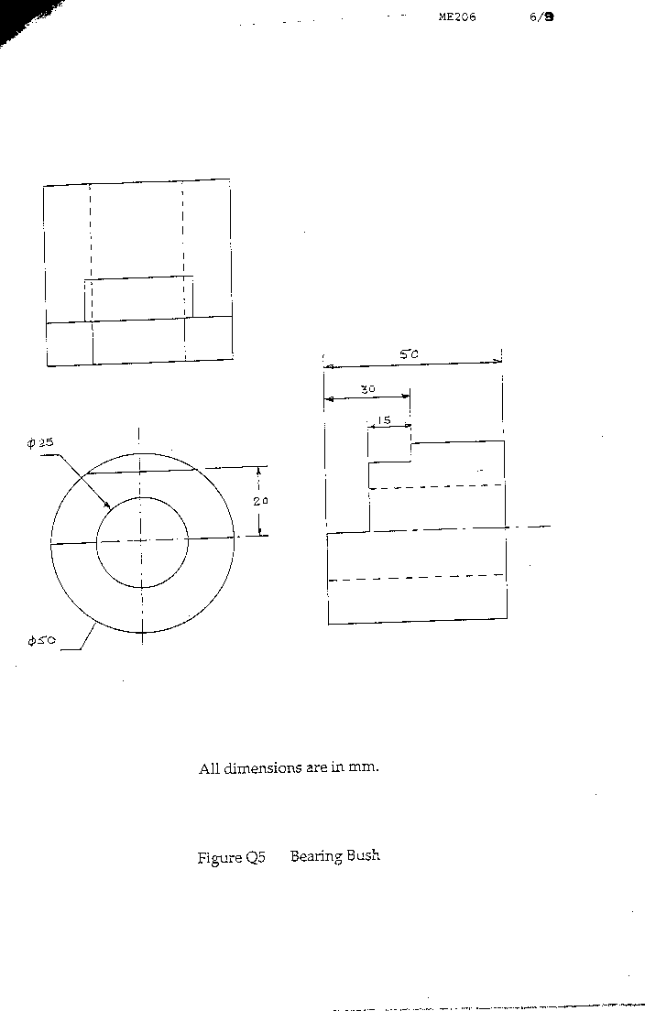
ME206 7/9

6. (a) Draw the Merchant's circle of cutting forces and clearly label the forces and the angles. (4)

(b) When turning a bar on a lathe at a speed of 170 m/min,
tangential force of 1120 N, axial force of 960 N, rake angle of 10°, shear plane angle was found to be 21°. Determine by graphical means or by calculations,

(i) the velocity of shearing along the shear plane and the velocity of sliding at the chip-tool interface (6)

(ii) the work done per minute in shearing the metal and against friction. (10)

7. (a) With the aid of sketches explain the difference between
orthogonal and oblique cutting. (4)

(b) With the aid of sketches discuss the mechanism of the three types of chip formation in the turning process. Explain the factors that promote such a chip formation. (14)

(c) Why are continuous chips not always desirable? (2)

ME206 8/9

8. (a) List five factors that should be considered when designing components for ease of automatic assembly. (10)

(b) You are a manufacturing manager in the assembly shop. Figure Q8 shows five components that are currently used in manual assembly by the company. It wishes to change over to fully automatic assembly. Write to the chief designer requesting any non-functional changes to these components you require, to make the fully automated assembling of these products easier. Explain the reasons for you requests and sketches of suggested modifications. (10)
