ME 205 1/9

DEPARTMENT OF MECHANICAL & MANUFACTURING ENGINEERING

MODULAR HONOURS DEGREE COURSE

LEVEL 2

SEMESTER 2

1997/98

DYNAMICS AND CONTROL

Examiners: Dr D Pearce/Dr C Hogg

Attempt FIVE questions only; Time allowed: 3 hours
at least one from Section A.

All questions carry equal marks. Total number of questions = 8

The figures in brackets indicate the relative weightings of parts of a question.

The following charts, tables and other special requirements are supplied:

Graph paper
4 cycle log/linear paper
Table of Laplace transforms
Mathematical Formulae (B & C)

ME 205 2/9

SECTION A

1. Part of a mechanism consisting of a slotted link and block is shown in figure Q1. The block is constrained to move in the x direction and has a constant velocity of 10 m $s^{−1}$ to the left. The block is connected to the link via the pin A. The link is pivoted at O and is free to slide relative to the pin A.

In the position shown with $q$ = 60°, determine:

(a) the angular velocity of the link (8)

(b) the relative sliding velocity between the link and pin A (7)

(c) the angular acceleration of the link (5)

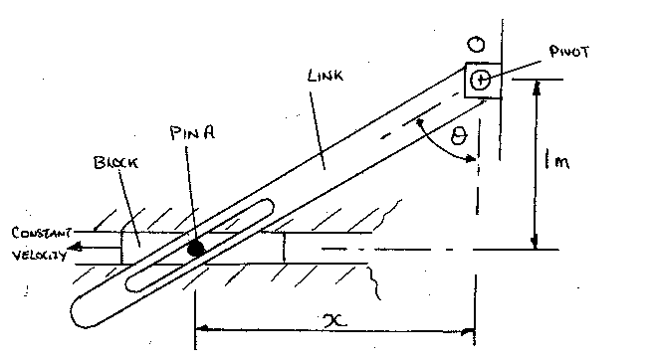

Figure Q1

ME 205 3/9

2. A mechanism shown in figure Q2 consists of a solid disc freely attached to a uniform rod, AB, which in turn is pivoted at B with a collar. The collar is constrained to move in a vertical direction and is attached to a spring which has a free unstrained length extending 2.5 m above the ground. The system is initially at rest in the position shown and it may be assumed that the disc can roll without slipping. Using the data provided below and following the release of the mechanism determine:

(a) the angular velocity of the rod AB when it reaches the horizontal position. (12)

(b) the maximum compression of the spring (8)

Data

Mass of rod = 5 kg
Mass of disc = 10 kg
Mass of collar = 3 kg
Spring stiffness = 500 N $m^{−1}$

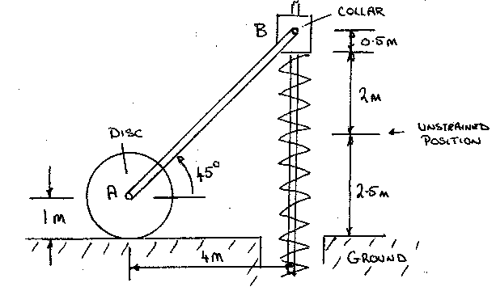

Figure Q2

ME 205 4/9

3. In a electrical suppliers catalogue a d.c. motor is described as having a planetary gearbox as part of the motor output drive, as shown in figure Q3. In the specification the electric motor is described as having a output torque of 100 x ${\text{10}}^{−3}$ Nm applied to the gearbox carrier. Using the data below, determine the maximum inertia load that can be connected to the output shaft, or sun gear, to provide the load with an acceleration of 50 rad $s^{−2}$. (20)

Data

 | Pitch Circle  Diameter  (mm) | Mass  (kg) | Moment of  Inertia  (kg mm${}^{2}$) | Technical  Description
Sun gear | 20 | 1 x ${\text{10}}^{−2}$ | 100 | Output shaft
Carrier | ? | 5 x ${\text{10}}^{−2}$ | 50 | Connected to  motor armature
Planet gear | 5 | 2 x ${\text{10}}^{−3}$ | 20 | Three gear wheels
Annulus | ? | 1 x ${\text{10}}^{−1}$ | 500 | Part of gearbox  housing and  connected to the  motor body

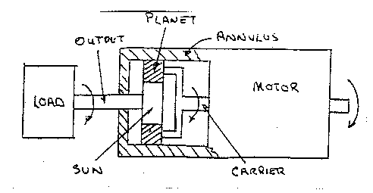

Figure Q3

ME 205 5/9

SECTION B

4. (a) The schematic diagrams shown in figure Q4(a) represent two separate mechanical systems where the input u${}_{\left(t\right)}$ and output y${}_{\left(t\right)}$ are displacements.

Determine in each case the transfer functions $\frac{Y_{\left(s\right)}}{U_{\left(s\right)}}$. (12)

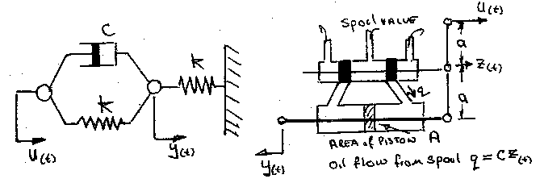

Spring/dashpot system Spool valve and hydraulic cylinder

Figure Q4(a)

(b) The block diagrams for two closed-loop control systems are shown in
figure Q4(b). For each system determine the expected steady state error resulting from a unit step input demand. (8)
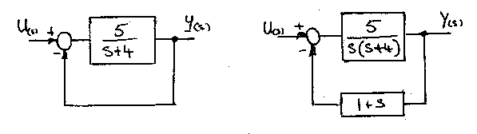
Figure Q4(b)

ME 205 6/9

5. The figure Q5 shows a moving gantry and suspension system for supporting a model boat whilst under test in a water tank. The time response from a step input excition to this spring, mass and damper system is also shown in figure Q5.

(a) Determine from the time response:

(i) the damped natural frequency (4)
(ii) the damping ratio z (4)
(iii) the characteristic equation for the system (4)

(b) The damped natural frequency of the system can be adjusted by
changing the length of the spring and hence its stiffness. If the
damped natural frequency is required to be 5 rad $s^{−1}$, find the value
for the spring stiffness, k, if the system mass is 10 kg and the damping coefficient is 20 Ns $m^{−1}$. (8)

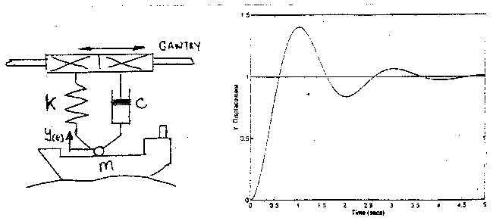

Figure Q5

ME 205 7/9

6. One element from an aircraft flight control unit has been analysed using an open-loop frequency response test. The results from this test are provided in table Q6.

(a) Draw the open-loop Bode diagram for this control system. (8)

(b) Assuming the control system has unity feedback, determine from the Bode diagram:

(i) the control system phase and gain margins (4)
(ii) the open-loop and closed-loop transfer functions (5)
(iii) the change in the forward path gain to give the system a phase margin of 90°. (3)

Table Q6

w (rads-1) | 0.2 | 0.5 | 1.0 | 3.0 | 6.0 | 10 | 30 | 50 | 100 | 300
Gain (dB) | 20 | 20 | 20 | 0 | -12 | -20 | -40 | -45 | -50 | -60
Phase (degree) | -23° | -53° | -90° | -137° | -150° | -150° | -131° | -119° | -106° | -96°

ME 205 8/9

7. The speed control of an electric vehicle is achieved with the use of a d.c. motor, tacho-generator and suitable power amplifier. A schematic of this system is shown in figure Q7, where the output load on the electric motor consists of an equivalent inertia and viscous drag. Using the data which is provided below, determine:

(a) the block diagram for this system (6)

(b) the open-loop and closed-loop transfer functions (6)

(c) an estimate for the systems closed-loop transient settling time (3)

(d) the steady state error following a unit step input demand (3)

(e) a method for reducing the steady state error (2)

Data

Equivalent inertia Im = 100 kg $m^{2}$
Viscous drag coefficient C = 20 Nms ${\text{rad}}^{−1}$
Input command potentiometer coefficient KP = 0.1 Vs ${\text{rad}}^{−1}$
Tacho feedback coefficient KT= 0.1 Vs ${\text{rad}}^{−1}$
Amplifier and motor gain, K, relating the motor output torque with the input voltage, Ve, is K = 100 Nm $V^{−1}$.

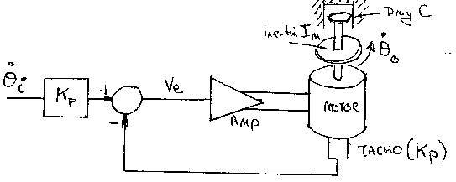

Figure Q7

ME 205 9/9

8. The open-loop transfer function of a hydraulic actuator is given as $F_{\left(s\right)}=\frac{K}{\left(s+3\right)\left(s^{2}+\text{12}s+\text{40}\right)}$

(a) Assuming that the control loop has unity feedback sketch the
root-locus for this system (6)

(b) Using the root-locus determine:

(i) the value of gain K to give closed-loop poles at s = - 2 ± j5.2 (5)
(ii) the value of gain K at which the system would become unstable (5)
(iii) a sketch of the output time response to a unit step input command when the closed-loop poles are s = - 2 ± j5.2 (4)

