ME 202 1/5

UNIVERSITY OF BRIGHTON

DEPARTMENT OF MECHANICAL & MANUFACTURING ENGINEERING

MODULAR HONOURS DEGREE COURSE

LEVEL 2

SEMESTER 2

1997/98

MATERIALS ENGINEERING

CHIEF EXAMINER: DR J RHODES/DR M PHILIP

Attempt FIVE questions only. Time allowed: 3 hours.
Number of questions = 8.
No more than THREE from either
section A or section B.

All questions carry equal marks.

The figures in the right hand margin indicate the relative weighting of parts of a question.

The following is provided:
Graph paper.

ME 202 2/5

SECTION A

1. A vertical force P is applied at a point A of the machine component shown, in figure Q1. If the yield strength of the material from which the component is made is 200 MPa, what, according to the "Maximum Shear Strain Energy Criterion", would be the value of P beyond which failure would occur at point H?
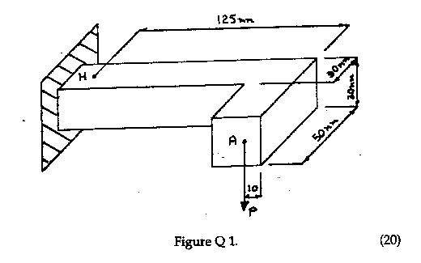

2. For the beam shown fig Q2 determine the reactions at A and B and the end moments caused by the ends being encastre'.

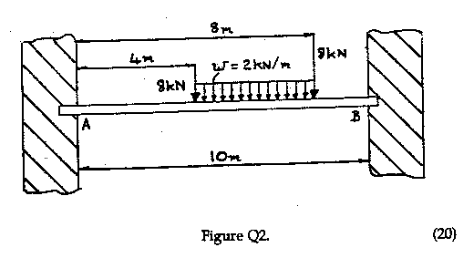

ME 202 3/5

3. For the uniform rod with circular form radius 2m and anguler length radians shown in figure Q3 and using Castigliano's theorem determine the horizontal deflection caused by a vertical load of 10kN. Take EI to be 400 MNm2.
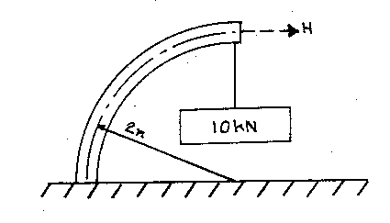

Figure Q3. (20)

4. A closed cylinder of external diameter 400 mm and internal diameter 300 mm
is subject to an external pressure of 40 MPa and the condition that the increase
in external diameter caused by the internal pressure P should not exceed 100 mm. Given that E and n for the material are 200 GPa and 0.29 respectively, determine
the value of P. (20)

ME 202 4/5

SECTION B

5. Briefly discuss three of the following topics in the context of polymeric materials:-

(a) Condensation polymerisation and its products
(b) Molecular weight distribution and its assessment
(c) Stereoregularity and its effect on the crystallisation and
mechanical properties of thermoplastics
(d) The glass transition temperature in thermoplastics.
(20)

6. Syndiotactic polypropylene is a semicrystalline polymer with the following properties:-

Density = 905 kg/m3
Glass transition temperature, TG = - 10 oC
Maximum operating temperature, TOp = 105 oC
Physical properties at T = 21 oC :-
Tensile strength = 33 MN/m2
Flexural modulus = 1.5 GN/m2
Elongation at break = 150 %

Sketch and describe the load / extension characteristics of such a polymer at T = 21 oC when subjected to a tensile test at a relatively low strain-rate.
(12)

How is this behaviour changed if the test is repeated at a higher strain- rate while keeping the temperature constant? (4)

State two examples of products manufactured from polypropylene, giving reasons for the choice of material. (4)

ME 202 5/5

7. (a) Discuss the advantages and disadvantages of the following when used in fibre form in fibre reinforced composites giving one example in each case:-
(i) E-glass and S-Glass
(ii) Carbon
(iii) Kevlar (12)

(b) The thermoplastic polymide (Nylon) 6,6 is to be reinforced with 40% by volume of unidirectional carbon fibres in the manufacture of a component. The properties of the individual materials are given below:-
Material Density Tensile Strength Young's Modulus
(kg/m3) (MN/m2) (GN/m2)
Nylon 6,6 1400 35 2.5
Carbon fibre 1800 2100 400.0

Calculate the Young's modulus and strength of the composite along the fibre direction and the fraction of the applied force which will be taken by the fibres. (8)

8. (a) Describe the essential features of the standard linear solid model when used to describe the behaviour of linear viscoelastic materials indicating its limitations. (14)

(b) A viscoelastic polymer obeying the Boltzmann superposition principle is subjected to the following load cycle. At time, t = 0, a tensile stress of 10 MNm-2 is applied and maintained for 100 s. The stress is then removed instantaneously. If the creep compliance is given by,

J (t) = Jo [ 1 - e-t/t]

where Jo = 2 m2GN-1 and = 200 s, what is the net creep strain after 200 s?. (6)

