ME 106 1/5

DEPARTMENT OF MECHANICAL & MANUFACTURING ENGINEERING

MODULAR HONOURS DEGREE COURSE

LEVEL 1

SEMESTER 2

1997/98

PROCESSING OF MATERIALS

Examiners: Mr R Morris/Dr D Koshal

Attempt FIVE questions only. Time allowed: 3 hours

Total number of questions = 8

All questions carry equal marks.
The figures in brackets indicate the relative weightings
of parts of a question.

ME 106 2/5

1. (a) For each of the following machining operations state whether they are classified as forming or generating or a mixture of both:

(i) milling a keyway using an end mill cutter

(ii) drilling a hole using a twist drill

(iii) finish shaping a flat surface using a broad tool

(iv) face milling a flat surface (4)

(b) With the aid of sketches describe the following types of milling

(i) up cut milling

(ii) down cut milling (4)

QUESTION 1 CONTINUES OVER THE PAGE

ME 106 3/5

(c) For each of the following batch sizes, describe a suitable process to manufacture the cylindrical part shown in figure Q1 from 40 mm dia mild steel bar:

(i) a batch of 4

(ii) a batch of 40

(iii) a batch of 4000 (12)

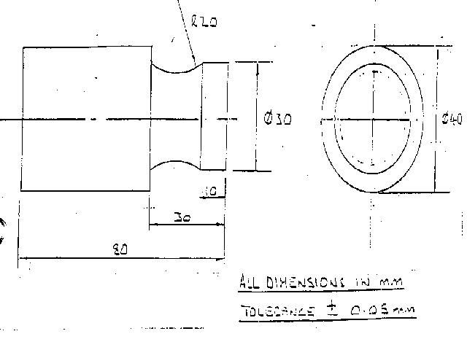
Figure Q1

ME 106 4/5

2. A design requires casting aluminium or an aluminium alloy to form a
lightweight component that must have high strength and close
dimensional tolerances. Discuss this problem from the point of view
of material selection and process specification and suggest a suitable
material and process. (20)

3. (a) Identify the forming process issues in creating the bearing race
housing from the blank billet as shown in figure Q3. (10)

(b) With the aid of diagrams suggest the stages that might be taken to manufacture the bearing race housing. (10)
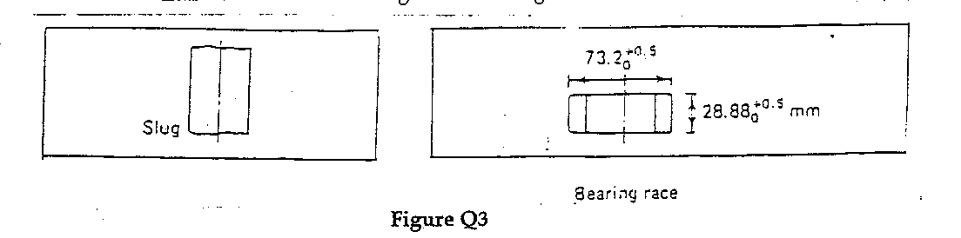

4. Using the information for electrical discharge machining, calculate the metal removal rate and the electrode feed rate iron is electrochemicaly machined in 100% efficient sodium chloride solution.

specific resistance is 6 ohm/cm
supply voltage is 18 V DC
current is 4500 amps
tool work gap is 0.5 mm
Iron atomic number is 56
valency is 2
density is 7.87 x 10-6 g/m3

Specific metal removal rate = (1/96500) x N/n x 1/d x y m3/amp/sec

Current density = E/(Ps x h) amp/m2 (20)

ME 106 5/5

5. Discuss the relative merits of spot welding and adhesive bonding for the production of lap joints in thin gauge sheet assemblies. What
considerations should be taken into account when designing these types
of joint? (20)

6. A titanium alloy turbine blade is approximately 100 mm long and 25 mm wide. The blade is tapered and twisted and the profile changes continuously from root to tip. Assuming that the root can be ignored, compare the respective merits and disadvantages of finish machining the blade by conventional cutting methods or by electro discharge machining.
(20)

7. Outline the design, manufacturing and cost criteria that need to be
considered when using CFRP instead of titanium alloy in the manufacture
of the turbine blade described in question 6. (20)

8. Simultaneous, integrated or concurrent engineering are terms used to describe a method or process of developing new products or components.

Describe in detail four aspects of concurrent engineering, explaining why
each is important and using examples to demonstrate your arguments. (20)

