ME102 1/6

DEPARTMENT OF MECHANICAL & MANUFACTURING ENGINEERING

MODULAR HONOURS DEGREE COURSE

LEVEL 1

SEMESTER 2

1997/98

MATERIALS ENGINEERING

Examiners: Dr M Philip/Dr J Rhodes

Attempt FIVE questions only. Time allowed: 3 hours

Not more than 3 from either Total number of questions = 8
Section A or B.

All questions carry equal marks.

The figures in brackets indicate the relative weightings of parts of a question.

The following are supplied:

Graph paper
Thermal equilibrium diagram for iron - carbon system
Thermal equilibrium system for aluminium - copper system
Thermal equilibrium system for iron - chromium system
Thermal equilibrium system for iron - chromium - nickel system
Periodic table

PLEASE USE SEPARATE ANSWER BOOKS FOR SECTION A AND SECTION B

ME102 2/6

SECTION A

1. (a) Using the Periodic Table, give one example of an element or combination of elements where each of the following bonding mechanisms take place. In each case use the example to explain how the mechanism works.

(i) Covalent

(ii) Ionic

(iii) Metallic

(iv) Hydrogen (14)

(b) With the aid of sketches, describe the following unit cells that occur in crystalline materials.

(i) Body-centred cubic

(ii) Face-centred cubic

(iii) Close packed hexagonal (6)

ME102 3/6

2. (a) Describe the process of normalising when applied to a steel. (4)

(b) A medium carbon steel component containing 0.6% carbon is subjected to normalising. Describe the microstructures that are formed as the component is cooled from 840oC to 21oC. (6)

(c) Describe how the microstructures seen in (b) would change if the component had been fully annealed. (4)

(d) Explain how stresses are developed during the quenching process and how they can be removed. (6)

3. (a) In terms of crystal structure, explain what is meant by the terms,

(i) dendritic growth

(ii) slip plane

(iii) edge dislocation (6)

(b) Describe the mechanism by which work hardening takes place in a steel. (4)

(c) After coldworking, residual stresses may be relieved by annealing. Describe the three stages in the process of annealing a steel indicating the effect of temperature on the process. (10)

ME102 4/6

4. Briefly discuss the microstrucure, properties and applications of the following:

(a) flake graphite cast iron (5)

(b) heat treatable aluminium alloys (5)

(c) austenitic stainless steel (5)

(d) low carbon steel (5)

ME102 5/6

SECTION B

5. For the truss shown in Figure Q5, determine the horizontal deflection
caused by the 20 kN load, if the members have rectangular section 20 mm
wide by 100 mm deep. Take E to be 200 GPa. (20)

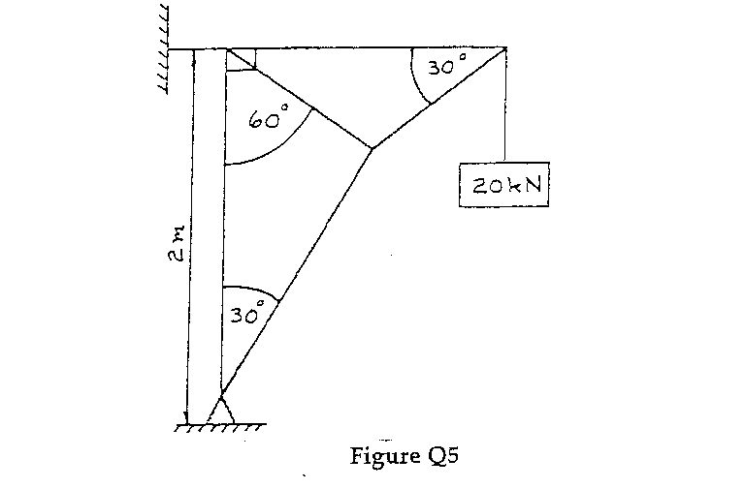

6. A steel rod area 600 mm2 and a coaxial copper tube of cross-sectional area 1000 mm2 are firmly attached at their ends to form a compound bar as illustrated in Figure Q6. Determine the stress in the steel and copper when the temperature of the bar is raised by 80° and an axial force of 60 kN is applied.

E for steel = 200 GPa and E for copper = 100 GPa
a for steel = 11 x 10-6/°C and a for copper = 16.5 x 10-6/°C (20)
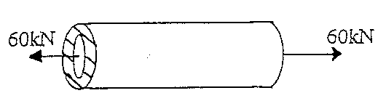

Figure Q6

ME102 6/6

7. For the beam illustrated in Figure Q7 locate the region where the maximum deflection will occur and write down the equations for the slope and deflection within it. (20)
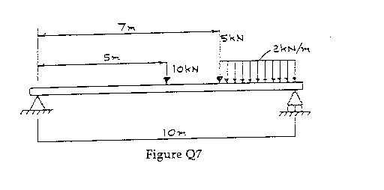
8. (a) What is meant by the following concepts?

(i) compatibility of equilibrium

(ii) compatibility and constituent equations (5)

(b) The illustration shown below, Figure Q8, shows four pulleys connected by a series of variable diameter shafts. In each case the shaft diameter is given together with the torque exerted on each pulley. Determine the shaft which bears the maximum torque and calculate the maximum shear stress. (15)

