YISHUN JUNIOR COLLEGE
Mathematics Department

SOLUTION

Examination : Preliminary Examination Date : 15/08/2008
Subject : JC2 H2 Mathematics Paper No. : 1

Q^{n} | Key Steps / Solution
1 | $y^{2}=x$ transforms to ${\left(y+4\right)}^{2}=2x+7$  $y=±\sqrt{x}$ transforms to $y=±\sqrt{2x+7}−4$  1.Scaling parallel to x axis by a factor of ½  2.Translation of 7/2 units to the left  3.Translation of 4 units downwards  OR  1.Translation of 7 units to the left.  2.Scaling parallel to the x axis by a factor of ½  3.Translation of 4 units downwards
2(i)  (ii)  (iii) | $y^{2}=f(x)$  x  y  O  B’(2, 0)  C’(–2, 0)  A’(0,  )  A’’(0,  )  $$y=f\left(\left|\frac{x}{2}\right|\right)$$  x  y  O  B’(4, 0)  B’’(– 4, 0)  A’(0,3)  $$y=f'(x)$$  y  x  B’(2, 0)  A’(0, 0)
3 | ${\left(1−x\right)}^{−2}=1+2x+3x^{2}+\text{.}\text{.}\text{.}+(n+1)x^{n}+\text{.}\text{.}\text{.}$ , $\left|x\right|<1$  Coefficient of $x^{n}=(n+1)$  $$\sum_{n=1}^{∞}{\frac{n}{2^{n}}}=\frac{1}{2}+\frac{2}{2^{2}}+\frac{3}{2^{3}}+\frac{4}{2^{4}}+\text{.}\text{.}\text{.}+\frac{n}{2^{n}}+\text{.}\text{.}\text{.}$$  $$=\frac{1}{2}\left(1+2\left(\frac{1}{2}\right)+3{\left(\frac{1}{2}\right)}^{2}+4{\left(\frac{1}{2}\right)}^{3}+\text{.}\text{.}\text{.}+n{\left(\frac{1}{2}\right)}^{n−1}+\text{.}\text{.}\text{.}\right)$$  $$=\frac{1}{2}{\left(1−\frac{1}{2}\right)}^{−2}=\frac{1}{2}{\left(\frac{1}{2}\right)}^{−2}=2$$
4(i)  (ii)  (iii) | $$\begin{aligned}y=\text{tan}\left(e^{x}−1\right) \\ \frac{\text{dy}}{\text{dx}}=e^{x}{\text{sec}}^{2}\left(e^{x}−1\right) =(1+{\text{tan}}^{2}(e^{x}−1))e^{x} =(1+y^{2})e^{x}\end{aligned}$$  $$\frac{d^{2}y}{{\text{dx}}^{2}}=(1+y^{2})e^{x}+2y\frac{\text{dy}}{\text{dx}}e^{x}=\frac{\text{dy}}{\text{dx}}+2y\frac{\text{dy}}{\text{dx}}e^{x} =\frac{\text{dy}}{\text{dx}}\left(1+2e^{x}y\right)$$  $$\begin{aligned}\frac{d^{3}y}{{\text{dx}}^{3}}=\frac{\text{dy}}{\text{dx}}(2e^{x}\frac{\text{dy}}{\text{dx}}+2e^{x}y)+\frac{d^{2}y}{{\text{dx}}^{2}}\left(1+2e^{x}y\right) \\ \end{aligned}$$  When x = 0, $y=0,\frac{\text{dy}}{\text{dx}}=1,\frac{d^{2}y}{{\text{dx}}^{2}}=1,\frac{d^{3}y}{{\text{dx}}^{3}}=3$  $$∴ y=f(x)=x+\frac{x^{2}}{2}+\frac{x^{3}}{2}+\text{.}\text{.}\text{.}$$  $$\begin{aligned} \frac{{\text{sec}}^{2}\left(e^{−x}−1\right)}{e^{x}}={\text{sec}}^{2}\left(e^{−x}−1\right)e^{−x}=f'(−x) \\ =1+(−x)+\frac{3}{2}(−x)^{2}+\text{.}\text{.}\text{.}\text{.} \\ =1−x+\frac{3}{2}x^{2}+\text{.}\text{.}\text{.}\end{aligned}$$
5(i)  (ii)  (iii) | $$\begin{aligned}A_{1}=2,A_{2}=2A_{1}=4, A_{3}=2(A_{1}+A_{2})=2(6)=\text{12}, \\ A_{4}=2(A_{1}+A_{2}+A_{3})=2(2+4+\text{12})=\text{36}\end{aligned}$$  For $n≥2$  $\begin{aligned}\frac{A_{n+1}}{A_{n}}=\frac{2(A_{1}+A_{2}+\text{.}\text{.}\text{.}+A_{n})}{A_{n}} \\ =\frac{2(A_{1}+A_{2}+\text{.}\text{.}\text{.}+A_{n−1})+2A_{n}}{A_{n}} \\ =\frac{A_{n}+2A_{n}}{A_{n}}=3=\text{const}\end{aligned}$  $∴A_{2},A_{3},\text{.}\text{.}\text{.},A_{n}$ form a GP with  first term = 4, common ratio = 3  $$\begin{aligned} A_{1}+A_{2}+\text{.}\text{.}\text{.}+A_{n} \\ A_{1}+S_{n−1} \\ A_{1}+\frac{4(3^{n−1}−1)}{3−1}=2+2\left(3^{n−1}−1\right)=2\left(3^{n−1}\right)\end{aligned}$$
6(i)  (ii)  (iii) | a = 2  $$\begin{aligned}y={\left(x−2\right)}^{2}−3 \\ (x−2)=±\sqrt{y+3}⇒ x=2±\sqrt{y+3}\end{aligned}$$  Since $x≤2, x=2−\sqrt{y+3}$  $$f^{−1}:x→2−\sqrt{x+3}, x≥−3$$  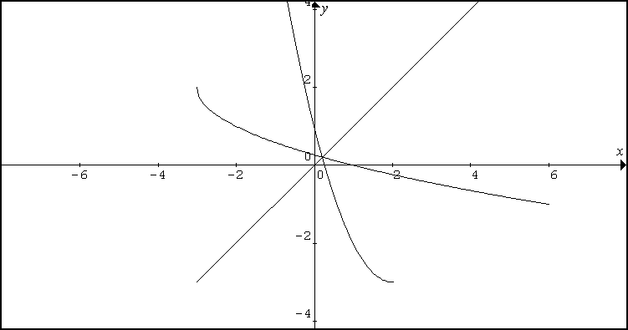  y=f⁻⁻¹(x)  y=f(x)  y=ff⁻⁻¹(x)  (−3,2)  (−3,−3)  (2,−3)  •  •  •  Solve $f^{−1}(x)=f\left(x\right)$  Since the 3 graphs intersect, solve $f(x)=x$  $$\begin{aligned}{\left(x−2\right)}^{2}−3=x⇒x^{2}−5x+1=0 \\ ⇒x=\frac{5±\sqrt{\text{21}}}{2}\end{aligned}$$  $$\text{Since }x≤2, x=\frac{5−\sqrt{\text{21}}}{2}$$  For h’ to be one to one,  $D_{h'}=(−∞,0]∪\left[\text{0,1}\right]$ ,  For gh’ to exist, $R_{h'}⊆D_{g}=[0,\frac{π}{2})$  Therefore, Possible $D_{h'}=(−\sqrt{\frac{π}{2}},−0]∪\left[\text{0,1}\right]$  For gh’ to gives max range, $D_{h'}=(−\sqrt{\frac{π}{2}},0]$  $\text{gh}(x)=g\left(x^{2}\right)=\text{cos}x^{2}, −\sqrt{\frac{π}{2}}<x≤0$
7  (a)  (b)  (i)  (ii) | $\begin{aligned}\int{\frac{x\text{ln}\left(4x^{2}+1\right)}{4x^{2}+1}\text{dx}} \\ \frac{1}{8}\int{\frac{8x\text{ln}\left(4x^{2}+1\right)}{4x^{2}+1}}\text{dx} \\ \frac{1}{8}\left[{\frac{\left(\text{ln}(4x^{2}+1)\right)}{2}}^{2}\right]+c=\frac{1}{\text{16}}{\left(\text{ln}\left(4x^{2}+1\right)\right)}^{2}+c\end{aligned}$  $$\text{Let }u=\sqrt{x}\text{.} \text{Then} \text{du}=\frac{1}{2}x^{\frac{−1}{2}}\text{dx}=\frac{1}{2u}\text{dx}$$  $$\text{When }x=4, u=2\text{.} \text{When }x=9, u=3$$  $$\begin{aligned}\int{\frac{\sqrt{x}}{x−1}}\text{dx}=\int{\frac{2u^{2}}{u^{2}−1}}\text{du} \\ \int{2+\frac{2}{u^{2}−1}}\text{du} \\ {\left[2u+\text{ln}\left|\frac{u−1}{u+1}\right|\right]}_{2}^{3} \\ \left(6+\text{ln}\frac{2}{4}\right)−\left(4+\text{ln}\frac{1}{3}\right)=2+\text{ln}\frac{3}{2} (\text{shown}) \end{aligned}$$  $$\begin{aligned}\int{\frac{\text{ln}(x−1)}{\sqrt{x}}}\text{dx}=\int{x^{\frac{−1}{2}}\text{ln}(x−1)}\text{dx} \\ {\left[2x^{\frac{1}{2}}\text{ln}(x−1)\right]}_{4}^{9}−\int{\frac{2x^{\frac{1}{2}}}{x−1}}\text{dx} \\ (6\text{ln}8−4\text{ln}3)−2\left(2+\text{ln}\frac{3}{2}\right) \\ \text{18}\text{ln}2−4\text{ln}3−2\text{ln}3+2\text{ln}2−4 \\ \text{20}\text{ln}2−6\text{ln}3−4\end{aligned}$$
8  (i)  (ii)  (iii) | $$y=\frac{x^{2}+\text{kx}+1}{2x+3}$$  $$\begin{aligned}2x+3\frac{\frac{x}{2}+\left(\frac{k−\frac{3}{2}}{2}\right)}{|x^{2}+\text{kx}+1} \\ x^{2}+\frac{3}{2}x \\ \text{ _________} \\ (k−\frac{3}{2})x+1 \\ (k−\frac{3}{2})x+\frac{3}{2}(k−\frac{3}{2}) \\ \text{ ______________} \\ \text{.}\text{.}\text{.}\text{.}\text{.}\text{.}\text{.}\text{.}\text{.}\text{.} \end{aligned}$$  Vertical asymptote : $x=−\frac{3}{2}$  Oblique asymptote : $y=\frac{x}{2}+\frac{k}{2}−\frac{3}{4}$  If x-axis is tangent to C,  $⇒\frac{\text{dy}}{\text{dx}}=0$ and when $y=0, x^{2}+\text{kx}+1=0$.  $$\begin{aligned}\frac{\text{dy}}{\text{dx}}=\frac{\left(2x+3\right)\left(2x+k\right)−(x^{2}+\text{kx}+1)(2)}{(2x+3)^{2}}=0 \\ ⇒2x+k=0 \\ ⇒x=\frac{−k}{2}\end{aligned}$$  $$\begin{aligned}\text{When }x=\frac{−k}{2}, \frac{k^{2}}{4}−\frac{k^{2}}{2}+1=0 \\ \frac{−k^{2}}{4}=−1 \\ k^{2}=4 \\ k=2 (\text{Since }k>0) \end{aligned}$$  Alternative Solution :  When y = 0, $x^{2}+\text{kx}+1=0$  Since x-axis is a tangent to C, $∴b^{2}−4\text{ac}=0$  $k^{2}−4=0$  $k=±2$ (reject k = –2 because k is a positive constant)  If k = 3, $y=\frac{x^{2}+3x+1}{2x+3}$  Vertical asymptote : $x=−\frac{3}{2}$  Oblique asymptote : $y=\frac{x}{2}+\frac{3}{2}−\frac{3}{4}=\frac{x}{2}+\frac{3}{4}$  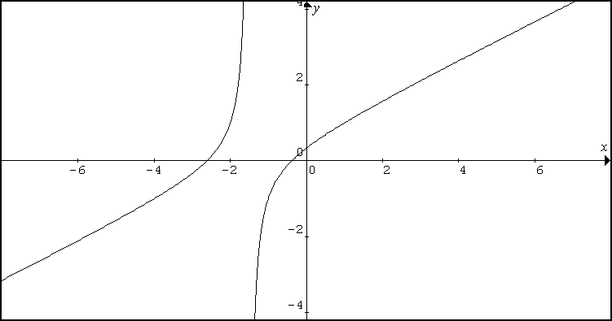  x=−1.5  0.75  −0.383  −2.62  $$\left|x^{2}+3x+1\right|>2\left|2x+3\right| ⇒ \left|\frac{x^{2}+3x+1}{2x+3}\right|>2$$  Hence,  $\frac{x^{2}+3x+1}{2x+3}>2$ or $\frac{x^{2}+3x+1}{2x+3}<−2$  Draw the graphs of $y=2$ and $y=−2$ together with the graph of $y=\frac{x^{2}+3x+1}{2x+3}$.  Using GC,  For $\left|\frac{x^{2}+3x+1}{2x+3}\right|>2$,  $$\begin{aligned}x<−5\text{.}\text{79}\text{ or }−1\text{.}\text{79}<x<−\frac{3}{2}\text{ or }−\frac{3}{2}<x<−1\text{.}\text{21} \\ \text{or }x>2\text{.}\text{79}\end{aligned}$$  Alternatively,  Draw the graphs of $y=\left|\frac{x^{2}+3x+1}{2x+3}\right|$ and y = 2,  x= −1.5  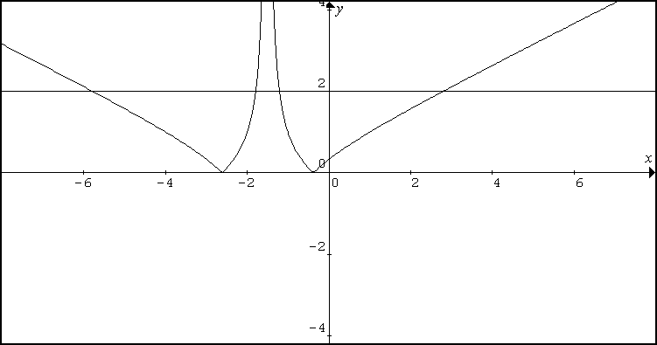  Using GC,  For $\left|\frac{x^{2}+3x+1}{2x+3}\right|>2$,  $$\begin{aligned}x<−5\text{.}\text{79}\text{ or }−1\text{.}\text{79}<x<−1\text{.}5\text{ or }−1\text{.}5<x<−1\text{.}\text{21} \\ \text{or }x>2\text{.}\text{79}\end{aligned}$$
9(i)  (ii)  (iii)  (iv) | If A , B, C are collinear,  $\begin{aligned}\overset{→}{\text{AB}}=k\overset{→}{\text{BC}} \\ \overset{→}{\text{OB}−}\overset{→}{\text{OA}}=k\left(\overset{→}{\text{OC}−}\overset{→}{\text{OB}}\right) \\ \left(\begin{matrix}−9 \\ −6 \\ −6\end{matrix}\right)=k\left(\begin{matrix}−6 \\ −4 \\ p+5\end{matrix}\right) \\ ⇒k=\frac{3}{2}, −6=\frac{3}{2}(p+5) \\ p=−9\end{aligned}$  If p is a variable, $\overset{→}{\text{OC}}=\left(\begin{matrix}−3 \\ −2 \\ p\end{matrix}\right)$ will be moving in the direction // to the z – axis,  Hence, $L_{1}:r=\left(\begin{matrix}−3 \\ −2 \\ 0\end{matrix}\right)+λ\left(\begin{matrix}0 \\ 0 \\ 1\end{matrix}\right)\text{ , }λ∈ℜ$  $$L_{2}:\frac{x+4}{2}=−y+2=z−1⇒\frac{x+4}{2}=\frac{y−2}{−1}=z−1$$  $$L_{2}:r=\left(\begin{matrix}−4 \\ 2 \\ 1\end{matrix}\right)+μ\left(\begin{matrix}2 \\ −1 \\ 1\end{matrix}\right)\text{ , }μ∈ℜ$$  Let $θ$ be the acute angle between $L_{1}$ and $L_{2}$  $$\begin{aligned}\text{cos}θ=\frac{\left|\left(\begin{matrix}2 \\ −1 \\ 1\end{matrix}\right)⋅\left(\begin{matrix}0 \\ 0 \\ 1\end{matrix}\right)\right|}{\sqrt{6}\sqrt{1}} \\ \text{cos}θ=\frac{1}{\sqrt{6}}⇒θ=\text{65}\text{.}9^{∘}\end{aligned}$$  Perpendicular distance from A to the line $L_{2}$  $$\begin{aligned}=\frac{\left|\left[\left(\begin{matrix}\text{12} \\ 8 \\ 1\end{matrix}\right)−\left(\begin{matrix}−4 \\ 2 \\ 1\end{matrix}\right)\right]×\left(\begin{matrix}2 \\ −1 \\ 1\end{matrix}\right)\right|}{\sqrt{2^{2}+1^{2}+1^{2}}} \\ \frac{\left|\left(\begin{matrix}\text{16} \\ 6 \\ 0\end{matrix}\right)×\left(\begin{matrix}2 \\ −1 \\ 1\end{matrix}\right)\right|}{\sqrt{6}}=\frac{\left(\begin{matrix}6 \\ −\text{16} \\ −\text{28}\end{matrix}\right)}{\sqrt{6}}=\frac{\sqrt{\text{1076}}}{\sqrt{6}}=\sqrt{\frac{\text{538}}{3}}\end{aligned}$$
10  (i)  (ii) | 1  R  $$\frac{1}{\sqrt{2}}$$  x  $$\frac{π}{2}$$  0  $$π$$  Area R =$\frac{π}{2}−\int{\frac{1}{\sqrt{1+\text{cos}x}}}\text{dx}$ or $\int{{\text{cos}}^{−1}\left(\frac{1}{y^{2}}−1\right)\text{dy}}$  =$\frac{π}{2}−1\text{.}\text{24645048}$ = 0.324 (using GC)  Volume generated  $\begin{aligned}=π\left(1^{2}\right)\left(\frac{π}{2}\right)−π\int{\frac{1}{1+\text{cos}x}}\text{dx} \\ \frac{π^{2}}{2}−π\int{\frac{1}{1+2{\text{cos}}^{2}\left(\frac{x}{2}\right)−1}}\text{dx} \\ \frac{π^{2}}{2}−π\int{\frac{1}{2}{\text{sec}}^{2}}\left(\frac{x}{2}\right)\text{dx} \\ \frac{π^{2}}{2}−\frac{2π}{2}{\left[\text{tan}\left(\frac{x}{2}\right)\right]}_{0}^{\frac{π}{2}}=\frac{π^{2}}{2}−π(1)=π\left(\frac{π}{2}−1\right)\end{aligned}$
11  (i)  (ii)  (iii) | when $n→∞$, $x_{n}→l$,$x_{n+1}→l$  $\begin{aligned}l=\frac{1}{2}\left(l+\frac{a}{l}\right) \\ 2l^{2}=l^{2}+a \\ l^{2}=a \\ l=±\sqrt{a} \\ l=\sqrt{a}, (\text{Since }x_{n}>0)\end{aligned}$  Since $x_{1}=a>0$, and $∀n≥2$,  $$\begin{aligned}x_{n}=\frac{1}{2}\left(x_{n−1}+\frac{a}{x_{n−1}}\right) \\ =\frac{1}{2}\left({\left(\sqrt{x_{n−1}}\right)}^{2}+{\left(\sqrt{\frac{a}{x_{n−1}}}\right)}^{2}\right) \\ ≥\left(\sqrt{\left(x_{n−1}\right)\left(\frac{a}{x_{n−1}}\right)}\right)=\sqrt{a}\end{aligned}$$  $$\begin{aligned}x_{n+1}−x_{n}=\frac{1}{2}\left(x+\frac{a}{x_{n}}\right)−x_{n} \\ =\frac{1}{2}\left(\frac{x_{n^{2}}+a−2x_{n^{2}}}{x_{n}}\right) \\ =\frac{1}{2}\left(\frac{a−x_{n^{2}}}{x_{n}}\right)≤0,(\text{Since }x_{n}≥\sqrt{a}⇒a−x_{n^{2}}≤0) \\ ⇒x_{n}≥x_{n+1}\end{aligned}$$  Alternative solution :  Consider the graph of $f(x)=\frac{1}{2}\left(x+\frac{a}{x}\right)$  x  y  $$\begin{aligned}\frac{\text{dy}}{\text{dx}}=\frac{1}{2}\left(1−\frac{a}{x^{2}}\right)=0 \\ ⇒x=±\sqrt{a}\end{aligned}$$  When $x=\sqrt{a}$,  $y=\frac{1}{2}\left(\sqrt{a}+\frac{a}{\sqrt{a}}\right)=\sqrt{a}$  Since $x_{1}>0$, we observe from the graph that $x_{2}=f\left(x_{1}\right)≥\sqrt{a}$, $x_{3}=f\left(x_{2}\right)≥\sqrt{a}$. In fact, $x_{n}≥\sqrt{a}$ for $n≥2$ (shown)
12  (a)  (b) | $$3{\text{xy}}^{2}\frac{\text{dy}}{\text{dx}}+y^{3}−2x=0$$  Let $u={\text{xy}}^{3}$.  $\frac{\text{du}}{\text{dx}}=y^{3}+3y^{2}x\frac{\text{dy}}{\text{dx}}$ --- (*)  Substitute (*) into the DE, we get  $$\begin{aligned}\frac{\text{du}}{\text{dx}}−2x=0 \\ \frac{\text{du}}{\text{dx}}=2x \\ u=x^{2}+c ⇒ {\text{xy}}^{3}=x^{2}+c ⇒ y^{3}=\frac{x^{2}+c}{x} ⇒ y={\left(x+\frac{c}{x}\right)}^{\frac{1}{3}}\end{aligned}$$  When c = 0, $y=x^{\frac{1}{3}}$ c = 1, $y={\left(x+\frac{1}{x}\right)}^{\frac{1}{3}}$ c = −1, $y={\left(x−\frac{1}{x}\right)}^{\frac{1}{3}}$  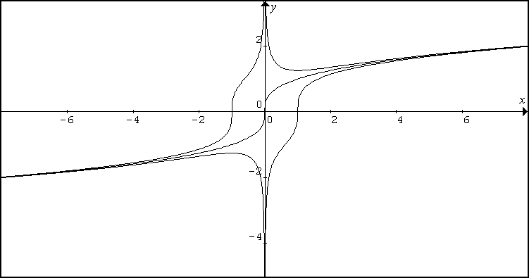  C = −1  C = 0  C =1  $$\frac{\text{dx}}{\text{dt}}=\text{kx}−0\text{.}3$$  When t = 0, $\frac{\text{dx}}{\text{dt}}=−0\text{.}1, x=5$  $\begin{aligned}−0\text{.}1=5k−0\text{.}3 \\ k=0\text{.}\text{04} \\ ∴\frac{\text{dx}}{\text{dt}}=0\text{.}\text{04}x−0\text{.}3 (\text{shown}) \\ \int{\frac{\text{dx}}{0\text{.}\text{04}x−0\text{.}3}}=\int{\text{dt}} \\ \text{25}\text{ln}\left|0\text{.}\text{04}x−0\text{.}3\right|=t+c \\ 0\text{.}\text{04}x−0\text{.}3={\text{Ae}}^{\frac{t}{\text{25}}} \\ x={\text{Be}}^{\frac{t}{\text{25}}}+7\text{.}5\end{aligned}$  When t = 0, x = 5, $5=B+7\text{.}5$  B = −2.5  $∴ x=−2\text{.}5e^{\frac{t}{\text{25}}}+7\text{.}5$  t  x  27.5  5  Since the curve $∴ x=−2\text{.}5e^{\frac{t}{\text{25}}}+7\text{.}5$ cut the t-axis  $⇒$ x = 0. It is possible that for the insects to be extinct in the experimental environment.  The duration is 27.5 days.
13  (a)  (b) | $z=1−\sqrt{3}i$  $$\begin{aligned}\text{arg}(z^{2}+\text{bz})=\text{arg}(z\left(z+b)\right)=\frac{−5π}{6} \\ \text{arg}z+\text{arg}(z+b)=\frac{−5π}{6} \\ \frac{−π}{3}+\text{arg}(z+b)=\frac{−5π}{6} \\ \text{arg}(b+1−\sqrt{3}i)=\frac{−π}{2} \\ ⇒b+1=0 \\ b=−1 \\ \end{aligned}$$  $$\begin{aligned}z^{n}=(z+i)^{n}⇒{\left(\frac{z+i}{z}\right)}^{n}=1 \\ ⇒{\left(1+\frac{i}{z}\right)}^{n}=e^{i\left(0+2kπ\right)} \\ ⇒1+\frac{i}{z}=e^{i\left(\frac{2kπ}{n}\right)} \\ ⇒\frac{i}{z}=e^{i\left(\frac{2kπ}{n}\right)}−1⇒z=\frac{i}{e^{i\left(\frac{2kπ}{n}\right)}−1} \\ \end{aligned}$$  $$\begin{aligned}z=\frac{i}{e^{i\left(\frac{2kπ}{n}\right)}−1} =\frac{{\text{ie}}^{\frac{−\text{ik}π}{n}}}{e^{\frac{\text{ik}π}{n}}−e^{\frac{−\text{ik}π}{n}}} \\ =\frac{i\left(\text{cos}\frac{kπ}{n}−i\text{sin}\frac{kπ}{n}\right)}{2i\text{sin}\frac{kπ}{n}} \\ =\frac{1}{2}\left(\text{cot}\frac{kπ}{n}−i\right), k=\text{1, 2, }\text{.}\text{.}\text{.}\text{.}\text{, }n−1\end{aligned}$$

