- Using the substitution $u=\sqrt{x}$, find $\int{ \frac{1}{\sqrt{x}} {\text{sin}}^{2}}\sqrt{x} dx$. [4]

- Old McDonald keeps hens, ducks, cats and pigs on his farm. One day, he counted a total of 53 heads and 186 legs for these animals. He also recorded the amount of food consumed and the waste produced by each animal on that particular day. The findings are recorded in the following table. (Assume each of the hens consumes the same amount of food and produces the same amount of waste. This assumption applies to the ducks, the cats and the pigs as well.)

 | Hen | Duck | Cat | Pig | Total
Amount of food consumed by each animal (kg) | 0.15 | 0.33 | 0.29 | ? | 21.89
Amount of waste produced by each animal (kg) | 0.034 | 0.076 | 0.087 | 0.12 | 4.543

He was unable to record the amount of food consumed by each pig as the pigs ate too quickly. Given that there are 10 hens on the farm, determine the amount of food consumed by each pig. [5]

- Find the set of values of x for which

$\frac{1}{2x−1}>1−5x$. [3]

Hence solve

$\frac{1}{2\text{ln}x−3}>6−5\text{ln}x$. [2]

- Use the method of mathematical induction to prove that $\sum_{r=1}^{2n}{r^{3}}=n^{2}(2n+1)^{2}$. [5]

- Express $\frac{1+x^{2}}{(1−x)(1+2x)}$in partial fractions. [3]

Hence, or otherwise, find the constant term in the expansion of $\frac{1+x^{2}}{−3x(1−x)(1+2x)}$ in ascending powers of x. [3]

- Sketch, on separate diagrams, the graph of ${\text{kx}}^{2}+y^{2}=4k$, where

- k = 4, [2]

- k < 0, [3]

making clear the main relevant features of each curve.

The graph in part (i) undergoes a single transformation (which is not a reflection) that leaves only the points on the x–axis unaffected. Give a possible description of the transformation. [1]

- The functions f and g are defined by

$\text{f:}x↦x+\frac{4}{x}, x∈$I , x > 0,
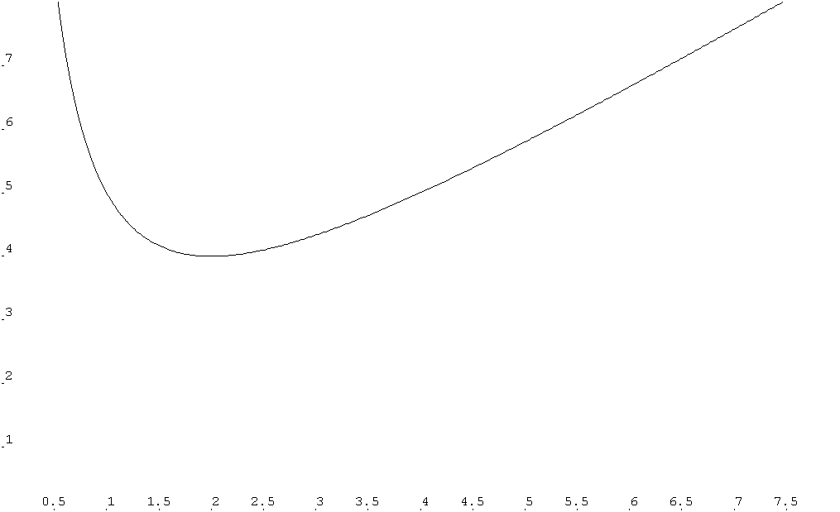
$\text{g:}x↦\text{tan} \left(\frac{x}{4}\right), x∈$I , $−π≤x<2π$.
x
y
0
y = x
(2, 4)
x = 0

The diagram shows a sketch of the graph of $y=f(x)$. The graph has a minimum point (2, 4) and the line y = x is an asymptote.

  - Give a reason why f does not have an inverse. The function f has an inverse if its domain is restricted to $0<x≤k$. State the largest value of k and find an expression for f ⁻¹(x) corresponding to this domain. [5]

  - State, giving a reason, whether fg exists. [2]

[Turn Over
- The sequence of real numbers u₁, u₂, u₃, … satisfies the recurrence relation

$$u_{n+1}=\frac{u_{n}(\text{10}−u_{n})(u_{n}+6)}{\text{40}}$$

for n ≥ 1.

- If u₁ = –1 and u_{n} → α as n → ∞, find the exact value of α. [3]

- Determine the behaviour of the sequence when u₁ = –11. [1]

- If u_{n} < α, show that u_{n+1} > u_{n}. [3]

- Shade on an Argand diagram the set of points representing all complex numbers z satisfying both of the following inequalities:

$−\frac{3π}{4}≤ \text{arg} \left(\frac{z−3}{2 i}\right) ≤0$ and $\left|z−3\right| ≤ 5$. [5]

Hence find the greatest and least possible values of , given that
$−\frac{3π}{4}≤ \text{arg} \left(\frac{z−3}{2 i}\right) ≤0$ and $\left|z−3\right| ≤ 5$. [3]

- A curve is defined by the parametric equations

, ,

where a is a non–zero constant. Show that the tangent to the curve at any point with parameter t has equation $\text{yt}=\frac{3}{4}x+\frac{3}{2}{\text{at}}^{2}$. [3]

Find the range of values of p such that the line l with equation intersects the curve at two distinct points. [3]

Given that l is a tangent to the curve, show that $4t^{2}+\text{st}+1=0$, where the values of s are to be determined. [2]

$$y=f (x)$$
y
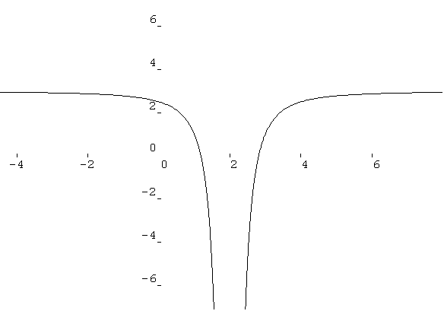

y = 3
2

x
0
1
3

x = 2

The diagram shows a sketch of the curve $y=f(x)$. The lines with equations x = 2 and y = 3 are asymptotes to the curve. The intersections of the curve with the x– and
y– axes have coordinates (1, 0), (3, 0) and (0, 2). On separate diagrams, sketch the graphs of

- $y^{2}=f(x)$, [2]

- $y=\frac{1}{f(x)}$, given that $\frac{1}{f(2)}=0$, [4]

- $y=f^{'}(x)$. [3]

Whenever appropriate, your sketch should indicate clearly the equations of any asymptotes, intercept(s) and the coordinates of turning point(s).

- Given that

$u_{1}+u_{2}+u_{3}+…+u_{n−1}+u_{n}=4^{2n+1}−4$,

prove that u_{n} = $\frac{\text{15}}{4}(4^{2n})$. [2]

- Find $u_{1}+u_{3}+u_{5}+…+u_{2n−3}+u_{2n−1}$, giving your answers in terms of n. [3]

- Show that ln(u₁) + ln(u₂) + ln(u₃) + …+ ln(u_{n}) = an² + bn, where the exact values of a and b are to be determined. [4]

[Turn over
- The planes $Π_{1}$and $Π_{2}$have vector equations

r.(2i + j – k) = 4, r = 2i + j – 2k + $θ_{1}$(–3i + 2j – 7k) + $φ_{1}$(i – j + 4k),

respectively, where $θ_{1}$ and $φ_{1}$ are real parameters. The point A has position vector $9i+2j−2k$.

- Find the coordinates of the foot of the perpendicular from A to $Π_{1}$. [3]

- $Π_{1}$ and $Π_{2}$ meet in a line l. Show that the vector equation of l may be expressed in the form r = (ai + bj + ck) + $λ$(2i – j + 3k), where $λ$ is a real parameter and a, b, c are constants to be determined. [4]

- The plane $Π_{3}$ has vector equation

r = i + j – k + $θ_{2}$(pi + j + k) + $φ_{2}$(–2i – j + k),

where $θ_{2}$ and $φ_{2}$ are real parameters and p is a constant. Given that $Π_{1}$, $Π_{2}$ and $Π_{3}$ meet in a line, find the value of p. [3]

- A curve C₁ has equation$y=f(x)$, x > – 4. The tangent to C₁ at the point (–2, ln16) is parallel to the x–axis. Given that for all points on C₁,

$\frac{d^{2}y}{{dx}^{2}}=\frac{1}{x+4}$,

show that the equation of C₁ is $y=(x+4)\text{ln}(x+4)+\text{mx}−2$ where the exact value of m is to be determined. [6]

- Sketch C₁, making clear its main relevant features. [2]

- A particle moves along C₁ such that x increases at a constant rate of 2 units s⁻¹. Find the rate of increase of y when x = 4, giving your answer in an exact form. [2]

- C₂ is obtained by reflecting C₁ in the line y = x. Write down the equation of C₂. [1].

