JC2 PRELIMINARY EXAMINATION 2008
Paper 1 Solution

1 | Let the number of days the traveller spent in Germany, France and Spain be x, y, z respectively.  30 x + 20 y + 20 z = 420  30 x + 30 y + 20 z = 440  10 x + 10 y + 10 z = 180  From GC : x = 6, y = 2 and z = 10  The traveller spent 6 days in Germany, 2 days in France and 10 days in Spain.  If the amount spent on food is $ 400,  30 x + 20 y + 20 z = 420  30 x + 30 y + 20 z = 400  10 x + 10 y + 10 z = 180  From GC, the solution is x = 6, y = − 2 and z = 14.  It is not possible for the number of days to be negative. The record is not correct.
2 | x = θ – sin θ and y = 1 – cos θ  When , the gradient of tangent, . [Shown]  When , the gradient of normal is -1,  and coordinates of the point is .  Thus, the equation of normal is y – 1 = – (x – )  i.e. y = – x+ .

3 | (i)  Differentiate w.r.t. x,  Differentiate w.r.t. x,  (ii) When x = 0, y = 1, = 1, = 4, 16
4 | [shown]  i.e. .  This implies that the discriminant < 0.  i.e.

5
6 | is a root,  is also a root.  a = -2, b = 5  ∙  ∙  1  x  2  - 2  y  O  and are conjugates of each other and is on the real axis,  ,  Base of triangle is = 4 units.  Height of triangle is (+1 ) units.  Area of triangle is (+1 ) = 8  = 3  = -3.  Cubic Equation:  ()() = 0
7 | (i) LHS =  = RHS  (ii)  =  +  + …….  +  =  =  Otherwise, students will need to illustrate the method of difference and show to get the full credit.
8 | (i) Let . i.e. When , .  Then when , also.  Since , l must satisfy the equantion . ---(*)  <=>  <=> <=> , 0 or 1.  (ii) forms an increasing sequence that converges to 1.  (iii)  =>  -1  0  1  - ve  + ve  - ve  + ve  Since for all real x,  => i.e. if or  => i.e. if or .  (iv)  Recall that if a function is increasing over an interval (a, b),  then .  Since 0 < < 1  and is increasing over an interval (0, 1),  => .  But eq(*) => where , 0 or 1.  Hence, .  i.e. .  Repeating the same argument, we obtain for all integer.  Hence we may apply the results in (iii) to obtain  for all integer.  Thus ,  i.e. forms an increasing sequence that converges to a limit 1  such that .  Since among the 3 possible values of l, l =1 is the only value that  satisfy this inequality.  Hence, forms an increasing sequence that converges to 1 if we  start with .

9 | Π₁ : r. = 2 and Π₂ : r. = 15  (i) = 10 −3 −20 = −13  cos θ =  θ = 109.6°  The acute angle between the planes = 70° (nearest degree)  (ii) × =  Equation of the line through A and parallel to the line of intersection is  r = + α , where α ∈  (iii) Let the equation of the line through A perpendicular to Π₂ be  r = + λ  At the point of intersection, + λ . = 15  2(1+2λ) + (−2 + λ) +5 (−3+5λ) = 15  λ = 1  The position vector of the foot of the perpendicular from A to  Π₂ is .

10 | (i) When y = 0, x = a ⇒ a = 1  Asymptote: x = -b = -1 ⇒ b = 1  Oblique asymptote: y = x – 3  (ii)  Let , (x + 1)² = 4  x + 1 = 2 or -2  x = 1 or -3  When x = -3, y = -8  has no real solutions if -8 < k < 0.  (iii)  ⇒ c = 3  Let f(x) ⇒ = f(-x)  The graph is the reflection of y = f(x) in the y-axis.  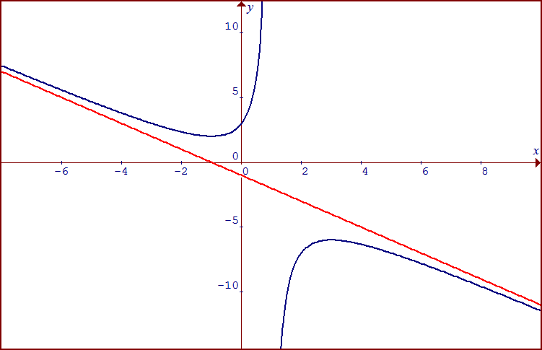  (-1, 2)  (3, -6)  y = -x - 1
11 | (a) y = vx² Differentiate w.r.t. x,  Substitute into DE:  ⇒  ⇒  ⇒ (Shown)  =  (b)  where A = e^{1000c}  when t = 0, x = 1,  (Shown)  when t = 10, x = 100,  when x = 500,  t = 14.7 days  Hence it will take 5 more days to have at least 500 mouldy biscuits.
12 | (a)  (b)  P=  P=  O  Imaginary Axis  Real Axis  (i)  The loci is a circle with center P, radius 6 and passing through Q  (ii)  The loci is a half line starting at P and is parallel to OQ  Let R be the point of intersection.

