INNOVA JUNIOR COLLEGE
JC 2 PRELIMINARY EXAMINATIONS 2
in preparation for General Certificate of Education Advanced Level
Higher 2

CANDIDATE
NAME

CLASS INDEX NUMBER

MATHEMATICS  Paper 1  Additional Materials: Answer Paper  List of Formulae (MF15)  Cover Page. | 9740/01  10 September 2008  3 hours

READ THESE INSTRUCTIONS FIRST

Do not open this booklet until you are told to do so.
Write your name, civics group and index number in the spaces at the top of this page.

Write your name and class on all the work you hand in.
Write in dark blue or black pen on both sides of the paper.
You may use a soft pencil for any diagrams or graphs.
Do not use staples, paper clips, highlighters, glue or correction fluid.

Answer all the questions.
Give non-exact numerical answers correct to 3 significant figures, or 1 decimal place in the case of angles in degrees, unless a different level of accuracy is specified in the question.
You are expected to use a graphic calculator.
Where unsupported answers from a graphic calculator are not allowed in a question, you are required to present the mathematical steps using mathematical notations and not calculator commands.
You are reminded of the need for clear presentation in your answers.

At the end of the examination, fasten all your work securely together.
The number of marks is given in brackets [ ] at the end of each question or part question.

This document consists of 7 printed pages and 1 blank page.
- The curve passes through the point and the tangent to the curve at the point is . Find the exact value of y when . [5]

- In triangle OAB, and the point C on AB is such that . With respect to the origin O, the position vectors of A and B are given as and respectively.

(i) Show that . [1]

(ii) Find c, the position vector of C in terms of a and b. [1]

(iii) Given that the lengths of OA and OB are 3 and 5 units respectively, find the length of projection of c onto b. [3]

- Given that x is sufficiently small for and higher powers of x to be neglected, show that
,

where k is a fraction to be determined. [5]

- The curve C has equation

.

(i) Sketch the curve C, stating the equations of the asymptotes clearly. [4]

(ii) Find the greatest value of k, where k is a positive integer, for which the curve cuts C at only one point. [2]
- A curve is given parametrically by
where .
(i) Find in terms of t. [4]

(ii) Find the equation of the normal to the curve at the point where the curve cuts the x-axis, giving your answer in exact form. [3]

- As part of an Art Project, a student designed a letterbox in the form of a prism. The cross-section forms a pentagon with two vertical sides of equal height, y cm, and two slant edges of equal length, 5x cm. The remaining faces are rectangles. A rectangular sheet of cardboard, ABCD, of area 1500 cm², is folded to make the surface ABCD of the prism as shown in the diagram. The front, back and bottom surfaces are made of another material.

5x
5x
y
y
6x
30
A
D
C
B

If the length of the letterbox is 30 cm and the width is 6x cm,

- show that the volume, V cm³, enclosed by the letterbox is given by
, [3]

(ii) determine the maximum value of V. [4]
- The diagram below shows the graph of . There is a minimum at the point , a maximum at the point and the curve cuts the x-axis at the point . The curve has asymptotes , and . Sketch, on separate diagrams, the graphs of

(i) , [2]
(ii) , [3]
(iii) . [3]
y = f(x)
O
a
y
x

- The functions f and g are defined by

(a) (i) State the range of f. [1]

(ii) Find an expression for . [2]

(iii) On the same diagram, sketch the graphs of , and . [5]

- Show that gf does not exist. [1]

The composite function gf exists if the domain of f is restricted to , state the greatest value of k. [1]

- (a) In an inter-house games competition, students from Green house decided to form a relay team. The first runner of the team will run 800 m, the second runner will run the next 808 m and each subsequent runner will increase the distance run by 8 m. Determine the minimum number of students needed to complete a total run of at least 80 km.
[4]

        - The sequence , , , is such that , and for .
(i) Write down the values of and . [1]

(ii) Show that for . [3]

(iii) Show that is a constant, and explain the significance of this result. [2]
- (a) Given that

find the exact values of the real numbers. [4]

(b) Express the complex number in exponential form. [2]
Solve the equation
,

giving your answers in form , where a and b are real values. [4]

Show that the points representing the roots of the given equation in an Argand diagram lie on a circle. Write down the centre and radius of this circle. [2]

- (i) Express in partial fractions. [2]
Hence find , giving your answer in the form , where k is a constant. [3]

(ii) Prove by induction that
. [5]

(iii) Using the above results, evaluate
. [3]
- (i) Use the substitution to show that
. [6]

(ii) The graph of , for , is shown in the diagram. A and B are points on the curve where and respectively.

y
x
O
A
B

(a) The region R is enclosed by the chord AB and the arc AB of the curve. Using the result in part (i), find the exact area of R. [3]

(b) The region S is enclosed by the arc AB, the y-axis and the line. Find the volume of the solid of revolution formed when S is rotated through about the x-axis, giving your answer correct to 3 significant figures. [3]

End of Paper

IJC 2008 Prelim 2 H2 Maths Paper 1
(Solutions)
1 | At ,  At ,  At , gradient =  Using GC, Solving eq (1), (2) & (3) simultaneously  When ,
2i | Since is perpendicular to ,
ii | or: | Using ratio theorem,
iii | Length of projection of onto  Alternative:
3 | Since x is small,
4i | 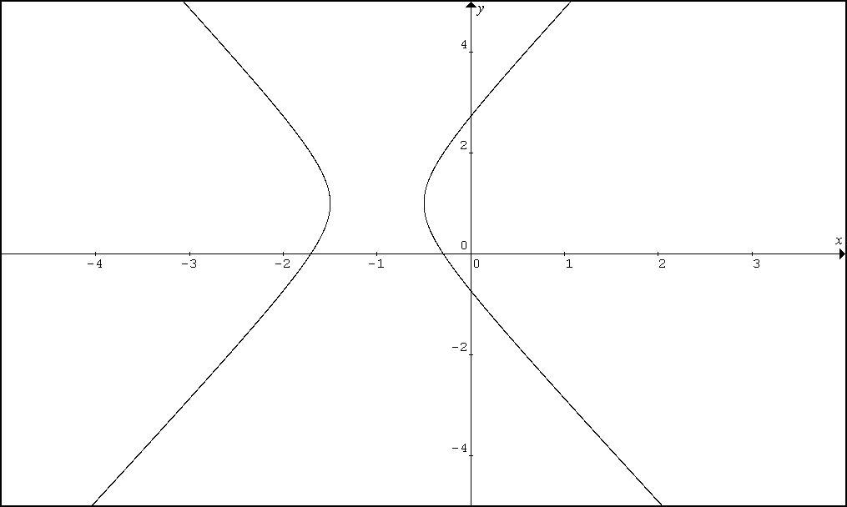
ii
5i
ii | When y = 0, t = 0 and
6i
ii | For maximum volume,  Need to show that Volume is maximum when ,  Since , V is maximum when .
7i
ii
iii

8ai
ii | ,
iii
b | and  gf does not exist.
 | Greatest
9a | or  The minimum number of students needed is 74.
bi
ii | =  =  ==  ==
iii | forms geometric sequence with common ratio as .
10a | Equating real and imaginary parts:  From (2) :  Sub (3) into (2):
b | = .  , where k = 0, 1, 2, 3.  , where k = 0, 1, 2, 3.  = .  Hence, the points representing the roots of the given equation in an Argand diagram lie on a circle with centre (-2,0) and radius 1 unit.
11i
ii | Let be the statement for .  Show is true.  is true.  Assume is true for some , i.e  Show that , i.e.  Since is true and is true is also true. By mathematical induction, is true for .
iii
12(i)
(ii)  (a) | When ,  When ,  Required Area =
(b) | Required Volume

