HCI 2008 Prelim Paper 2 Solution

Qn | Solution
1 |  | When  (up term in )  =
2i | 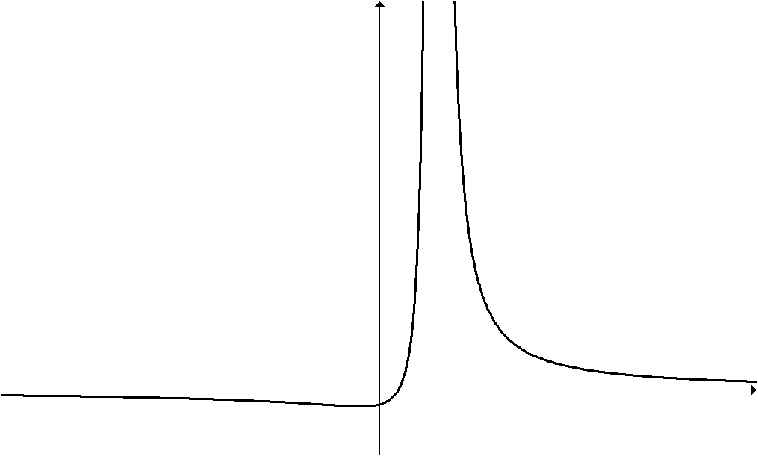  a  1
2ii | 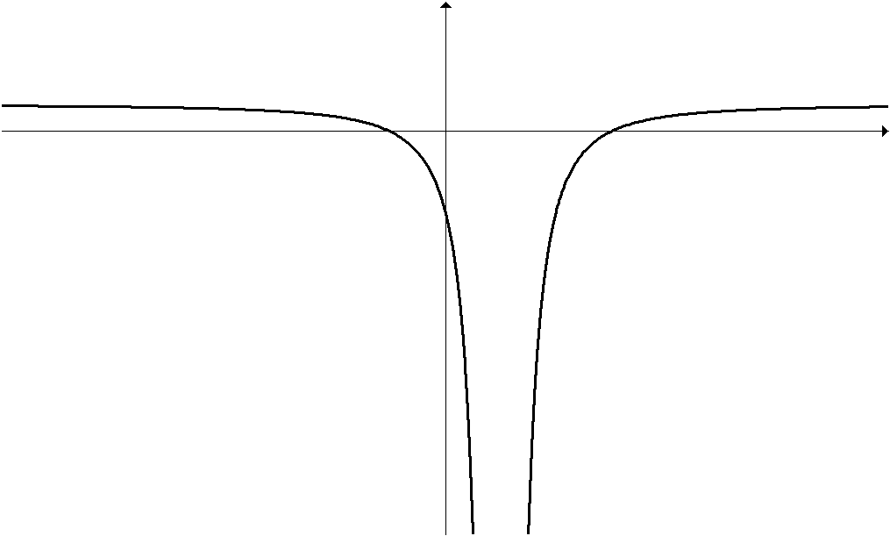  1  1  a  − a
2  iii | 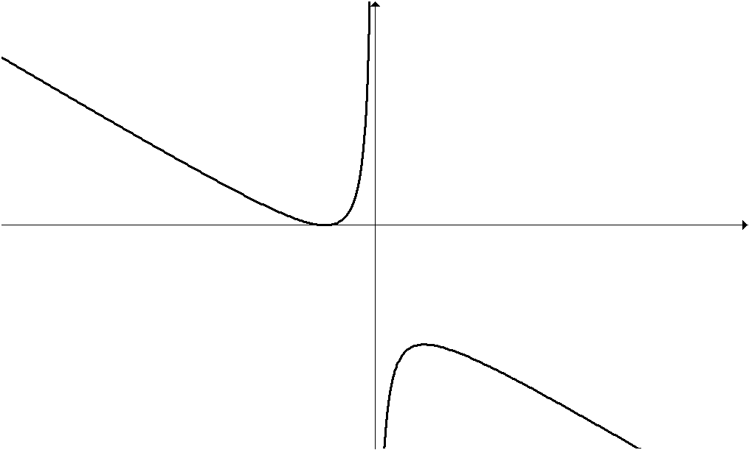  (a + 1, − 4a)  (1 − a, 0)
3i | Amount owed before interest is added at end of nth year (as $12000 is paid for 1 yr)  Thus amt owed with interested added
3ii
3  iii | (Use GC, Sequence mode) or  Needs 23 years | 3iv  Total interest paid  Penalty =  As total interest paid is greater than penalty,  it’s to John’s benefit to terminate his loan early.
4i |  | 4ii
4
iii
4  iv | Greatest
5i | Quota Sampling
5ii | A list, in alphabetical order of the male and female employees can be generated separately. The list of male employees will be numbered from 1 to 580 in that order while the list of female employees will be numbered from 1 to 420 in that order. A number between 1 to 20, inclusive is then selected at random. The corresponding employee and every 20th employee thereafter will be included in the sample for interview. This method of selection is done for both the list of male and female employees.
5iii | In (ii), the sample selected would be random whereas in (i), the sample is non-random as the interviewers were free to choose who they wanted to interview thus creating biasness.
6 | vs  Using GC, select t- test, p - value = 0.0792  Since p - value = 0.0792 < 0.10, we reject H₀ and  conclude that there is sufficient evidence at the 10% level of significance that the promotional campaign was successful in encouraging customers to spend more money at the store.
7 | General comments for Q7  - There is a general lack of explanation on the approach to the qn. When solving a qn by considering cases, candidates should state the cases clearly.  - Many students just wrote a 'string of numbers' without explanation.  - Solution only has all numerical computations without any words; not even the phrase 'number of ways".  - Use of diagrams is lacking. Diagrams are helpful for marker's understanding (if you are not good in words)
7 | No. of ways the committee can be formed  = = 1218
7i | No. of ways the committee can be seated without restriction = = 5040
7ii | No. of ways the committee can be seated such that no two girls are seated next to each other = 4! (5)(4)(3) = 1440
No. of ways the committee can be seated when there are two absentees = = 2520
or = 2520
8i | Solving both equations: and
8ii
8iii | Let x = 26.  y =18.5+0.1 (26) = 21.1 ≈ 21  The above equation is used because x is given and y has to be found.  The estimate is not reliable because is small, i.e. it is close to 0, hence the linear correlation between x and y is very weak.
9i | P (player wins the grand prize) = P (WWW)  = =
9ii | P (player wins a consolation prize)  = P (BWW or WBW or WWB)  =  =
9iii | P (player wins a consolation prize/first draw was white) =  = = =
P (player wins at least 2 grand prizes in his 4 attempts)
= 1 − P (player did not win any grand prize) – P (player wins only 1 grand prize)
= = 0.0140

Alternative:
Let random variable X be the number of grand prizes a player wins in his 4 attempts at the game. Then .
P (player wins at least 2 grand prizes in his 4 attempts)
=
= 1 −
= 1 − 0.98598 = 0.0140
10i | X ∼ B(108,0.04)  Assume independence of customers not turning up.  P(X = 0) = 0.96¹⁰⁸ = 0.0122
10  ii | Since n > 50, by CLT, the sample mean .
10  iii | - Since n is large, np = 4.32 <5, X ∼ Po(4.32)  X₁+X₂+X₃+…+X_{m} = the number of customers that do not turn up for m consecutive days  - Y = X₁+X₂+X₃+…+X_{m}∼Po(4.32m)  - P(Y ≥ 6) > 0.999  - P(Y ≤ 5) < 0.001  - Using G.C, m > 3.8  Or when m = 3, P = 0.011 > 0.001  - when m = 4, P = 0.00055 < 0.001  Least number of days = 4
11a | P(X >500) ≤0.01  Using GC, graphically  Alternatively,  P(X >500) ≤0.01⇒
11  bi | Let X denote the amount of soft drink that is dispensed into a cup of 500 ml. X∼N(470,20²)  P(X >500) = 0.0668 (3s.f.)
bii | Required Probability = (1−0.066807)² = 0.871
b  iii | X₁+X₂ ∼N(940,800)
biv | Let Y denote the number of cups that overflowed out of 300 cups.  Y ∼ B(300,0.066807), np = 20.04217 > 5, nq = 279.95783 > 5,  Y ∼ N(20.04217, 18.70321) (approximately)  P(Y > 20) P(Y > 20.5) = 0.458 (3 s.f.)

