HCI 2008 Prelim Paper 1 Solution

Qn | Solution
1 | Let x, y and z be the no of 10 cent, 20 cents and 50 cents coins respectively.  The 3 equations are ,  Aug matrix A = rref A =
2 | for all or .
3 | Volume of water V | Given
4i |  | 4ii
5
6 | =  = | Expansion is valid if .  Let x = , n = & sub into above expansion  =
7 |  | When  When ,  When  When
8 | 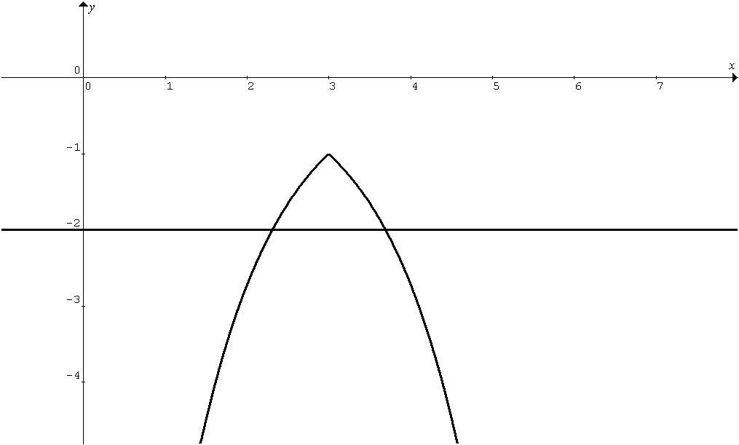  Any line () cuts the graph at 2 points.  f is not one-to-one.  Therefore, f does not have an inverse. | Let  For to exist,  Therefore,  Largest and
9a | Let P_{n} be for all  P₁: = 5 & P₁ is true  Assume that P_{k} is true for some  We want to show that P_{k+1} is true  P_{k+1} is true  Since P₁ is true & P_{k} is true P_{k+1} is true ,  P_{n} is true for all .
b | to n terms  = | = =  =  As n → ∞ , → 0
10i
Ii | When  When .  Thus two curves intersect at the point .(Verified)
 | Alternatively
10  iii | Volume
11i | 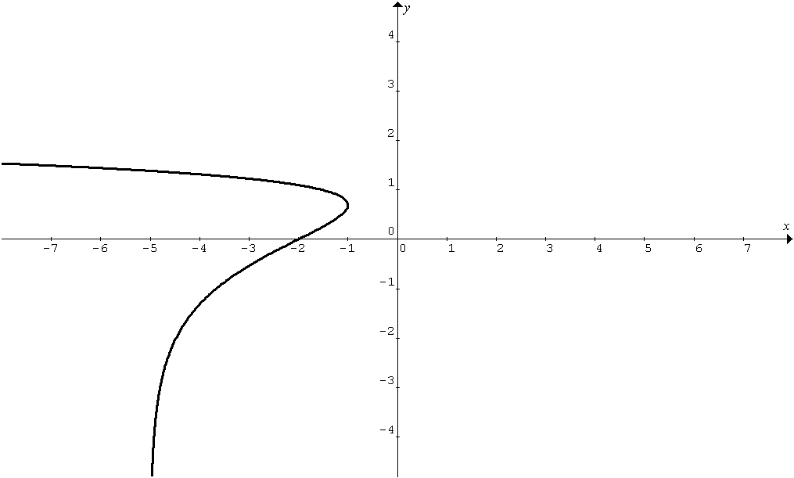
ii | Equation of normal at :  , is undefined  Therefore, equation of normal: | Equation of tangent at :  ,
iii
iv | Let the angle θ be the acute angle between normal and tangent.
12i | (− μ − 1) a + μb + c = 0 λ = − μ − 1  μ (b − a) + (c − a) = 0  A, B, C are collinear
ii | p = 4a - 3b  ⇒ 4a = p + 3b  ⇒ a = (p + 3b) / 4  A divides PB in the ratio 3 : 1  P lies on BA produced with ratio | Alternatively  P lies on BA produced with ratio
bi | Alternatively  Take a point in , say C ( 13,0,0) which satisfies
 | Proj on =

Alternatively
Using a long method
Vector equation of a line through A and parallel to : R
Let C be the foot of the perpendicular from A to
Then
C lies on : λ =
=;
d =
bii | Since d is positive, the angle between & is acute  Alternatively  Using a long method  Vector equation of a line through A and parallel to : R
Let C be the foot of the perpendicular from A to
Then
C lies on : λ =
=
By ration theorem :

iii | : x + 2y − 4z = 13 ……. (1)  : x + 3y + 3z = −8 ……. (2)  By G.C. solve equations (1) & (2)  The vector equation of the line of intersection is  l : where . or etc
iv | Since B and l lie on the image plane of so the equation of image plane is  where and
Alternatively
Using as a dir vector
n =

