Section A : Pure Mathematics [40 marks]
1. If , show that
[1]
By further differentiation of the above result, find the Maclaurin’s series expansion for y in ascending powers of x up to and including the term in
Hence find the first three non-zero terms in the expansion of
. [7]

2. The diagram shows the graph of . The equation of the oblique asymptote, also shown in the diagram, is . There is a minimum at the point A(a, 0) and a maximum at the point B(– a, – 4a) where .
y
x
A
1
O
B

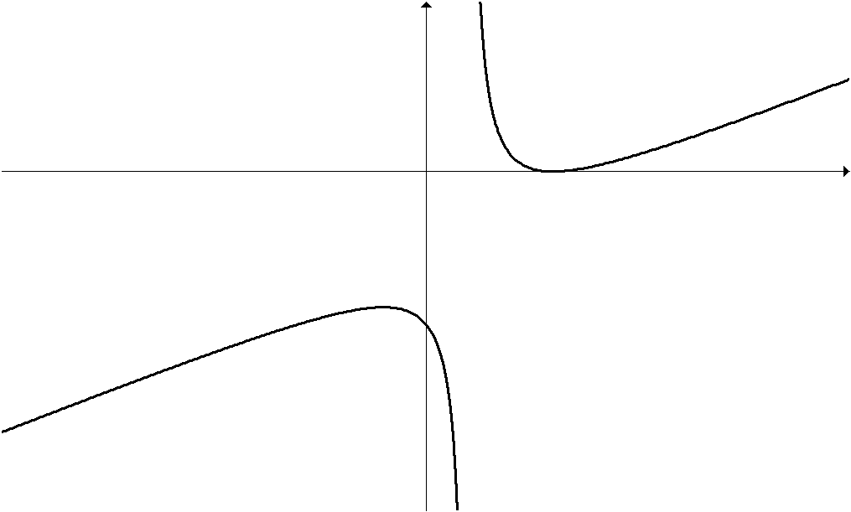

On separate diagrams, sketch the graphs of
(i) , [3]
(ii) , [3]
(iii) . [3]
State the equations of any horizontal and/or vertical asymptotes, the coordinates of the points corresponding to A, B and any points of intersection with the x-axis.
3. John took a bank loan of $200 000 to buy a flat. The bank charges an annual interest rate of 3% on the outstanding loan at the end of each year. John pays $1000 at the beginning of each month until he finishes paying for his loan. Let denote the amount owed by John at the end of nth year, where .
(i) Show that , where k is a constant to be determined. [1]
(ii) Express in the form of , where a and b are constants to be determined. [3]
(iii) Find the minimum number of years required for John to pay up the bank loan. [2]
(iv) Suppose John decides to terminate his loan after 15 years by paying the remaining sum by cash. However, there is a penalty of 5% of the remaining loan for early termination. If John had not terminated his loan earlier, find the total interest he has to pay after 15 years.
Determine, with justification, if it is to John’s benefit to make an early termination. [4]
4. (a) Consider the complex number .
(i) Find the modulus and the exact value of the argument of z. [3]
(ii) Find the set of values of n such that is purely imaginary. [3]
(b) Show clearly on an Argand diagram the locus given by
. [3]

A complex number u satisfies . Sketch on the same Argand diagram, the locus of the point which represents u. Hence find the greatest possible value of . [4]
Section B : Statistics [60 marks]

5. A company has 1000 employees of whom 58% are males and 42% are females. The research department at the company wants to conduct a quick survey by selecting 50 employees and seeking their opinions on an issue. The research department divides the employee population into two groups, males and females, and then interview 29 males and 21 females from these respective groups. The interviewers are free to choose any 29 males and 21 females they want to interview.

(i) Identify the method of sampling involved in the above scenario. [1]
(ii) Describe in detail how the method of systematic sampling can be used to select the 50 employees for the interview. [3]
(iii) Give an advantage of using the method of sampling in (ii) rather than the method identified in (i). [1]

6. The past records of a supermarket show that its customers spend an average of $55 per visit at this store. To encourage customers to spend more money at the store, the management of the store initiated a promotional campaign where each customer will receive a bonus stamp for every $30 spent and these bonus stamps can be used to redeem products at the store. A week after the start of the campaign, the manager of the store took a sample of 15 customers who visited the store. The amount of money (in dollars) spent by these customers, x, at this supermarket during their visits are summarised by
.
Assume that the money spent by all customers at this supermarket follows a normal distribution. Test, at the 10 % level of significance, whether the promotional campaign was successful in encouraging customers to spend more money at the store. [6]

7. A student committee comprising of 8 people is to be selected from a group of 10 boys and 4 girls. In how many ways can this be done if the committee comprises of at least 3 boys and 3 girls? [2]
After a round of interview was conducted by the selection team, the student committee of 5 boys and 3 girls was finally formed. The student committee holds regular meetings in a discussion room where they are seated at a round table with 8 seats.

Find the number of ways they can be seated if
(i) there is no restriction, [1]
(ii) no two girls are to sit next to each other. [2]

At a particular meeting, two boys in the committee are absent. Find the number of ways the other members of the committee can be seated if the meeting is still held in the same discussion room with the same round table with 8 seats. [2]

8. A teacher decided to investigate the association between students’ performances in Mathematics and Physics. She selected 5 students at random and recorded their scores, x and y, in Mathematics and Physics tests respectively. She found that, for this set of data, the equation of the regression line of on was and the equation of the regression line of on was .
(i) Show that and . [3]

It is given that , and .
(ii) Calculate the product moment correlation coefficient for the data. [1]
(iii) The Physics score of a sixth student was mislaid but his Mathematics score was known to be 26.

Use the appropriate line of regression to estimate this student’s Physics score, and give a reason for the use of the chosen equation. [2]
Comment on the reliability of your estimate. [1]

9. A bag initially contains 2 white and 6 black balls. A game is played by drawing 3 balls, one at a time, from the bag. Each time a ball is drawn, its colour is noted and it is replaced in the bag along with 2 other balls of the same colour.
To win the grand prize, a player has to draw 3 white balls but if he obtains only 2 white balls in his 3 draws, he gets a consolation prize. Otherwise, he will walk away empty-handed.
(i) Show that the probability that a player will win the grand prize is . [1]
Find the probability that
(ii) a player wins a consolation prize, [3]
(iii) a player wins a consolation prize, given that his first draw is a white ball.
[3]
A player plays the game four times. Find the probability that he wins at least 2 grand prizes in his 4 attempts at the game. [3]

10. An airline always sells 108 tickets for her daily 6 a.m. flight from Singapore to Los Angeles and, on average, 4% of customers who have purchased tickets do not turn up. Let X represent the number of customers who do not turn up for this flight.
State the distribution of X and state the assumption you must make. [3]
(i) Find the probability that the flight is full. [1]
(ii) Find the probability that the mean number of empty seats for each daily flight is at most 4, in a randomly chosen 60-day period. [3]
(iii) By using a suitable approximation, find the least number of consecutive days in which the probability of at least 6 customers do not turn up exceeds 0.999. [4]
11. A customer can order a regular 500 ml cup drink or a double 1000 ml cup drink from a vending machine. To make a regular cup drink, the vending machine dispenses once, while to make a double cup drink, the vending machine actually dispenses twice. Drinks which dispense from the vending machine follow a normal distribution with mean μ ml and standard deviation 20 ml. The amounts that are successively dispensed are independent.
(a) Find the set of values for μ so that at most 1% of regular cups overflow. [3]
(b) It is later found that . Find the probability that
(i) a regular cup will overflow, [2]
(ii) no overflow occurs if the customer orders 2 regular size drinks, [2]
(iii) for a double cup, no overflow occurs, [3]
(iv) more than 20 cups overflowed if 300 cups of 500 ml are dispensed in one day, by using a suitable approximation. [4]

