1. A student has been saving 10 cent, 20 cent and 50 cent coins in a moneybox. When she opened the box after one month, she found the amount saved is $15 and the number of 10 cent coins equals the total number of 20 cent and 50 cent coins. She also found that only half as many coins is needed to save the same amount using just 50 cent coins. Find the number of 10 cent, 20 cent and 50 cent coins in the moneybox. [4]

2. Express in the form [2]
Hence solve
leaving your answer in exact form. [3]

3. A right circular cone with radius 3 cm and height 9 cm is initially full of water. Water is leaking from the circular base of the cone at a rate of 2 cm³ s⁻¹, find the exact rate of change of the depth of water when the depth of water is 6 cm. [5]

4. (i) Prove that . [2]
(ii) Hence find . [4]

5. The complex number z is given by, where . Show that the equation can be reduced to . Hence express each root of in the form , where x and y are real numbers. [6]

6. Expand in ascending powers of x up to and including the term in x². [3]
State the set of values of x for which the series expansion is valid. [1]

Hence find an approximation to the fourth root of , in the form , where p and q are positive integers. [3]

7. A hospital patient is receiving a certain drug through a drip at a constant rate of 50 mg per hour. The rate of loss of the drug from the patient’s body is proportional to x, where x (in mg) is the amount of drug in the patient at time t (in hour). Form a differential equation connecting x and t and show that
[3]
where A and k are constants.
Given that .
(i) Find the time needed for the drug in the patient to reach 200 mg, if initially there is no trace of this drug in the patient’s body. [2]
(ii) When there is 80 mg of the drug in the patient’s body, the drip is disconnected. Assuming that the rate of loss remains the same, find the time taken for the amount of drug in the patient to fall from 80 mg to 20 mg. [3]

8. The functions f and g are defined by

and a is a constant.

Sketch the graph of y = f(x), and show that f does not have an inverse. [2]
- The function f has an inverse if its domain is restricted to. State the smallest possible value of b and define, in similar form, the inverse function corresponding to this domain for f. [4]
(ii) Find the largest value of a such that the composite function exists and state the range of for this value of a. [4]

9. (a) A sequence of real numbers is defined by = 5 and for all . Prove by induction that for every positive integer n, . [4]
Show that is a product of two odd numbers. [1]

(b) A sequence of real numbers is defined by
for all .
By taking , express as a difference between and . [2]
Evaluate where . to n terms. [3]
Find the limit of as n → ∞. [1]

10. The diagram below shows the graphs of and , for . R is the region bounded by the y-axis, both curves and .
y
x
O

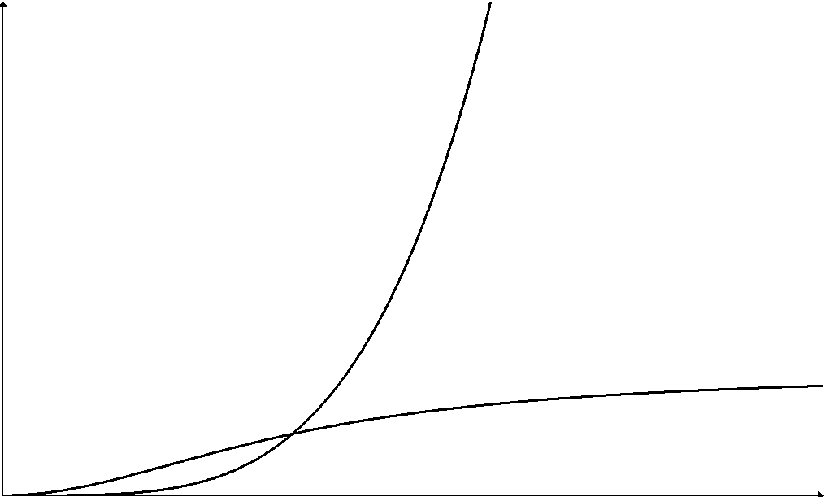

(i) By substituting , find the exact value of . [5]
(ii) Verify that the two curves intersect at the point Hence or otherwise find the exact area of region R. [4]

(iii) Find the volume of the solid generated when R is rotated through radians about the y-axis, giving your answer correct to 3 decimal places. [3]
11. The parametric equations of a curve C are
and , .
(i) Sketch the curve C, showing clearly the axial intercepts. [2]
(ii) Find the equations of the normal to the curve at and the tangent to the curve at . [6]
(iii) Find exactly the coordinates of the point of intersection of the tangent and the normal. [2]
(iv) Find, in radians, the acute angle between the tangent and the normal. [2]

12. (a) The points A, B, C have position vectors a, b, c respectively.
(i) Given that non-zero numbers λ, μ are such that λa + μb + c = 0 and λ + μ + 1 = 0. Show that A, B, C are collinear. [2]
(ii) Show that the point P with position vector p given by lies on BA produced, and find the ratio PA : PB. [3]

(b) Referring to the origin O, two planes and are given by
and .
(i) Given that a point A (1, 7, −10) lies on , show that the perpendicular distance from A to is . [2]
(ii) Hence or otherwise find where B is the image of A when reflected in the plane . [2]
(iii) Write down the Cartesian equations of both and . [1]
Find a vector equation of the line of intersection of and . [1]
(iv) Find a vector equation of the plane which is the image of when is reflected in . [3]

