Name |  | Reg. No. |  | Year 6 ( )



DUNMAN HIGH SCHOOL, SENIOR HIGH
PRELIMINARY EXAMINATION 2008
Higher 2

MATHEMATICS 9740/01
Paper 1 11 September 2008
3 hours
Additional Materials: Answer Paper
Graph paper
List of Formulae (MF15)

READ THESE INSTRUCTIONS FIRST

Write your Name, Class and Index number on all the work you hand in.
Write in dark blue or black pen on both sides of the paper.
You may use a soft pencil for any diagrams or graphs.
Do not use paper clips, highlighters, glue or correction fluid.

Answer all the questions.
Give non-exact numerical answers correct to 3 significant figures, or 1 decimal place in the case of angles in degrees, unless a different level of accuracy is specified in the question.
You are expected to use a graphic calculator.
Unsupported answers from a graphic calculator are allowed unless a question specifically states otherwise.
Where unsupported answers from a graphic calculator are not allowed in a question, you are required to present the mathematical steps using mathematical notations and not calculator commands.
You are reminded of the need for clear presentation in your answers.

At the end of the examination, attach the question paper to the front of your answer script.
The number of marks is given in brackets [ ] at the end of each question or part question.

For teacher’s use:
Q1 | Q2 | Q3 | Q4 | Q5 | Q6 | Q7 | Q8 | Q9 | Q10 | Q11 | Q12 | Total

The sum of the first n terms of a series is given by .
(i) Show that the series is a geometric series. [3]
(ii) Explain why this series converges and find its sum to infinity. [2]

Prove by mathematical induction that
$\sum_{r=0}^{n}{\left(\frac{1}{r+1}+\frac{1}{r+2}−\frac{2}{r+3}\right)}=2−\frac{1}{n+2}−\frac{2}{n+3}$. [4]

Hence, or otherwise, find $\sum_{r=1}^{∞}{\left(\frac{1}{r+1}+\frac{1}{r+2}−\frac{2}{r+3}\right)}$. [2]

Shown below are Mdm Tham's household utilities usage for the months of May, June, July and August in a particular year:

 | Monthly usage (units)
 | May | June | July | August
Electricity | 22 | 30 | 25 | 28
Gas | 10 | 16 | 12 | 19
Water | 19 | 35 | 20 | 21

A household's monthly utility bill is calculated by summing up for that particular month, the charges it incurs respectively for its usage of electricity, gas and water, each of which is priced at a different rate per unit. Mdm Tham's monthly utility bills for May, June and July were $100, $155 and $113 respectively. Assuming that the price rates of the utilities were unchanged for these three months and August, find Mdm Tham's monthly utility bill for the month of August. [5]

The diagram shows the graph of . The curve has turning points at and where p and q are positive real numbers.

Sketch, on separate clearly labelled diagrams, the graphs of:
(i) , [3]
(ii) . [3]

(a) The curve C has equation . Sketch C, indicating clearly the equations of any asymptotes and the coordinates of any axial intersections and turning points.
[4]
(b) Show that the curve with equation, where k is a positive constant, lies entirely in the region . [3]

The functions f and g are defined as follows:
$f:x↦e^{−2x},$ $x>0$.
$g:x↦x^{3}+1,$ .

- Show that f is one-one and define f ^{–1}. [3]
- On the same axes, sketch the graphs of f, f ^{–1} and ff ^{–1}. [3]
(iii) Explain whether the composite function gf exists and find gf(x) if it does. [3]

(a) Given , find an expression for in terms of x and y. [3]
(b) (i) By considering the standard series for , show that the first four non-zero terms in the series expansion of is given by . State the range of x for which the expansion is valid.
[4]
(ii) Write down the equation of the tangent to the curve at . [1]

(a) Given that the first three terms in the expansion of in ascending powers of x are , where a and b are constants, find the values of a and b. [4]
Hence expand as a series in ascending powers of x, up to and including the term in x². [3]

(b) Given that x is sufficiently small for x³ and higher powers of x to be neglected, show that [4]

The sequence , , , … is defined as where a is real constant.
(a) Given that , find the value of a such that all the terms in the sequence have the same value. [2]
(b) It is given that .
(i) Find the range of possible values of such that is defined. [3]
(ii) For , as . Using the calculator to compute the first 10 terms in the sequence, it was observed that approximately. Find the exact value of . [4]

(a) Two complex numbers w and z are such that
w* = z − 2i , |w|² = z + 6.
By eliminating z or otherwise, find w in the form , where a and b are real and positive. [4]

(b) The point P in an argand diagram represents the variable complex number z, and the point A in the first quadrant represents the fixed complex number a.
Draw on the same diagram, the point A and the locus of P for the following cases, making clear the relationship between the locus and the point A:
(i) ,
(ii) arg (z − a) = arg (a) + .
Hence, find a value of a such that the complex number z satisfying both equations in parts(i) and (ii) is purely imaginary. [6]

(a) Find . [3]
(b) (i) Using the substitution x = 2 sin θ, show that . [4]
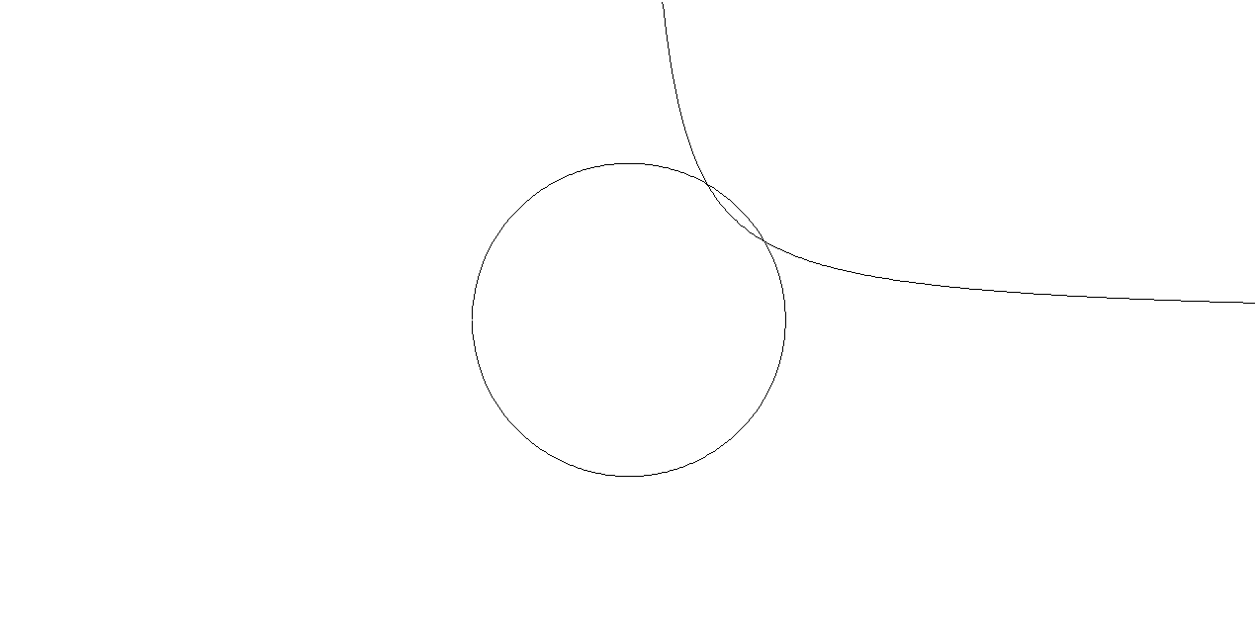
(ii) The diagram shows the shaded region R which is bounded by the circle with equation $x^{2}+y^{2}=4$ and part of the curve with equation $y=\frac{\sqrt{3}}{x}$, x > 0. Use your result from part (i) to find the exact area of region R. [3]
y
R

x

(iii) The finite region bounded by the curve $y=\frac{\sqrt{3}}{x}$, the y-axis, the lines y = 1 and y =$\sqrt{3}$ is rotated through 2π radians about the y–axis. Find the volume of the solid generated, giving one decimal place in your answer. [2]


The diagram shows a sketch of the curve .
y
x

(i) Find, by differentiation, the exact maximum value of y. [3]
(ii) Hence show that for all positive values of x. [3]
(iii) Determine the range of values of x for which the graph of is concave upwards. [3]
(iv) Another curve has equation , Find the range of values of k such that the equation has (a) 1 real root, (b) 2 real roots. [3]

THE END

