GAUTENG DEPARTMENT OF EDUCATION

SENIOR CERTIFICATE EXAMINATION

WOODWORK SG
(Second Paper: Theory)

TIME: 2 hours

MARKS: 100

INSTRUCTIONS:

- Sketches may be used to illustrate your answers.

- Start each question on a new page.

- Answer ALL the questions.

QUESTION 1
TIMBERS, CONVERSION METHODS, COMMERCIAL FORMS AND GRADING

  - You will find that part of the fascination of making things with wood is learning to identify the different species of timber and being able to tell how each piece will behave when you begin to work it.

Table 1.1 shows various characteristics and names of timber. Write down the letters A to X below one another. Read the rows vertically and use the information provided to find the answers. Choose the relevant facts and write it next to the letters A to X.

 | Origin | Colour of heartwood | Odour | Texture | Contains | Working properties
 | Zambia  Knysna (SA)  Uganda  Britain  Mpumalanga  Brazil  Japan  USA  South-America | Grey  Light brown  Dark brown  Reddish  Reddish-brown  Light red  Dark red  Straw  Yellow | Cedar  Spicy  Resin  Sweet | Fine  Medium  Rough | Oil  Resin  Gallic acid | Work very easily  Tearing  Grain filling necessary  Difference in hardness makes finishing difficult
Beech | A |  |  | O
Yellowwood
Imbuia | B |  | L |  |  | U
Iroko
Japanese oak |  |  |  |  | R
Kiaat | C | H |  | P |  | V
Oregon pine | D | I
Pau Marfin | E |  |  | Q |  | W
S.A. pine | F |  |  |  | S | X
Sapele mahogany |  | J | M
Stinkwood | G | K
Tamboti |  |  | N |  | T
(24)
Table 1.1

- Which timber listed in Table 1.1 is traditionally used for each of the following:  1.2.1 Tool handles  - Roof trusses  - Cottage furniture (exotic timber)  - Durable furniture (indigenous timber)  - Furniture with components that are bent | (5)

1.3 Conversion methods  - Name and sketch the method of conversion which is generally used on timbers such as beech and oak.  - What is the reason for using this method specifically on beech and oak?  - State TWO disadvantages of this method. | (1)  (1)  (2)

1.4 Figure 1.4 shows sketches of wooden forms that are commercially available. Write down the letters A to C below one another, and next to each letter the correct term for each form.

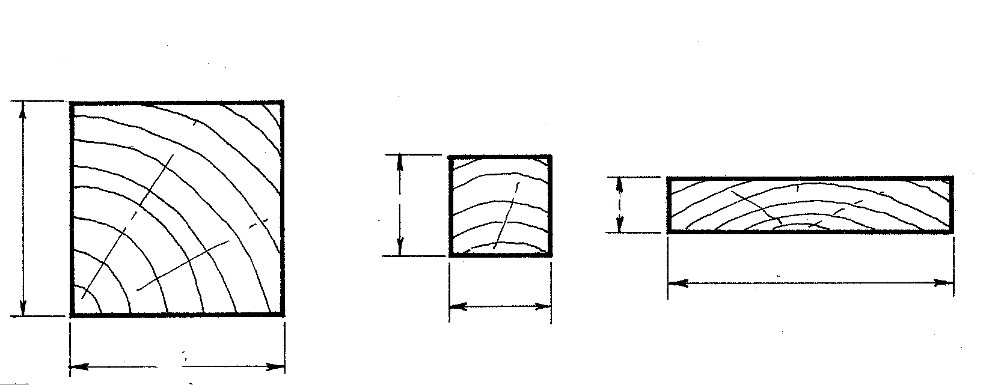  152  76  38  152  76  228  A  B  C | (3)

Figure 1.4

1.5 Name and sketch FOUR growth defects that occur in logs. | (4)  [40]

QUESTION 2  HAND TOOLS  - Figure 2.1 shows the FIVE steps that should be taken when a board is worked into fixed dimensions. Use the following headings and for each step describe, step by step, how it will be done.  - Identify the process of each step.  - Name the tools used to measure, test and mark out, and their uses.  - Name the other hand tools.  - What are the meanings of the two marks below?  - ∧ | (10)

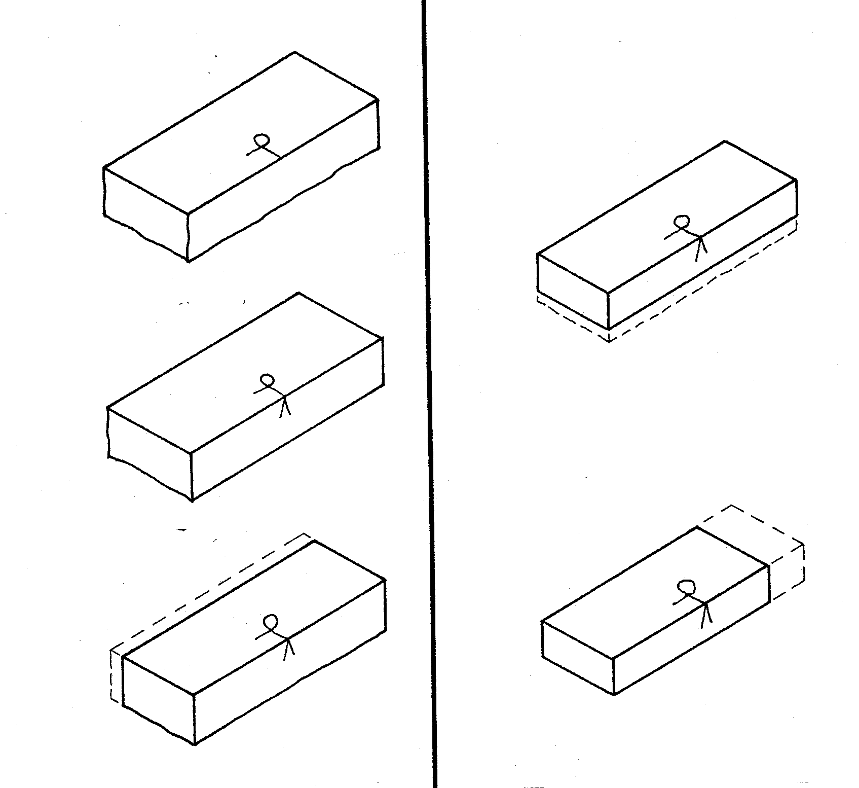
Step 1
Step 2

Step 3
Step 5

Step 4

Figure 2.1

2.2 Figure 2.2 shows the side of a board with two plane directions (A and B) on it.

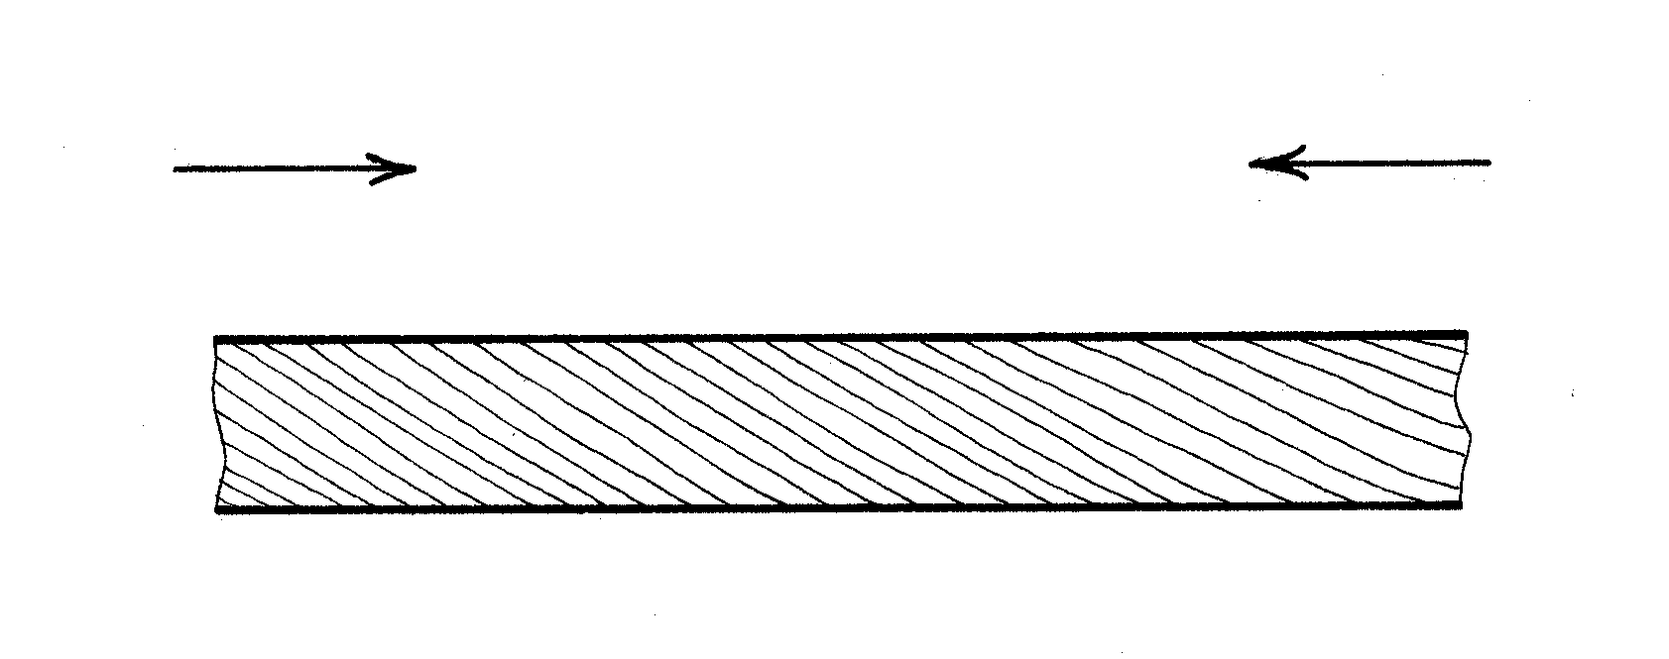
A
B

Figure 2.2

- Which direction is the correct direction for planning?  - Provide a reason for your answer. | (1)  (1)

2.3 Figure 2.3 shows part of a jack plane blade assembly.

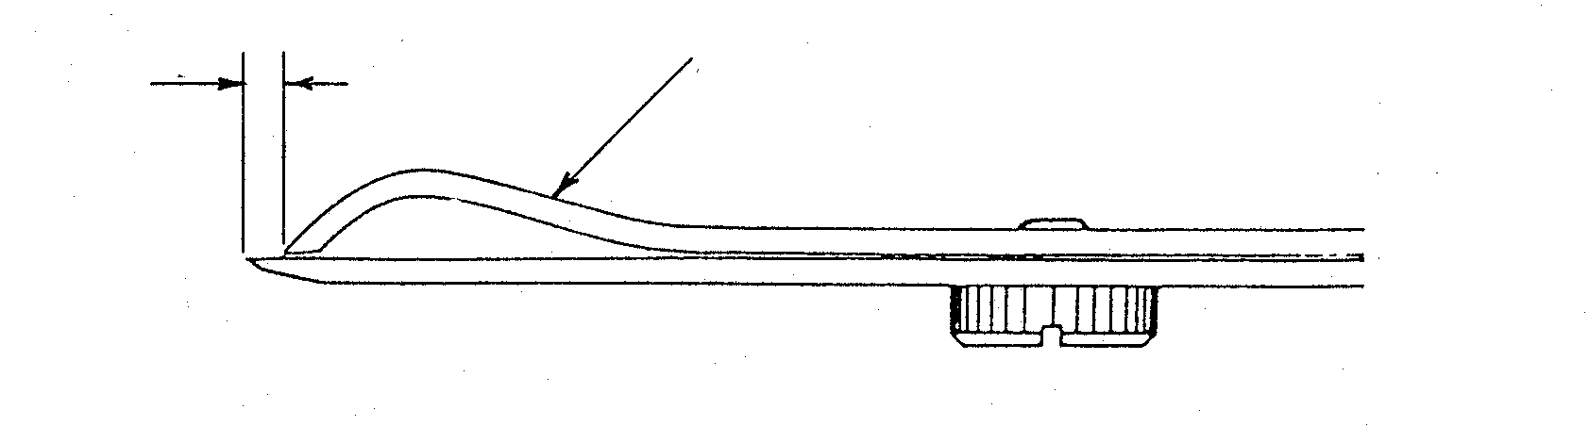
B
A

Figure 2.3

- Name the part labelled A and explain its purpose?  - How will you adjust distance B (in millimetres) for  - rough planing and  - finishing. | (2)  (2)

2.4 Figure 2.4 shows the sketch of a small fish formed out of wood.

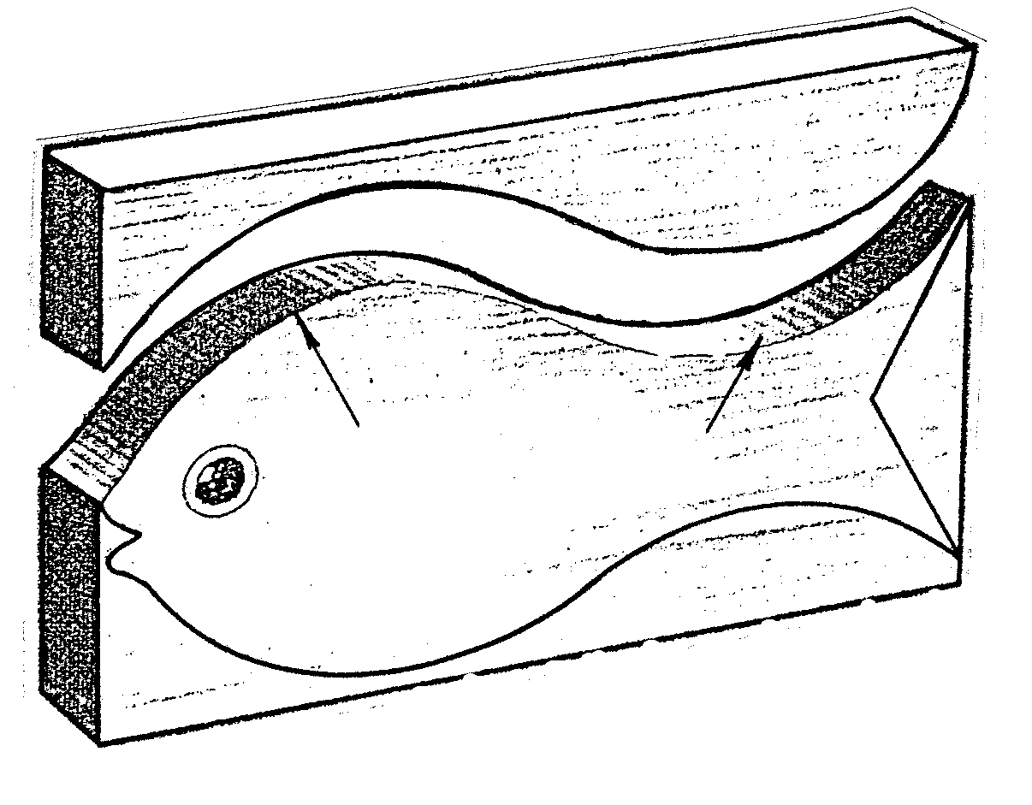
A
B

Figure 2.4

- Which handsaw will you use to cut the form?  - What will you use to hold the wood while working on it?  - Which plane would you use to finish curve A?  - Which plane would you use to finish curve B?  - Name any other hand tool which you could use to finish the fish’s curves. | (5)

2.5 Figure 2.5 shows four drawer fronts (A, B, C and D), all 15 mm thick, each with a different hole cut through for use as a handle or into which a handle will be fitted.

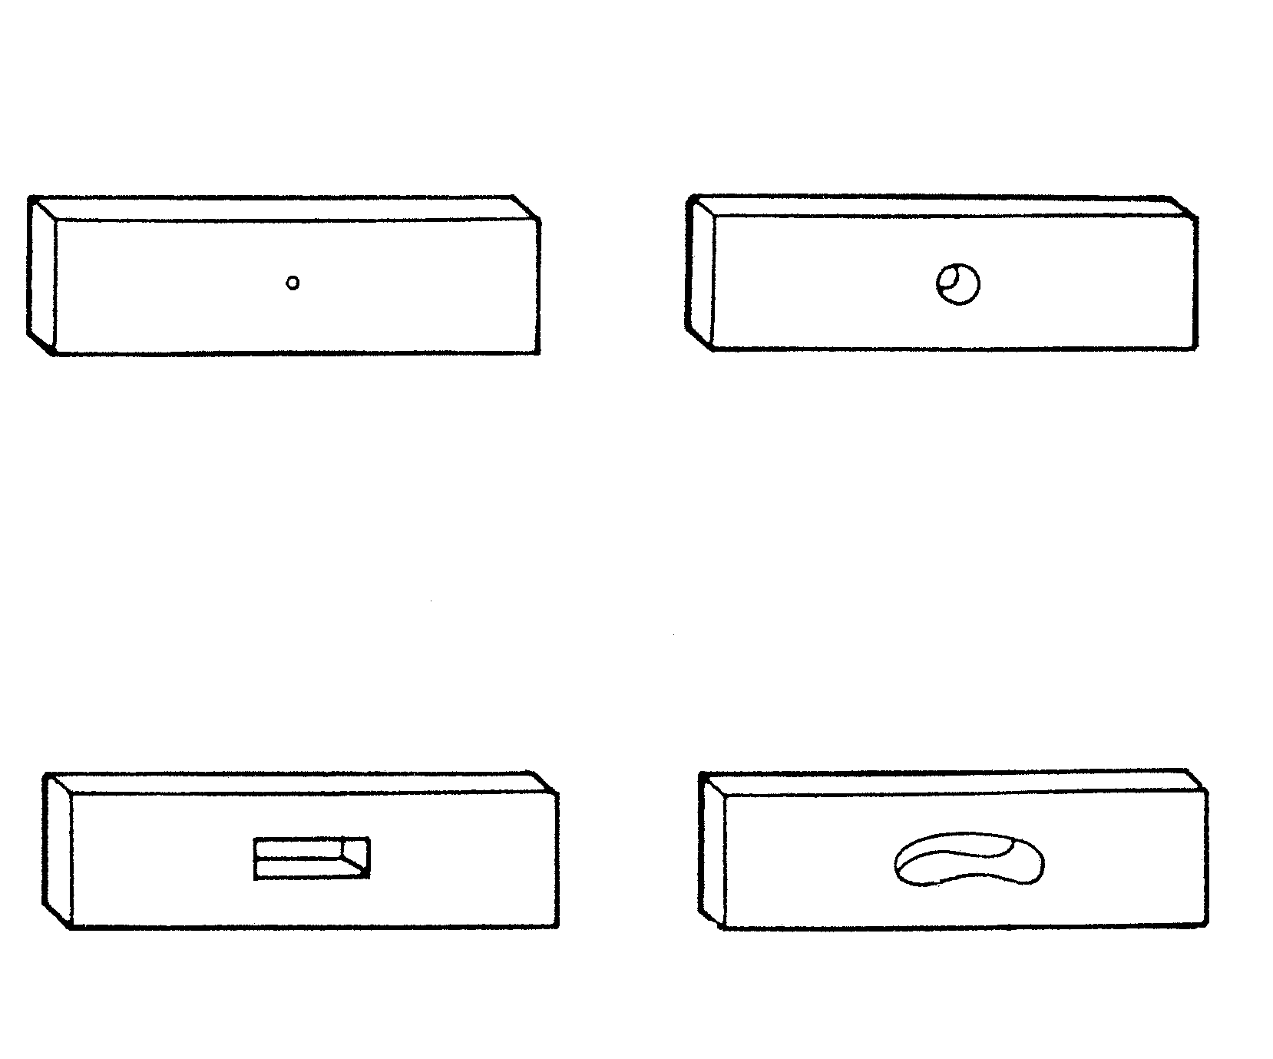
A
B
C
D

Figure 2.5

Explain and sketch

- how the holes can be measured and marked out and  - how each hole would be cut. State the tools you will use. | (4)  (6)

2.6 Figure 2.6 shows a joint where the waste wood has been removed.

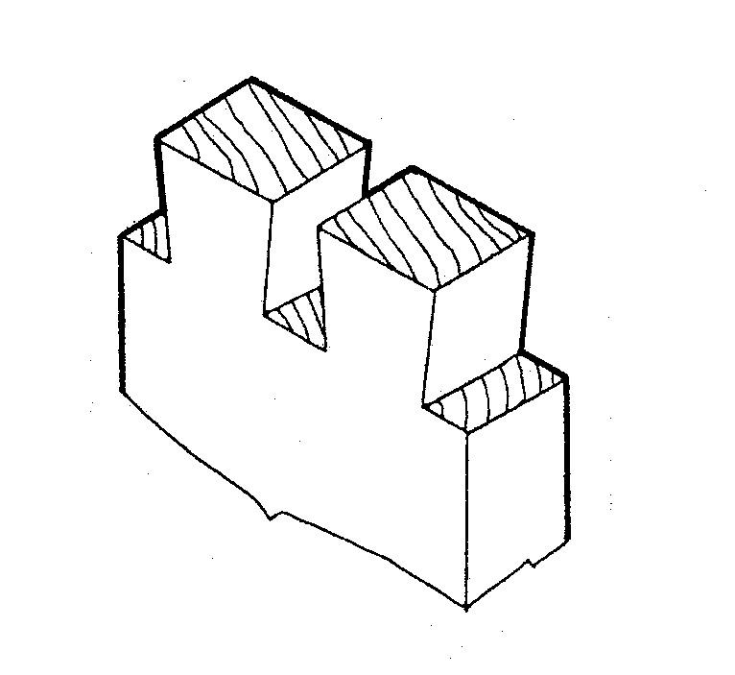

Figure 2.6

- Describe step by step how you would make a similar joint (name the tools you will use).  The joint has already been marked out. | (6)

2.7 Figure 2.7 shows a board with THREE cuts on it.

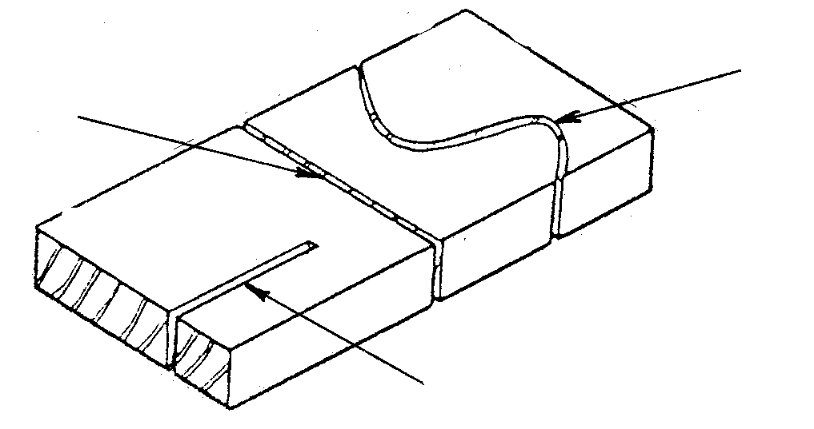
B
C
A

Figure 2.7

2.7.1 Name the saws (hand saws) most suitable to make each of the cuts. | (3)  [40]

QUESTION 3
MACHINE TOOLS

3.1 Figure 3.1 shows a drawing of a three-pin plug of the type which is commonly fitted to portable power tools.

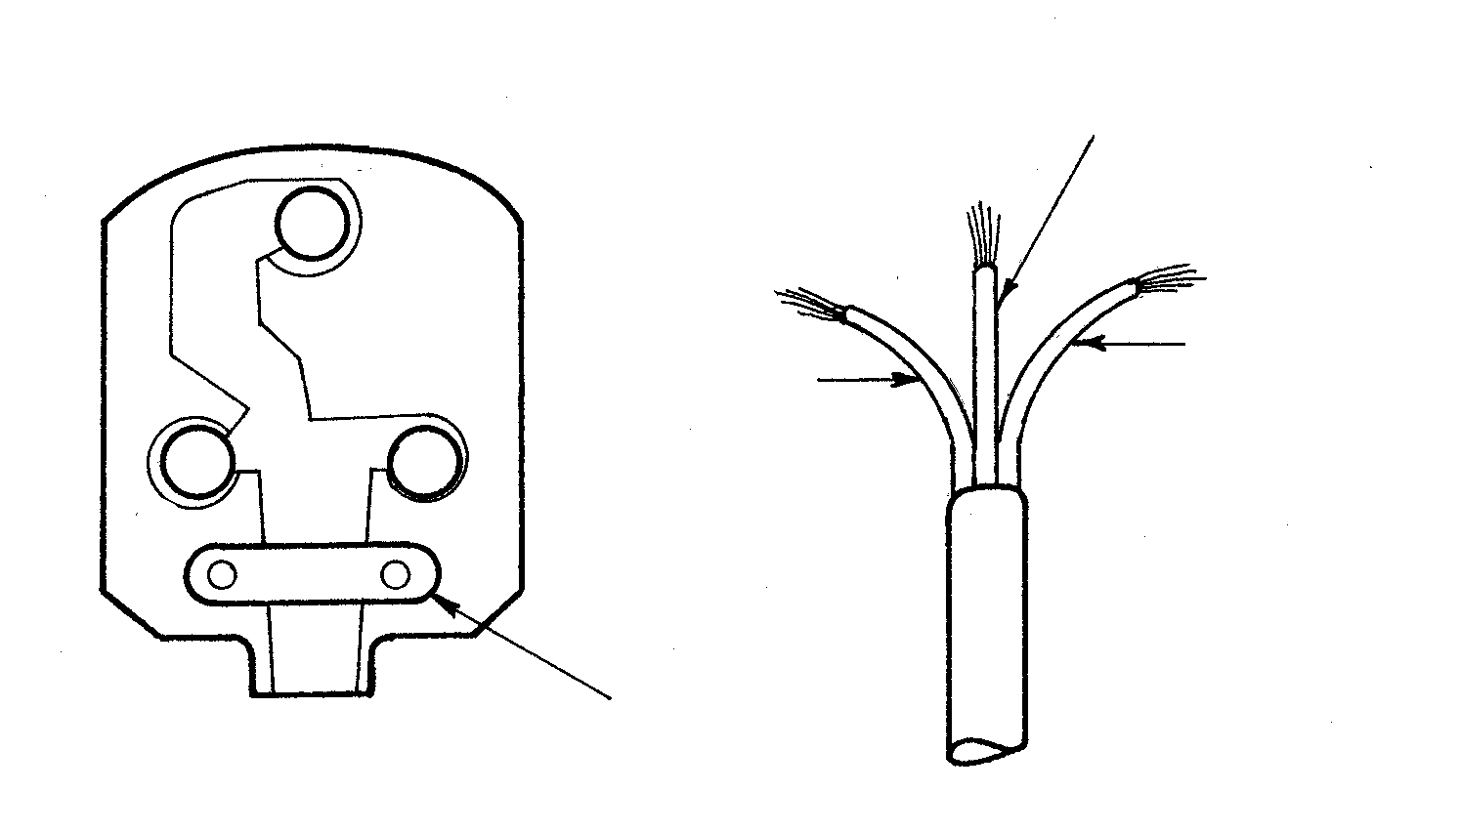
BROWN
BLUE
GREEN AND YELLOW

N
L
X
E

Figure 3.1

- Write down the codes L, N and E, below one another, and for each of the terminals, state the colour of the electrical wire that should be connected to it.  - What is the function of the part marked X? | (3)  (1)

3.2 The circular saw:  3.2.1 Figure 3.2.1 shows a sketch of a circular saw blade and a board that is being ripped. What should the distance (X) be set at, above the board’s surface? | (1)

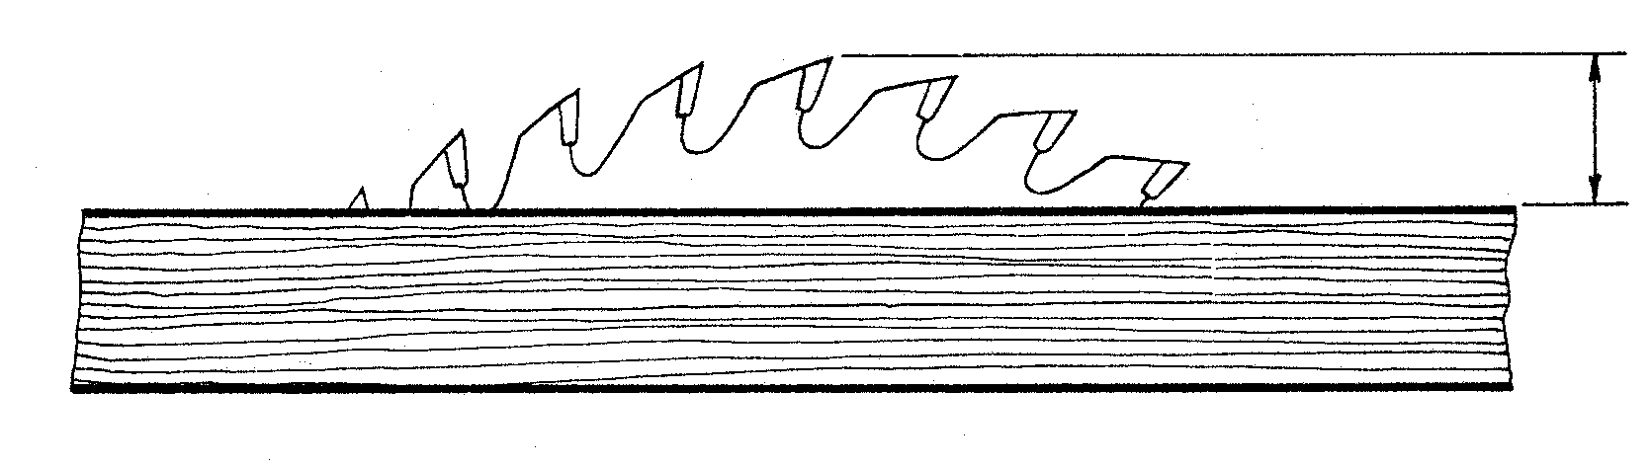
X

Figure 3.2.1

3.2.2 Figure 3.2.2 shows THREE unsafe situations. Identify them and briefly describe how you would rectify each one.

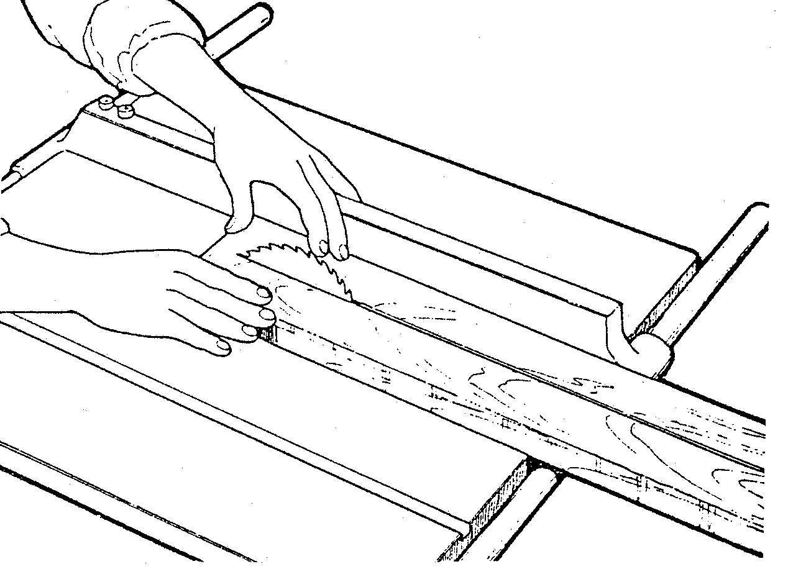 | (6)

Figure 3.2.2

3.3 The wood turning lathe  - Figure 3.3.1 shows the pulley arrangement for a wood turning lathe.  Which symbol (A, B, C or D) shows the lowest speed? | (1)

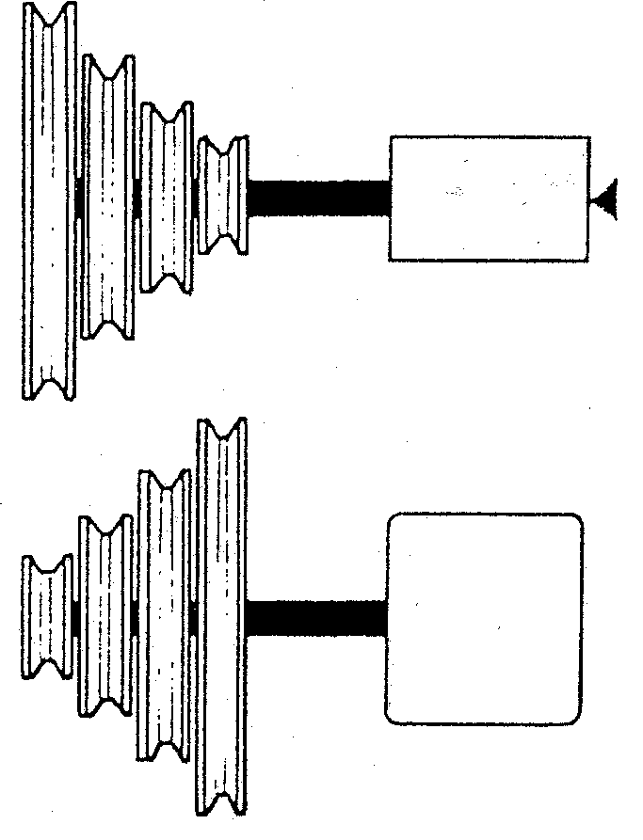
A
B
C
D
WORK
MOTOR

Figure 3.3.1

3.3.2 Figure 3.3.2 shows a sketch of a handle that has been turned between centres on a lathe. The piece of waste wood on the end will be sawn off.

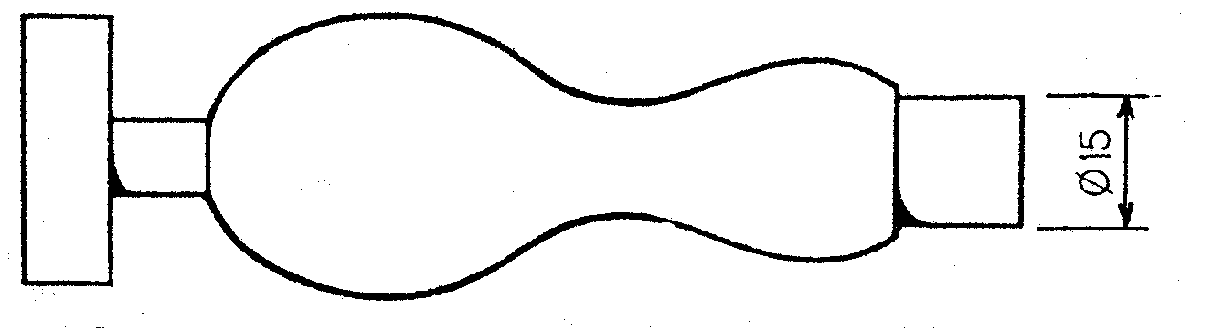

Figure 3.3.2

Using the following sub-headings, explain how you would turn a similar piece of work (use sketches to illustrate your answer):  - Preparation of wood to be turned  - Fitting of turning piece to the lathe  - Setting the tool rest for the cutting technique  - The names of the turning chisels to be used  - The tool that is used to check the 15 mm diameter for correct size. | (2)  (3)  (2)  (4)  (1)

3.4 The bandsaw  - How would you determine the size of a bandsaw?  - To make a bandsaw safe, certain parts are covered with guards.  State the names of THREE such safety guards.  - What can be done when a blade is too wide to follow a curve that is to be cut? Use a sketch to illustrate your answer. | (1)  (3)  (2)

3.5 The jointer  - The jointer is one of the most dangerous machines in the woodwork centre. State THREE safety measures which should be applied when planing a board 400 mm in length.  - Figure 3.5.2 shows two methods that may be used to plane a curved board. | (3)

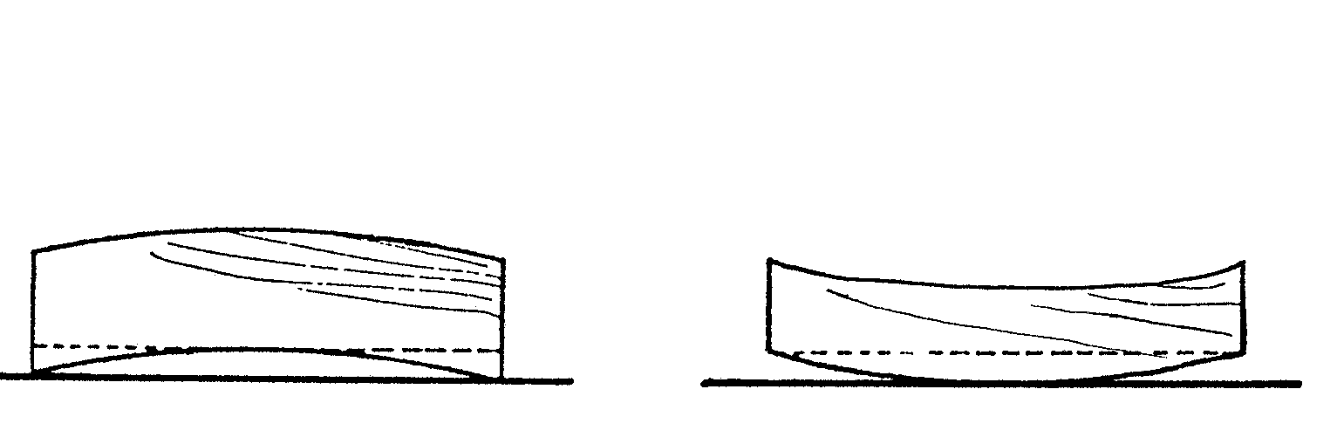
A
B

Figure 3.5.2

- Select the method you would choose (A or B).  - Why have you chosen this method? | (1)  (1)

3.6 Portable power tools  - Study Figure 2.4 on page 6 and answer the following questions:  - Which portable power tool can be used to cut the fish?  - What can be used to hold the board while cutting out the fish?  - Which portable sander would you use to do the final finishing on the board? | (1)  (1)  (1)

- The lifetime of portable power tools depends a lot on how well they have been maintained. State TWO precautionary measures which you consider important when caring for portable power tools. | (2)  [40]

QUESTION 4  CONSTRUCTION AND WOODWORKING JOINTS  - Describe step by step how you would prepare four boards for making a tabletop by using rubbed glued joints. Make use of THREE sash cramps to clamp the boards. Use the following headings:  4.1.1 Preparation of edges  - Sketch the arrangement of the boards showing the endgrain.  - The glue process  - Placing of cramps | (2)  (1)  (2)  (2)

4.2 Figure 4.2 shows a sketch of a simple picture frame.

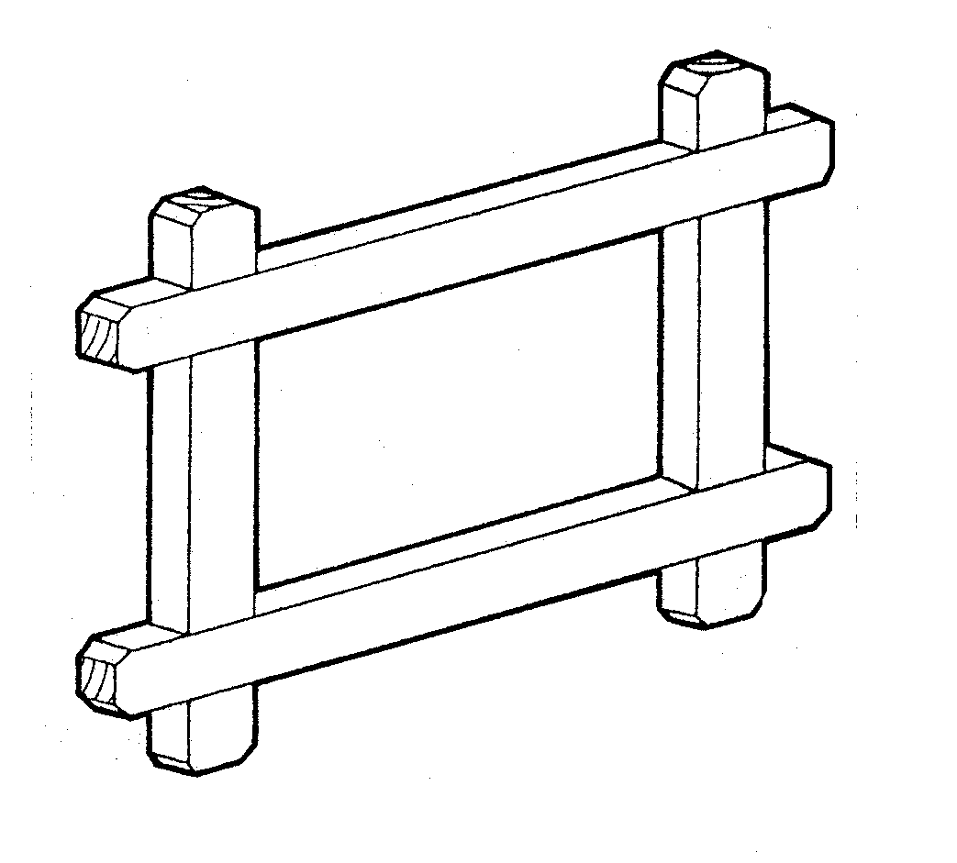

Figure 4.2

- Which joint can be used?  - By means of a sectional sketch, show how the frame can be altered to accommodate the picture and the glass | (1)  (2)

4.3 Figure 4.3 shows a sketch of a simple book-shelf without the applicable joints.

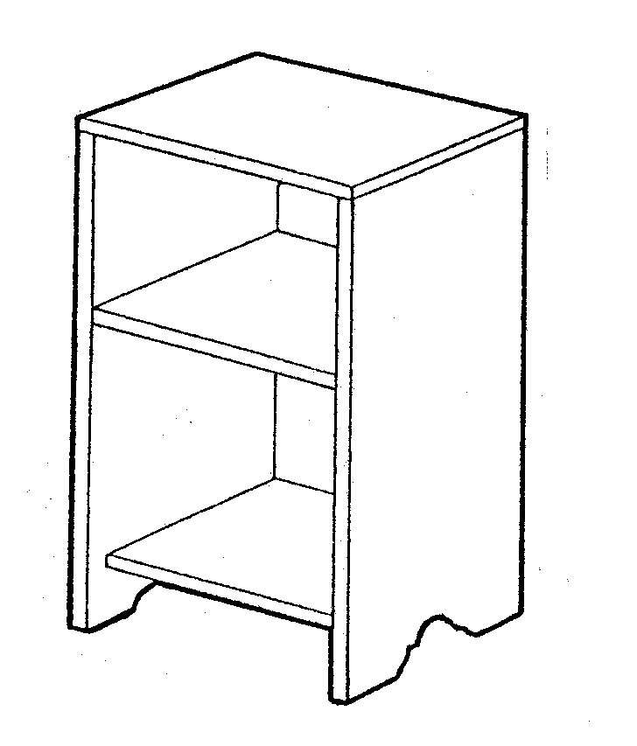

C
B
A
A

Figure 4.3

- Which joint can be used to join A and B?  - Which joint can be used to join C to A?  - A back-piece is attached to the back without being visible from the sides. How can it be done? | (1)  (1)  (1)

4.4 Figure 4.4 shows a drawing of a table construction.

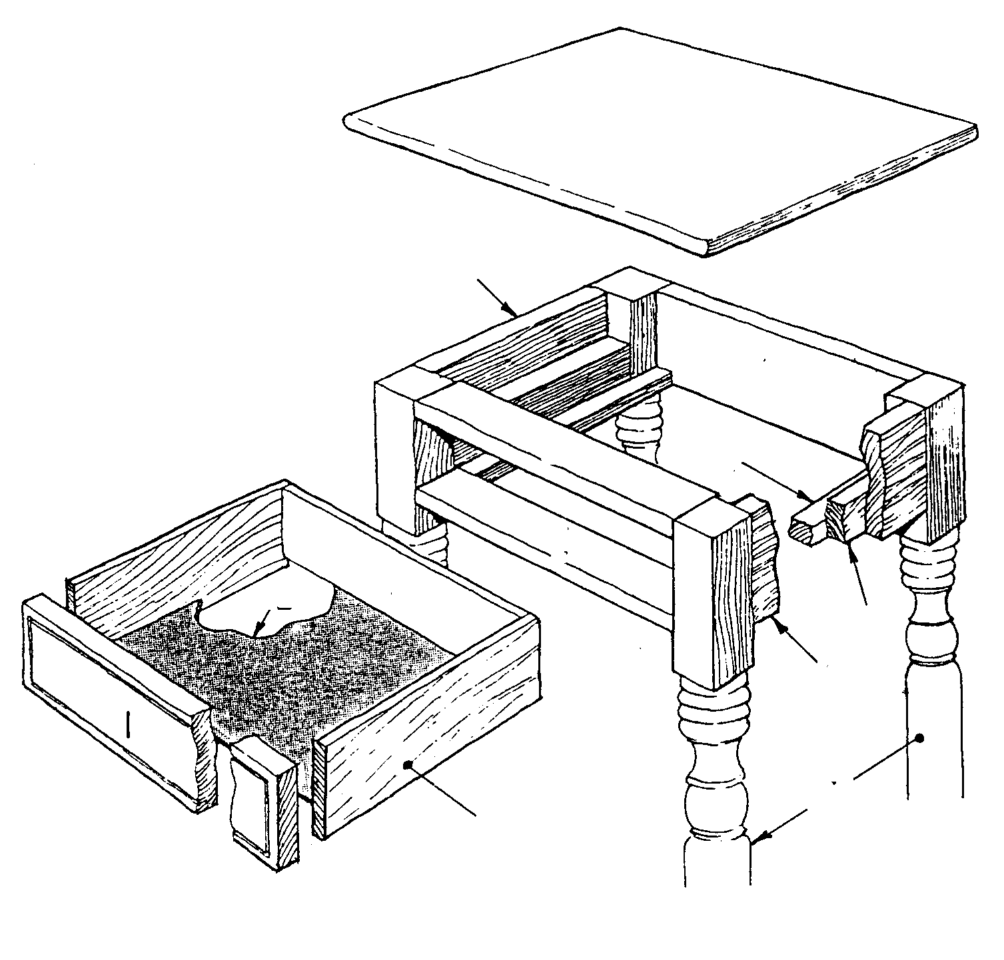
H
A
F
C
B
A
J
G
K
L
D
E

Figure 4.4

- Write the letters A-L below one another and next to it the name of the specific part.  - Which joint can be used to join the following parts?  - A to G  - D to G  - E to G  - I to J  (e) J to K  (f) L to I and J | (12)  (6)

- Show by means of a sketch how H can be fixed to the frame of the table.  - Show by means of a sketch the steps you will follow to secure C to B by using countersink screws. | (3)  (3)

4.5 The ratio for a single dovetail joint is normally 1:6 or 1:8.  - Which ratio is used for softwood?  - Provide a reason for your answer. | (1)  (1)

4.6 What precaution may be taken to ensure that joints made in a high oil containing wood will join well? | (1)  [40]

QUESTION 5
DESIGN, PRESERVATION AND FINISHING

  - Design

5.1.1 Figure 5.1.1 shows a wall cabinet which is designed to accommodate removable 6 mm plywood sliding doors.

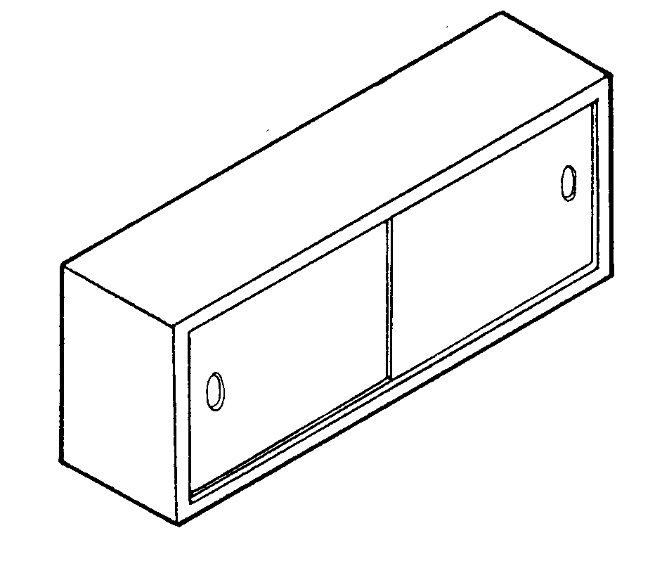

Figure 5.1.1

The grooves for the doors will be cut directly into the top and bottom of the cabinet.

One of the following options is regarded as correct:

- The grooves at the top and bottom are the same depth
- The grooves at the top are deeper than those at the bottom
- The grooves at the bottom are deeper than those at the top

- Draw, freehand, a sectional drawing showing the grooves of the top and bottom sections to accommodate the sliding doors. | (4)

5.1.2 A quartz-electric kitchen clock is to be housed in the illustrated wooden case (Figure 5.1.2).

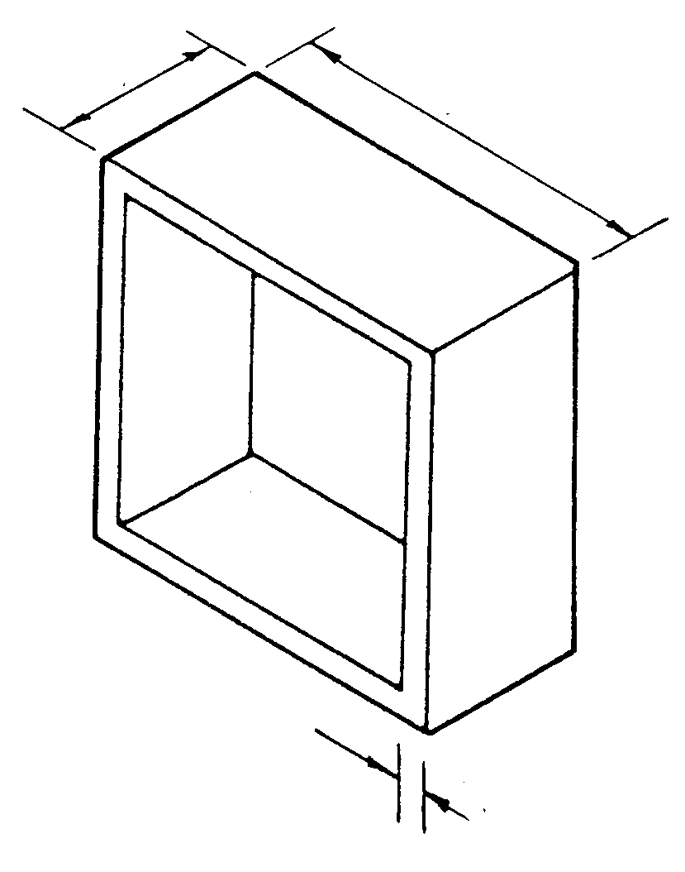
150
70
10

Figure 5.1.2

- Design a clock face and draw the front view.  - The following design principles are applicable in the manufacturing of the case. Discuss these principles.  - Functionality  - Choice of material  - Construction (joints used on the case and mounting of the face)  - Which type of protective coating will you use and why? | (4)  (8)

5.1.3 Figure 5.1.3 (A) shows a chest of an early period while Figure 5.1.3 (B) shows a contemporary chest.

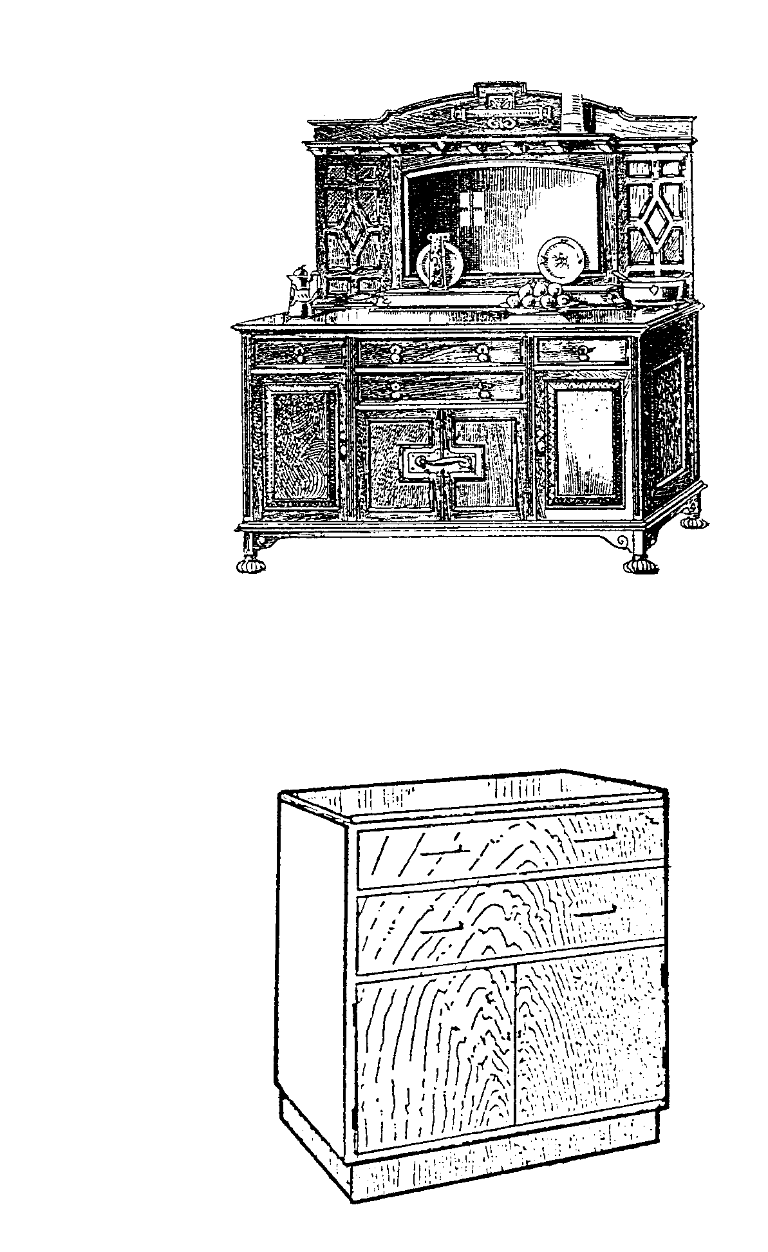
A
B

Figure 5.1.3

Copy the table below in your answer book and compare the characteristics of the two above-mentioned pieces of furniture. List FIVE characteristics of each. | (10)

Early furniture design  (Fig. 5.1.3 A) | Contemporary furniture design  (Fig. 5.1.3 B)
1.  2.  etc. | 1.  2.  etc.

- Wood that is used outdoors becomes exposed to a number of wood-destructive factors.  5.2.1 List THREE organic factors.  - State the name of a preservative that could be used outdoors with great success.  - List EIGHT requirements such a preservative should meet.  - State the name of a method of treatment.  TOTAL: | (3)  (1)  (8)  (2)  [40]  200 2=100

