GAUTENG DEPARTMENT OF EDUCATION

SENIOR CERTIFICATE EXAMINATION

WOODWORK SG
(Second Paper: Theory)

TIME: 2 hours

MARKS: 100

INSTRUCTIONS:

- Sketches may be used to illustrate your answers.

- Start each question on a new page.

- Answer ALL the questions.

QUESTION 1

TIMBERS, CONVERSION METHODS, COMMERCIAL FORMS AND GRADING

1.1 You will find that part of the fascination of making things with wood is learning to identify the different species of timber and being able to tell how each piece will behave when you begin to work with it.

Table 1.1 shows various characteristics and names of timber. Write down the letters A to X below one another. Read the rows vertically and use the information provided to find the answers. Choose the relevant facts and write it next to the letters A to X.

 | Origin | Colour of heartwood | Odour | Texture | Contains | Working properties
 | Zambia  Knysna (SA)  Uganda  Britain  Mpumalanga (SA)  Brazil  Japan  USA  South - America | Grey  Light brown  Dark brown  Reddish  Reddish  brown  Light red  Dark red  Straw  Yellow | Cedar  Spicy  Resin  Sweet  Disagreeable | Fine  Medium  Rough | Oil  Resin  Gallic acid | Works very easily  Tearing  Grain filling necessary  Difference in hardness makes finishing difficult
Beech |  | G
Yellowwood | A |  |  | P
Imbuia |  |  | M
Iroko |  |  |  | Q |  | V
Japanese oak |  |  |  |  | S
Kiaat | B | H |  | R
Oregon pine |  | I
Pau Marfin | C | J
S.A. pine | D |  |  |  | T | W
Sapele mahogany | E | K
Stinkwood |  | L | N |  |  | X
Tamboti | F |  | O |  | U
(24)
Table 1.1

- Which timber listed in Table 1.1 is traditionally used for each of the following?  1.2.1 Fruit and vegetable trays  - Durable panelling (indigenous timber)  - Building construction  - Durable furniture (exotic timber) | (4)

1.3 Timbers used commercially are classified as softwoods and hardwoods.  List the FIVE categories which the SABS uses to classify timber used by the industry. | (5)

1.4 Conversion methods  - State and sketch the method which is generally used for S.A. pine.  - List three reasons why this method is used on S.A. pine. | (1)  (3)

1.5 State and sketch three different types of warping that occur in seasoned boards. | (3)  [40]
QUESTION 2  HAND TOOLS  - When buying hand tools, the size of the specific tool should be given. How will you specify each of the following tools?  2.1.1 Steel rule  - A saw  - A chisel  - A cross pene hammer | (4)

2.2 Figure 2.2 shows a drawing of a long board with two planes (A and B) on it.

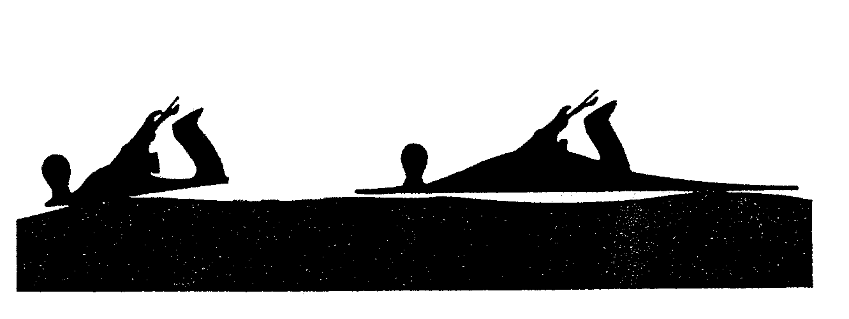
A
B

Figure 2.2

- Write down the letters A and B below each other and next to each the correct names of the planes.  - Which plane will you use to even the board? | (2)  (1)

2.3 What can be done to prevent a board’s endgrain, as illustrated in Figure 2.3, from tearing out when the end is planed? | (2)

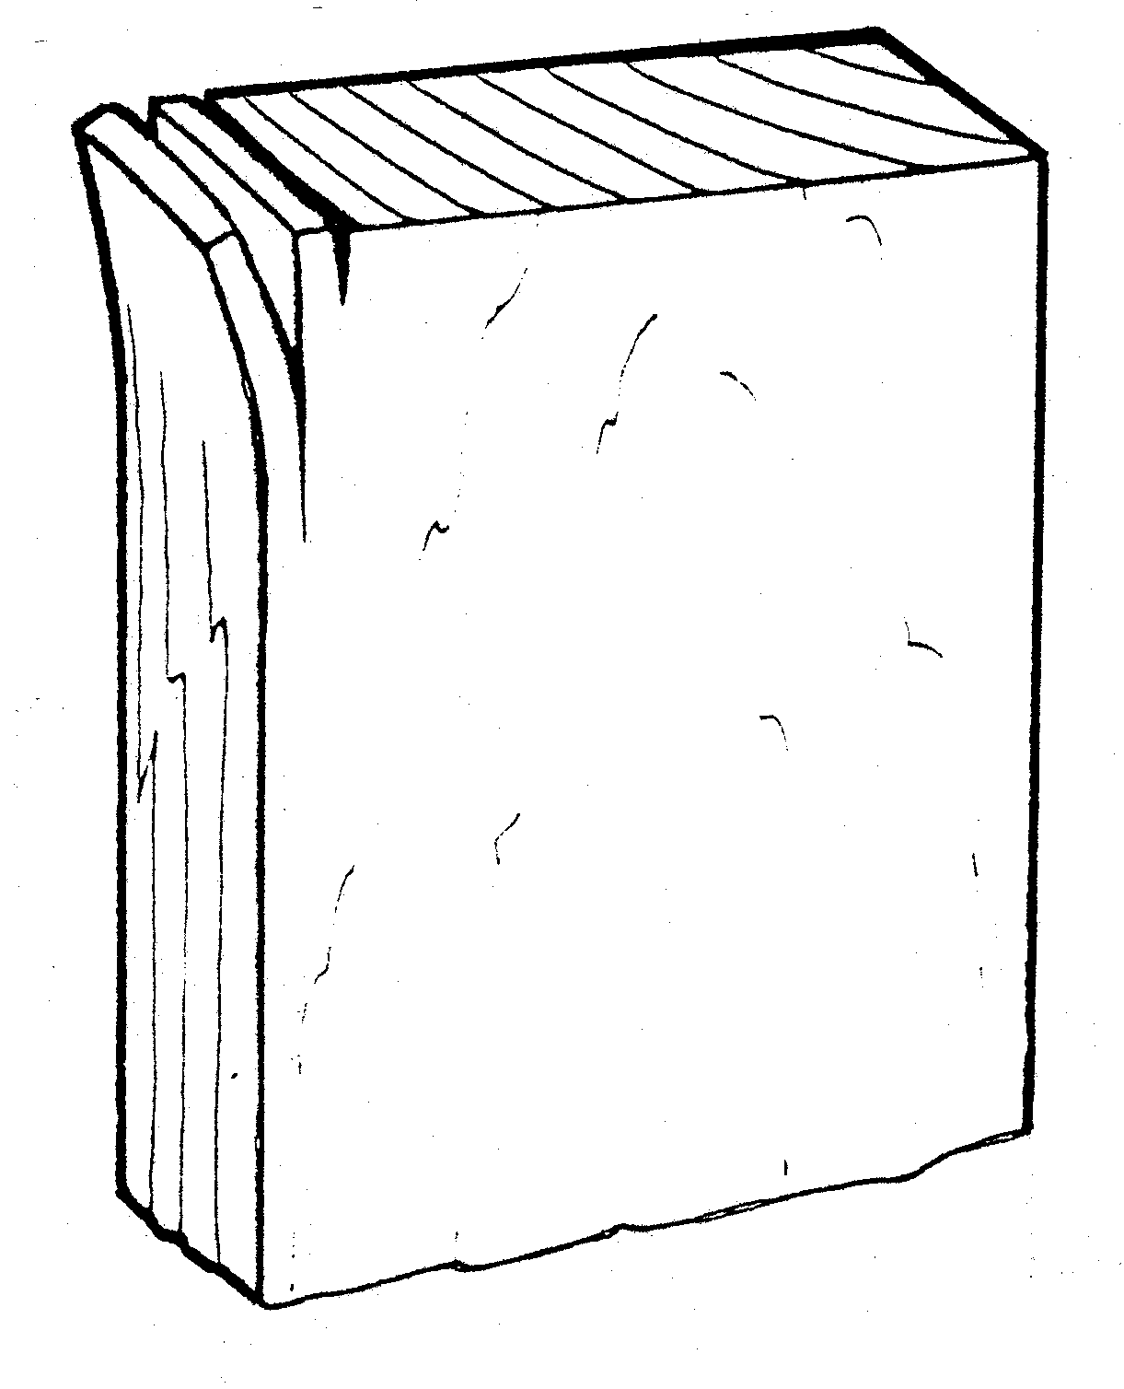

Figure 2.3

2.4 Figure 2.4 shows drawings of two drill bits.

A

B
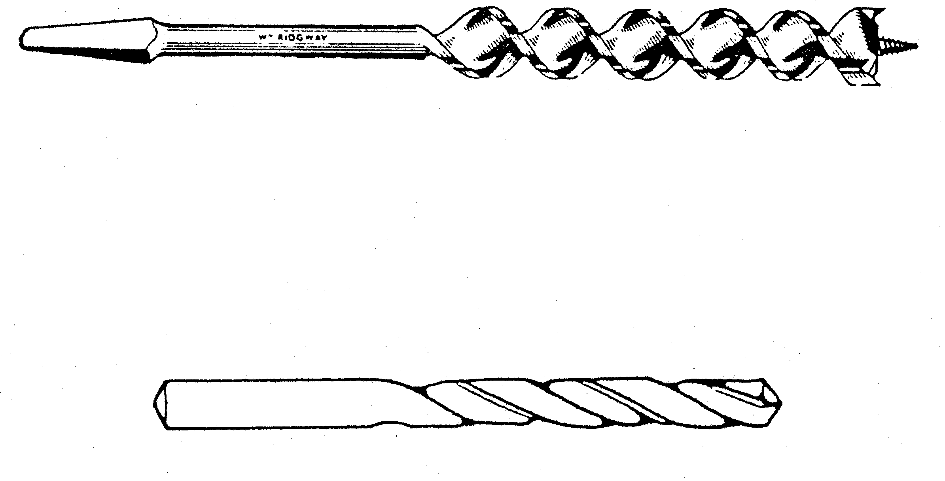

Figure 2.4

- Write down the letters A and B below each other and next to each the correct name of each drill bit.  - Into which type of chuck does each drill bit fit?  - If you want to drill a hole through a board by using A, what will you do to prevent the wood at the back from tearing out? | (2)  (2)  (1)

2.5 Figure 2.5 shows a joint where the waste wood has been removed.

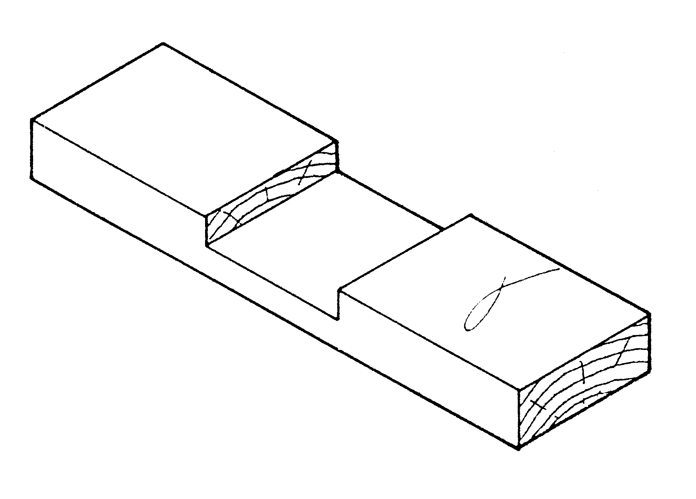

Figure 2.5

- Describe step by step how you will make a similar joint (the joint has already been marked out).  List the tools you will use. | (6)

2.6 Figure 2.6 shows the front view of a plane. What is wrong with the cutting iron and how could it be rectified? State the parts that are used to do the adjustments. | (2)

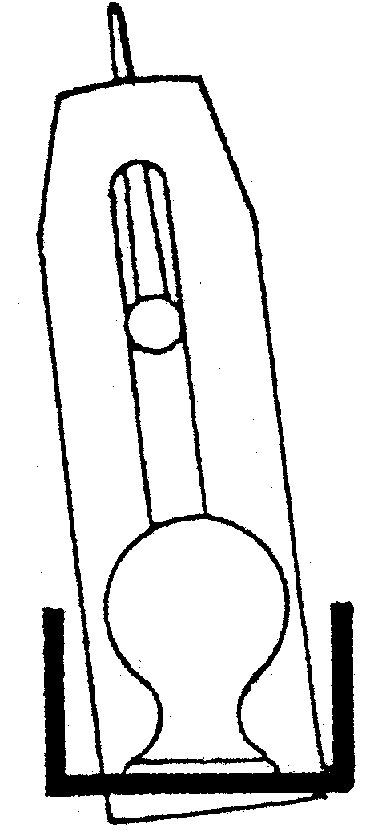

Figure 2.6

2.7 Figure 2.7 shows part of a side view and front view of the teeth of two different saw blades.

A
B
KERF
KERF
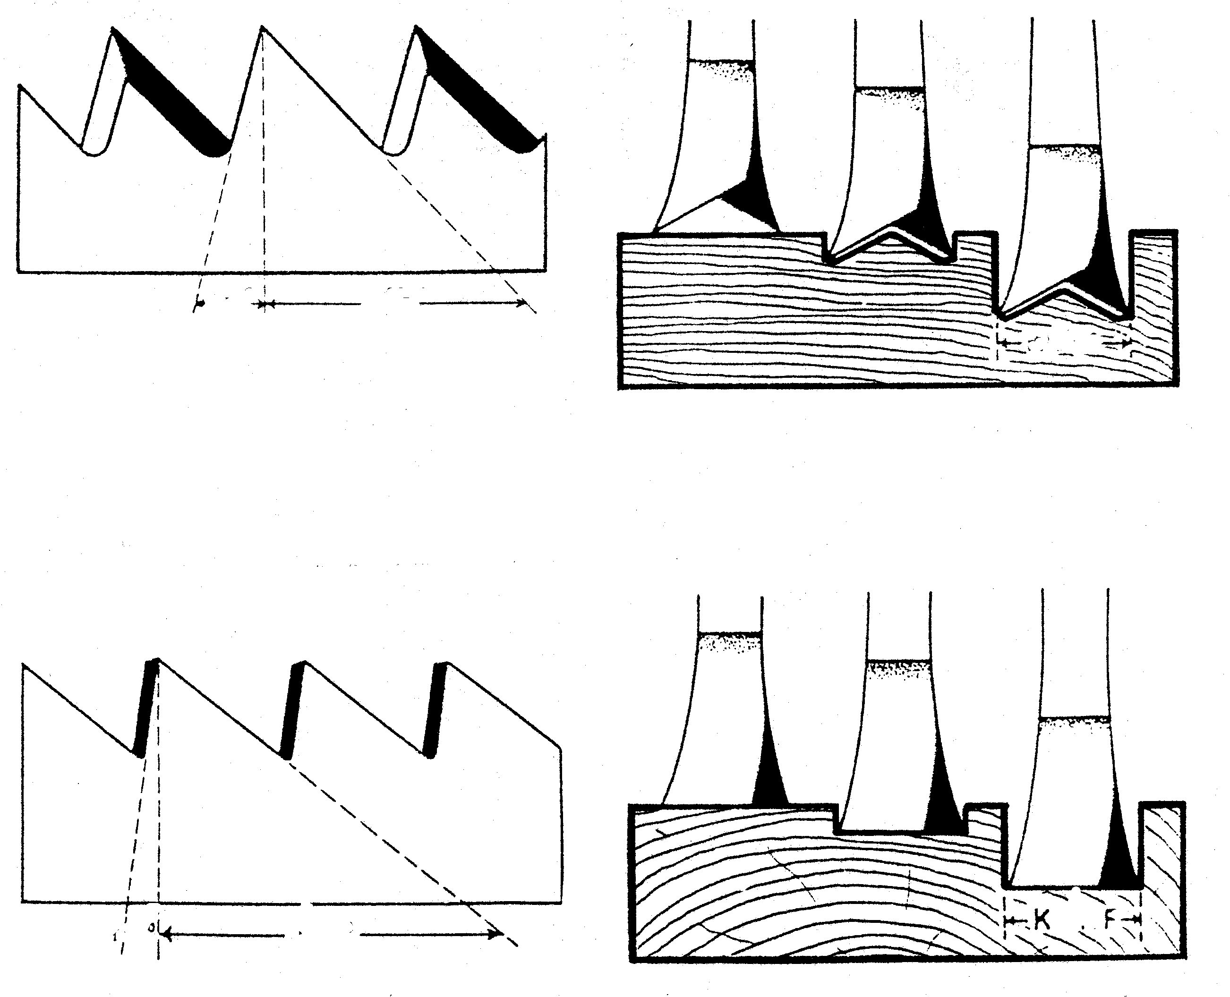

Figure 2.7

2.7.1 To which saw does the teeth as shown in A belong? | (1)
- To which saw does the teeth as shown in B belong?  - State the specific function of each saw. | (1)  (2)

2.8 Figure 2.8 shows two useful aids.

A

B
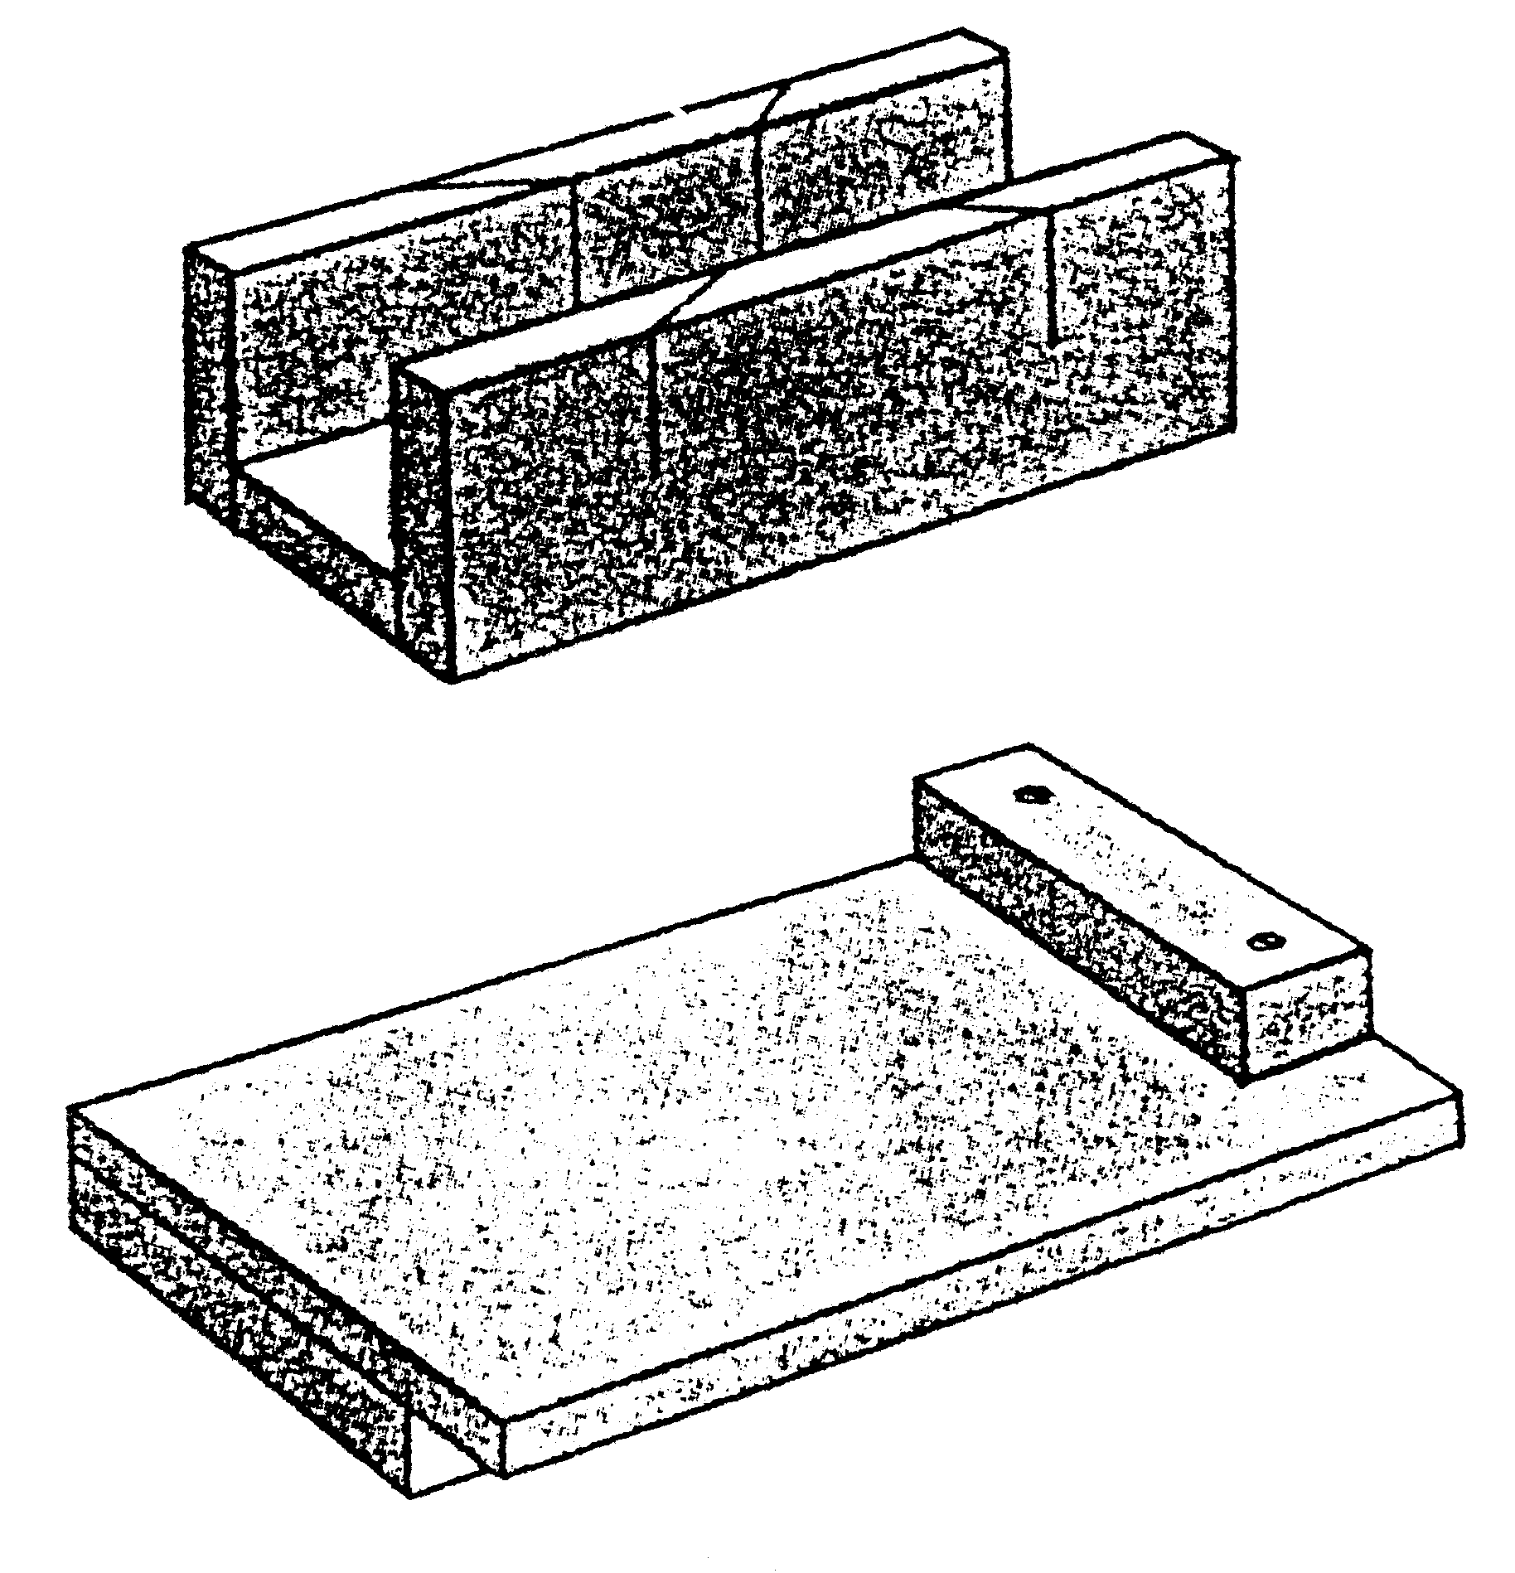

Figure 2.8

- State the correct names of the two aids.  - Which saw is usually used with these aids?  - What can A be used for?  - Name TWO different uses for B. | (2)  (1)  (1)  (2)

2.9 How can the following hand tools be maintained? List three points of importance for each.

2.9.1 A jack plane  2.9.2 A tenon saw | (6)

2.10 What are the TWO main causes of accidents when working with hand tools? | (2)  [40]

QUESTION 3

MACHINE TOOLS

3.1 Figure 3.1 shows a rough, square cut board to be used as a leg for a table.

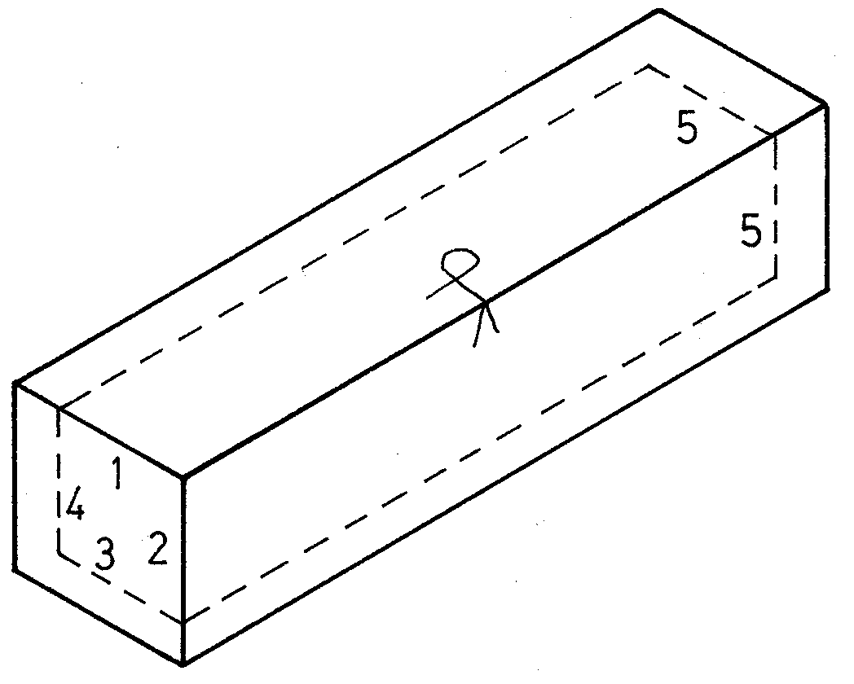

Figure 3.1

- Write the numbers 1–5 beneath each other and explain briefly how the board can be finished to the required dimensions (see hidden details) by using machine tools.  - Draw the TWO symbols shown on the board and explain the meaning of each. | (10)  (2)

3.2 The circular saw

Figure 3.2 shows the top view of a board with two saw cuts (A and B).

B
A

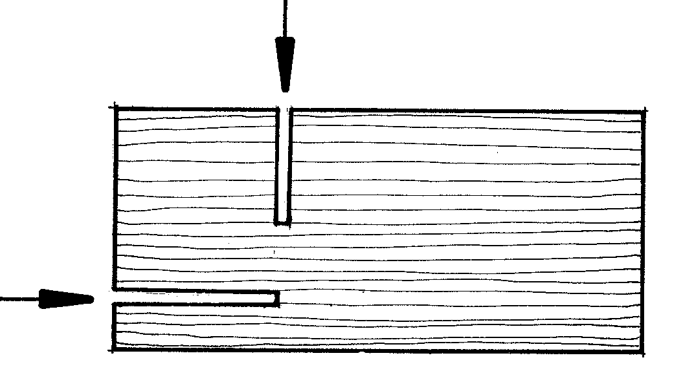

Figure 3.2

- Name the TWO cuts.  - Which aid is used to cut A?  - Which aid is used to cut B with safety? | (2)  (1)  (1)

3.3 The wood turning lathe

3.3.1 Figure 3.3.1 shows an illustration of a turning chisel.

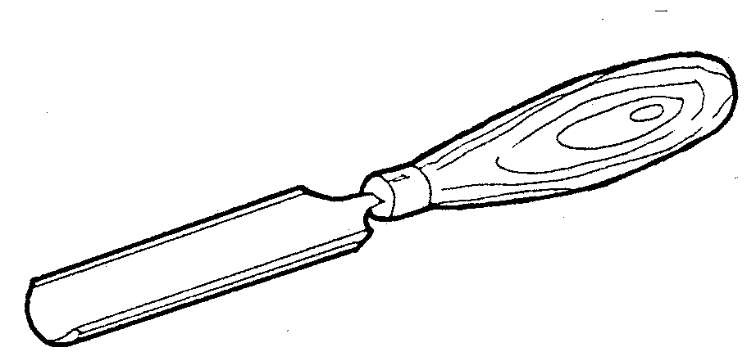

Figure 3.3.1

- (a) Name the chisel.  (b) What is it used for? Specify  (c) Briefly describe how you will sharpen it. | (1)  (1)  (2)

3.3.2 You must turn four identical legs for a table on the wood turning lathe. The school does not have a copy lathe or copying appliance.  What aids and testing tools will you use to ensure that the four legs are identical? | (3)

3.4 The jointer

Figure 3.4 shows the cutter block of a jointer with two cutters (A and B) fitted into it. The turning direction of the cutter block is also shown.

B

A
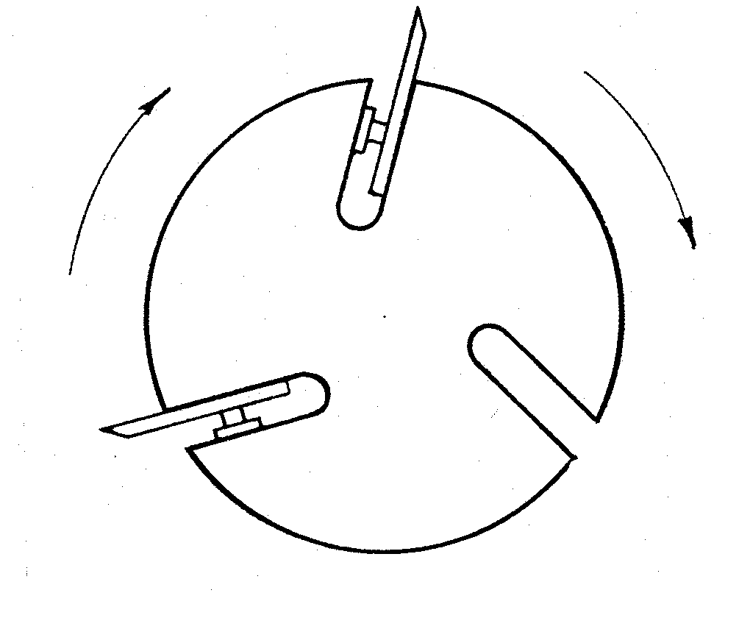

Figure 3.4
- Which cutter is correctly fitted (A or B)?  - What will the result be if the cutters are not set evenly above the cutter block? | (1)  (2)

3.5 The thicknesser

3.5.1 Figure 3.5.1 shows two boards (A and B) that are planed by a thicknesser.
A
B

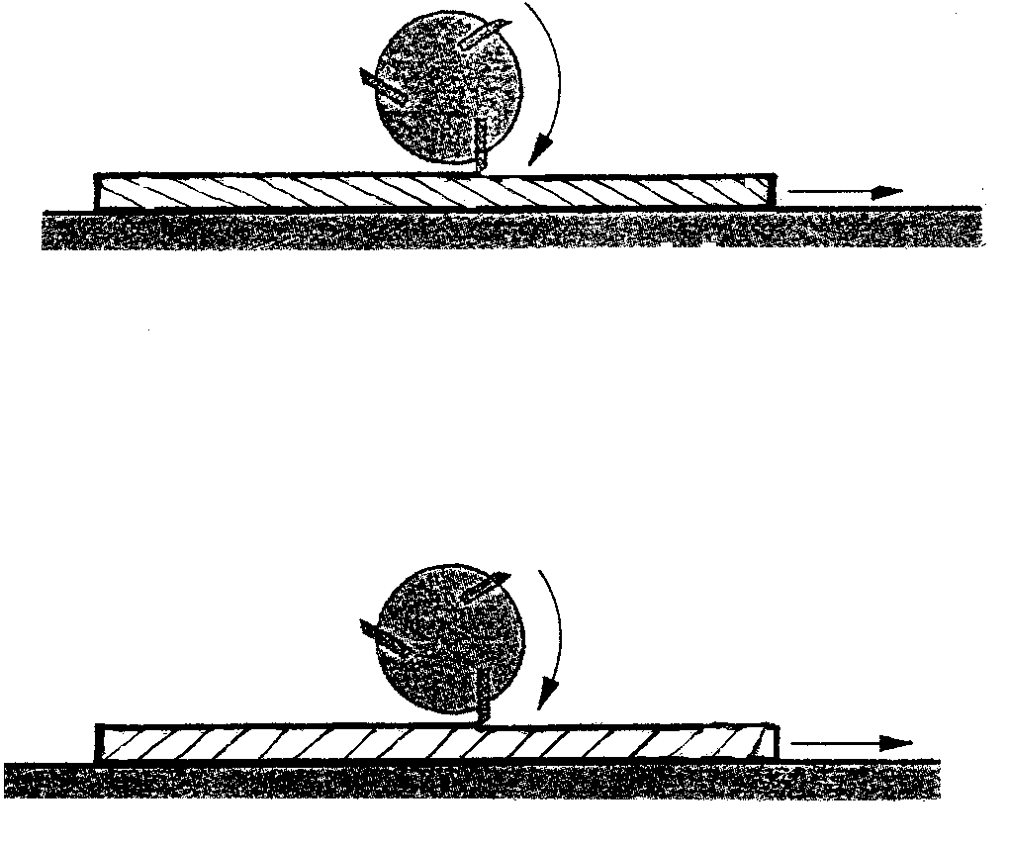

Figure 3.5.1

- Which board is placed correctly (A or B)  - Motivate your answer in (a). | (1)  (1)

3.5.2 State THREE safety measures (not personal safety measures) that should be taken before a board is put through the thicknesser. | (3)

3.6 The drill press

3.6.1 Figure 3.6.1 shows the pulley arrangement of the drill press. Which symbol (A, B, C or D) shows the highest speed?

MOTOR
CHUCK KLEMBUS
A
B
C
D
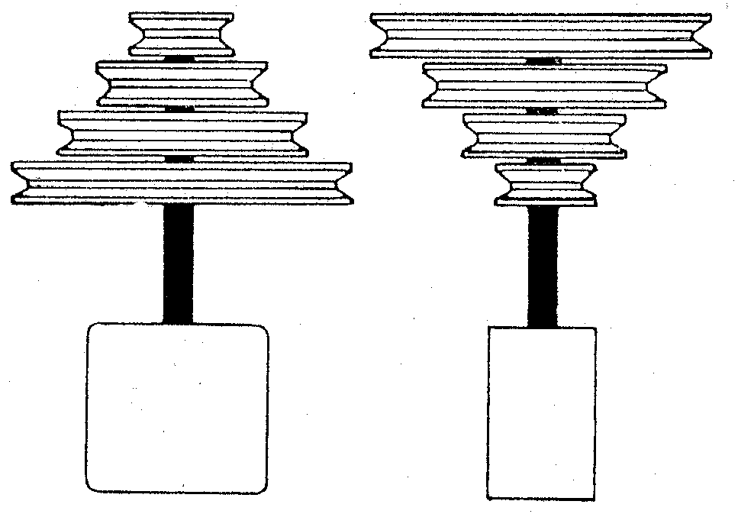

Figure 3.6.1

- Which aid will you use to ensure that a hole will be drilled accurately in a cylindrical turning piece.  - Describe the mortising tool. | (1)  (2)

3.7 The bandsaw

Figure 3.7 shows a board from which a rectangular shape must be cut (see the hidden detail for the shape).

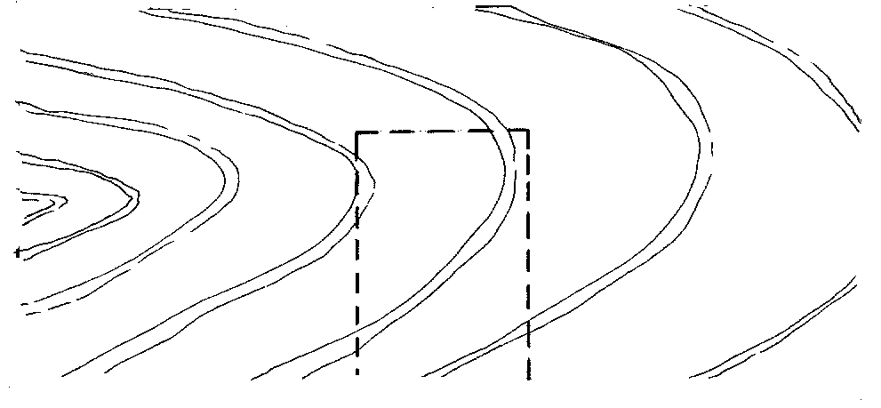

Figure 3.7

Show by means of sketches how this shape can be cut from the board. | (3)

3.8 Portable power tools

Which portable tool can be used to do the following?

- To cut a drawer dovetail joint.  - To cut curves out of 17 mm thick chipboard.  - To shape the edge of a tabletop. | (3)  [40]
QUESTION 4

CONSTRUCTION AND WOODWORKING JOINTS

4.1 Figure 4.1 shows the top sides of four boards with the endgrain clearly visible.

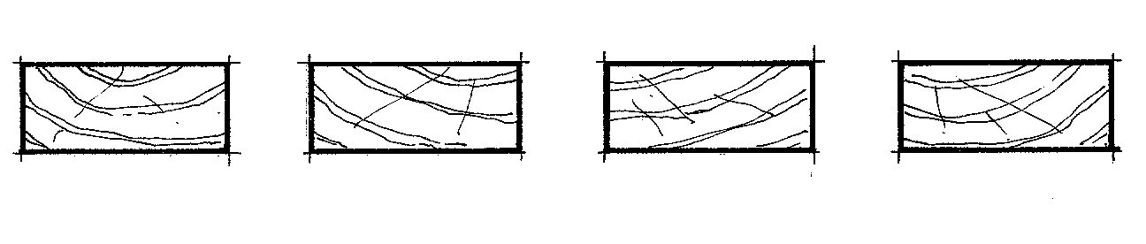

Figure 4.1

4.1.1 Show by means of a sketch how the endgrain of the boards should be arranged for making a tabletop. | (1)
4.1.2 List FIVE different joints that could be used to join the boards. | (5)
4.1.3 Which joint should be used to join wood with a high oil content? | (1)

  - Figure 4.2 shows two doors. Door A has a solid panel and door B has a
glass panel.

A
B
a
b
a
b
c
d
d
c
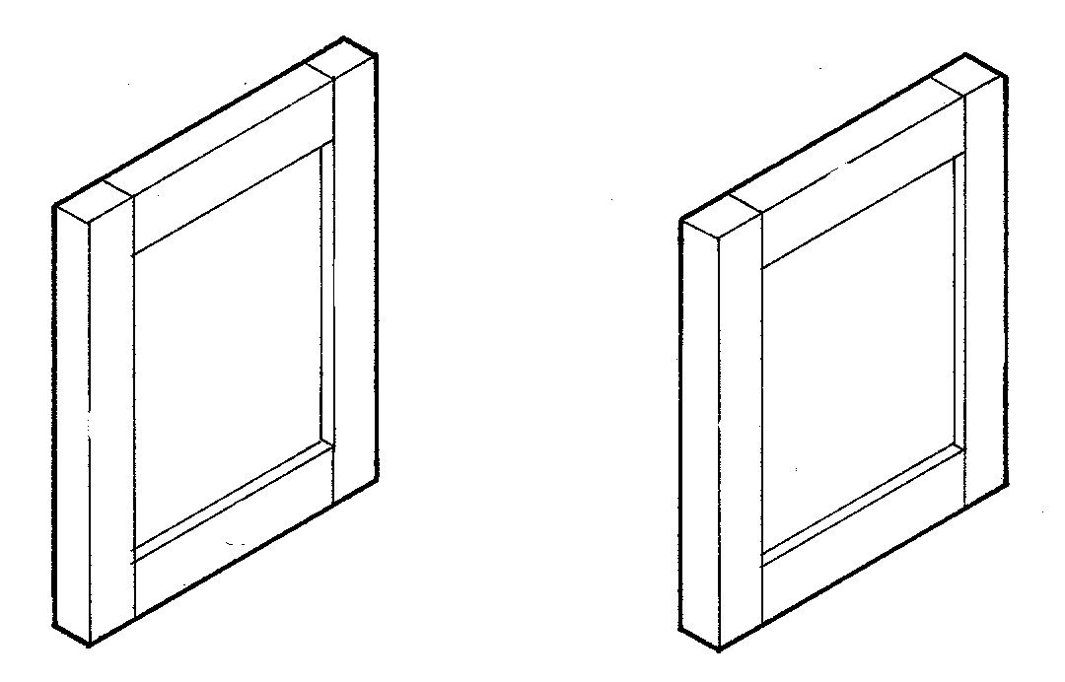

Figure 4.2

- Name the parts a and b.  - Which joint can be used to join a and b at door A?  - Is the panel fixed to the frame with glue? (Yes or no.)  - Provide a reason for your answer.  - Which joint can be used to join c and d at door B?  - How is the glass kept in position? | (2)  (1)  (1)  (1)  (1)  (1)

4.3 Figure 4.3 shows a jewel box without the applicable joints.

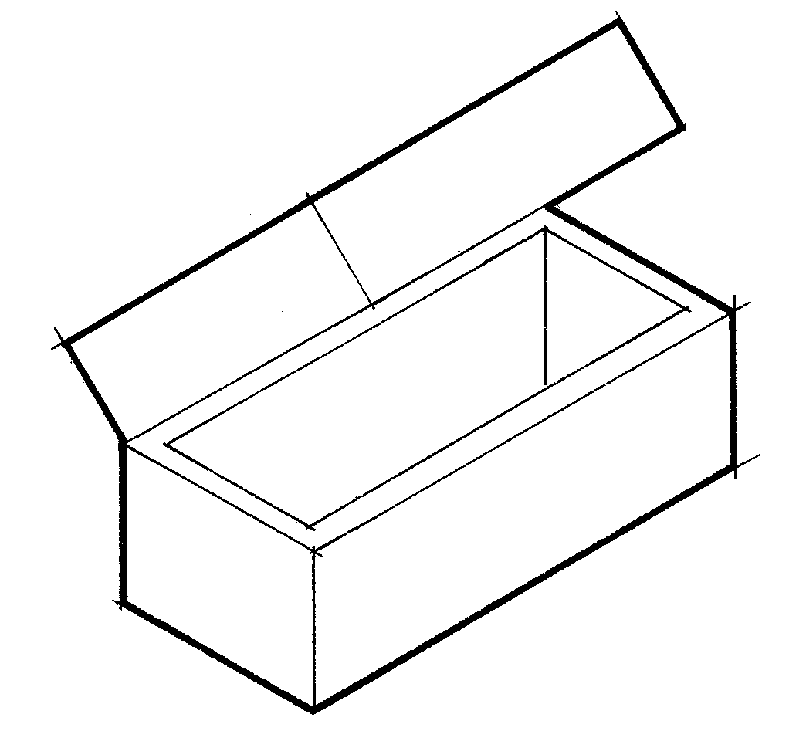

Figure 4.3

- List FIVE different types of joints that can be used to join the sides of the jewel box.  - The bottom of the box is not made of solid wood and should be 4mm thick. State the name of a material (wood product) that could be used.  - How could the bottom be fixed without being visible from the side? | (5)  (1)  (1)

4.4 Figure 4.4 shows a bedside table with the drawer pulled out.

A

A
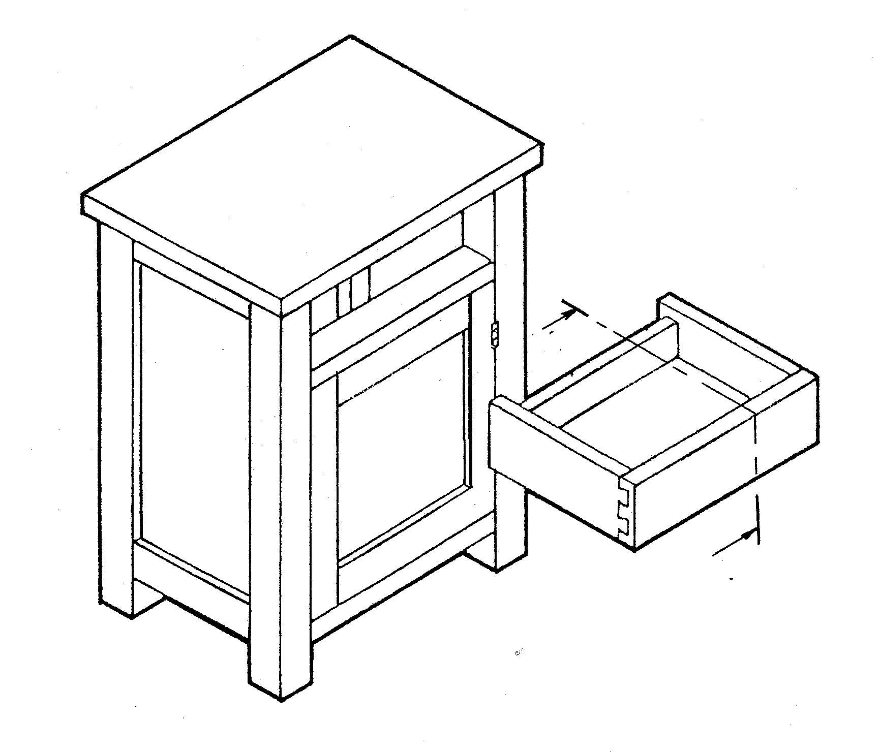

Figure 4.4

4.4.1 Make a neat sectional sketch of the drawer on cutting plane A-A. | (3)
4.4.2 Name the parts of the table construction which hold the drawer in position when it is pulled in and out. | (3)

4.5 Figure 4.5 shows the mortise and tenoned framework of a stool.

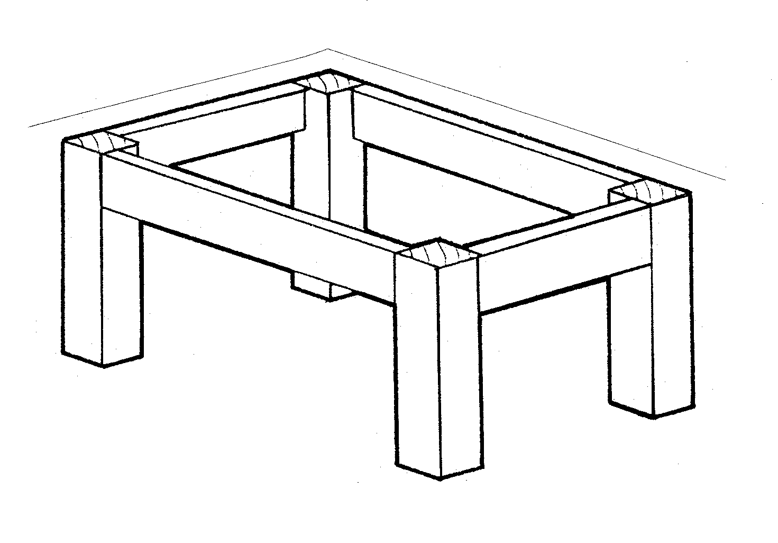

Figure 4.5

4.5.1 State the sequence in which you will glue the frame. | (2)
4.5.2 State TWO reasons why cramps are used while gluing. | (2)
4.5.3 Why is it necessary to remove all excess glue from glued surfaces as quickly as possible? | (1)
4.5.4 State TWO methods that could be used to test the squareness of the frame during the gluing process. | (2)

4.6 Figure 4.6 shows a single dovetail joint.

2
1
3
4
32
24
AS
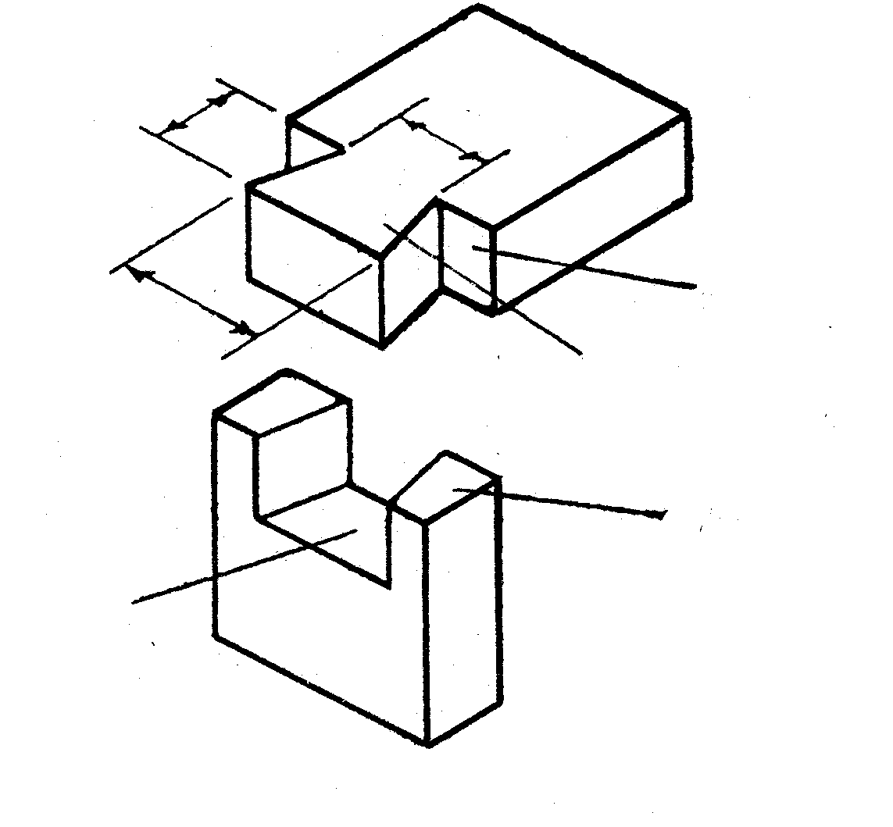

Figure 4.6

- Name the parts/levels marked 1–4.  - The ratio of the dovetail is 1:6. What is the distance at A?  - Supply a suitable use for this joint. | (4)  (1)  (1)  [40]

QUESTION 5

DESIGN, PRESERVATION AND FINISHING

  - Design

5.1.1 Figure 5.1.1 shows sketches of three different types of chairs.

A

B
C
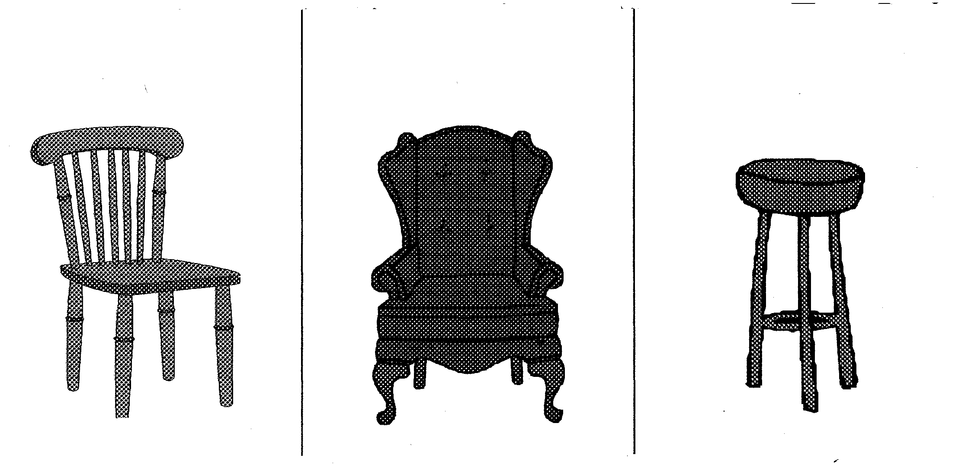

Figure 5.1.1

Copy the table below in your answer book and compare the three above-mentioned chairs with each other with reference to the following design principles: | (6)

 | A | B | C
Function
The role ergonomics
played in the design

    - Figure 5.1.2 shows the outside measurements of a bedroom stool.
The stool has a loose seat which is fixed on to the top of the frame.

400
450
600
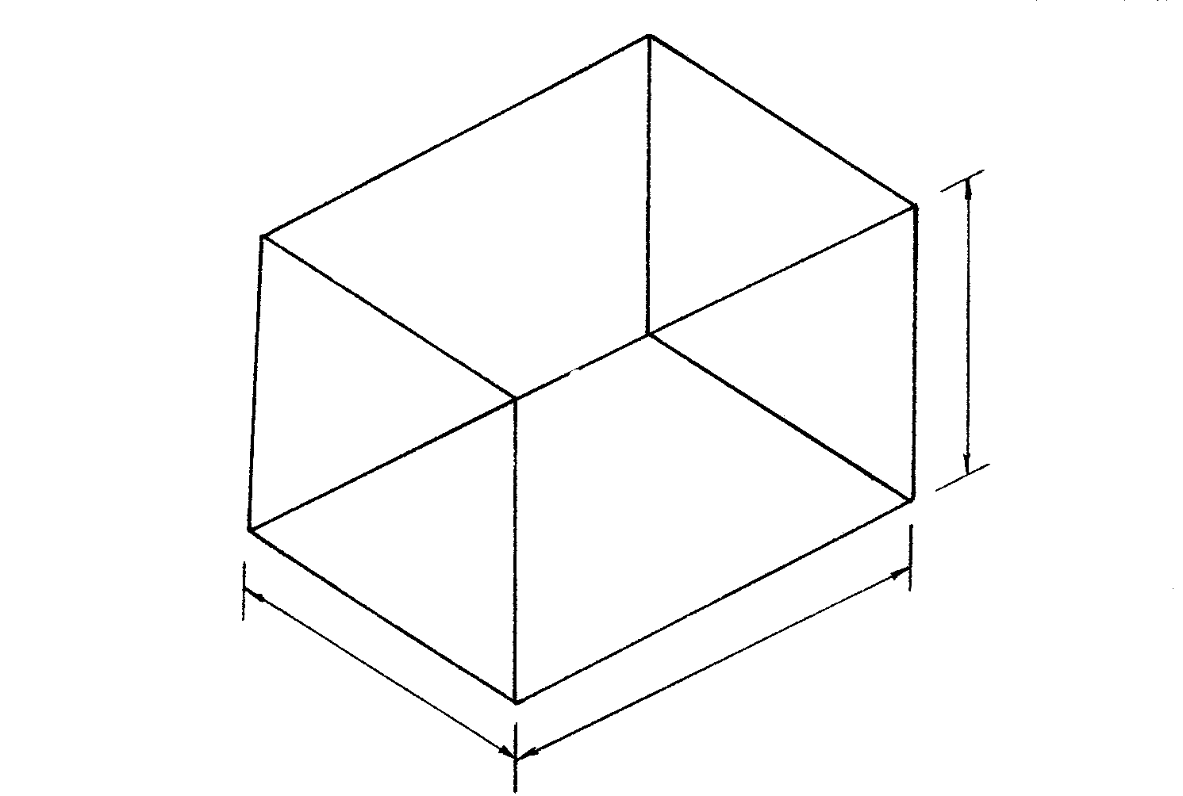

Figure 5.1.2

- Make a freehand isometric sketch of your own design of this stool.  - Show detailed sketches of TWO joints you will use.  - Specify the materials that you could possibly use.  - Which type of polish (protective coating) will you recommend and how will you apply it?  - How will you fix the seat? | (6)  (4)  (2)  (2)  (1)

5.1.3 Figure 5.1.3 shows two tabletop edges (A and B).

B
A
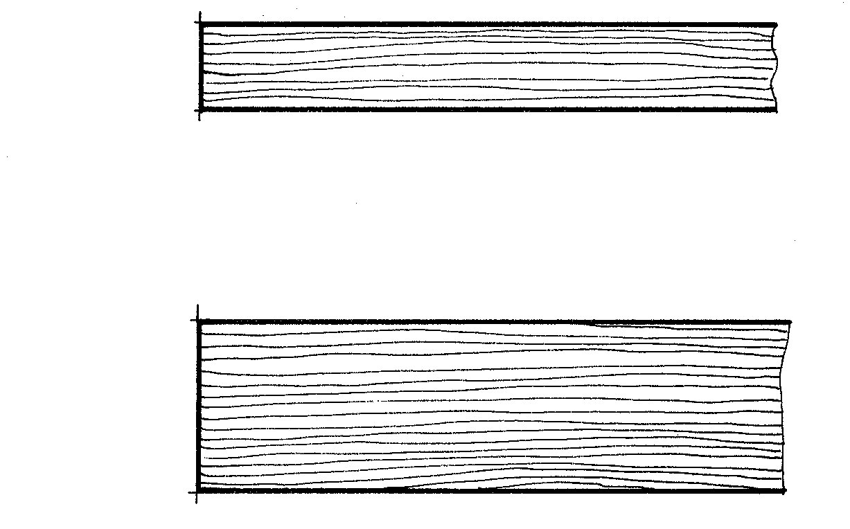

Figure 5.1.3

Show by means of sketches how you would make  - A appear thicker.  - B appear thinner. | (1)  (1)

5.2 Finishing  Which grade (grit) of sandpaper (40, 80,120,220 or 600) will you use to do the following?  - To do the final finishing to the top of a small table before polishing it.  - To remove paint from an old door.  - To prepare a project, after one coat of varnish for another coat. | (3)

5.3 Polishing  - State THREE advantages for the use of varnish.  - State THREE disadvantages for the use of wax polish. | (3)  (3)

5.4 Preservation

- List THREE physically destructive factors that could affect wood.  - Which TWO wood diseases are caused by fungi?  - How will one know that there are beetles present in wood?  - What is a preservative?  - Name a preservative that is suitable for the treatment of telephone poles.  TOTAL: | (3)  (2)  (1)  (1)  (1)  [40]  200÷2= 100

