GAUTENG DEPARTMENT OF EDUCATION
SENIOR CERTIFICATE EXAMINATION

WELDING AND METALWORKING SG

TIME: 3 hours

MARKS: 200

REQUIREMENTS:

- Answer book
- A3 size drawing paper
- Drawing instruments and an approved pocket calculator

INSTRUCTIONS:

- You must answer FIVE questions.
- Section A is COMPULSORY.
- Answer any FOUR other questions from SECTION B.
- Number your answers in accordance with the question paper.
- Only the first five questions will be marked. Cancel all questions that should not be marked.

SECTION A
COMPULSORY

QUESTION 1

  - Indicate whether the statements below are TRUE or FALSE. Write only the question number and next to it TRUE or FALSE in your answer book.

1.1.1 Only steel without carbon can be heat-treated the conventional way.
    - Gloves should be used when heavy plates are rolled or pressed.
    - The lower critical temperatures (AC1) for all carbon steels are the same.
    - Carbon has no or very little effect on steel during heat treatment.
    - Steel wire ropes may be dragged on the floor.
    - Distortion may be reduced by pre-setting.
    - A single run weld is preferred to a multi-run weld.
    - A large weld will shrink more than a small weld.
    - Tempering gives steel the maximum degree of hardness.
    - Tungsten added to steel will improve heat- and shock resistance.
    - The aim of heat-treatment is to give steel specific mechanical and physical properties.

1.1.12 After heat-treatment, the cooling speed is not important.  1.1.13 Annealing gives steel the maximum degree of hardness.  1.1.14 Tempering is applied to reduce the brittleness of heat-treated steels.  1.1.15 Hydrogen causes a weld to crack. | (15)

1.2 Choose the correct answer in Column B to fit the information given in Column A by writing only the letter of your choice next to the corresponding question number, e.g. 1.2.16 P.

COLUMN A | COLUMN B
1.2.1 Safety factor of four | A. Malleability
1.2.2 Non-destructive test | B. Weld defect
1.2.3 Stored in a dry place | C. Template making
1.2.4 Rolling, bending and forging | D. Increase harden ability
1.2.5 Undercut | E. Given steel a harden crust
1.2.6 Reference line | F. Ladders
1.2.7 720°C | G. Dead mild steel 0,05% to 0,15%
1.2.8 Hard board, sheet metal | H. Wire rope slings
1.2.9 Chromium | I. Cold working
1.2.10 Case hardening | J. Unsafe act
1.2.11 Never to be painted | K. Lower critical point (AC1)
1.2.12 Unsafe lighting | L. Welding symbol
1.2.13 Work hardening | M. Scaffolding
1.2.14 Cannot be heat-treated | N. Unsafe condition
1.2.15 Working at unsafe speed | O. Dye penetrant test

(15)

1.3 Each of the following questions has five possible answers of which only ONE is correct. Write down the appropriate letter next to the relevant question number, e.g. 1.3.6 A.

    - Elasticity is the ability of steel to

- be permanently deformed by bending.
- be hammered into shape.
- return to its original shape and size.
- not to deform during cold working.
- withstand shock.

    - The landing on a riveted joint is always:

- 2d
- 4d
- 3d
- 1,5d
- 3,5d

    - Case hardening is a process whereby

- heated carbon steel is dropped into water or brine.
- the steel is allowed to cool in the furnace after heat treatment.
- the heated steel is placed in a room and covered with bricks to allow it to cool at a uniform rate.
- dead mild steel is placed in a box and covered with carbon and then heat-treated.
- steel is heat-treated with an oxy-acetylene flame.

    - A non-destructive test is a

- nick break test.
- cold bend test.
- dye penetrant test.
- test where the weld is sawn and machined across before inspection.
- None of the above.

- Electrodes weld more easily when they are  - kept cold.  - wet.  - damp and at room temperature.  - heated in a furnace.  - None of the above.  TOTAL FOR SECTION A: | (10)  [40]

SECTION B

Answer any FOUR questions from this section.

QUESTION 2

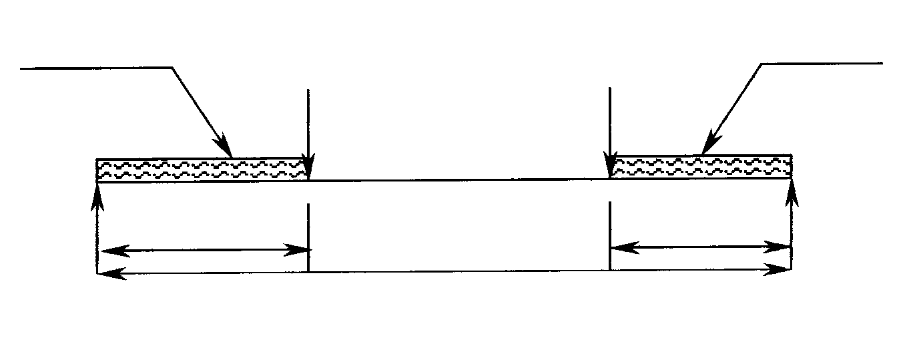
2.1 Figure 1 shows a simple supported beam with two point loads. The beam carries two distributed loads, one of 2kN/m two metres from the left reaction, and a 3kN/m four metres load from the right reaction.
2 kN/m 5 kN 4 kN 3 kN/m
2 m10 m4 m
L R

10 m

Figure 1

2.1.1 Calculate the left and right reactions. | (16)

- Draw a fully detailed sketch of the carbon equilibrium diagram for carbon steel with 0% to 1,4% carbon content and temperature of 500°C to 1000°C.  - State SIX conventional methods of heat-treating steel.  - State FOUR causes of weld spatter. | (14)  (6)  (4)  [40]

QUESTION 3

- Calculate the stress in a 25mm round bar if it is subjected to a force of 80 kN.  3.1.1 Calculate the strain in the bar if Young’s Modules for the bar is 120GPa. | (10)  (5)

3.1.2 Calculate the deformation in millimetres if the original length of the test piece is 800mm. | (5)

FORMULAE:

Stress (Pa) = $\frac{\text{Force }(N)}{\text{Area }(m^{2})}$

Strain = $\frac{\text{Change in length }(\text{mm})\text{ or }(\text{ m})}{\text{Original length }(\text{mm})\text{ or }(m)}$

E (Pa) = $\frac{\text{Stress }(\text{Pa})}{\text{Strain}}$

3.2 Show on your drawing paper, one geometrical method of obtaining the camber of a girder, if the height at the centre of the girder is given as 40 mm. The span is 3 metres. (Divide into 10 equal parts.) Use a scale of 1:10 for the span. | (20)  [40]

QUESTION 4

- Figure 2 shows a line diagram of a framework supported at the free ends. The framework has three vertical point loads. All the internal angles are 45°.  4.1.1 Draw the force diagram by using a scale of 10 mm : 5 kN. | (11)

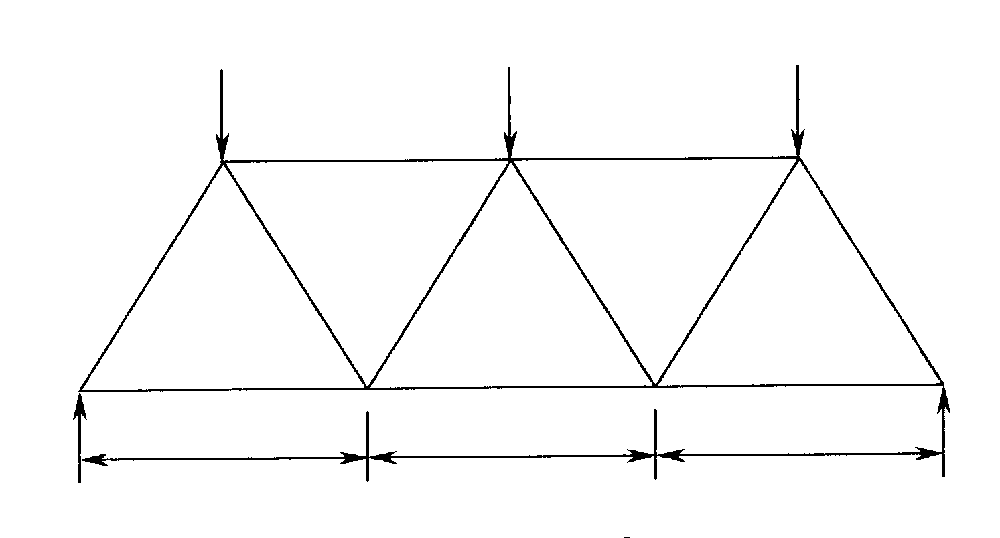
10 kN 20 kN 10 kN
C D
B E
J G
K H F
45° 45° 45° 45° 45° 45°
4 m 4 m 4 m
20 kN A 20 kN

Figure 2

4.1.2 Graphically determine the nature and magnitude of the forces in each component of the framework. Copy and complete the table below. | (18)

MEMBER | FORCE (kN) | NATURE
BK
KA
CJ
JK
DG
GH
EF
FA
HA

- Draw the space diagram to a scale of 1cm : 1m and indicate the nature of each member. | (11)  [40]

QUESTION 5

5.1 Figure 3 shows the top and front view of a hopper. By using the theorem of Pythagoras, calculate the following:

5.1.1 The true length of the plate marked X-X¹  - The true length of the plate marked Y-Y¹  - The true length of AE  - The true length of GC | (7)  (7)  (8)  (8)

5.2 Construct the dihedral angle on the joint AE by using a scale of 1cm: 100mm. | (10)

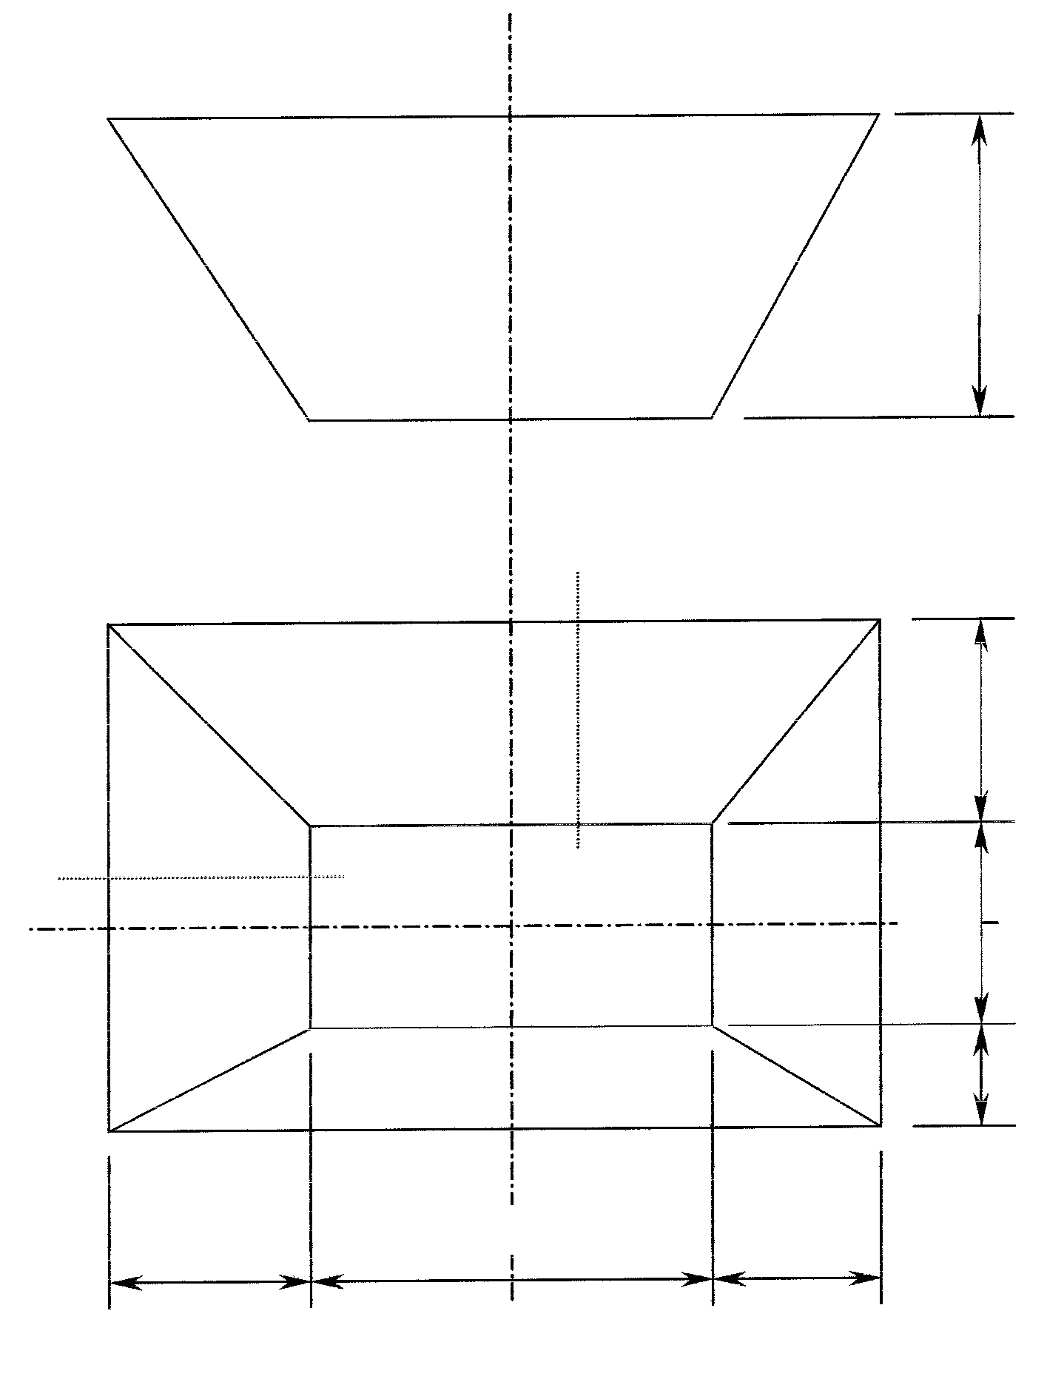
500
A Y B
X X¹ Y¹ F
H G
300 600 200
D
C
200 300 400
E

Figure 3

[40]

QUESTION 6

6.1 A truss consists of 20 metres of 76x76x8mm angle iron. The cost of the angle iron with a mass of 8,2 kg/m length is R3,50 per kilogram. The total time taken for carrying out the task is 12 hours at a tariff of R63,50 per hour. The overhead cost is 120% of the labour cost.

Calculate:

- The labour cost  - Cost of the material used  - Overhead expenses incurred  - The total cost of the completed roof truss | (4)  (5)  (5)  (4)

6.2 Figure 4 shows a section of a riveted lattice girder. Lay out the section by using a scale of 1:1 and draw the gusset plate. Show only the position of the rivets.

Use the following data to complete the layout:

Material for ties and rafters 50x50x6mm angle iron  Pitch for the ties and rafters is 3d  The diameter for the rivets is 10mm  The landing is 1,5d  Back mark for ties and rafters is 31mm | (22)
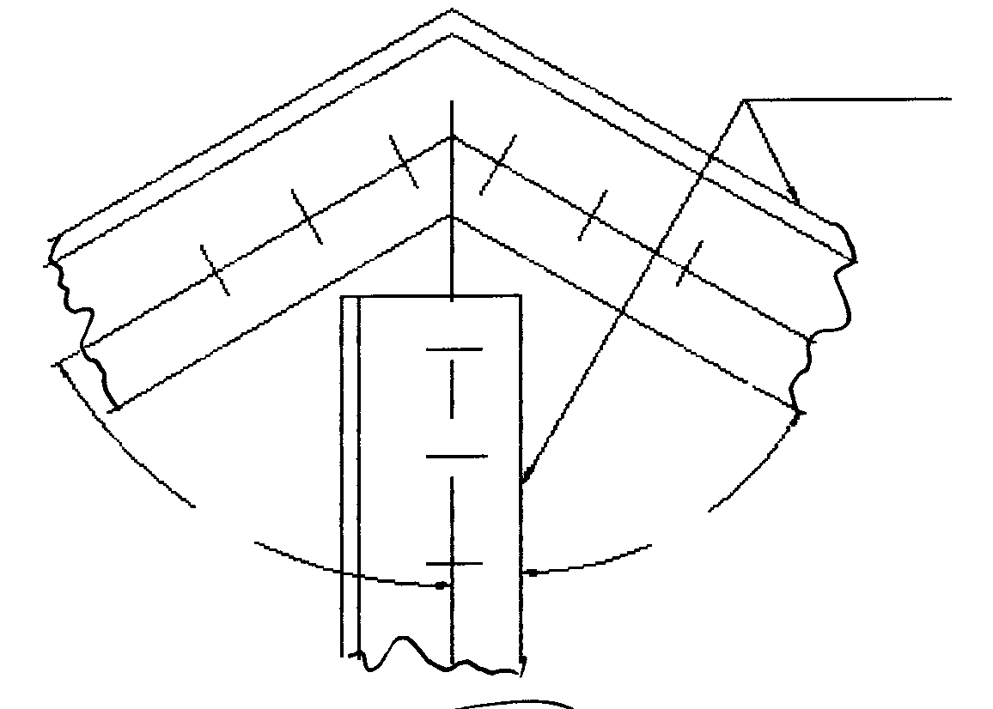
50x50x6
60º
60º

Figure 4

[40]

QUESTION 7

- Figure 5 shows a cantilever, which is 10 metres long and subjected to three point loads.  7.1.1 Calculate the bending moment at points A, B, C and D.  - Calculate the bending moment at X.  - Calculate the shear force at points A, B, C and D.  - Draw the space diagram by using a scale 1cm : 1m.  - Draw the bending moment diagram to a scale of 1 cm : 10 kN/m.  - Draw the shear force diagram to a scale of 1cm : 2 kN. | (8)  (2)  (8)  (2)  (10)  (10)

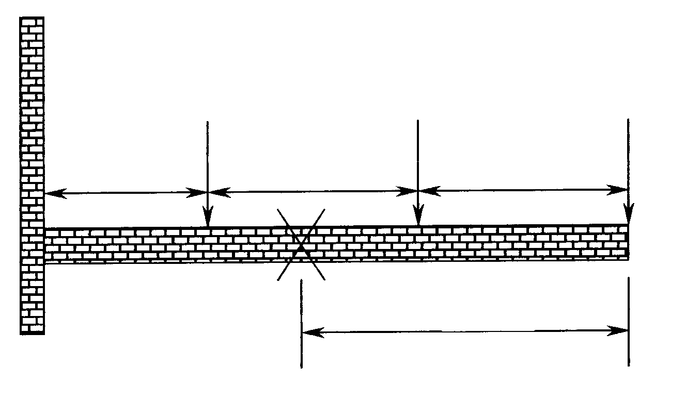
3 kN 4 kN 5 kN
4 m 3 m 3 m
A B C D
4.5 m

Figure 5

TOTAL: | [40]  200

