GAUTENG DEPARTMENT OF EDUCATION
SENIOR CERTIFICATE EXAMINATION

WELDING AND METALWORKING SG

TIME: 3 hours

MARKS: 200

REQUIREMENTS:

- Answer book
- A3 drawing paper
- Drawing instruments and an approved pocket calculator

INSTRUCTIONS:

- You must answer FIVE questions.
- Question 1 is COMPULSORY.
- Answer any FOUR other questions from SECTION B.
- Number your answers in accordance with the question paper.

SECTION A

QUESTION 1
COMPULSORY

  - Each of the following questions has five possible answers, only ONE of which is correct. Write down the appropriate letter next to the relevant question number e.g. 1.1.1 A.

1.1.1 You are aware of the dangers of Aids. Your friend has cut himself accidentally and seeks your help. You immediately

- run for help.
- wash the cut.
- put on surgical gloves and treat the cut.
- bandage the cut.
- try to stop the bleeding.

    - The pitch on a riveted joint is the distance

- from the edge of the plate to the middle of the rivet.
- between two rivets.
- between two rows of rivets.
- from the centre of the one rivet to the centre of the next rivet in the same row.
- on the outside of the rivets.

    - Indicate at which temperature mild steel melts:

- 685ºC
- 3800ºC
- 1500ºC
- 4200ºC
- 1200ºC

    - Shear force may be defined as

- the amount by which a bar lengthens or shortens when subjected to
an external load.
- the stress required to deform a bar.
- the force required to shear a bar between two sliding planes.
- the force required to bend a bar.
- the force required to break a bar.

- Porosity in weld is when  - slag is trapped in the weld metal.  - small pinholes occur in the weld metal.  - a crater forms at the end of the weld.  - holes occur in the weld due to trapped gasses.  - the welded metal is corroded. | 5x2=(10)

1.2 Choose the correct answer from Column B to fit the information supplied in Column A by writing only the letter of your choice next to the corresponding question number, e.g. 1.2.1 A.

COLUMN A |  | COLUMN B
1.2.1 | Castellated beams | A. Safety factor of 4
1.2.2 | Plate girders | B. The effect of hot-working on the grain structure
1.2.3 | Load | C. The ability that metal has to stretch and become permanently flattened
 | Deformation and recrystallisation occur simultaneously | D. Strain
1.2.5 | Scaffolding | E. Oxygen
1.2.6 | General safety precautions | F. Consists of a combination of plates and angle iron welded together
1.2.7 | The smallest grain structure | G. Good housekeeping
1.2.8 | Mild steel | H. The depth of the beam section is increased by 50%
1.2.9 | Destructive test | I. An external force which acts upon matter
1.2.10 | The ratio between deformation and original length | J. 0,30% to 0,80% carbon content
1.2.11 | Medium carbon steel | K. Cold bending test
1.2.12 | Heat treatment | L. Screws and nails
1.2.13 | Lowest critical point. | M. Austenite
1.2.14 | Malleability | N. ACI
1.2.15 | Forms iron oxide in steel | O. Results in toughness

(15)
1.3 Indicate whether each of the statements below is TRUE or FALSE. Write only the question number and TRUE or FALSE in your answer book.

1.3.1 Only hardened steel can be cut or punched with the cutting and punch machine.

1.3.2 Steel-wire rope slings may not be allowed to rust or disintegrate.

1.3.3 Use gloves when heavy steelplates are rolled and pressed.

1.3.4 Toughness is the resistance the materials offer against the force that is used to pull them from each other.

1.3.5 Four different grain structures are found in steel.

1.3.6 High-carbon steel does not react at all to heat treatment.

1.3.7 Carbon is the most important alloying element in steel.

1.3.8 Silicon is added to steel to control the oxygen content.

1.3.9 A very important factor in heat treatment is the speed at which the steel cools off.

1.3.10 Low-carbon steel is used for the manufacturing of axes and conrods.

1.3.11 Hardening does not render steel an extreme grade of hardness.

1.3.12 The template loft is not an important section of a constructural workshop.

1.3.13 The lower critical temperature is not the same for all types of steel.

1.3.14 High frequency sound waves are used in ultrasonic tests.

1.3.15 Strip-templates are used for angle irons and U-irons. | (15)  [40]

TOTAL FOR SECTION A: | [40]

SECTION B

Answer any FOUR questions from this section.

QUESTION 2

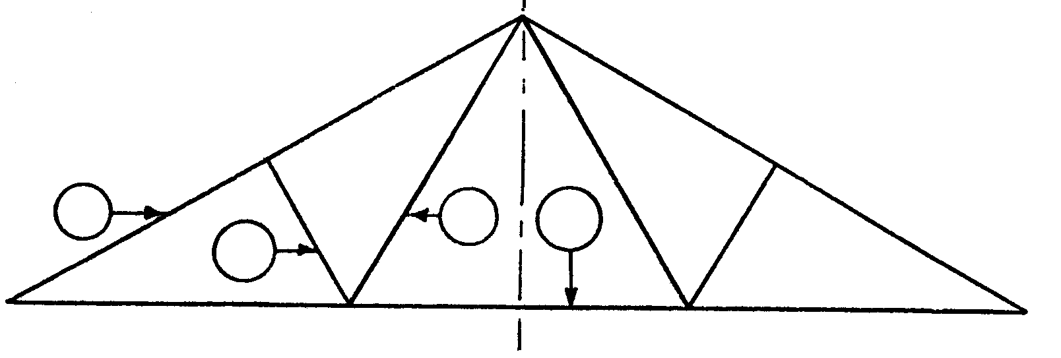
A
B
C
D

Figure 1

2.1 Figure 1 shows a line diagram of a steel framework. The framework is welded and consists of single-angle profiles without gusset plates. The total time taken to manufacture one framework is nine hours, at a tariff of R111.20 per hour, while the overhead costs are calculated at 95% of the labour costs. The cost of the angle profiles of 80x80x8 mm with a mass of 8,8 kg/m length is R3,90 per kilogram and the profiles of 60x60x6 mm with a mass of 6,49 kg/m length is R2,50 per kilogram. An amount of R196,00 is allocated to each framework for welding material.

Mark A = 80 x 80 x 8L = 6,92 m
Mark B = 60 x 60 x 6L = 2 m
Mark C = 60 x 60 x 6L = 3,994 m
Mark D = 80 x 80 x 8L = 12 m

Copy and complete the table below in your answer book. Calculate:

MARK | NUMBER  REQUIRED | MATERIAL REQUIRED | MASS/M  LENGTH | TOTAL  MASS | TARIFF  PER KG | R C
A | 2 | 80x80x8mm L=….m long | 8,8 kg |  | R3,90
B | 2 | 60x60x6mm L=….m long | 6,49 kg |  | R2,50
C | 2 | 60x60x6mm L=….m long | 6,49 kg |  | R2,50
D | 1 | 80x80x8mm L=….m long | 8,8 kg |  | R3,90
 |  |  | Welding material cost
 |  |  | Material cost (Total)

- the cost of the material.  - the labour cost.  - the overhead cost.  - the total of the complete framework. | (14)  (3)  (3)  (2)

2.2 Figure 2 shows the upper section of a bolted roof truss. Use a scale of 1:2 to lay out the joint and draw the gusset plate. Show only the position of the bolts. The pitch of the rafters and the struts is 3d. The diameter of each bolt is 20 mm. Use the following back marks: rafters 30 mm, struts 25 mm.

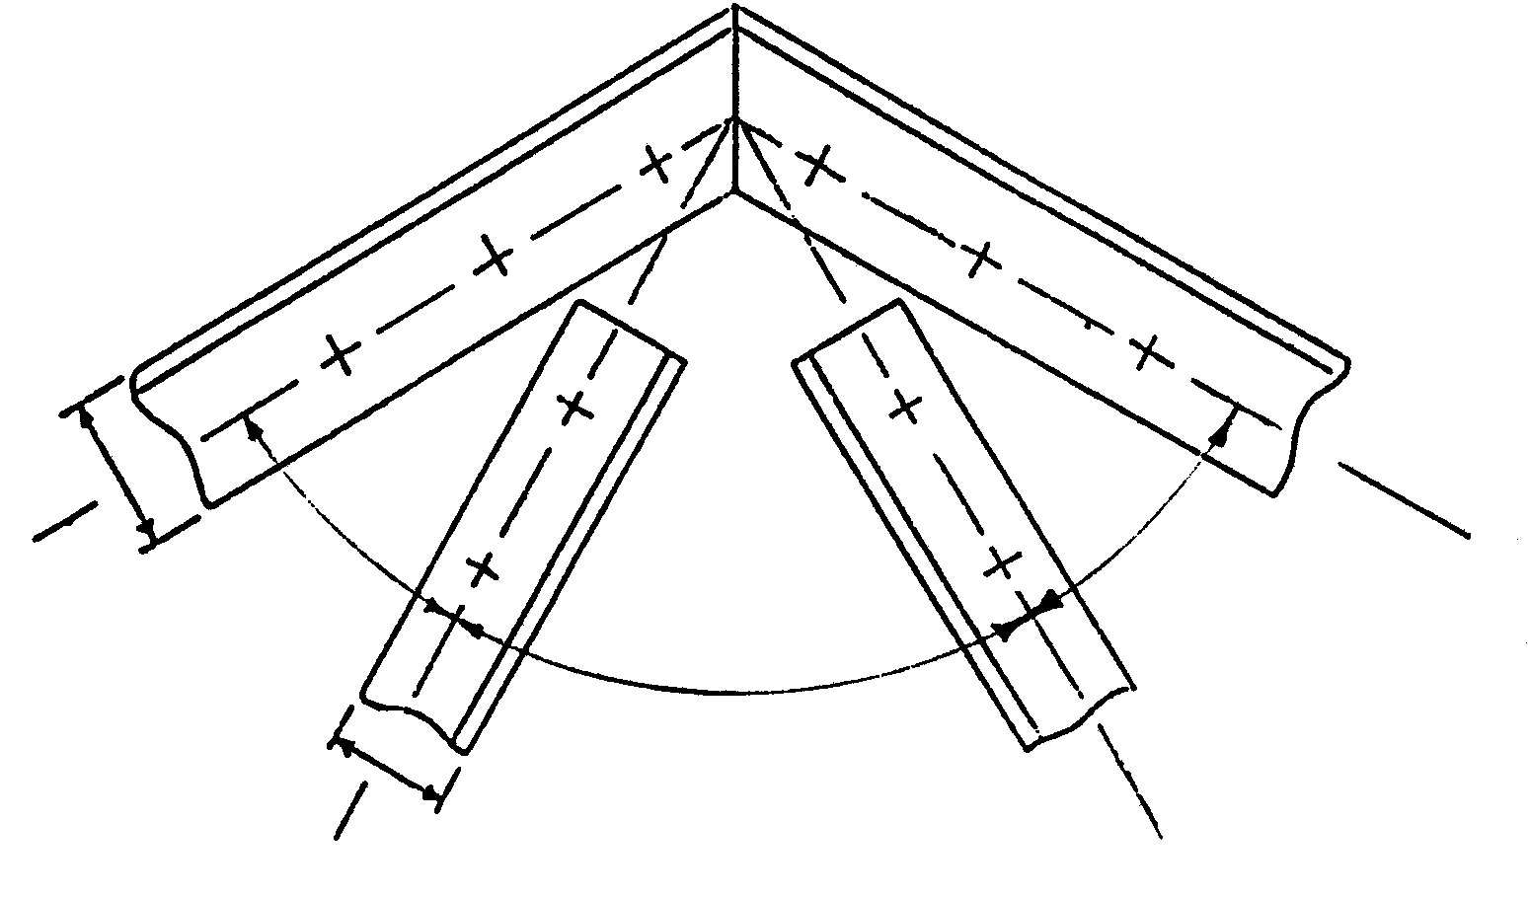  Figure 2 | (18)  [40]

QUESTION 3

3.1 State THREE factors which are of great importance when heat-treating carbon steel. | (6)

3.2 Name SIX mechanical properties of steel. | (6)

3.3 A welding symbol consists of seven elements. Name SIX of the elements. | (6)

- A round bar has been prepared for testing in a tensile testing machine.  3.4.1 Draw the stress-strain diagram and indicate the following:  - Proportional limit  - Elastic limit  - Maximum stress  - Point of fracture | (7)

- Name TWO advantages of the ultrasonic test. | (4)

3.6 Name FIVE causes of cracks in welds. | (5)

3.7 Name the THREE groups into which carbon steels are divided and state the percentage carbon for each group. | (6)  [40]

QUESTION 4

4.1 4.1.1 What is the maximum load a concrete column of square cross section  300 mm x 300 mm can support, if the stress is not to exceed 5,2 MPa?  - If the height of the column is 10 metres, how much will it shorten due to this load? The value of Young’s Modulus (E) is 16 GPa. | (7)  (14)

4.2 Calculate the diameter of a steel bar designed to carry a load of 40 kN, if the ultimate stress of the steel is 420 MPa. Use a safety factor of 4. | (19)

Formulae:  Strain = Deformation  -----------------------------  Original length  Young’s Modulus (E) = Stress  ------------------------------  Strain  Stress = Load  ------------------------------  Cross-sectional area  Safe stress = Maximum stress (Ultimate stress)  --------------------------------------------  Safety factor | [40]

QUESTION 5

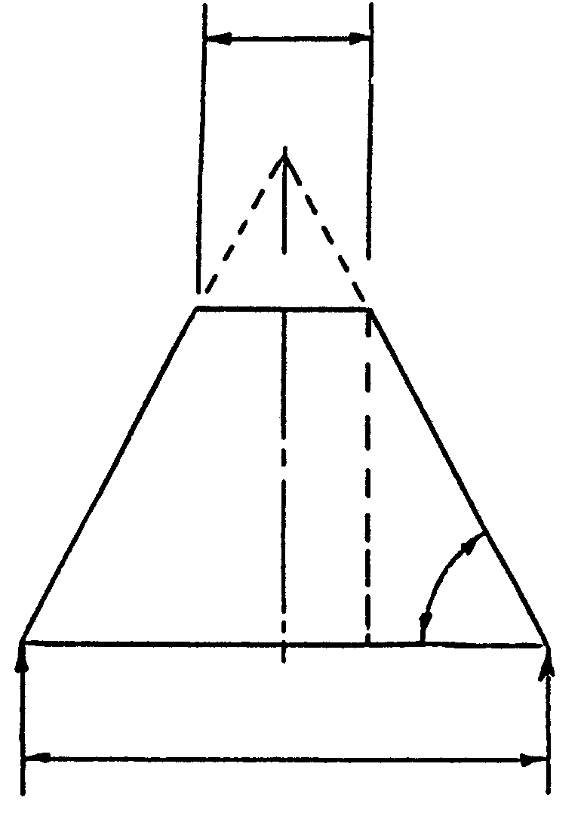
300

A

G

D

B

H

58º

C

E

F

900
Figure 3

Figure 3 shows a conical hopper. Calculate the following:  - Large radius – AC. (Use the Sin, Cos or Tan formulae)  - Small radius – AB. (Use the Sin, Cos or Tan formulae)  - Vertical height – AE. (Use the Sin, Cos or Tan formulae)  - Vertical height – BF. (Use the Sin, Cos or Tan formulae)  - Circumference – HC  - Circumference – BG | (8)  (8)  (6)  (6)  (6)  (6)  [40]

QUESTION 6

Figure 4 shows a line diagram of a framework with four vertical loads

6M
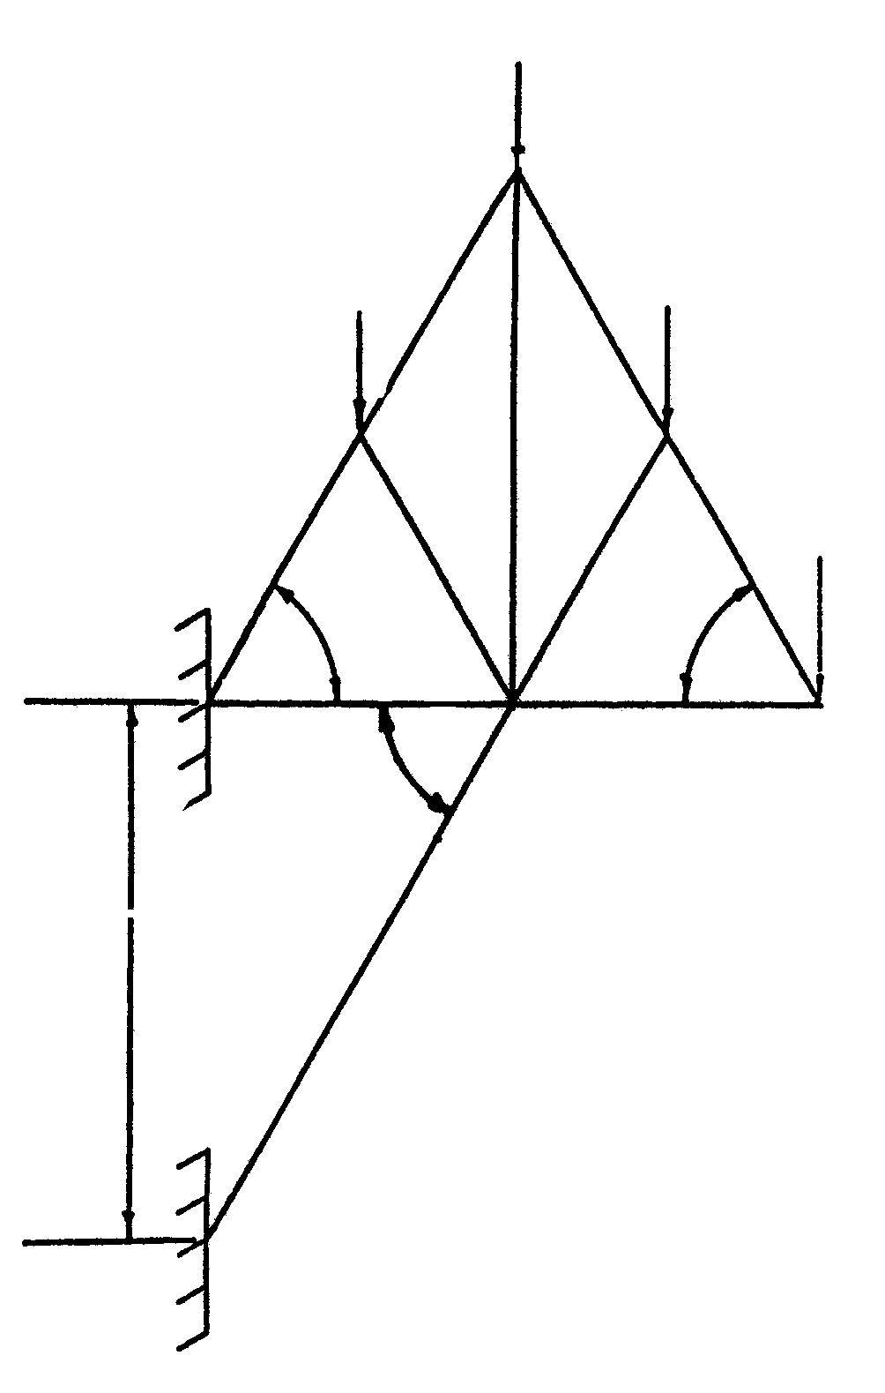
40 kN
E
F
K
H
30 kN
30 kN
20 kN
B
C
A
M
60º
G
Figure 4
60º
60º
D

6.1 Draw the space diagram of the framework to a scale of 10 mm = 1 m and indicate the nature of the members on it. | (10)

6.2 Draw the force diagram to a scale of 10 mm = 10 kN. | (10)

6.3 Determine the magnitude and nature of the forces in each component of the framework. Copy and complete the table below. | (20)

MEMBER | FORCE - kN | NATURE
AG
BH
CK
DM
FG
EM
EF
GH
HK
KM
[40]

QUESTION 7

Figure 5 shows a beam supported at both ends. The beam is subjected to THREE loads.

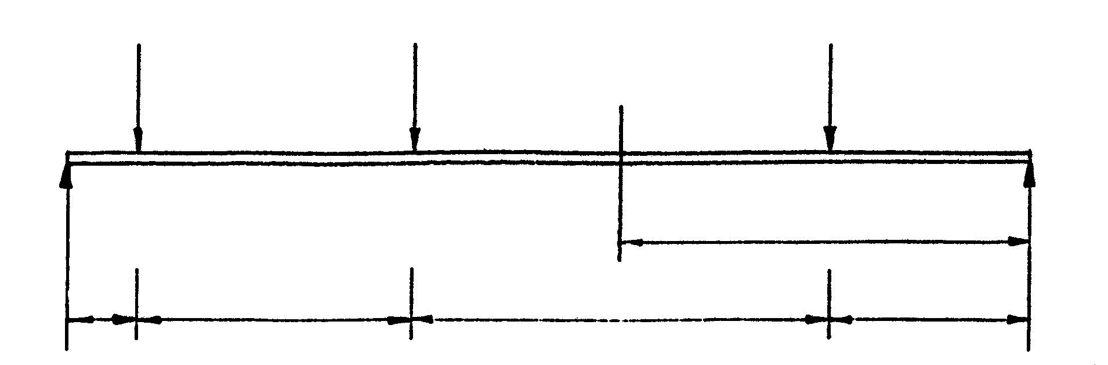
6 kN
1,5 m
3 m
8 kN
6 kN
0,5 m
2 m
3 m
B
C
A
X
D
E
L = 12 kN
R = 8 kN

Figure 5

7.1 Indicate by means of calculation that the following reactions at supports L and R will read 12 kN and 8 kN respectively. | (6)

7.2 Calculate the bending moment at points B, C, D and X. | (11)

7.3 Calculate the shear force between AB, BC, CD and DE. | (8)

7.4 Draw the bending moment and shear diagram for the beam. | (15)

Use the following scales:

Space diagram 1:50
Bending moment diagram 1 kN m = 2mm
Shear force diagram 1 kN = 3mm

TOTAL: | [40]  200

