GAUTENG DEPARTMENT OF EDUCATION
SENIOR CERTIFICATE EXAMINATION

WELDING AND METALWORKING SG

TIME: 3 hours

MARKS: 200

REQUIREMENTS:

- A3 drawing paper
- Drawing instruments
- An approved pocket calculator

INSTRUCTIONS:

- You must answer FIVE questions:
– Question 1 is COMPULSORY.
– Answer any FOUR questions from Section B.
- Number your answers in accordance with the question paper.

SECTION A

QUESTION 1
COMPULSORY

  - Each of the following questions has five possible answers, only ONE of which is correct. Write down the appropriate letter next to the relevant question number e.g. 1.1.1A.

1.1.1 One of the workers slips, falls and hits his head against the work-bench and an open wound appears. How will you treat this person without contaminating yourself with the AIDS virus?

- Immediately put an adhesive plaster on the wound.
- Apply immediate pressure onto the wound with your hand.
- Put on surgical gloves before touching the blood or the wound.
- Clean the wound with a clean cloth and treat it.
- Clean the wound with water.

    - Which of the following properties are obtained when a metal is
case-hardened by the heat-treatment process?

- Hard and brittle
- Hard and tough
- The outer layer is hard and the core is tough.
- The outer layer is soft and the core is hard.
- The metal is not shock resistant.

    - Elasticity is defined as the ability

- to withstand abrasion.
- to withstand shock loads.
- of a metal to return to its orginal dimension after the load has been removed.
- of metal to break easily.
- to resist wear and abrasion

    - Bad root-weld penetration is caused by

- a current setting that is too high.
- a root opening which is too small.
- no or insufficient plate bevelling.
- a root opening which is too small and an insufficient plate bevelling.
- None of the aspects mentioned in A, B, C or D.

- The lower critical temperature as given in the iron-carbon equilibrium diagram, stays constant at a given temperature of  - 780ºC.  - 730ºC.  - 720ºC.  - 710ºC.  - 750ºC. | 5x2=(10)

1.2 Choose the correct answer from Column B to fit the information in Column A by writing only the letter of your choice next to the corresponding question number, e.g. 1.2.1 A.

COLUMN A | COLUMN B
1.2.1 Critical point AC₃ | A. 10¹²
1.2.2 This is an internal force in material resisting a load. | B. Wrong electrode
1.2.3 Overhead costs | C. N/m²
1.2.4 Tera | D. Boring machine
1.2.5 Template loft | E. Tensile stress
1.2.6 Pa | F. 10⁹
1.2.7 Distributed load | G. Rent of premises
1.2.8 This is an internal force present in material when an external force is applied. | H. Austenite structure
1.2.9 Weld spatter | I. Beams
1.2.10 Giga | J. Stress
(10)

1.3 Indicate whether each of the statements below is TRUE or FALSE. Write only the number of the question and TRUE/FALSE in your answer book.

1.3.1 Bad root penetration is caused by using a current setting that is too high.

1.3.2 The presence of spatter on top of a weld is caused mainly by an arc length that is too high .

1.3.3 The x-ray testing method (that is used mainly in testing welded joints) has certain advantages because it can be easily installed.

1.3.4 The ultrasonic testing method (which is usually used in determining weld defects) entails the use of transmitters to create sound waves.

1.3.5 The non-destructive method of testing welded joints entails the breaking of a test piece to enable easy location of welding defects.

1.3.6 The properties of hardening is that the metal has become extremely hard and brittle.

1.3.7 Normalising is used especially on steel where the steel was subjected to internal stresses.

1.3.8 The properties of case-hardening are that the whole structure of steel becomes hard and brittle.

1.3.9 Tempering can only be carried out on brass.

1.3.10 Lines on the graph paper that correspond to the upper and lower critical temperature intersect each other where the steel has a carbon content of 0,75%.

1.3.11 Rays that are formed by the X-ray machine consist of electro-magnetic rays of shortwave length and can penetrate any solid mass of steel.

1.3.12 With reference to the iron-carbon equilibrium diagram, carbon steels heated above the upper critical temperature mainly contain ferrite and perlite.

1.3.13 Grinding machines can only grind mild steel.

1.3.14 A safety factor of not less than three must be obtained with ladders and scaffolding.

1.3.15 Mild steel cannot be hardened because it is ductile and malleable. | (15)

1.4 State THREE characteristics which the floor in a template loft should have. | (3)

1.5 State TWO advantages of castellated beams. | (2)  [40]

TOTAL FOR SECTION A: | [40]

SECTION B

Answer any FOUR questions from this section.

QUESTION 2

Figure 1 shows a line diagram of a steel framework. The framework is welded and consists of single angle profiles without gusset plates. The total time taken to manufacture one framework is 7 hours, at a tariff of R58,50 per hour, while the overhead costs are calculated at 75% of the labour costs. The cost of the angle profiles of
60x60x6 mm with a mass of 4,7 kg/m length is R1,50 per kilogram and profiles of
50x50x6 mm with a mass of 4,47 kg/m length is R1,50 per kilogram. An amount of R25 is allocated for welding material.

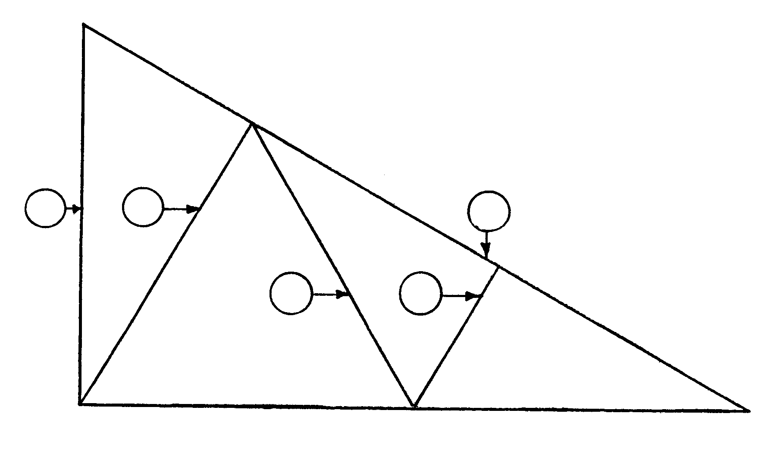

B

A

D

E

F

C

Figure 1

- Copy and complete the undermentioned table in your answer book. Calcuate:  2.1.1 The cost of material  - The labour costs  - The overhead costs  - The total cost of the completed framework. | (14)  (3)  (3)  (2)

MARK | NUMBER REQUIRED | MATERIAL REQUIRED | MASS/M  LENGTH | TARIFF  PER KG | R C
A | 1 | 60x60x6mm 5,8 m long | 4,7 kg | 1,50
B | 1 | 60x60x6mm 11,5 long | 4,7 kg | 1,50
C | 1 | 60x60x6mm 10 m long | 4,7 kg | 1,50
D | 1 | 50x50x6mm 5m long | 4,47 kg | 1,50
E | 1 | 50x50x6mm 5m long | 4,47 kg | 1,50
F | 1 | 50x50x6mm 2,5m long | 4,47 kg | 1,50
 |  |  | Welding material costs
 |  |  | Material costs (Total)

2.2 Draw neat sketches of the front elevation and the top view of a bolted column base, manufactured from the following components:  ONE 300 mm by 200 mm rolled steel column  FOUR 70 mm by 70 mm by 8 mm angle irons  ONE base plate 600 mm by 600 mm by 20 mm thick  TWO wing plates 12 mm thick  Bolts need not be shown. | (9)

2.3 Draw neat sketches to show how the following rolled sections are prepared for welding to form a T-joint:  2.3.1 I beam to I beam of different sizes  2.3.2 Channel iron to channel iron of different sizes. | (3)  (3)

2.4 Name the THREE types of templates that will be used to mark the positions of the holes on different steel profiles. | (3)  [40]

QUESTION 3

3.1 Inspection during welding is very important for obtaining the best results. Name THREE important factors to take into account during welding. | (6)

3.2 State FIVE defects which may occur in arc welding. | (5)

3.3 What is the main purpose of the heat treatment process of hardening? | (3)

3.4 Name SIX tools that are used in the template loft. | (6)

- Draw a fully detailed sketch of the carbon equilibrium diagram for carbon steel with 0% to 1,4% carbon content and a temperature of 500ºC to 1 000ºC. | (14)

3.6 List TWO factors that will determine the choice of an electrode when welding. | (2)

3.7 List FOUR safety precautions you would observe when welding using the electric arc welder. | (4)  [40]

QUESTION 4

- A tensile force of 60 kN causes a steel bar with a diamater of 36 mm and a length of 1,6 m to stretch 0,4 mm.  4.1.1 Indicate by means of calculations that the stress in the bar is 58,946 MPa  - Indicate also by means of calculations that the strain is 0,25 x 10⁻³ .  4.1.3 Calculate the value of Youngs Modulus for this bar. | (10)  (7)  (7)

4.2 Calculate the load to which a 40 mm squarebar is subjected if the stress is  5x10⁶ Pa. | (9)

4.3 Calculate the length of a bar if it shortens by 0,6 mm under a compression force. The strain is 0,8 x 10⁻³. | (7)

Formulas:  Load______________  Cross-sectional area  Deformation_________  Original length  Stress _________  Strain  Stress =  Strain =  Young’s Modulus (E) = | [40]

QUESTION 5

800
600
300
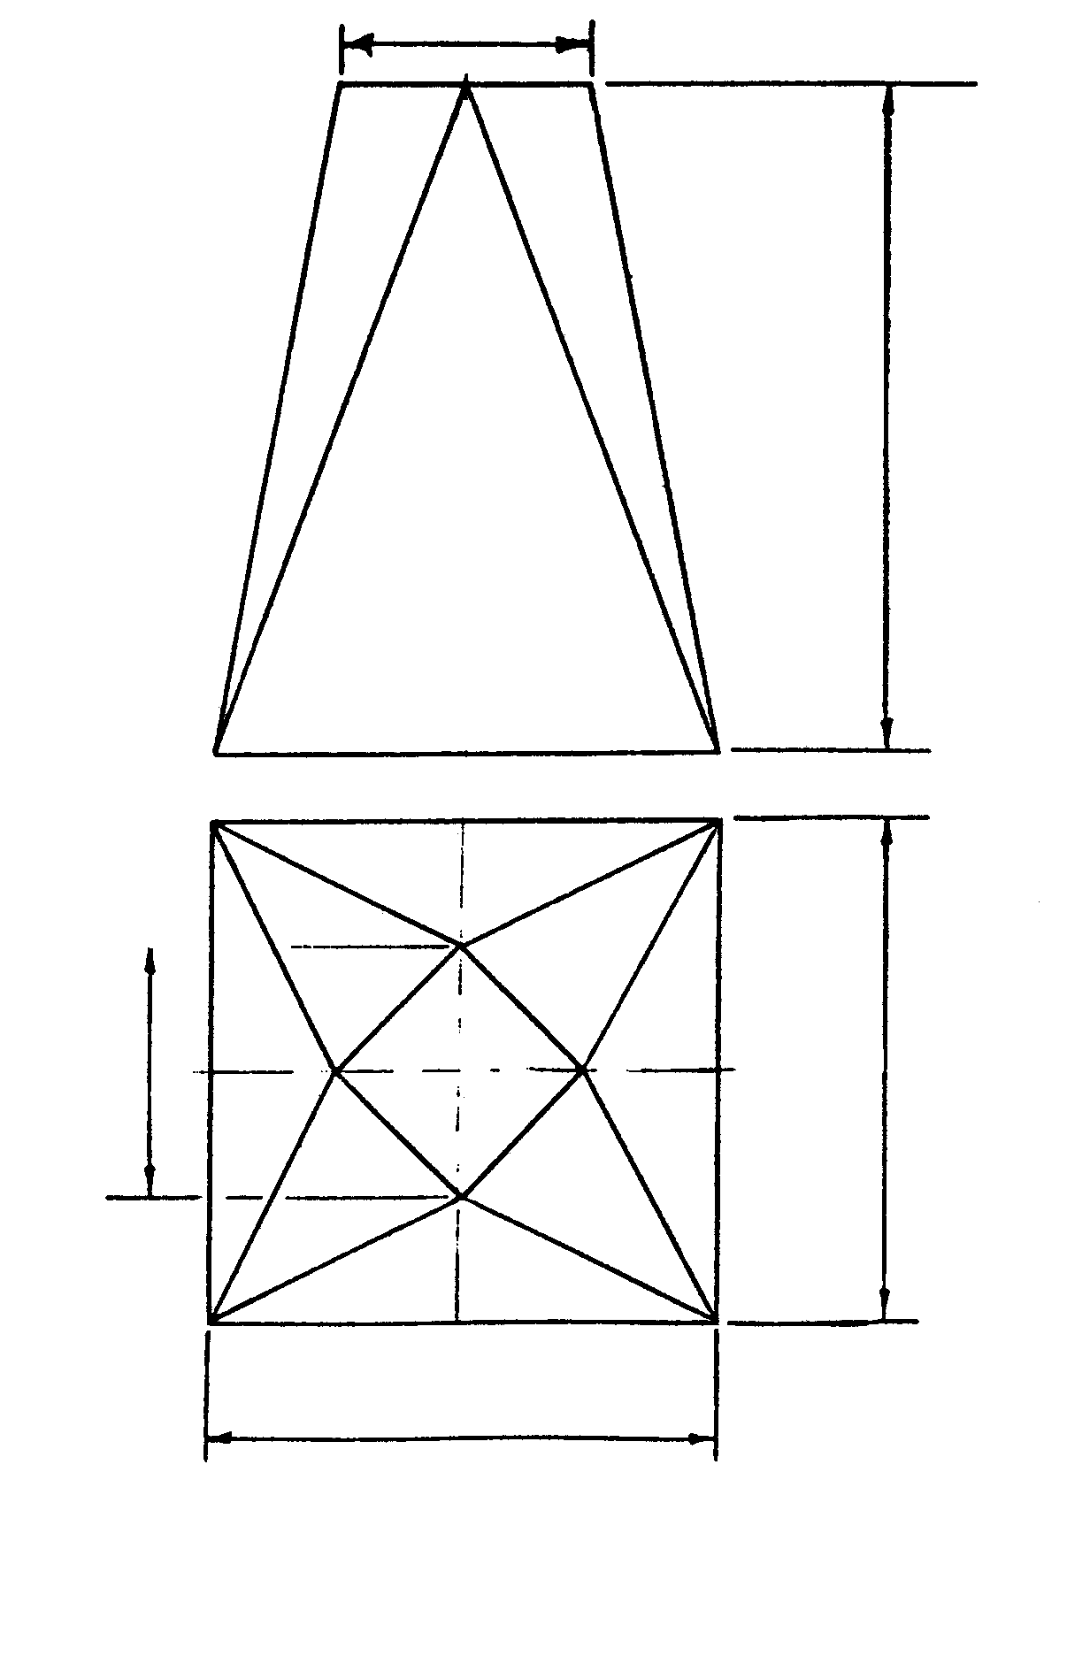
300
600
A
B
H
J
K
C
E
D
Figure 2

Figure 2 shows the front view and the top view of a square to a square hopper, that has been turned.  - Calculate the plan length of EK.  - Calculate the true length of EK.  - Calculate the plan length of CK.  - Calculate the true length of CK.  - Calculate the length of HK. | (4)  (9)  (9)  (9)  (9)

(Use the theorem of Pythagoras.) | [40]

QUESTION 6

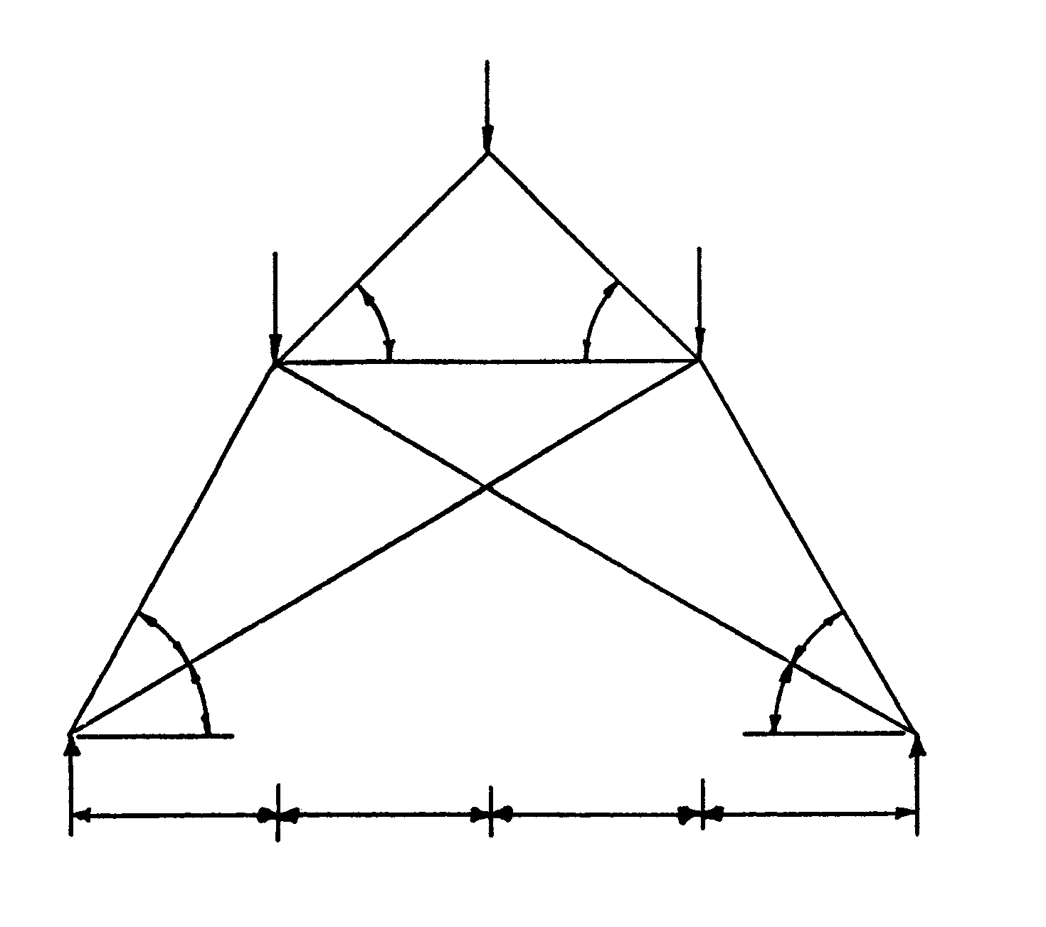
5kN
B
C
4 kN
2 kN
G
45º
45º
H
F
K
A
D
E
30º
30º
30º
30º
3m
3m
3m
3m
LR = 6 kN
RR = 5 kN

Figure 3

6.1 Indicate by means of calculation that the following reactions at supports L and R will read 6 kN and 5 kN respectively. | (4)

6.2 Draw the space diagram of the framework to a scale of 1:100 and indicate the nature of the forces on it. | (9)

6.3 Draw the force diagram to a scale of 1 kN = 10 mm. | (9)

6.4 Determine the magnitude and nature of the forces in each component of the framework. Copy and complete the table on page 11 in your answer book. | (18)

MEMBER | FORCE - kN | NATURE
AF
BG
CG
DK
GH
EK
EF
FH
HK

[40]

QUESTION 7

7.1 Figure 4 shows a beam, 6 metres long, supported at its ends. The beam carries one distributed load and two vertical point loads. | (10)

7.1.1 Calculate the reaction forces at supports L and R.
5 kN
4 kN
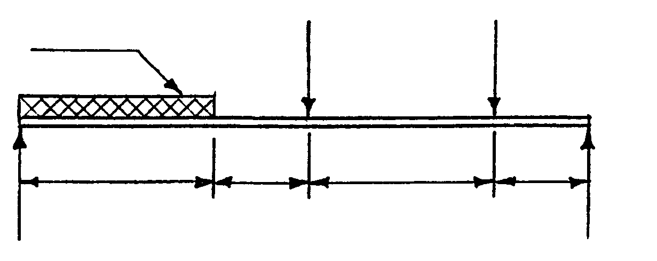
2 M
1 M
2 M
1 M
0,5 kN/m
L
R

Figure 4

7.2 Figure 5 shows a cantilever beam 6 metres long which is firmly fixed at point A. The beam is subjected to three vertical point loads.

10 kN
20 kN
A
B
C
P
D
3m
3m
3m
3m
30 kN
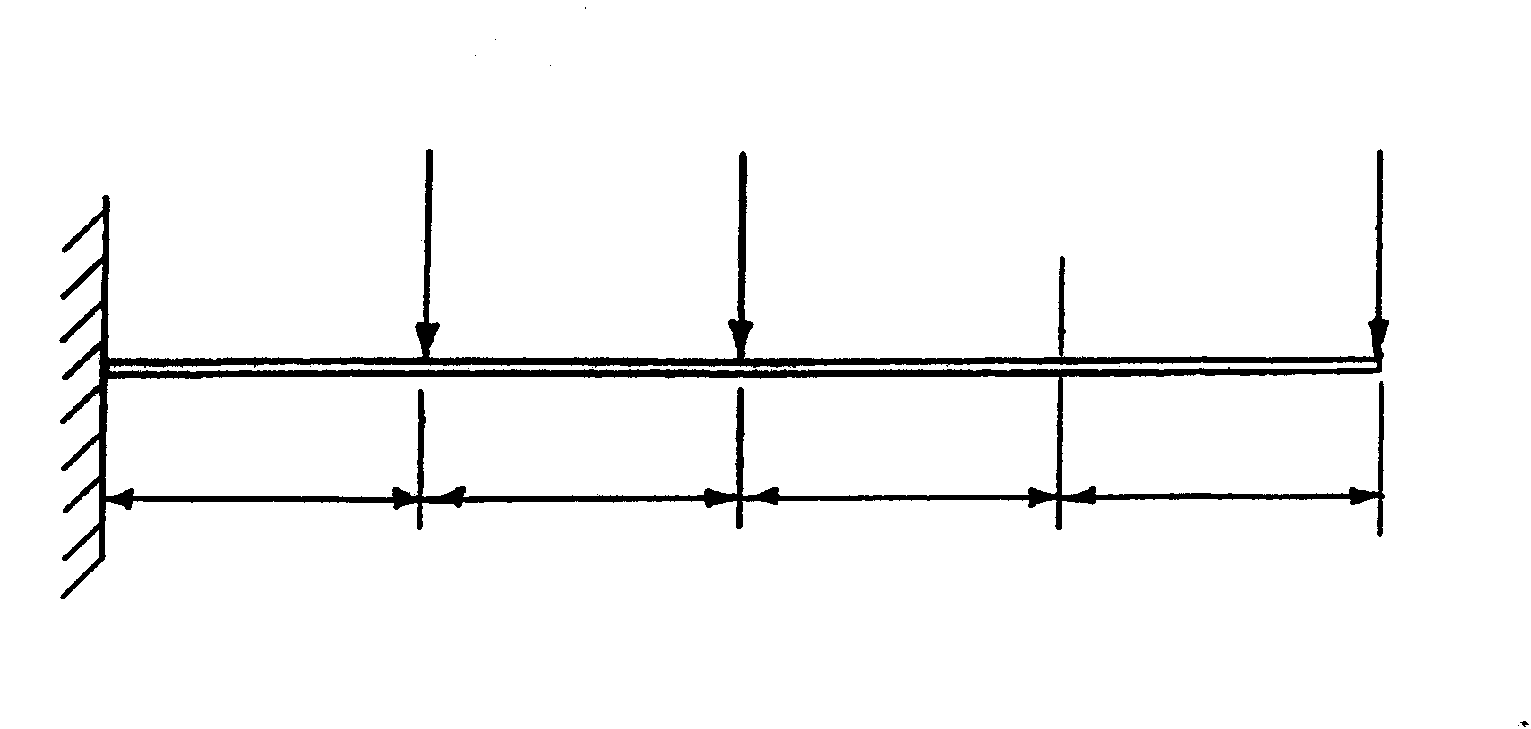
Figure 5

7.2.1 Calculate the bending moment at A, B, C and D as well as point “P” | (10)

7.2.2 Calculate the shear force between AB, BC and CD as well as point “P” | (8)

7.2.3 Draw the bending moment diagram. | (6)

7.2.4 Draw the shear force diagram. | (6)

Use the following scales:

Space diagram 1:100
Bending moment diagram 1 mm = 10 kNm
Shear force diagram 1 mm = 1 kN
TOTAL FOR SECTION B: | [40]  [160]

TOTAL: | 200

