GAUTENG DEPARTMENT OF EDUCATION
SENIOR CERTIFICATE EXAMINATION

TYPING SG
(Second Paper)

TIME: 3 hours

MARKS: 300

INSTRUCTIONS TO CANDIDATES:

READ THE FOLLOWING INSTRUCTIONS CAREFULLY BEFORE YOU START WITH THE PAPER.

- Type your examination number at the top of every sheet of paper used in answering the questions.
- Begin each question on a separate sheet of paper.
- Arrange your answers in the examination cover provided, in the correct numerical order.
- If you answer the timed accuracy test in English you are to answer Questions 2, 3, 4, 5, 6, 7 and 8 in English as well.
- Please read through your typed answers carefully.
- The invigilators will give you instructions about Question 1.
- You are to complete Question 1 and hand it in before answering the other questions.

INSTRUCTIONS TO INVIGILATORS:

1. Place at least eighteen sheets of A4 paper (80 g) in the examination cover prior to the examination.
2. The typing teacher is to ensure that the typewriters are in perfect working order.
3. Neither carbon ribbon nor correcting ribbons may be used during the examination.
4. It is essential that a typing teacher be one of the invigilators for the duration of the examination to assist with malfunctioning typewriters.
5. Candidates are to report to the typing centre at least 15 minutes before the examination commences.
6. Candidates should be given approximately 10 minutes to read through the examination paper before beginning Question 1. They may rule lines and underline words.
7. Both invigilators are to use stopwatches for time control. The timed accuracy test is to be timed by the typing teacher. Invigilators may not move among candidates during this test.
8. 8.1 Before the candidates start with this paper, they should be instructed to type their examination numbers in the top RIGHT HAND CORNER of the paper used for the timed accuracy test. After all the candidates have done this, the signal may be given to begin the test.
  - After the time allowed for the accuracy test has expired, the invigilator is to collect all the tests and initial them after the LAST WORD TYPED ON EVERY SHEET USED FOR THE SPEED TEST. All the sheets used by a candidate to answer Question 1 are to be stapled together. ONLY THE ANSWER SHEETS TO QUESTION 1 ARE TO BE STAPLED TOGETHER.
  - It is an invigilator’s responsibility to place the accuracy test correctly in each candidate’s examination cover on completion of the examination.
- During the rest of the paper, moving among candidates is to be restricted to handing out additional paper, assisting with faulty typewriters, etc.

QUESTION 1  TIMED ACCURACY TEST | [60]

The timed accuracy test is to be typed in double line or 1½ line spacing on one side of the paper only. Use margins of 10º. A minimum of 35 w.p.m. is expected and the limits are indicated by (…..).

TIME: 10 MINUTES

People are often surprised to find that purchasing management is a field of study within
the broader concept of business management. The reasons for this are obvious.
Consumers usually buy products on a daily basis and are convinced that they are buying
efficiently because they are spending their own funds. This presumed expertise, which
is common property, is often the main reason for the fact that the purchasing function,
even in large enterprises, is underestimated.

Consumer purchasing is vastly different from purchasing in the business world.
Consumer purchasing has a number of characteristics, products are purchased for final
consumption, the consumer has complete freedom of decision-making regarding the
quality of the product, small quantities are usually bought, there are a large number of
suppliers for similar products, and individual buyers can bring little pressure to bear in
affecting price changes.

Purchasing in the business world has contrasting characteristics, there are quality
specifications limiting the production of the product, related to the further processing of
products, the quantities required are often so large that all the suppliers in South Africa
cannot satisfy the demand for a particular product, in addition, the demand can be so
specialised that there are perhaps only one or two suppliers in the world, and the
enterprises which buy are sometimes so large that their buyers prescribe prices to the
suppliers. If the complicated procedures involved in international purchasing are added
to this, it becomes clear that the presumed expertise, which is based on general
knowledge of consumer purchasing, is completely ……………………………………….35 w.p.m.
inadequate for purchasing in the business world. Purchasing for business companies
required specialised knowledge of products and of the markets in which these products
may be purchased. Purchasing management has the responsibility of
acquiring ……………………………………………………………………………………….40 w.p.m.

this specialised knowledge for the task of converting the liquid assets of the enterprise
into assets which are less liquid and which carry higher risks. From the point of view of
business management it is therefore well worth taking notice of ………………………..45 w.p.m.
all the aspects of purchasing management.

Through efficient purchasing decisions, individuals and organisations can ensure that
the resources of a community are applied in such a way as to achieve an optimal ratio
between inputs of resources and ……………………………………………………………50 w.p.m.
outputs of products to satisfy the needs of the community. In exactly the same way
purchasing decisions and the activities following on these decisions can ensure an
optimal input/output ratio in individual enterprises. It is clear that ………………………55 w.p.m.

QUESTION 2  Type the following tabulation on ONE sheet of A4 paper, LANDSCAPE. All manuscript instructions should be executed. Horizontal lines must be typed with the typewriter. All vertical lines must be typed in ink or with the typewriter.  TIME: 20 MINUTES | [30]

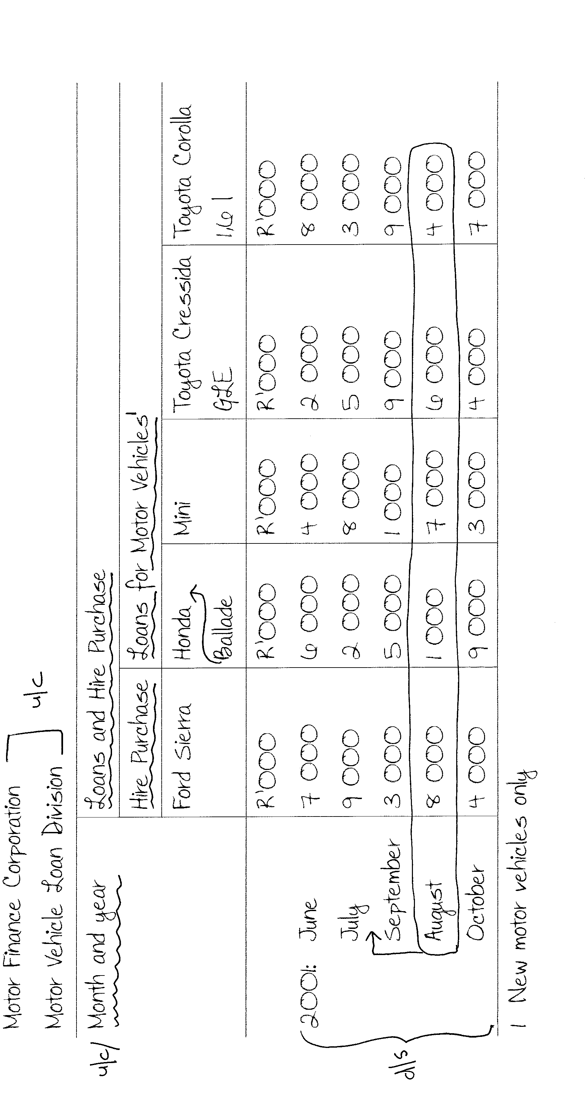

QUESTION 3  Type the following income statement correctly.  TIME: 20 MINUTES | [30]
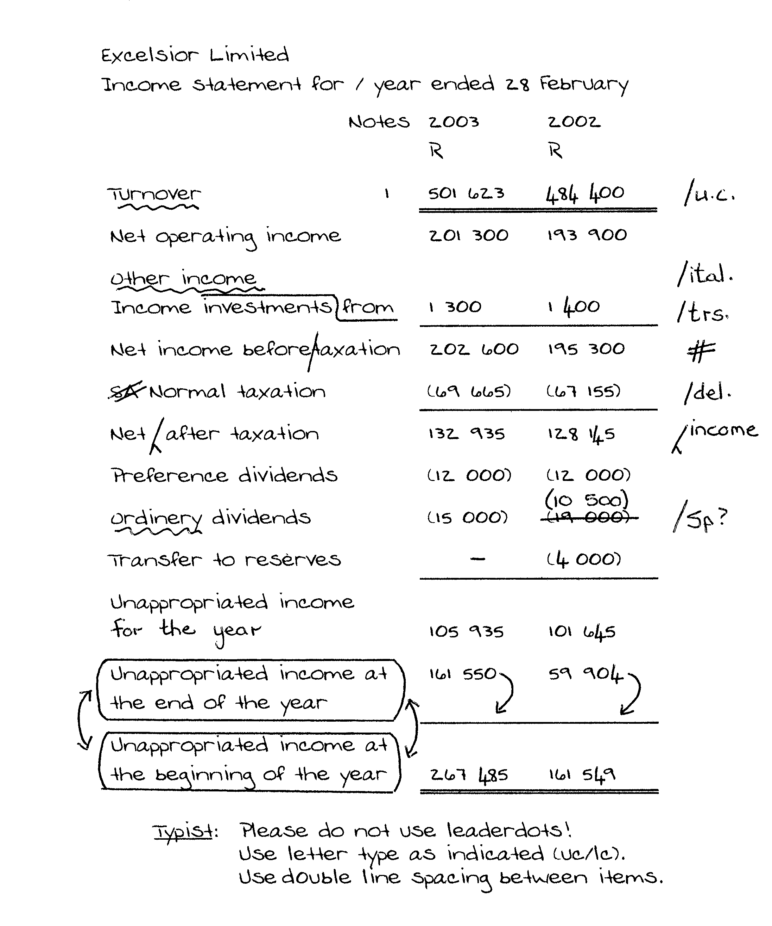

QUESTION 4  Type the following circular correctly on the enclosed letterhead.  TIME: 35 MINUTES | [50]

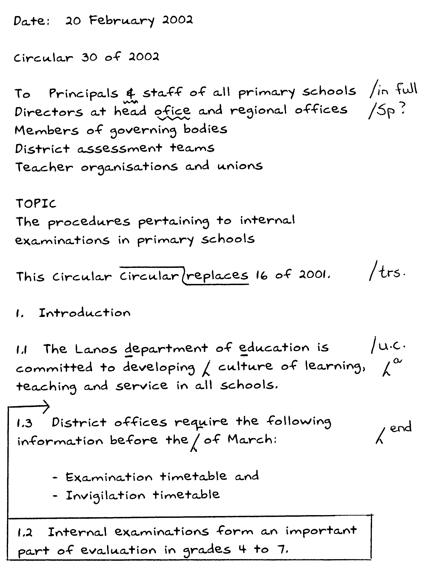

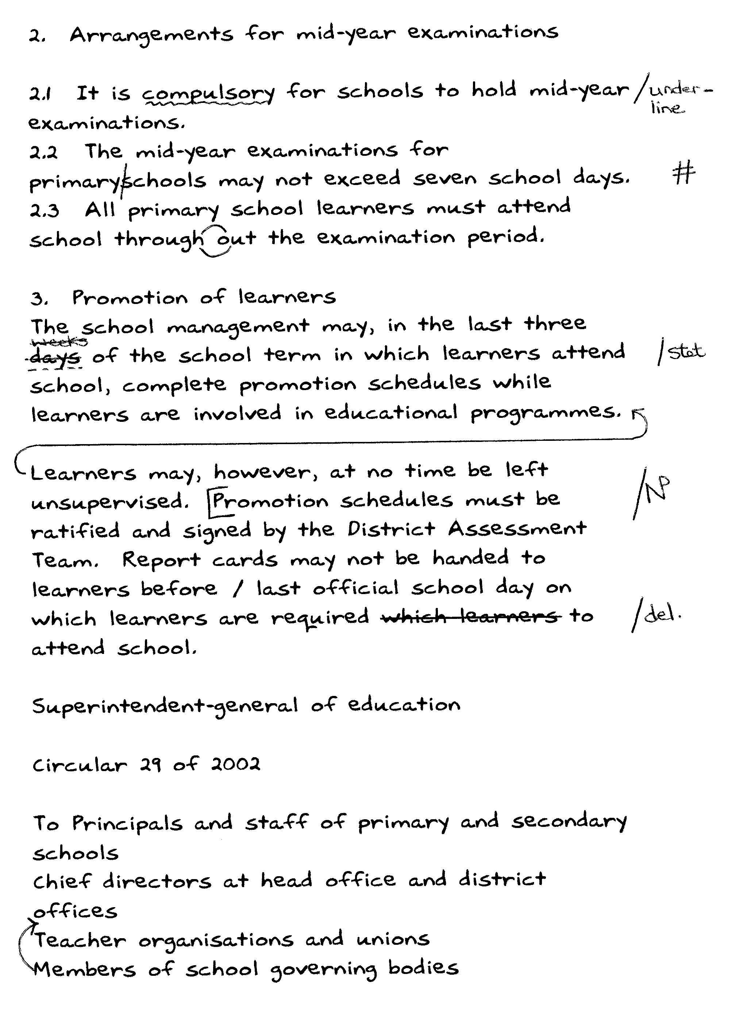

QUESTION 4

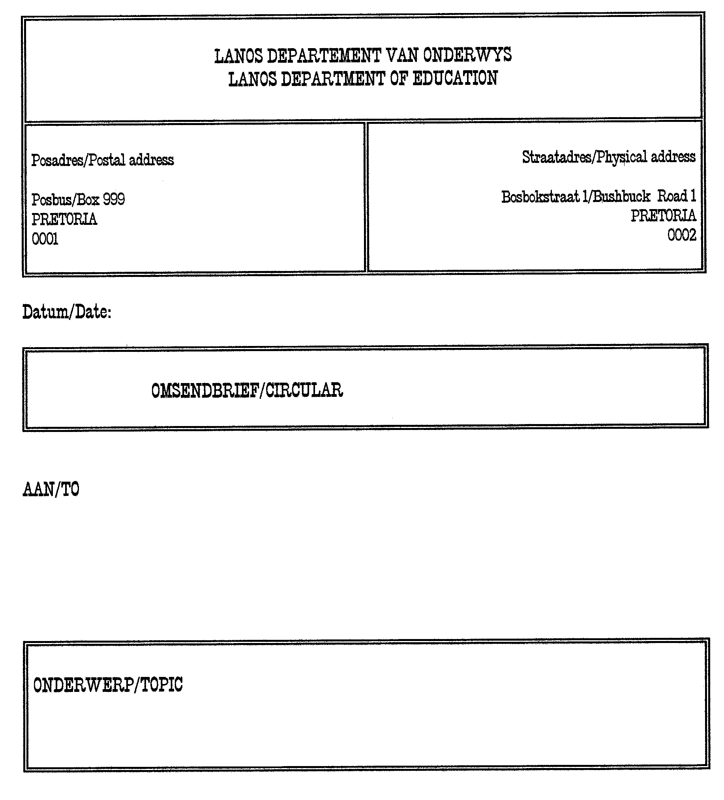

QUESTION 5  Type the following agenda.  TIME: 15 MINUTES | [24]

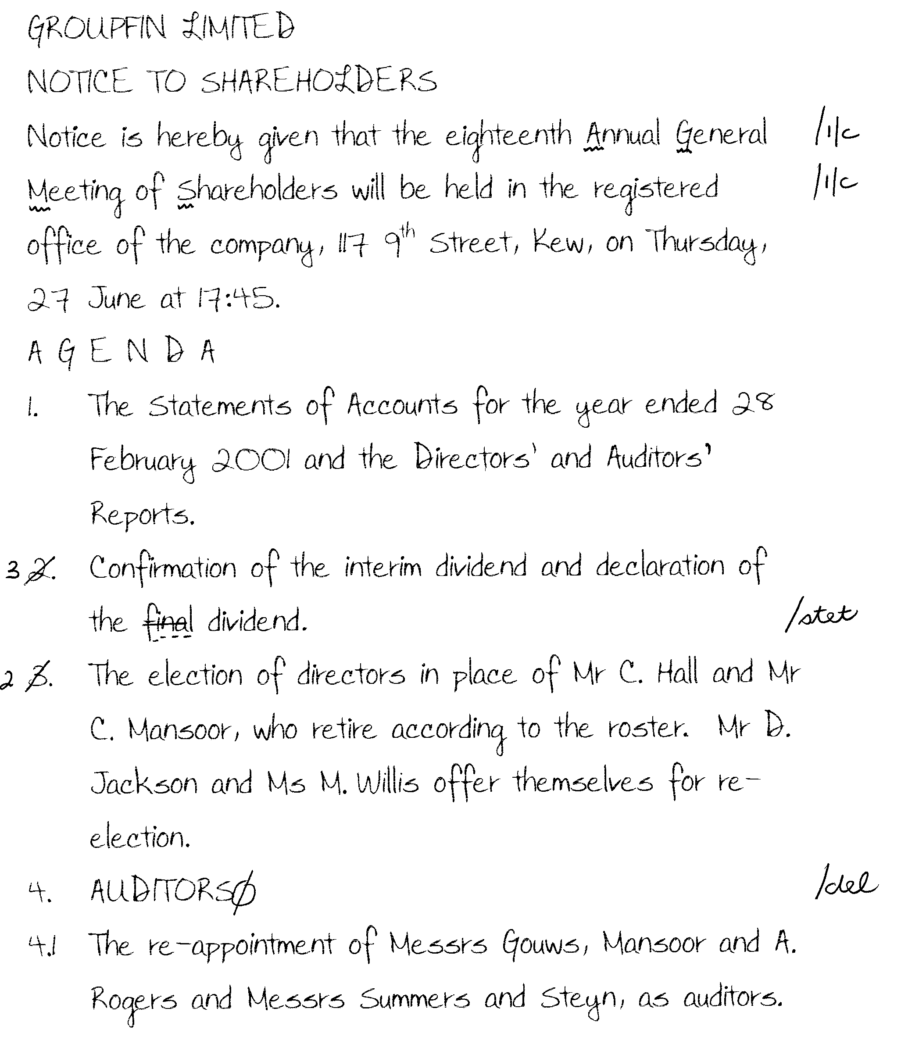

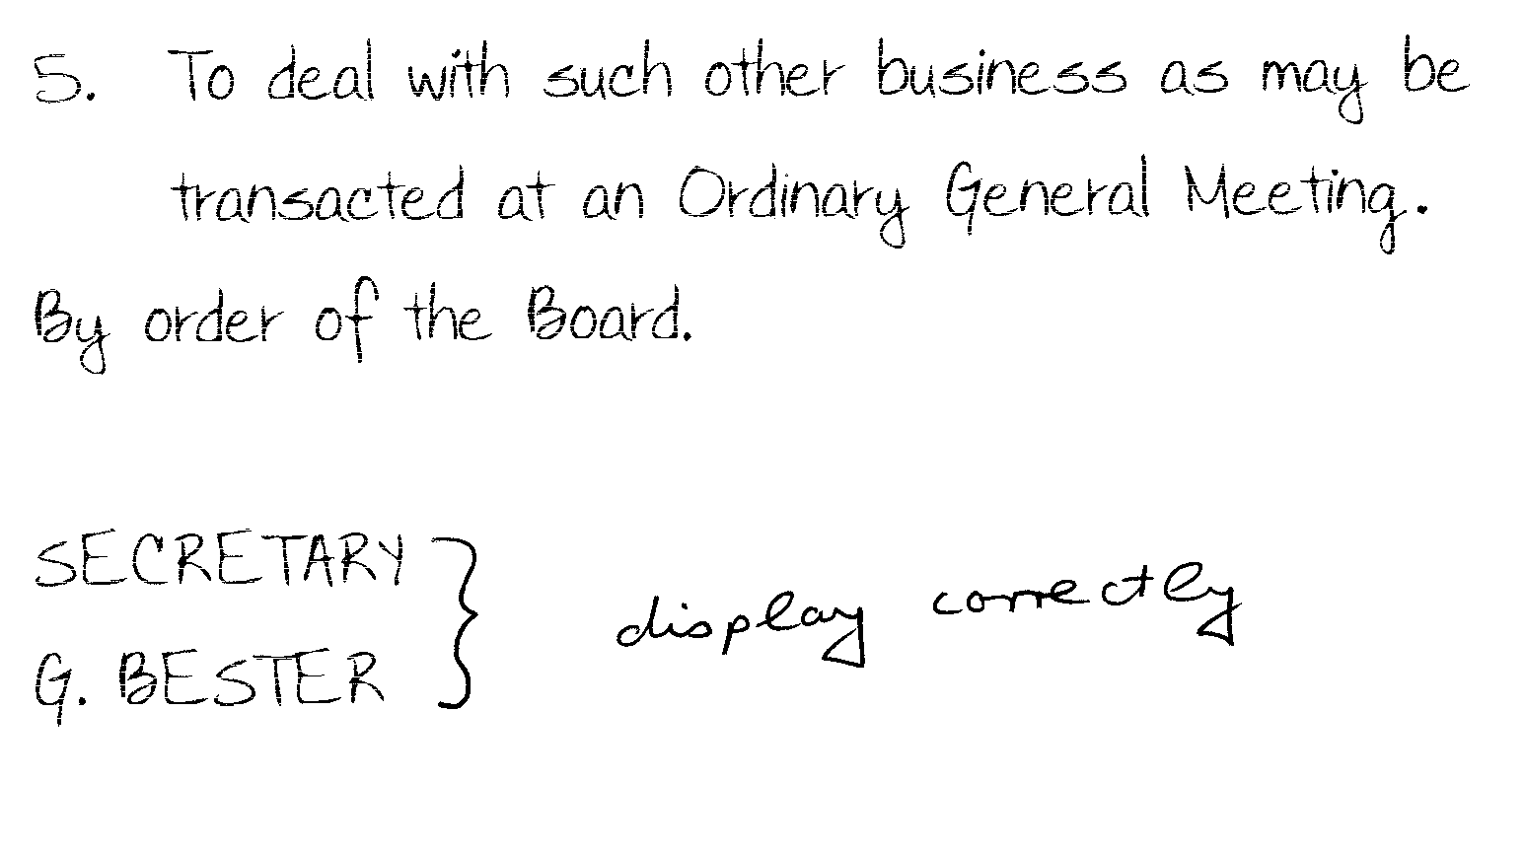

QUESTION 6  Type the minutes of a meeting correctly.  TIME: 25 MINUTES | [40]

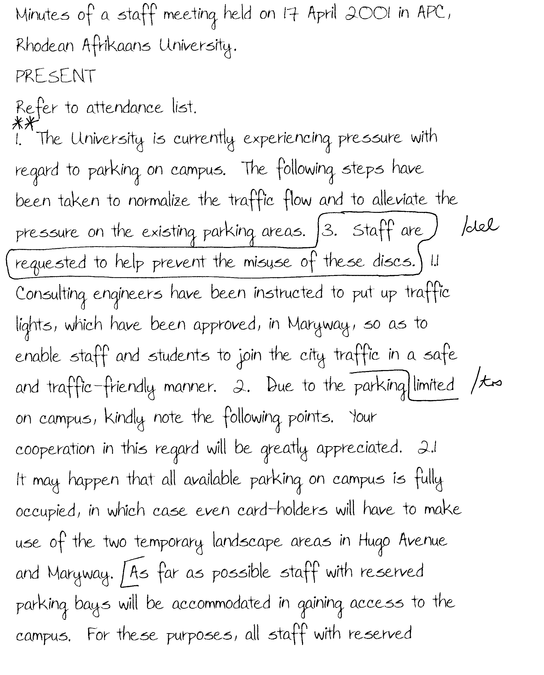

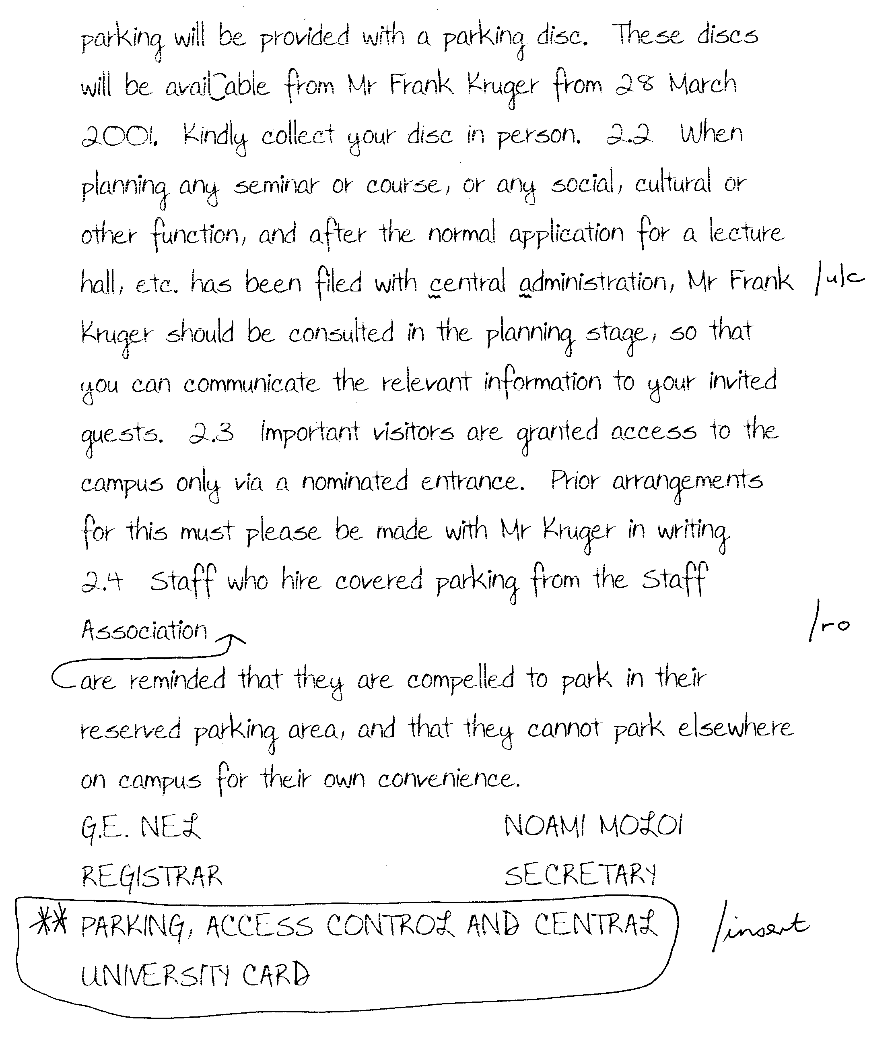

QUESTION 7  Type the following report correctly.  TIME: 24 MINUTES | [36]

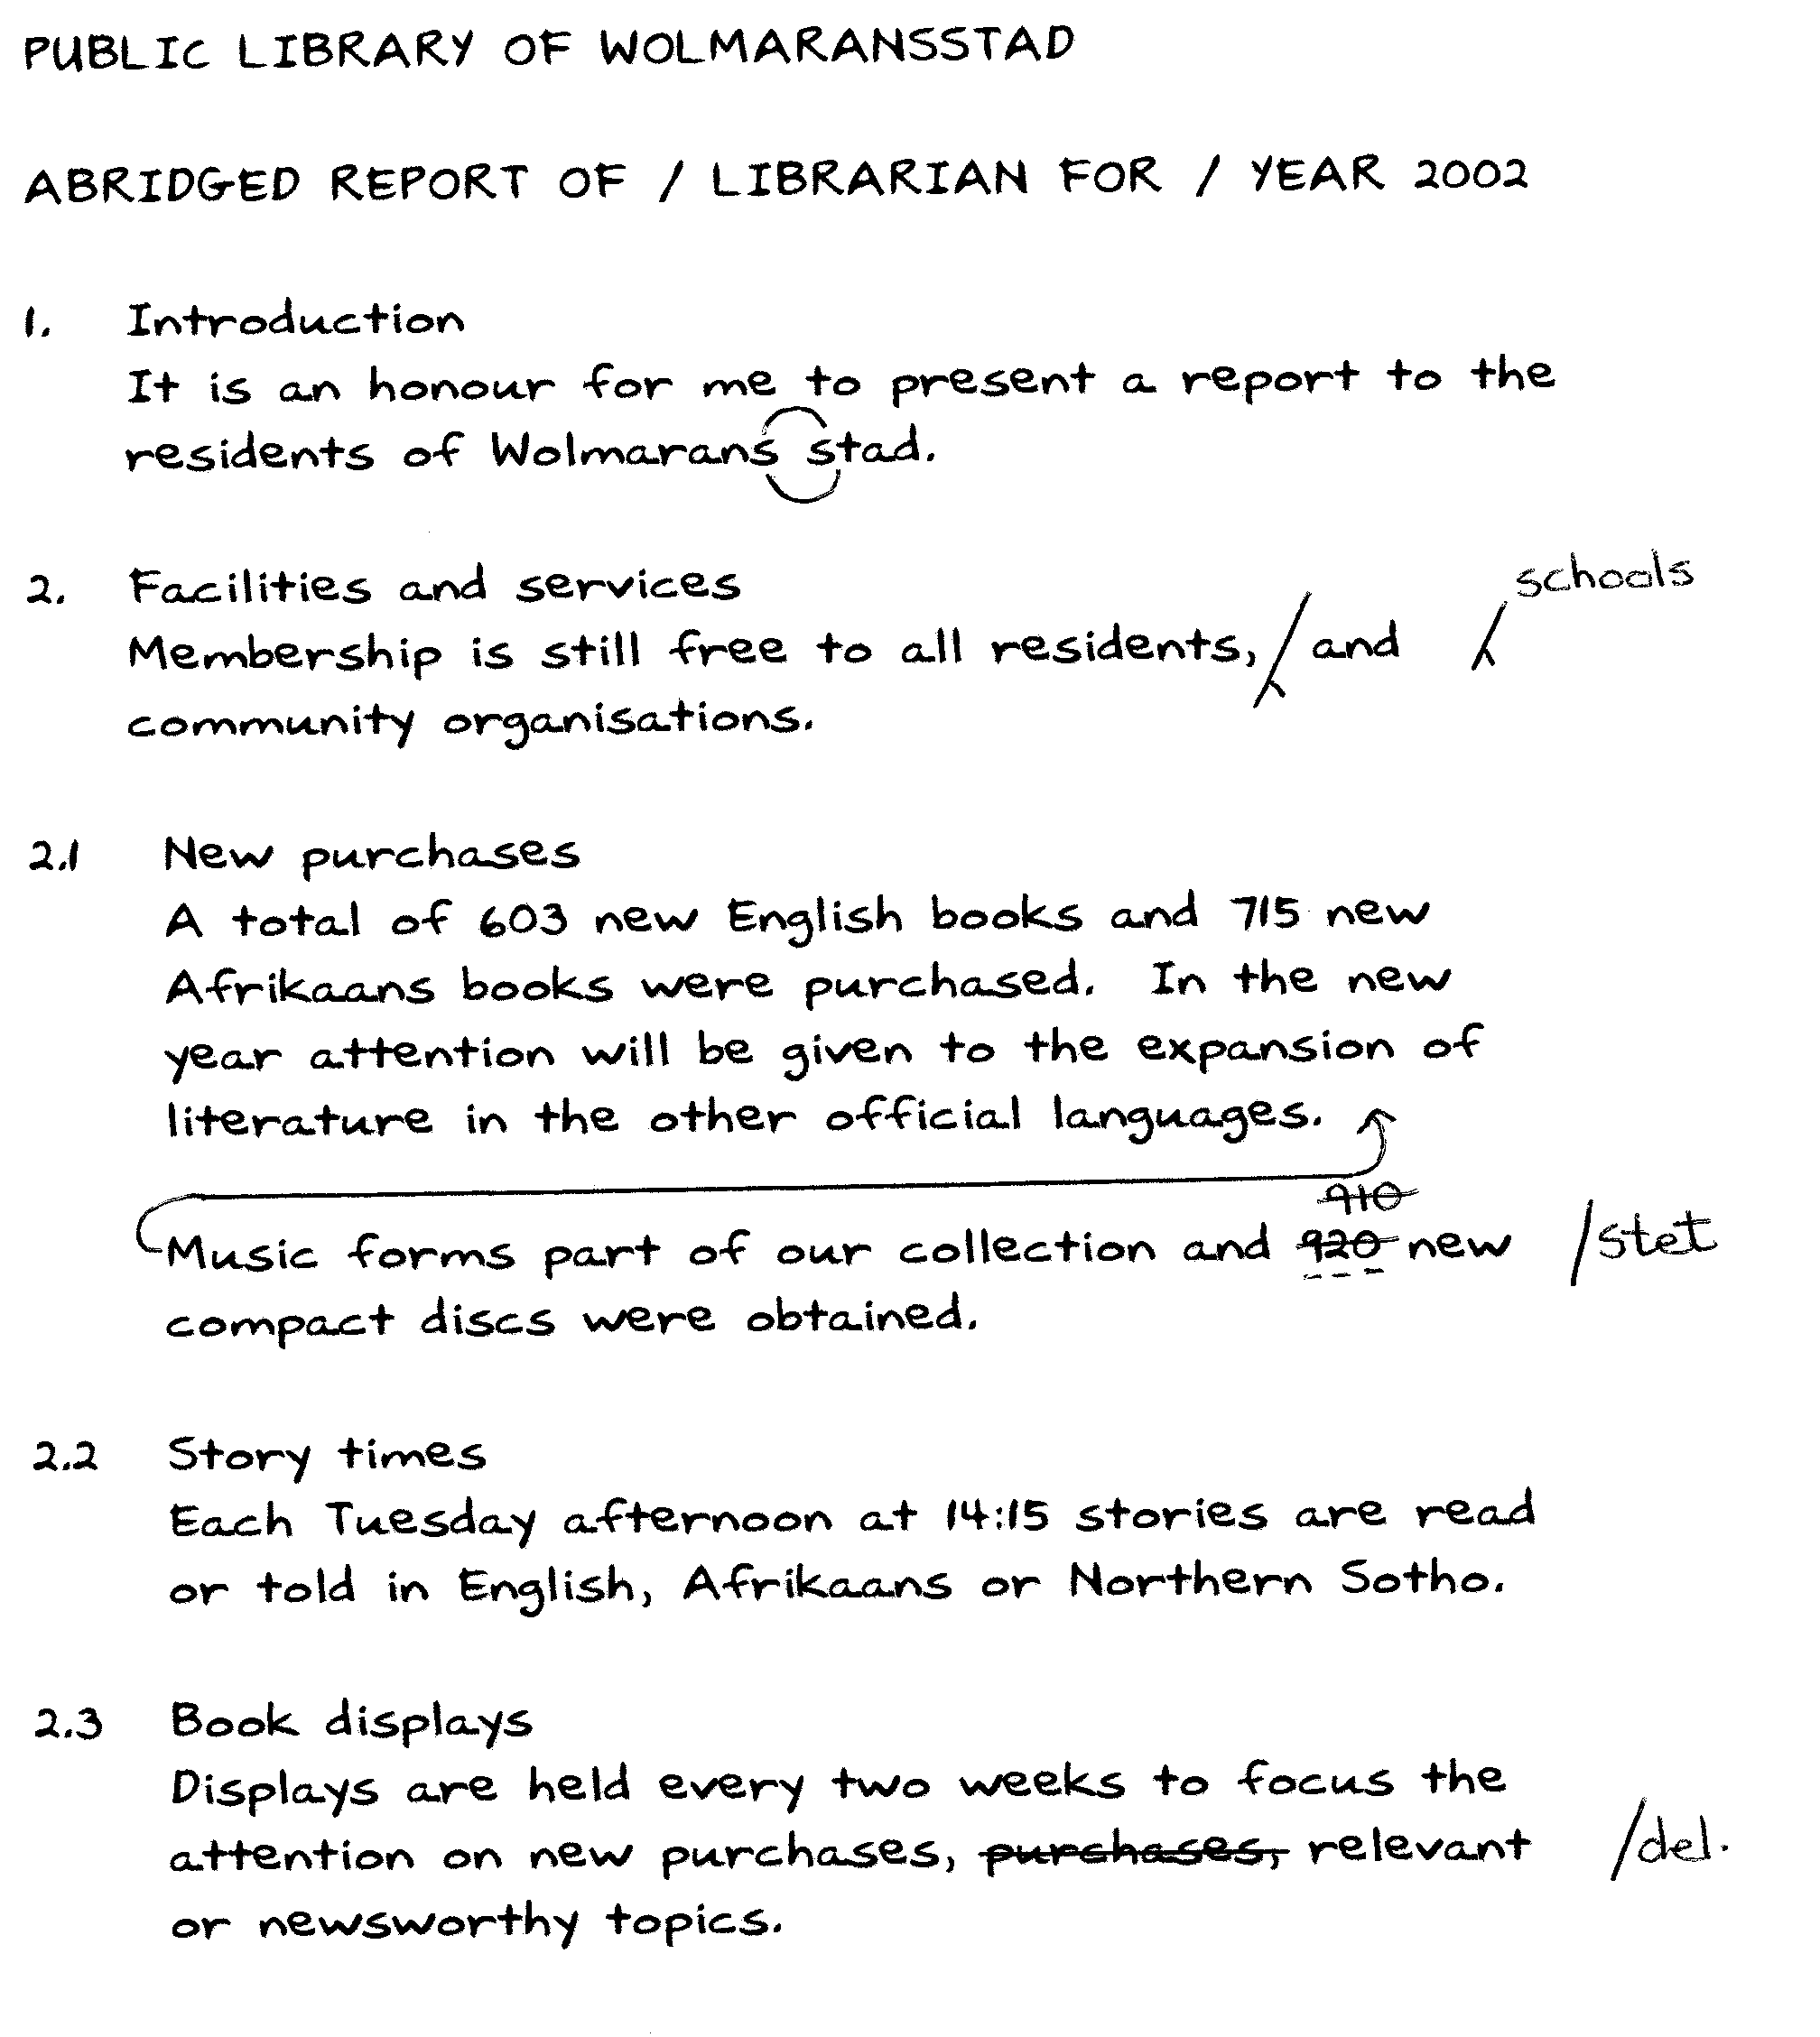

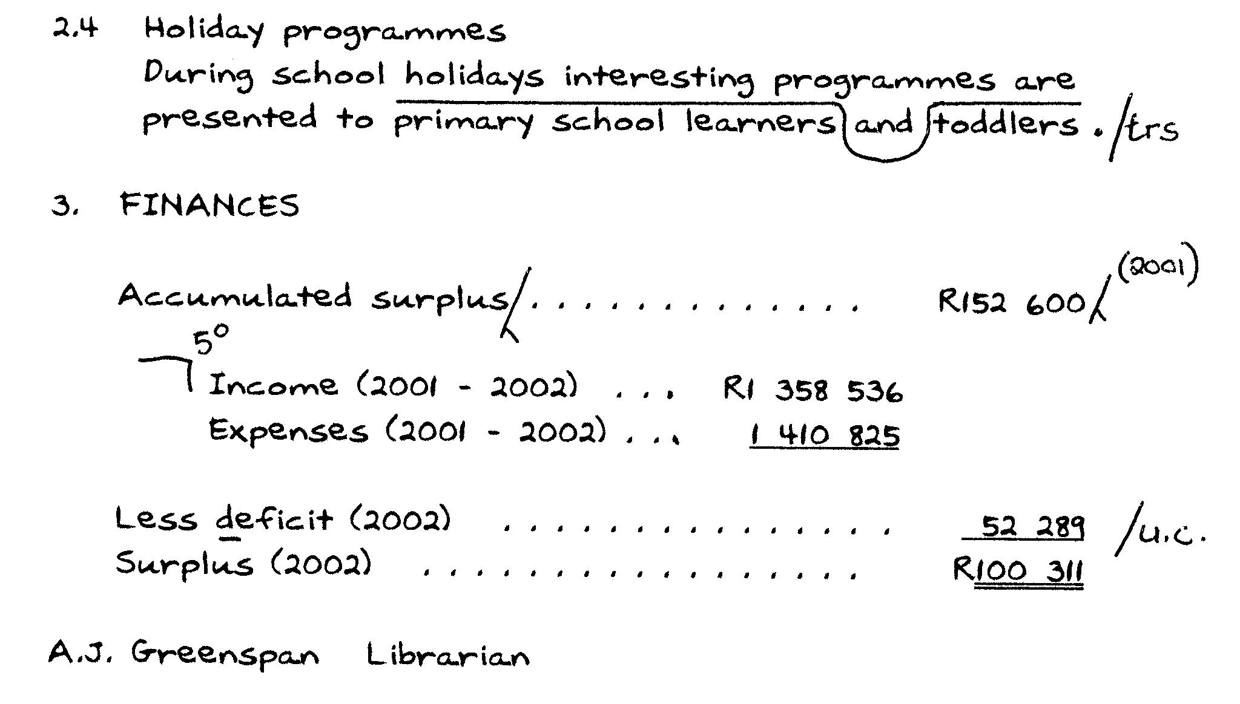

QUESTION 8  Type the following testimonial correctly.  TIME: 20 MINUTES | [30]

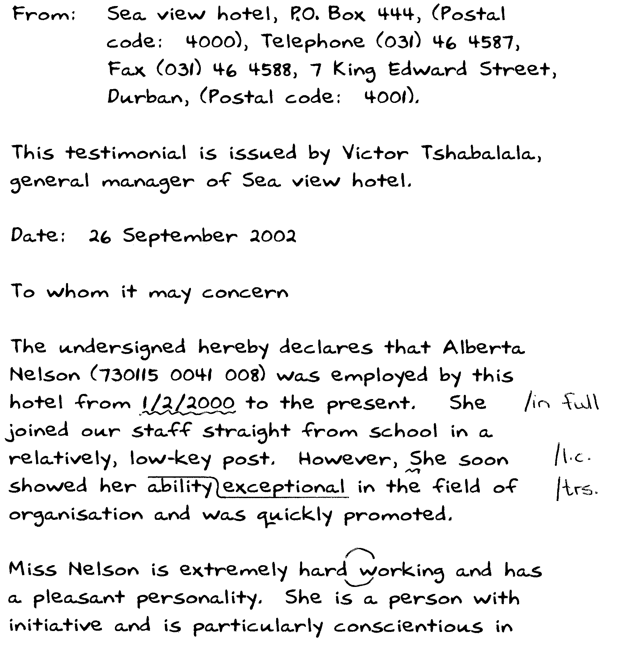

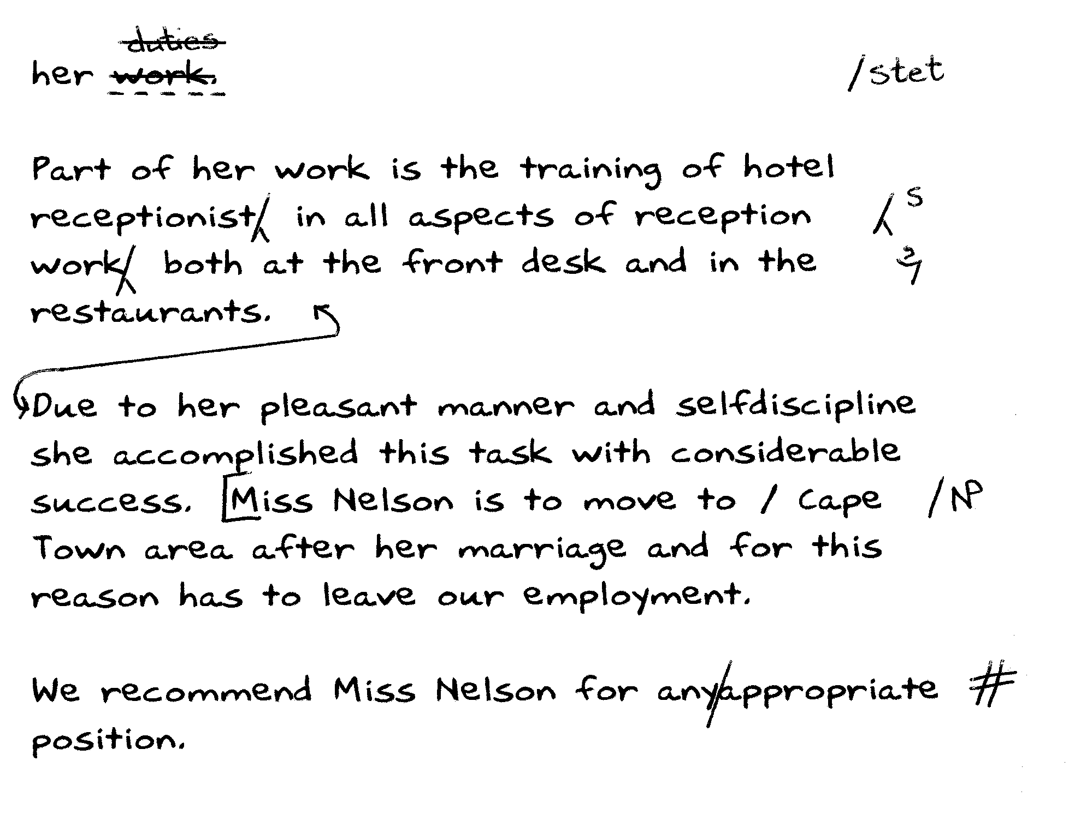

TOTAL: 300

