GAUTENG DEPARTMENT OF EDUCATION

SENIOR CERTIFICATE EXAMINATION

TYPING SG
(Second Paper)

TIME: 3 hours

MARKS: 300

INSTRUCTIONS TO CANDIDATES:

READ THE FOLLOWING INSTRUCTIONS CAREFULLY BEFORE YOU BEGIN THE PAPER.
- Answer ALL questions.
- Type your examination number at the top of every sheet of paper used in answering the questions.
- Begin each question on a separate sheet of paper.
- Arrange your answers in the examination cover provided, in the correct numerical order.
- If you answer the timed accuracy test in English you are to answer Question 2,3,4,5,6,7 and 8 in English as well.
- Please read through your typed answers carefully.
- The invigilators will give you instructions about Question 1.
- You are to complete Question 1 and hand it in before answering the other questions.

INSTRUCTIONS TO INVIGILATORS:

- Place at least eighteen sheets of A4 paper (80 g) in the examination cover prior to the examination.
- The typing teacher is to ensure that the typewriters are in perfect working order.
- Neither carbon ribbons nor correcting ribbons may be used during the examination.
- It is essential that a typing teacher be one of the invigilators for the duration of the examination to assist with malfunctioning typewriters.
- Candidates are to report to the typing centre at least 15 minutes before the examination commences.
- Candidates should be given approximately 10 minutes to read through the examination paper before beginning Question 1. They may rule lines and underline words.
- Both invigilators are to use stopwatches for time control. The timed accuracy test is to be timed by the typing teacher. Invigilators may not move among candidates during this test.
- 8.1 Before the candidates start with this paper, they should be instructed to type their examination numbers in the top RIGHT-HAND CORNER of the paper used for the timed accuracy test. After all the candidates have done this, the signal may be given to begin the timed accuracy test.
  - After the time allowed for the accuracy test has expired, the invigilator is to collect all the tests and initial them after the LAST WORD TYPED ON EVERY SHEET FOR THE SPEED TEST. All sheets used by a candidate to answer Question 1 are to be stapled together. ONLY THE ANSWER SHEETS FOR QUESTION 1 ARE TO BE STAPLED TOGETHER.
  - It is an invigilator’s responsibility to place the timed accuracy test correctly in each candidate’s examination cover on completion of the second paper.
- During the rest of the paper, moving among the candidates is to be restricted to handing out additional paper, assisting with faulty typewriters, etc.
QUESTION 1

The timed accuracy test is to be typed in double line or 1½ line spacing, on one side of the paper only. Use margins of 10°. A minimum of 35 w.p.m. is expected and the limits are indicated by (…).  Time: 10 minutes | [60]





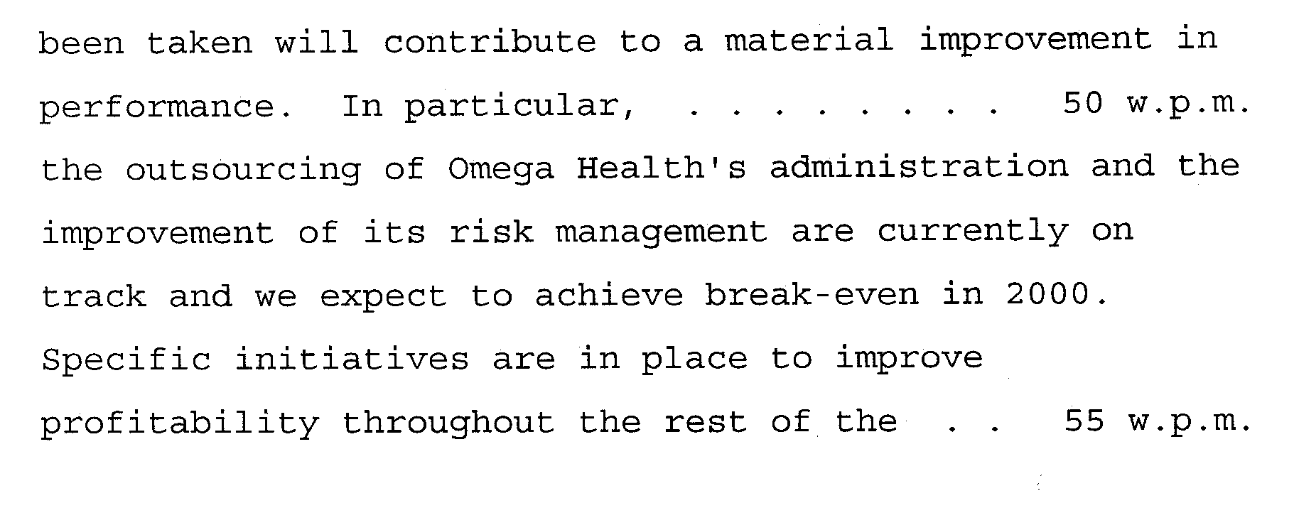

QUESTION 2

Type the following tabulation on one sheet of A4 landscape paper. Draw the vertical lines in ink or on the typewriter. Time: 30 minutes | [40]
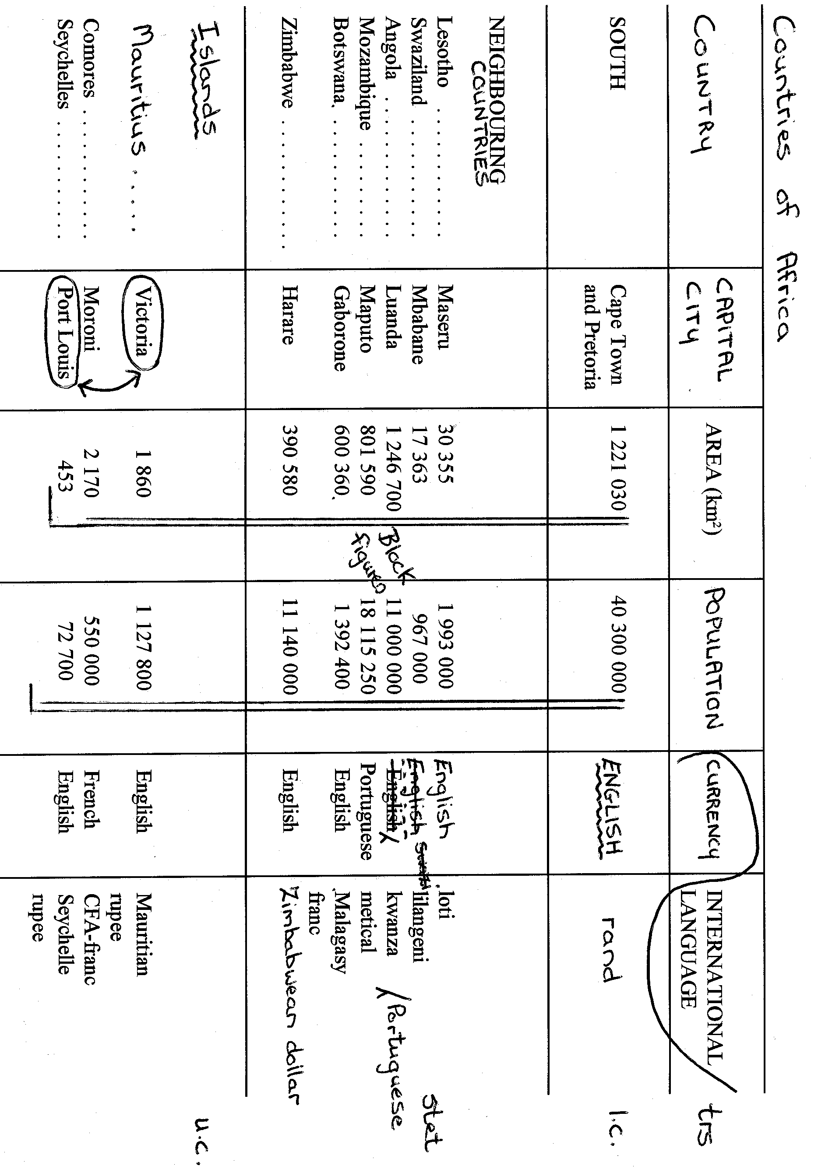
QUESTION 3

Type the following directors’ report and display correctly. Consider all manuscript signs  Time: 25 minutes | [32]

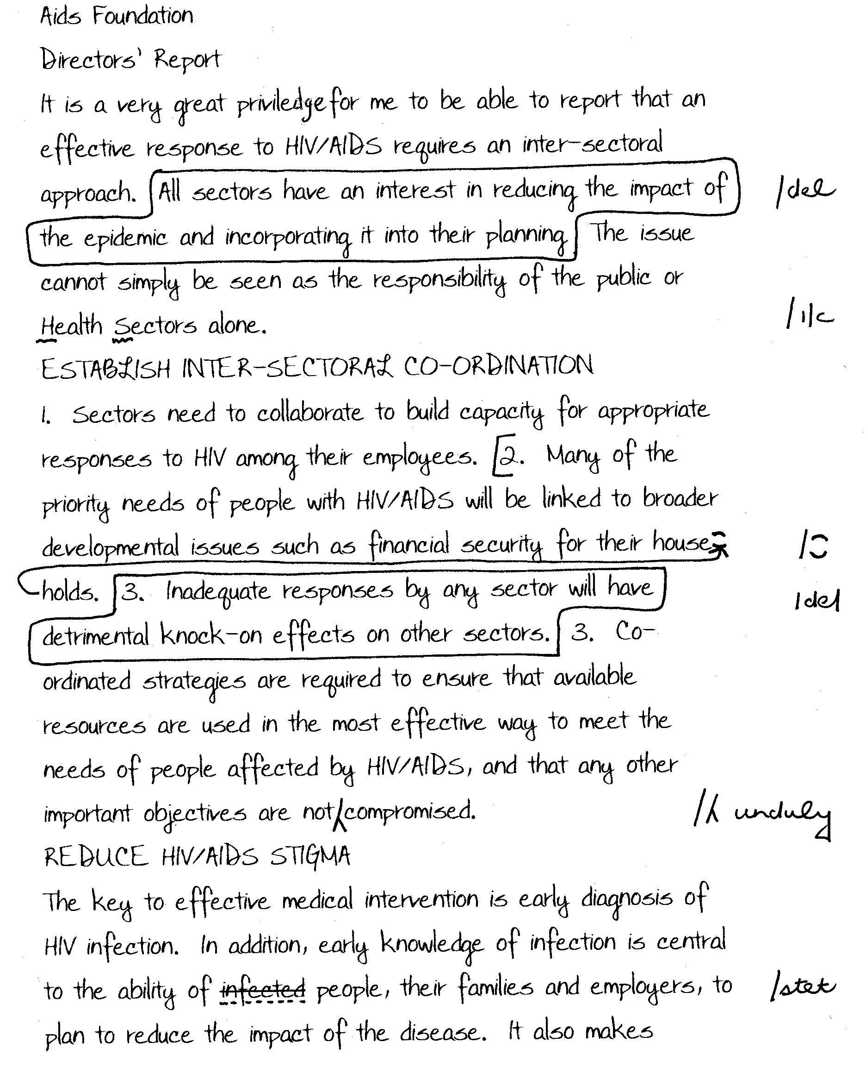

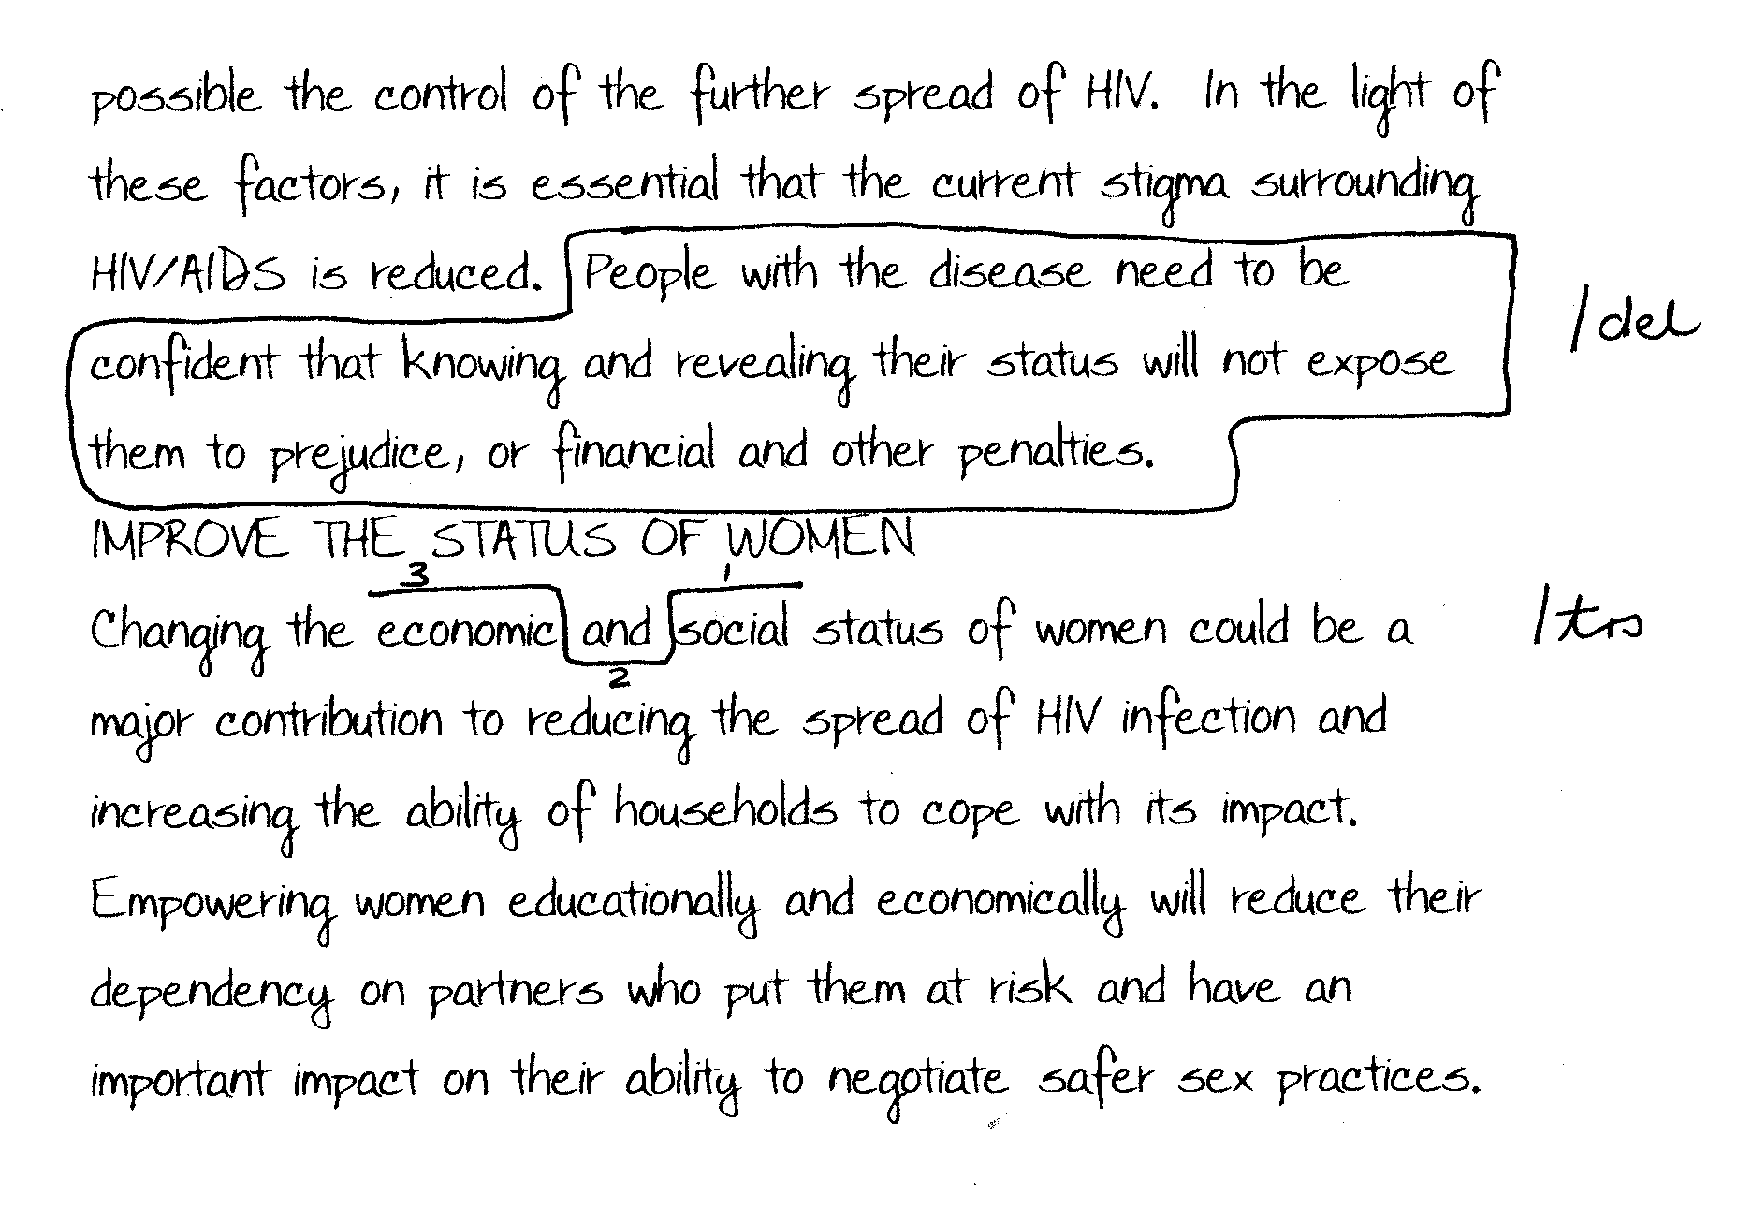

QUESTION 4

Type the following testimonial correctly on the enclosed letterhead. An extra letterhead is provided.  Time: 10 minutes | [20]

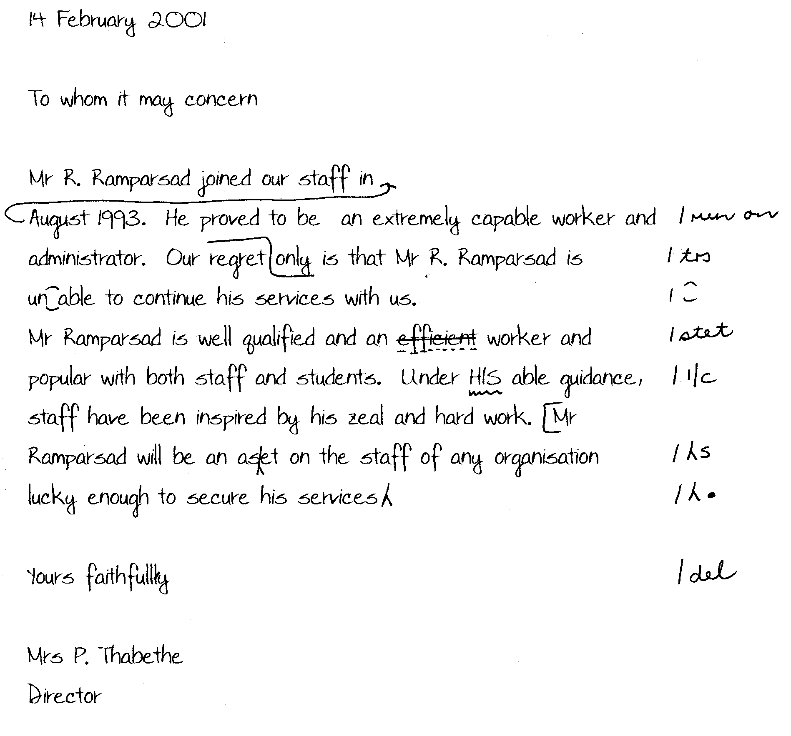

QUESTION 5

Type the following minutes of a meeting correctly.  Time: 30 minutes | (30)

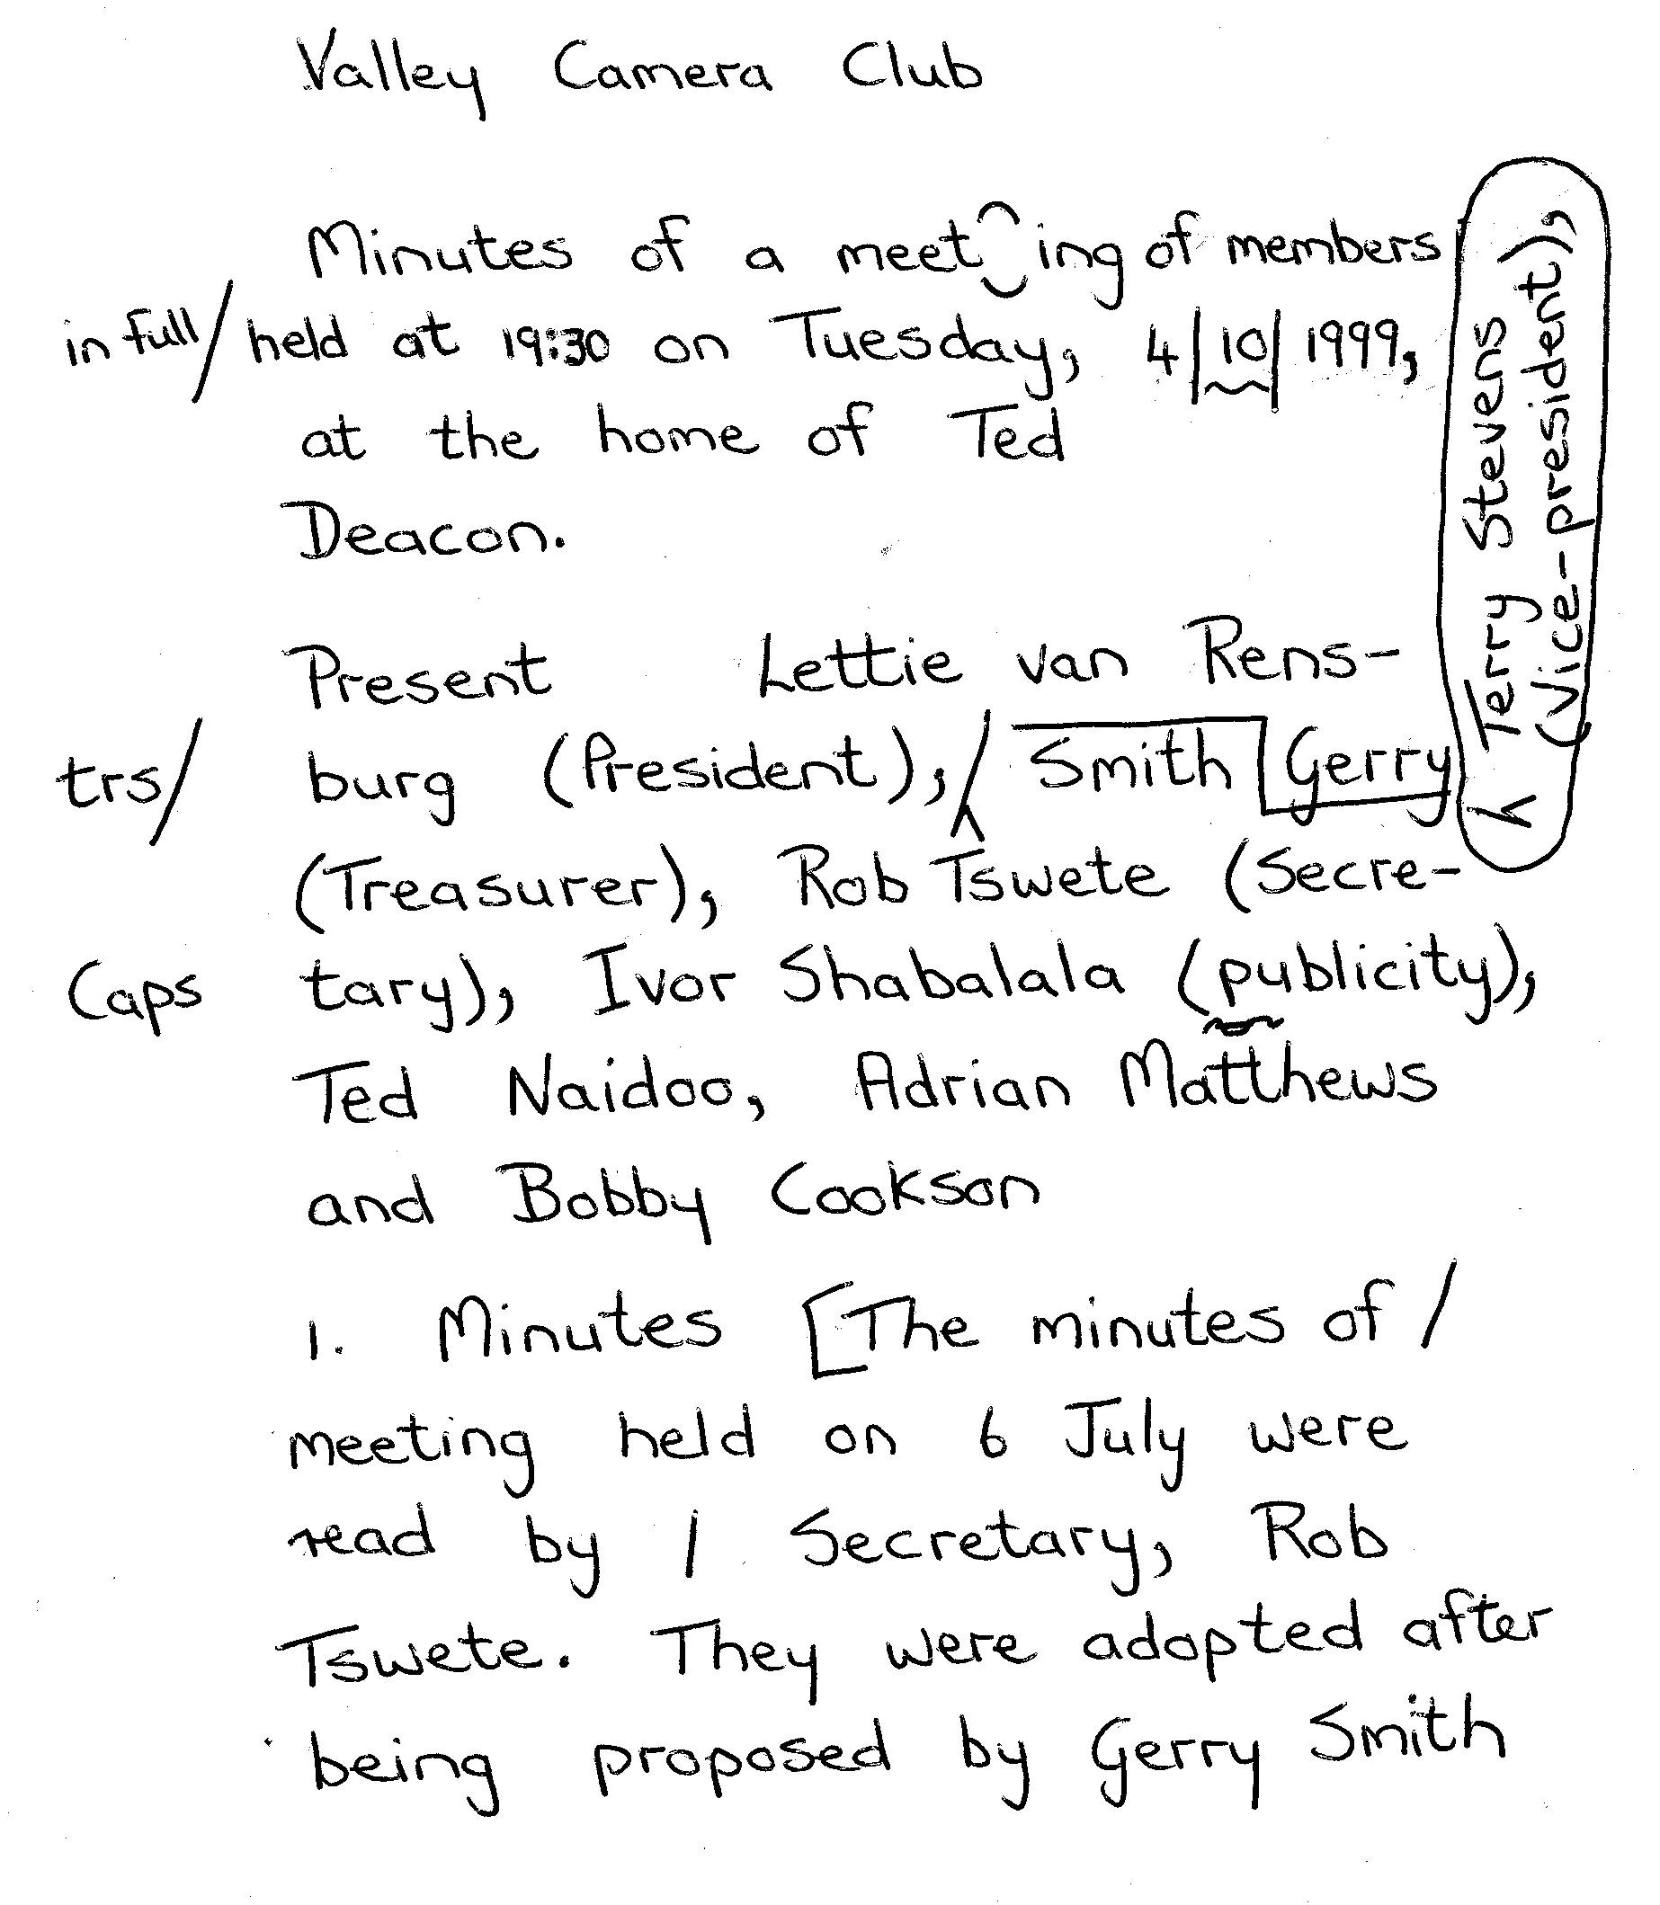

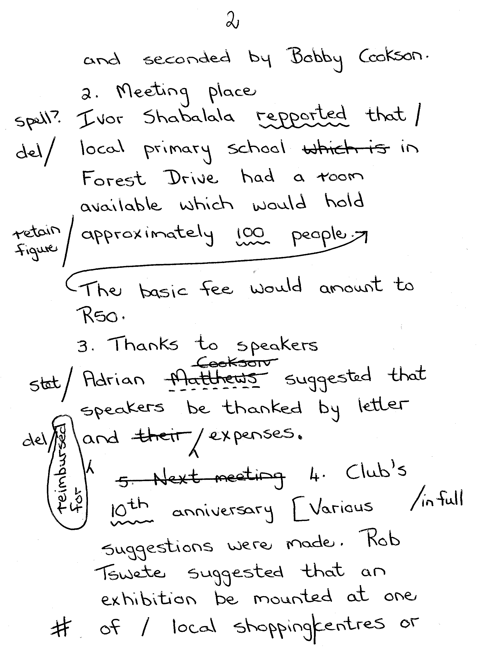

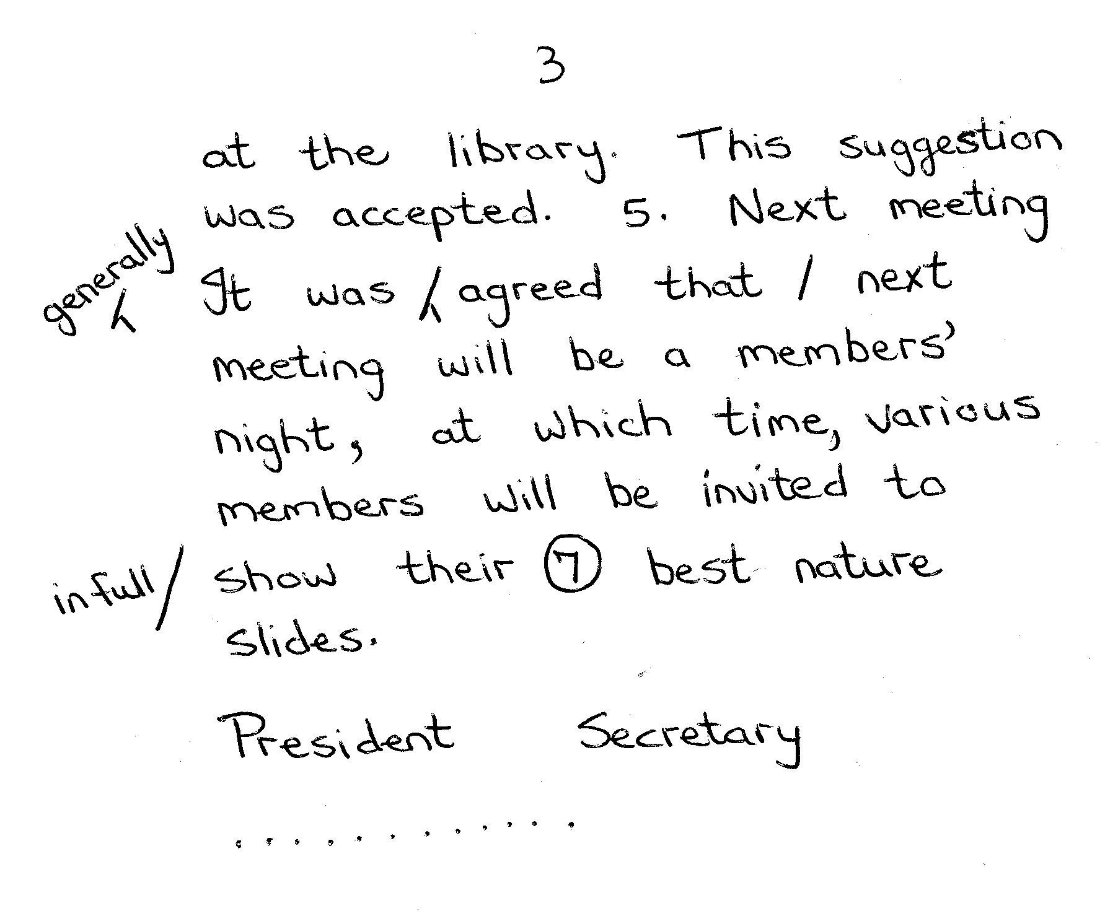

QUESTION 6

Type the following part of a statement correctly.  Time: 25 minutes | [30]

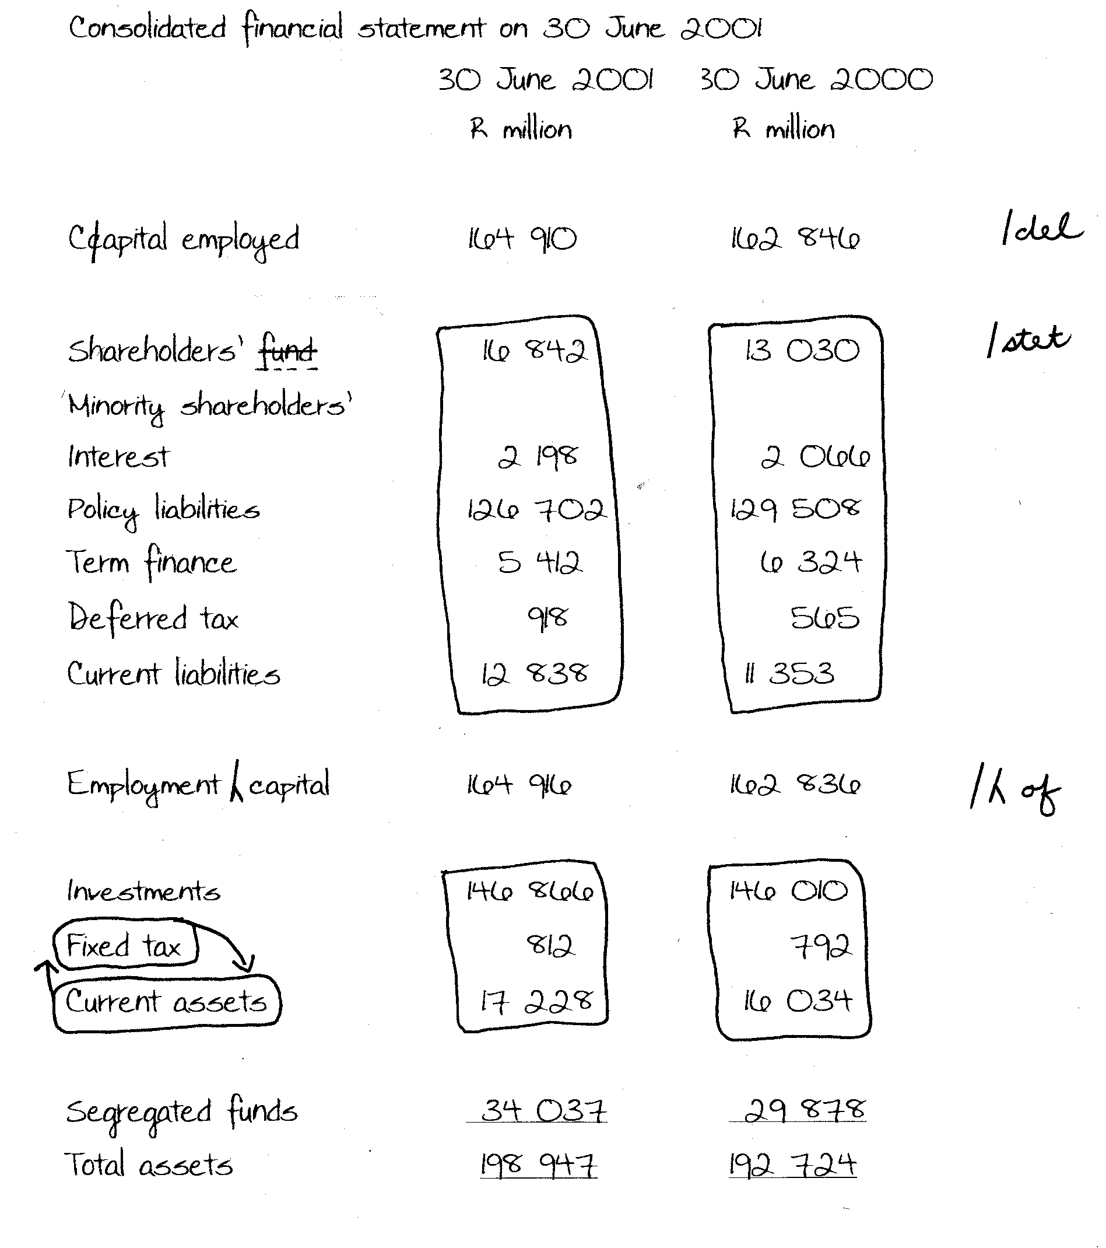

QUESTION 7

Type page 4 of a lease agreement correctly.  A title page is not required.  Time: 25 minutes | [44]

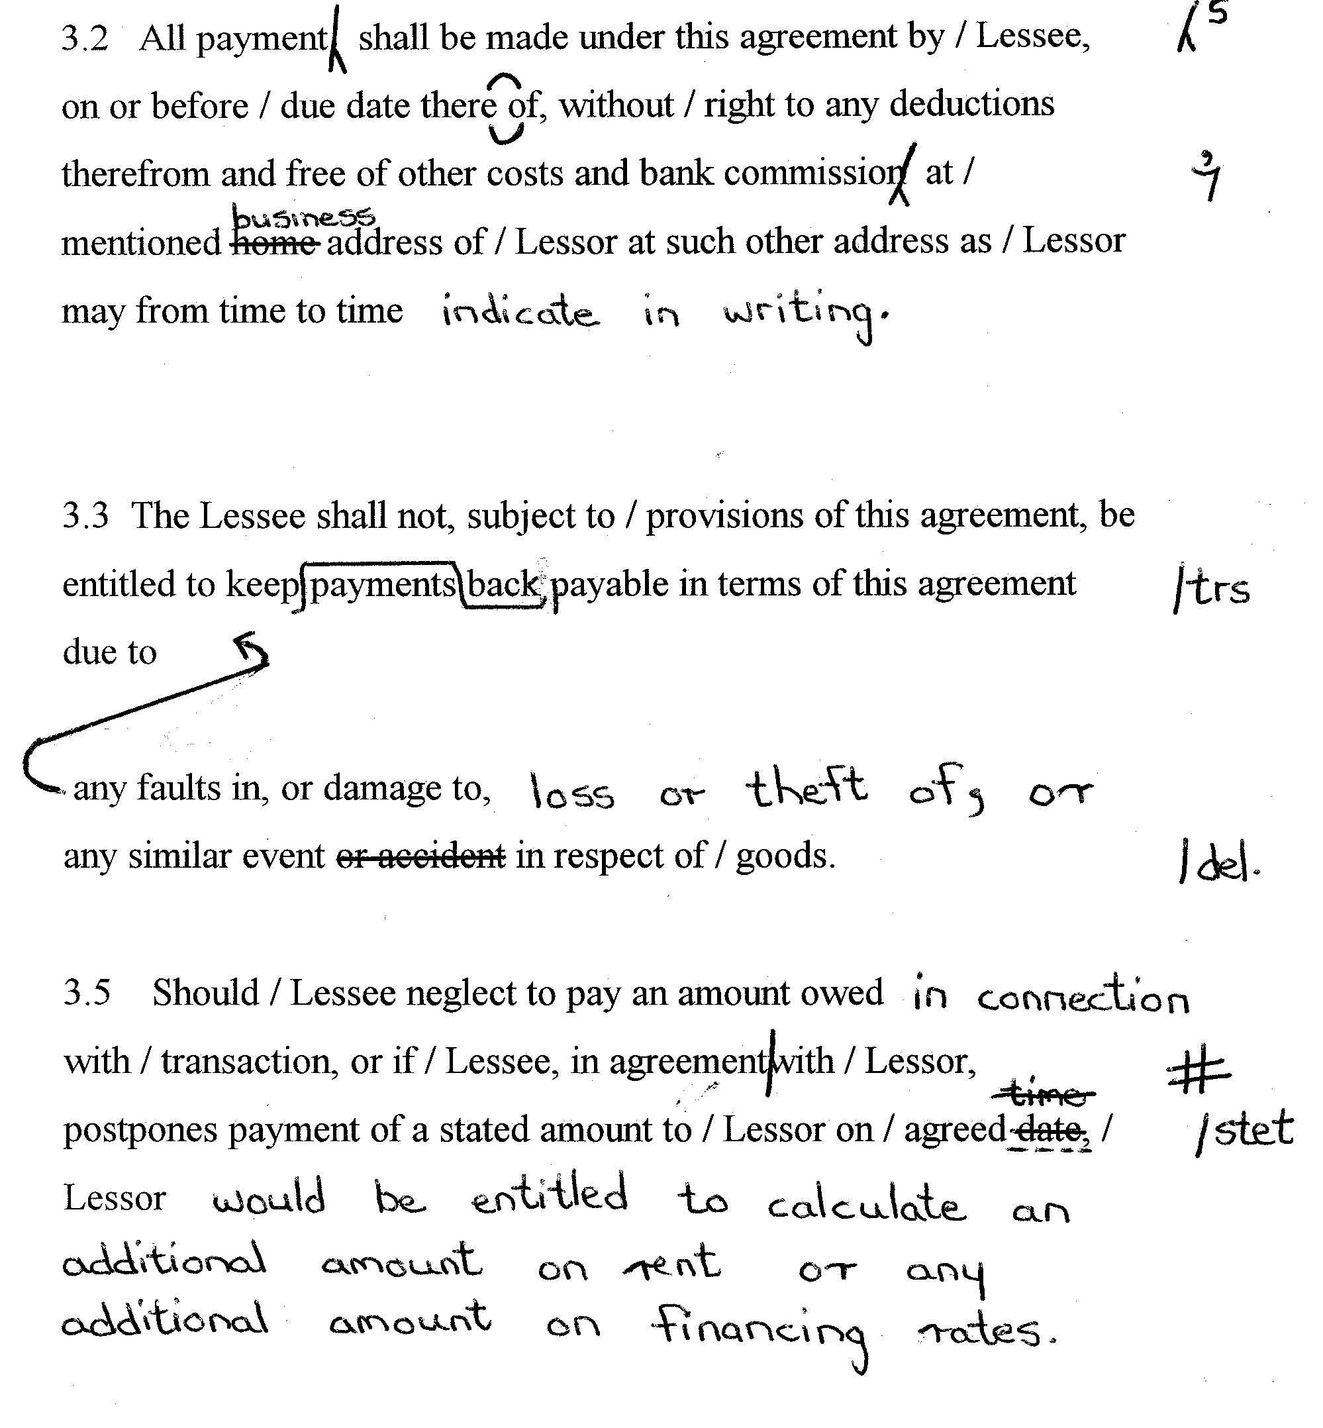

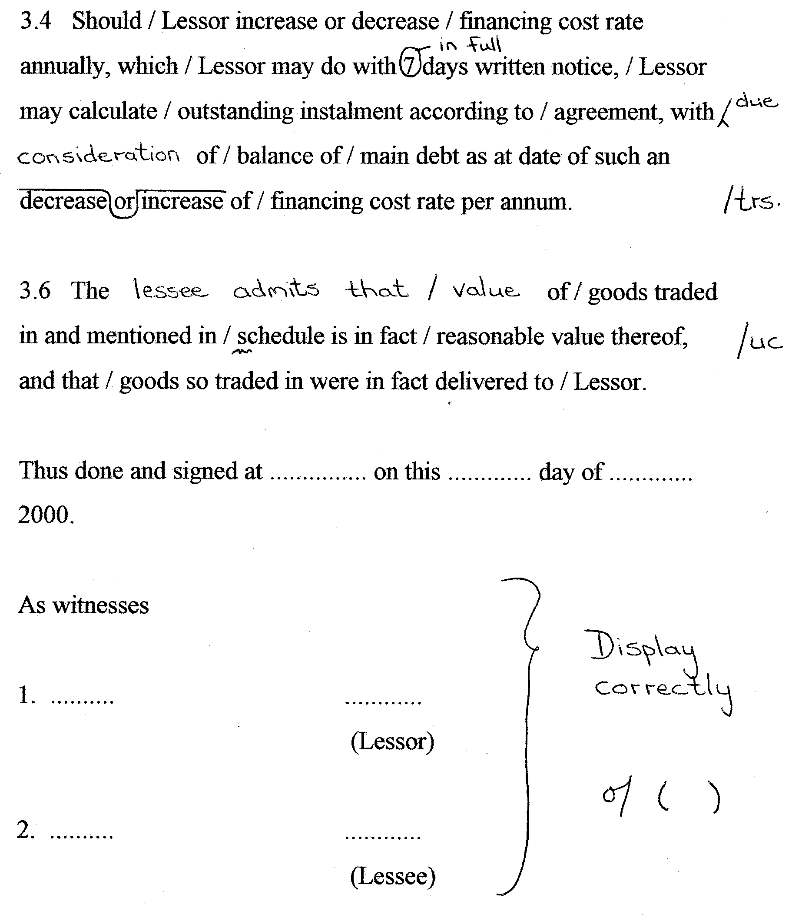

QUESTION 8

Type the following letter on the letterhead provided correctly. Consider all manuscript signs. An extra letterhead is provided.  Time: 25 minutes | [44]

