GAUTENG DEPARTMENT OF EDUCATION

SENIOR CERTI E EXAMINATION

TRAVEL AND TOURISM SG

TIME: 3 hours

MARKS: 150
INSTRUCTIONS:

- The paper consists of TWO sections.

- Section A (Questions 1 and 2) is COMPULSORY.

- Answer any THREE questions from Section B (Questions 3 to 7).

- Please number your answers exactly as the questions are numbered, using the decimal numbering system e.g. 2.1.1.

- Start each new question on a new page in your answer book.

- The Addendum (pages 12 to 18) contains information which pertains to various questions in this paper. You are advised to detach the Addendum and place it alongside the relevant questions for easy reference.

SECTION A  COMPULSORY  QUESTION 1  - Which of the icons that you have studied, would you associate with the following places? State the icon, then say in which country or city it is located.  - New York  - Italy  - France  - India  - Japan  - Consider all the International Tourist Destinations you have studied. To which attraction would you send the tourist(s), in each of the following cases?  - A family of four waiting to have fun and pleasure together in America.  - A group of art students keen to see the works of Leonardo da Vinci and Michelangelo. | 5x2=(10)

    - An Islamic religious tourist going on a hadj or pilgrimage.
    - An ecotourist wishing to combine game viewing with mountain climbing.
    - A sports tourist keen on snow skiing.
    - A wealthy businessman and his wife who want to embark on a tax free shopping spree.
    - A member of the British Royal family wanting to relax at a destination in Europe, renowned for its sunny climate, even in winter.
    - A couple on honeymoon wanting to visit Italy’s most popular coastal resort. They want to experience the rich cultural heritage of this city built on a group of islands and enjoy a romantic gondola ride.
    - Christian religious tourists wanting to visit a holy city of the Christian, Jewish and Muslim religions.
    - Ecotourists wanting to visit the most popular game park in South Africa.
(10)

- Which European country has the highest number of visitors to South Africa?  - List South Africa’s FOUR top tourist markets.  - Which event “opened doors internationally” for South Africa?  - Who is the current Minister of Environmental Affairs and Tourism?  - Which province in South Africa has the highest number of guest beds?  - What is the NGSC? Name the TWO broad categories into which it is divided.  - Which city is known as the Mother City and what is its most popular urban attraction?  - South Africa has produced FOUR Nobel Peace Prize winners. Name them.  - Name the Big Five.  - In table form list the 9 provinces and next to each, ONE major tourist attraction in that province.  - In which province do we find most of South Africa’s top 10 tourist attractions? | (1)  4x½=(2)  (1)  (1)  (1)  (3)  (2)  (4)  (5)  18x½=(9)  (1)  [50]

QUESTION 2
ITINERARY

Use the information in Addendum C on pages 14 and 15 to answer this question.

Read the information, background and instructions very carefully before answering this question.

Background

Four wealthy tourists from Johannesburg want you to organise a three day, two night tour to Mpumalanga.

They have heard much about the area’s natural beauty and would like to experience as much of it as possible. They have heard rave reviews from friends of theirs about Pilgrim’s Rest, and would enjoy spending an afternoon and night in this unique little town. They would also like to see the attractions of the Panorama Route such as God’s Window and Bourke’s Luck Potholes.

Instructions  Plan a tour and budget for the tourists, by using the information provided. Wherever possible, show all your calculations, as you will be awarded marks for all calculations.  Note the following when compiling the itinerary:  2.1 The itinerary should follow a logical route. Describe the route briefly  Use the Airlink timetable on page 12 of the Addendum to draw up a table of airfare in each of the following cases (2.2.1 and 2.2.2). They are flying economy class. Copy the table below into your answer book.  They will reach Nelspruit on the 10:00 flight on a Friday morning.  - They will leave Nelspruit on Sunday, on the last flight out. | (1)

 | Flight | Depart | Arrive | A/C | Class | Fare | (2)
2.2.1 |  |  |  |  |  |  | (2)
2.2.2 |  |  |  |  |  |  | (2)

- Your clients would like to hire a Toyota Venture from Avis Car Hire. Work out a quotation for them and include CDW and TLW. They will travel about 600 kms in all.  - Calculate the total cost for transport for the entire tour.  2.5 All accommodation has already been arranged and bookings have been made. Your clients have each paid R 750,00 for accommodation on a DB & B basis for the weekend. Calculate the cost of their accommodation.  2.6 They have budgeted R 50,00 each a day for lunches and R 100,00 each a day for excursions. Calculate the total cost for lunches and excursions.  2.7 For gifts and souvenirs they have each budgeted R 200,00. How much will they have to spend altogether?  2.8 For unexpected expenses each person will put aside R 1000,00. What will the total amount be for these unexpected expenses?  2.9 Copy the table below into your answer book and use it to show what they will be doing and where they will be going during the weekend. | (2)  (1)  (1)  (2)  (1)  (1)

Friday afternoon

Friday evening

Saturday morning

Saturday afternoon

Saturday evening

Sunday morning

Sunday afternoon
(7)

2.10 Copy the table below into your answer book and use it to compile a travel budget for the tourists.

COSTS FOR THE TWO COUPLES
FOR THE WEEKEND
 | Travel Budget
 | Travelling expenses
 | Accommodation expenses
 | Meals
 | Excursions
 | Gifts / Souvenirs
 | Unexpected expenses
 | Total
 | Cost per couple
TOTAL FOR SECTION A: |  |  |  | (8)  [25]  [75]

SECTION B  Answer any THREE of the following questions.  QUESTION 3  ESSAY  In 1996 Satour conducted two surveys among foreign tourists, that revealed the unique features which attract overseas visitors to our country. Explain in your own words what each of these SEVEN “unique selling points” means, and name examples of each one.  Your essay should be at least 250 words in length.  Your answer will be assessed according to the following criteria:  - Your overall knowledge of facts associated with the topic  - Your logical reasoning in the discussion of the topic  - Your ability to express your thoughts clearly and fluently | [25]

QUESTION 4  TRAVEL JARGON AND COMPREHENSION  4.1 You are a travel agent. Your client is a South African, flying overseas for the first time. He will be flying from South Africa to England, then on to New York, before returning to Johannesburg. He makes enquiries concerning baggage allowances. Supply him with detailed information. | (10)

Explain to your client what is meant by the following terms:  - Carry on luggage  - Excess baggage costs | (3)  (3)

Your client flies from South America to Germany. In the itinerary you have worked out for him, you have left him with plenty of leisure time on Day 1. Explain why you have arranged it like this, taking into consideration the effects of jet-lag.  4.4 Study the table below taken from the Cape St. Francis Resort then answer the following questions. | (3)

 | PRICE LIST  1997 | RATES FOR 1997  Effective from 12 Jan. 1997 to 10 Jan. 1998  self catering rate per 2 guests |  | HIGH SEASON – XMAS  Period 12 Dec. 1997 to 10 Jan. 1998  self catering rate per UNIT |  |  | HIGH SEASON – EASTER  Period 27 March to 30 April  self catering rate per UNIT
 | CHALETS | 140.00 | XTRA @ R20 PP | 225.00 | sleeps 4 |  | 180.00 | sleeps 4
 | APARTMENTS | 120.00 | XTRA @ R20 PP | 245.00 | sleeps 4 |  | 210.00 | sleeps 4
 | APARTMENTS BUDGET | 100.00 | XTRA @ R20 PP | 195.00 | sleeps 4 |  | 175.00 | sleeps 4
 | COTTAGES SMALL | 170.00 | XTRA @ R35 PP | 380.00 | sleeps 5 |  | 325.00 | sleeps 5
 | COTTAGES STANDARD | 170.00 | XTRA @ R35 PP | 460.00 | sleeps 6 |  | 380.00 | sleeps 6
 | COTTAGES LARGE | 170.00 | XTRA @ R35 PP | 590.00 | sleeps 8 |  | 470.00 | sleeps 8
 | COTTAGES SUPERIOR | 220.00 | XTRA @ R35 PP | 725.00 | sleeps 8 |  | 550.00 | sleeps 8
 | SITE(NO ELECTRICITY) | 35.00 (No Electricity) | XTRA @ R7 PP | 100.00 | For 4 People | XTRA @ R35 PP | 50.00 | For 2 People | XTRA @ R15 PP
 | SITE(ELECTRICITY) | 40.00 (10 amp elect.) | XTRA @ R7 PP | 120.00 | For 4 People | XTRA @ R35 PP | 60.00 | For 2 People | XTRA @ R15 PP
 | BEACHFRONT SITE |  |  | 150.00 | For 4 People | XTRA @ R35 PP | 75.00 | For 2 People | XTRA @ R15 PP
PRICES MAY CHANGE WITHOUT PRIOR NOTICE
CAMPERS BOOKED ONTO A SITE WITH AN ELECTRICAL POINT WILL GET A REDUCTION OF R5.00 PER DAY OUT OF SEASON & R10 PER DAY IN SEASON

In your own words explain what you understand by the following:  - In season  - Out of season / Low season  - PP  - B & B | (1)  (1)  (1)  (1)

4.5 What is the difference between a Continental and an English breakfast? | (2)  [25]

QUESTION 5

TIME TABLES AND GRAPHS

5.1 Study the time table below, taken from Egypt Air 26 Oct – 29 March 1998, then answer the questions which follow.
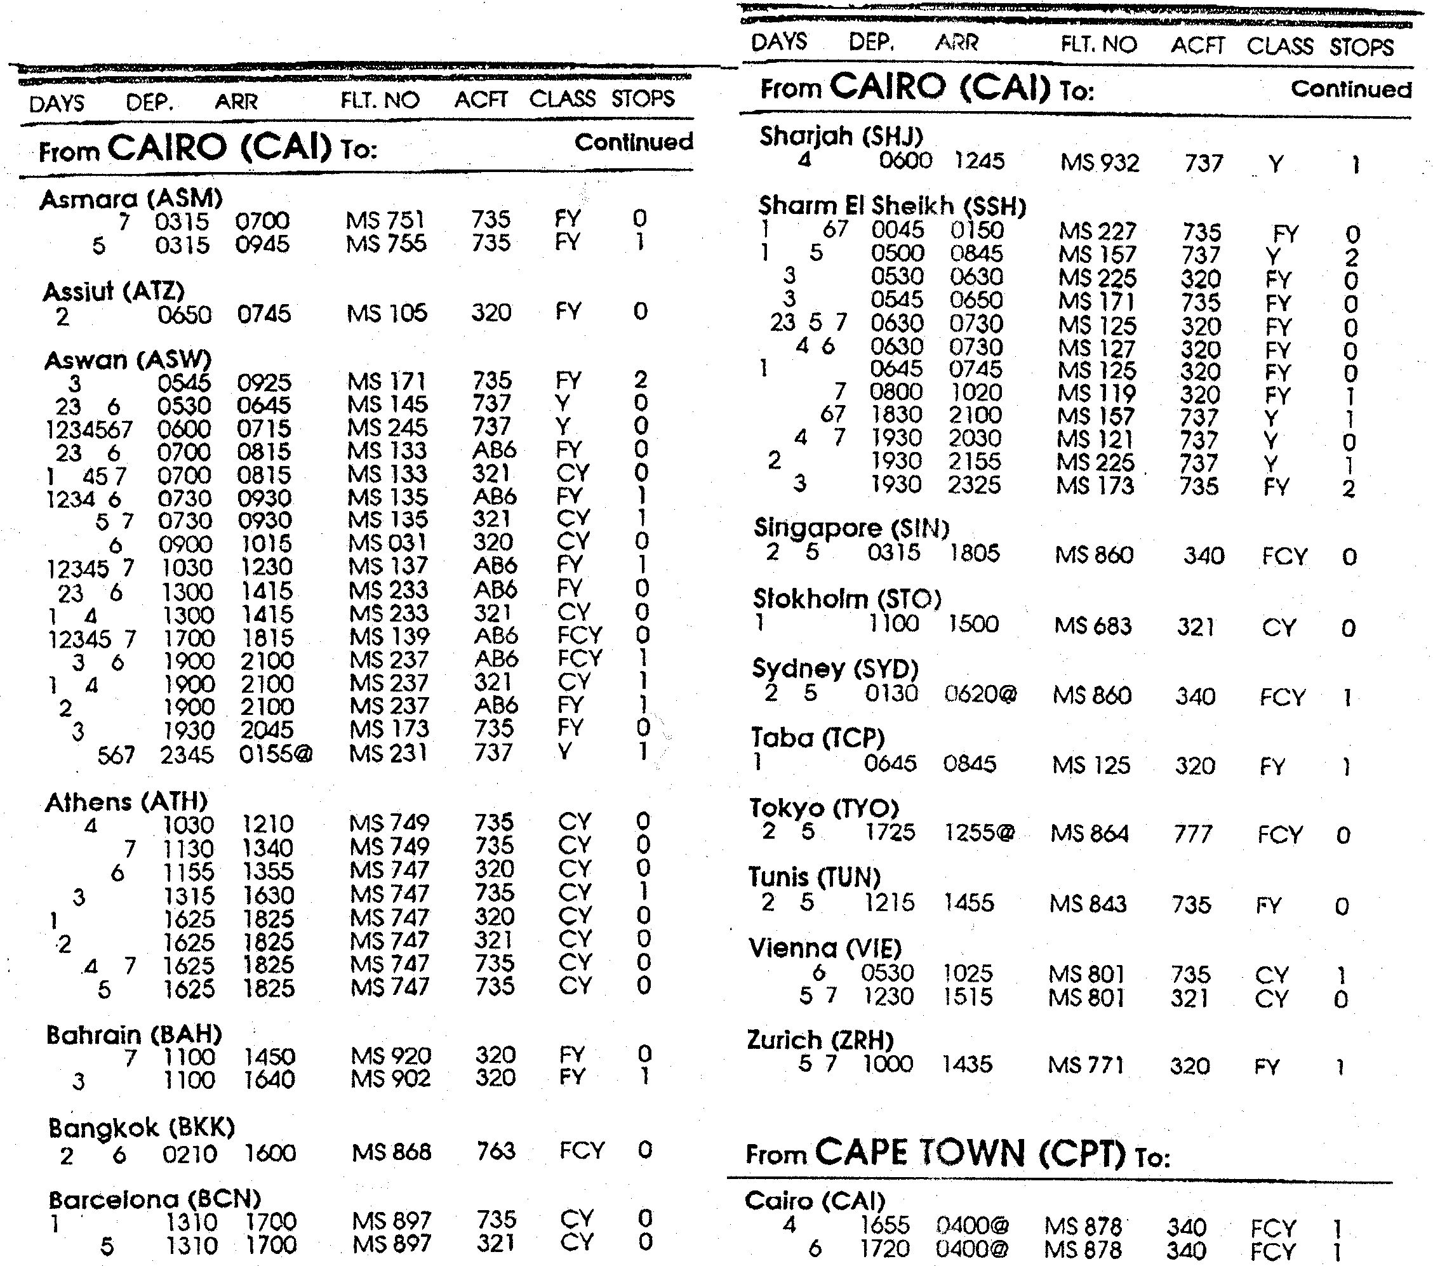

Your client would like to catch a direct flight from Cairo to Sydney. He wants to leave Cairo and arrive in Sydney on the same Tuesday. Is this possible? Motivate your answer.  - What do you understand by the term direct flight?  - A student wants to fly from Cape Town to Athens, in the cheapest way possible. Provide him with information concerning:  - Days of departure  - Arrival times  - Flight numbers  - Class | (2)  (2)

Supply a brief summary of his journey. | (5)

5.2 Would you recommend a connecting flight to a businessman? Motivate your answer.  - Study the line graphs taken from an RCI South African Resort Directory,  July 1998 – 2000 and answer the following questions: | (2)

RCI MEMBER FAMILIES
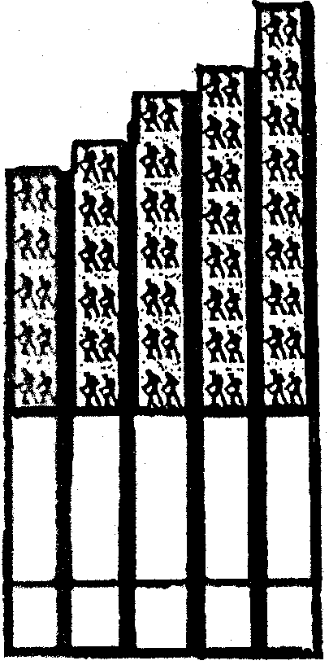  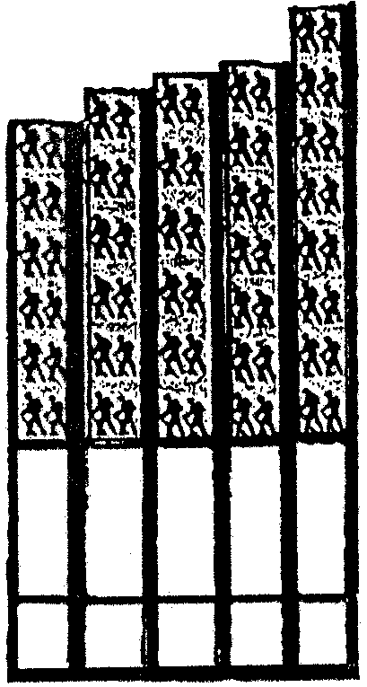  In South Africa  97  96  95  94  93  1 732 982  2 500 000  2 000 000  1 500 000  1 000 000  97  96  95  94  93  120 000  128 000  132 000  135 000  150 000  160 000  120 000  80 000  40 000  0  1 875 213  2 108 276  2 214 000  2 500 000  0 | Around the World

During which year did South African families go on the lowest number of hiking tours?  - What percentage of South Africans compared to the rest of the world undertook hiking tours in the same year as Question 5.3.1? Show all calculations.  - How many people, worldwide, went on hiking tours during 1996?  - What was the total number of hikers who went on hiking tours during 1993 – 1996 in South Africa? Show all calculations. | (1)  (2)  (1)  (2)
5.3.5 When were hiking tours the most popular? State the year, number of hikers and where these hikes took place. | (3)

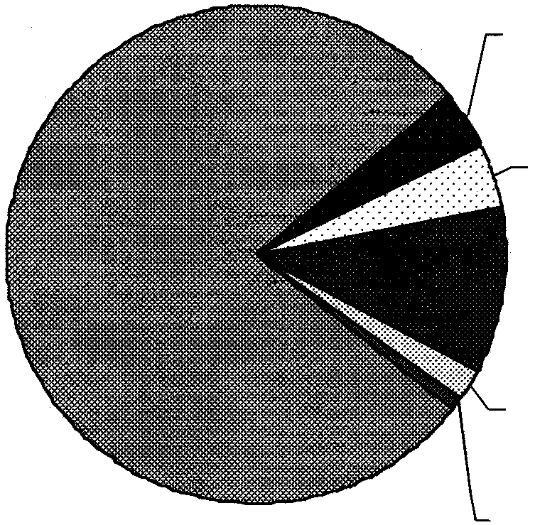
Study the Pie-graph below, taken from the “Central Statistics Services Tourism and Migration Sept 1997”, and answer the questions that follow.
Border
Concessions
4%
Work
4%
Business
11%
Transport
2%
Other
1%
Holiday
78%

Main reasons for visits to SA during September 1997

State the TWO main reasons why tourists visit South Africa.  - In 1996 Satour launched a survey questioning foreign tourists visiting South Africa. Three unique aspects were found to be underlying reasons as to why tourists visit South Africa. Name these THREE aspects. | (2)  (3)  [25]

QUESTION 6  TIME ZONES AND BASIC CALCULATIONS  Study the World Time Zone Map in Addendum E on page 18 and answer the questions that follow.  - A businessman makes a business call from Tokyo, Japan (140°EL) on a Monday at 18:00 to Los Angeles (120°WL).  - What time will it be in Los Angeles?  - What day of the week will it be?  - Will the call be possible? Motivate your answer.  6.2 A South African tourist travels from South Africa to Germany in December. The flight leaves at 20:00 on a Wednesday and takes 12 hours. At what time will the aeroplane arrive in Germany? Which day of the week will it be? | (1)  (1)  (2)  (2)

6.3 | The following exchange rates are used by the bank.
 | 1 US Dollar  1 German Mark  1 Japanese Yen  1 British Pound  1 Euro  1 Zimbabwe Dollar | =  =  =  =  =  = | R  R  R  R  R  R | 6,57  3,52  0,05  10,56  6,53  0,20

A South African will pay R 8,56 for a two litre colddrink in South Africa. How many South African rands will he pay in:  - Britain, if the colddrink costs 3,20 British Pounds?  - Germany, if the colddrink costs 5,30 German Marks?  - Japan, if the colddrink costs 140 Yen?  - Zimbabwe, if the colddrink costs 15,92 Zim Dollars?  Show all calculations and round off to two decimal points. | (2)  (2)  (2)  (2)

6.4 A South African tourist wants to travel to the USA. He will pay R8 000 for a return ticket. How many US Dollars would that be? Show your calculations and round off to two decimal points.  6.5 Use the exchange rates in Question 6.3 and answer the following question.  Many young South African tourists who want to visit London, England are deported back to South Africa at the airport. One of the requirements before a tourist can visit England is that they must have 100 British pounds per day. How many British pounds must a tourist have to stay in London for a month (30 days)? How much will this be in rands?  Show all calculations and round off to two decimal points. | (3)  (4)

What does the abbreviation DST stand for? Briefly explain what this means and why it is used.  6.7 A South African tourist visits Washington D.C. during June. The flight leaves JHB International at 16:00 and lasts 18 hours. At what time will the flight land in Washington? Show your calculations. | (2)  (2)  [25]

QUESTION 7  ECOTOURISM  Study the case study in Addendum D on pages 16 and 17, then answer the questions that follow.  - Who does the Mdluli Tribal Trust represent?  - Where does this community reside?  - Describe where the piece of land lies of which the ownership was transferred to the Mdluli Trust. | (1)  (1)  (3)

Discuss the plans Chief Mdluli has in mind for the development of their newly acquired land.  What will the development be known as?  - Mention SIX facilities or features which this development will provide.  - Compose a short paragraph discussing how the development will help Chief Mdluli’s people.  - Taking your answer to Question 7.7 into consideration, explain what you understand by the concept Ecotourism and the Community.  - Mention any TWO other business opportunities that would be created by the development.  - A portion of the profits will be placed in the Mdluli Trust. In what ways will the trust be of assistance to the Mdluli Tribe?  TOTAL FOR SECTION B:  TOTAL: | (2)  (1)  6x½=(3)  10x½=(5)  (2)  (2)  (4)  [25]  [75]  150

ADDENDUM A
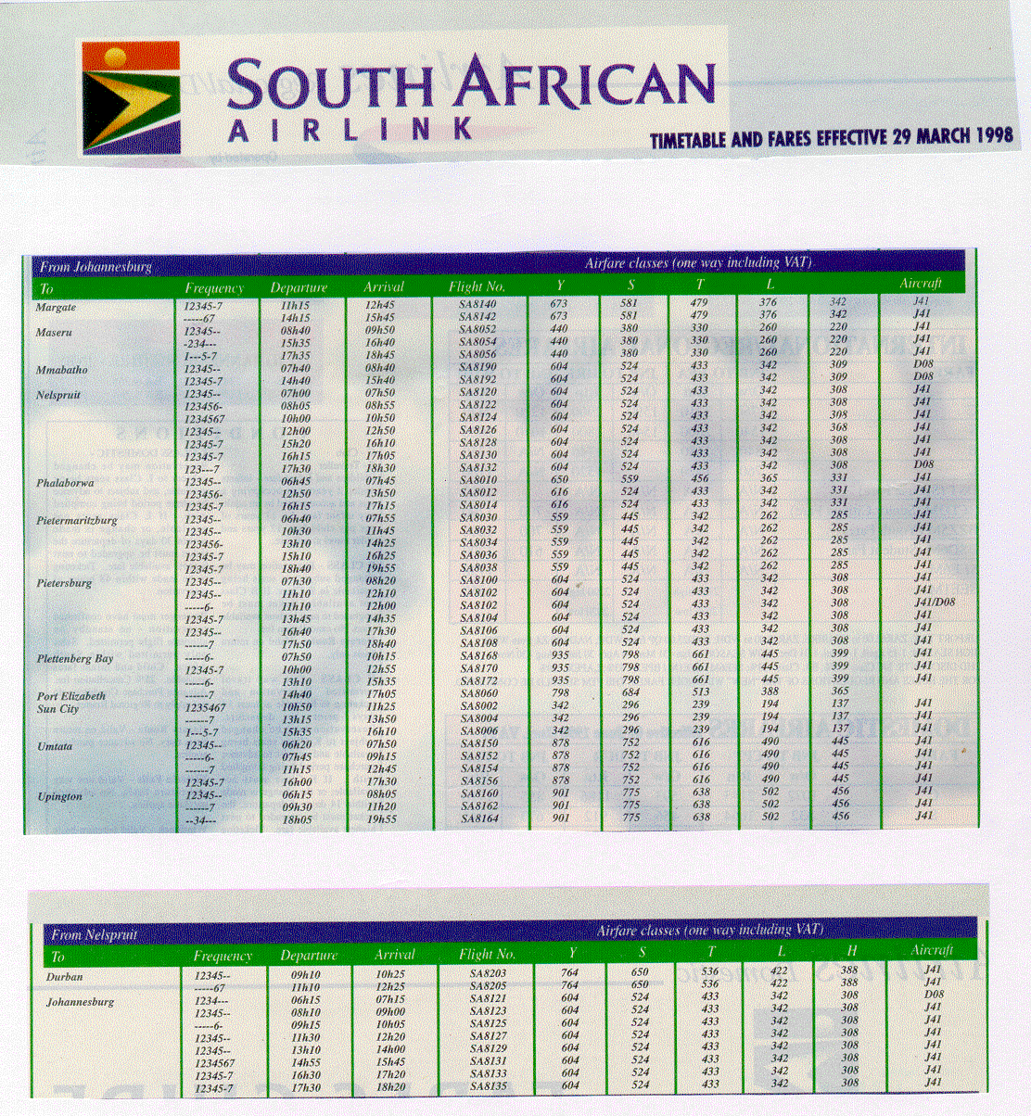

ADDENDUM B
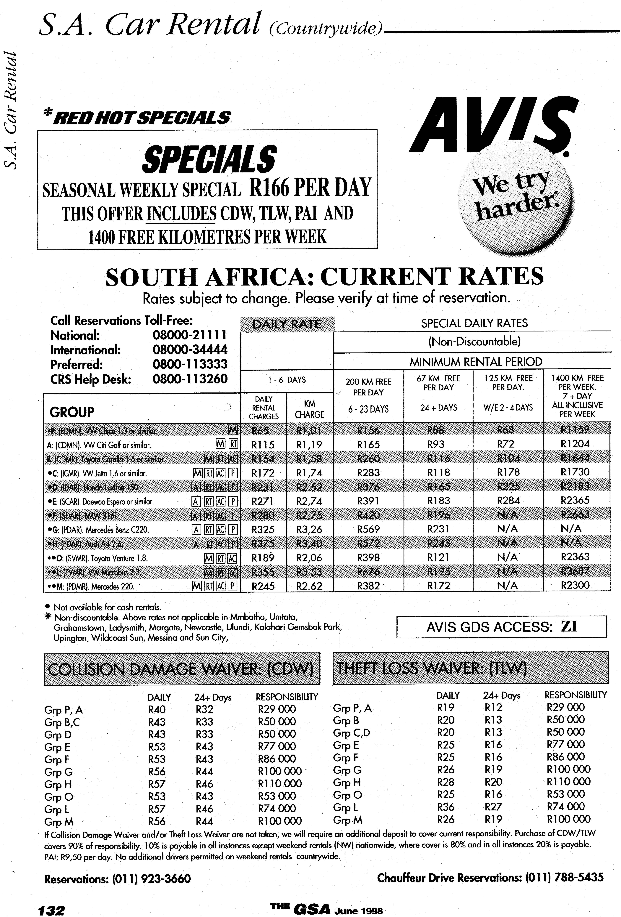

ADDENDUM C

MPUMALANGA

10 A3 Makobulaan Nature Reserve. This 1 000-ha sanctuary between Lydenberg and the Sudwala Caves offers a rare experience of pristine wilderness. Three trails lead through the reserve which is inhabited by small mammals, including mongoose, caracal, genet, vervet monkey, baboon and a prolific bird life. Overnight accommodation is available at the hiker’s hut at Uitsoek Forest Station.  11 A3 Montrose Falls In the scenic Schoemanskloof, the Crocodile River cascades 12 metres into an attractive series of rock pools. Annual event: Starting point of Lowveld Crocodile Canoe Marathon – February.  12 A2 Mount Sheba Nature Reserve South of Pilgrim’s Rest, Mount Sheba is best known for its indigenous forest – one of the few left in the region. More than 100 tree species have been identified, including yellowwood, white stinkwood, Cape chestnut and mountain cedar. Forest mamals such as red duiker, bushbuck and samango monkey are occasionally seen. Bird life is more conspicuous.  13 A2 Pilgrim’s Rest One of the best examples of a living museum, the village is a replica of the early gold mining town. Gold was discovered here in 1873, and many restored miner’s houses serve as shops. Among a number of fascinating places of interest, the Alanglade House Museum offers guided tours of the former mine manager’s house, exquisitely furnished in Victorian, Edwardian and Art Deco styles, and set in a large, informal garden. The Diggings Museum (just over a kilometre south of the town on the Graskop road) arranges conducted tours of gold-panning activities. The Dredzen Shop Museum consists of a store stocked with a range of items in use nearly a century ago. Horseriding trails through the Pilgrim’s Rest Nature Reserve surrounding the town are conducted daily. Trout fishing is popular on the Blyde River. Annual event: Pilgrim’s Rest Festival – December. | Private Game reserves Some of South Africa’s finest private game reserves are situated on the western boundary of the Kruger National Park. All of them offer comfortable (in some cases luxurious) airconditioned accommodation, excellent cuisine and conducted game drives. Most are fully licensed, with bars and lounges.  14 B2 Sabie The town originated in the 1880s as a gold-mining camp. Today, Sabie is the centre of the largest man-made forest in South Africa, supplying half the country’s timber needs. The Cultural Historical Forestry Museum houses exhibits depicting various aspects of South Africa’s forestry industry. Near town, Bridal Veil Falls, Horseshoe Falls and Lone Creek Falls are well worth a visit. Twelve kilometres of the Sabie River have been reserved for trout fishing, and are stocked with rainbow trout. Brown trout are found in the upper reaches. For information about licences, phone (013) 751 2688.  Bennial event: Forest Fair – April/May.  15 A3 Sudwala Caves A series of caverns featuring stalactites and stalagmites. Guided tours are offered seven days a week: 08:30 – 16:30. The six-hour Crystal Cave Tour takes place on the last Saturday of the month. Phone (013) 733 4152. At the adjacent P R Owen Dinosaur Park, full-scale replicas of the long-extinct giant reptiles are on display.  16 B3 White River Set in an important agricultural and forestry area, the streets of White River are lined with date palms, bougainvillaea and jacaranda trees. About three kilometres from town, Rottcher Wineries, in Nutcracker Valley, offer cellar tours which will introduce you to unusual orange wines and liqueurs. The orange and ginger liqueurs are attractively bottled in hand-painted stoneware jugs. Closed Sundays and religious holidays. Phone (013) 751 3884. Three large dams nearby are frequented by anglers and watersports enthusiasts. There are several good country hotels, guest farms and holiday resorts in the area.

Further afield  MPUMALANGA  4 B2 Blyderivierspoort Nature Reserve Stretching from the Pinnacle near Graskop to Swadini in the north, the reserve is characterised by striking rock formations and a rich diversity of plants which support an equally rich and varied fauna.  Within the reserve, Bourke’s Luck Potholes (deep cylindrical cavities) were formed by river erosion and the action of flood water. The magnificent Blyde River Canyon, a gigantic gorge 26 km long carved out of the face of the escarpment, is one of the natural wonders of Africa. God’s Window provides a boundless view, stretching across miles of thickly forested mountains, the lush and fertile lowveld and the Blyde River Canyon. The 65-km Blyderiviers-poort Hiking Trail, which starts at God’s Window, takes five days to complete. Phone (01315) 8 1216. A number of other hiking trails traverse the reserve which is also the setting for two resorts.  5 D1/2 Kruger National Park (southern section) This major international tourist drawcard offers a wilderness experience which ranks with the best in Africa. The sight of elephant, lion, leopard, rhino and buffalo is always a thrill, especially at close range on a conducted wilderness trail. After an exciting day in the bush, sunset heralds the crackle of campfire,sundowners and shared anecdotes.  The main camps have an excellent range of visitor facilities, including licensed reataurants, shops, swimming pools and conference venues. Game viewing is easier in winter, but many people prefer the lush vegetation of summer. The park falls within a summer rainfall area. Summer temperatures sometimes exceed 40°C, but winters are generally mild and frost-free.  The Malelane, Crocodile Bridge, Numbi and Paul Kruger gates to the park are easily reached from Nelspruit. There are daily Comair flights from Johannesburg to the main camp, Skukuza, where cars can be hired. Your travel agent can advise you about fly-drive packages, luxury | coach tours and minibus safaris.  NB Visitors should consult a local pharmacist for advice on the best anti-malaria drug or drug combination they should take.  Reservation and additional information: phone (012) 343 1991 or (013) 735 5159.  6 D5 Kaapsehoop The quaint, historical village of Kaapsehoop offers a panoramic view of the lowveld. Wild horses frequent the district, and blue swallows are regular visitors from September to April.  7 B3 Lowveld National Botanical Garden The turnoff to the garden is situated on the R40 to the White River, about three kilometres from the centre of Nelspruit. Set in spectacular scenery on the banks of the Crocodile River, this is one of the country’s most magnificent botanical gardens, featuring a waterfall and many rare lowveld species. The huge diversity of plants includes South Africa’s best collection of indigenous ferns, 500 tree species and the rare cycads for which the garden is famous. A number of trails meander through the garden, which is at its best in summer. Even people who aren’t interested in gardening will be impressed by the beauty and variety of the indigenous plants. Trail maps are available at the entrance gate.  8 A2 Lydenburg Set in a wide, fertile valley against a backdrop of rolling hills and enormous cultivated forests, Lydenburg’s major features are its well-preserved old buildings. The Gustav Klingbiel Reserve, east of town, supports antelope and over 100 bird species, and is the site of archeological ruins from the Later Iron Age. The Lydenburg Museum is situated in the reserve. Annual event: Peach Carnival –December.  9 B2 Mac Mac Pools and Falls The crystal-clear Mac Mac Pools are idyllic for swimming. About two kilometres further north, two waterfalls plunge into a densely wooded chasm. The  69-km Prospector’s Trail from the Mac Mac Forest station to Bourke’s Luck Potholes takes five days to complete.  Phone (013) 764-1058.

ADDENDUM D

MDLULI TRIBAL TRUST TO DEVELOP ECO-TOURISM PROJECTS AT THE KRUGER NATIONAL PARK

The Mdluli Tribal Trust, representing the Mdluli Communtiy which resides in areas surrounding the southern part of the Kruger National Park, is to embark on an existing tourism development on land it owns, historically perceived to be in the Kruger National Park.

The Mdluli Community, through the Trust, was recently granted the Title Deed to the farm Daannel 33JU which lies just inside the fence of the Kruger National Park, south of Numbi Gate and west of Pretoriuskop.

The Mdluli Tribal Authority has long held the right of use over the land. On May 8th 1998 ownership of the farm was transferred to the Mdluli Trust.

Chief M.Z. Mdluli said that his community had been struggling for many years to develop the land which was rightfully theirs, but added that the farm would continue to form part of the environmental preservation philosophy of the Kruger National Park and neighbouring reserves.

“For over a hundred years the land has been devoted to wildlife and nature,” said Chief Mdluli. “We appreciate that its greatest asset lies in maintaining this status, and our community can benefit from the commercial activities of eco-tourism and environmental conservation. We plan to develop the land for this purpose and will establish an international standard game lodge on the property.”

The Kruger National Park administration will continue to manage the land and the wildlife on it, and to all intents and purposes, the farm will most likely continue to be part of the greater Kruger Park.

The Mdluli Tribal Trust has entered into agreements with a developer who will manage the development which will be known as the Mdluli Hilton Lodge.

Mr Piers Bunting of TDC said that the project would not only preserve the environmental value and importance of the land,but would at last be a sound commercial venture for the Mdluli Tribe.

“We are extremely pleased to be involved in this project, and will ensure that the development meets with all the exacting standards of the relevant authorities. An extremely detailed and comprehensive environmental impact study is being undertaken and the development will be based on its findings,” said Bunting. “The Kruger National Park is one of the finest parks in the world. It is extremely well-managed, and very popular with local and international visitors.”

The development will include an international standard hotel comprising about 100 rooms. Aside from a wide range of recreational facilities on the site, game viewing and tracking will be a key attraction. The Lodge will be built to complement the setting and its surroundings. As with all hotels of this standard, fitting will be top quality. The hotel will have conference facilities.

Chief Mdluli said that the development would benefit his people in many ways. “Every effort will be made to create job and business opportunities for the local people,” he said. “This process would start with the construction phase, where local people will not only be brought in to build the hotel, but will be invited to tender for certain aspects of the contract. Once the resort is fully operational, local people will staff it. Again we will encourage local people to supply the hotel with commodities as well as create secondary business opportunities for local businessmen such as waste removal, laundry, game tour operations and many more.”

Other business opportunities exist in these areas, such as curio sales, game guides and trackers and tribal dancing. People who manufacture curios will be taught how to conserve the natural materials they use and this activity will be carefully monitored.

A portion of the profits made from the entire development will be placed into the Mdluli Trust and the community will make collective decisions on how this money is to be used in terms of the trust deed.

“We need a large number of facilities, including classrooms, clinics and medicine, recreation centres and other important community structures,” said Chief Mdluli. The “Trust will be in a position to answer the community’s prayers,” he said.

TDC’s Piers Bunting said that design and planning work would progress immediately, with final plans being based on the outcome of the environment impact study. “There are a large number of stakeholders involved, including the public and various local communities. It is important that the project progresses with the participation and support of all interested parties. The Lodge will be one of the finest additions to this important ecological area and we will ensure that it fully complements its surroundings.”

ADDENDUM E

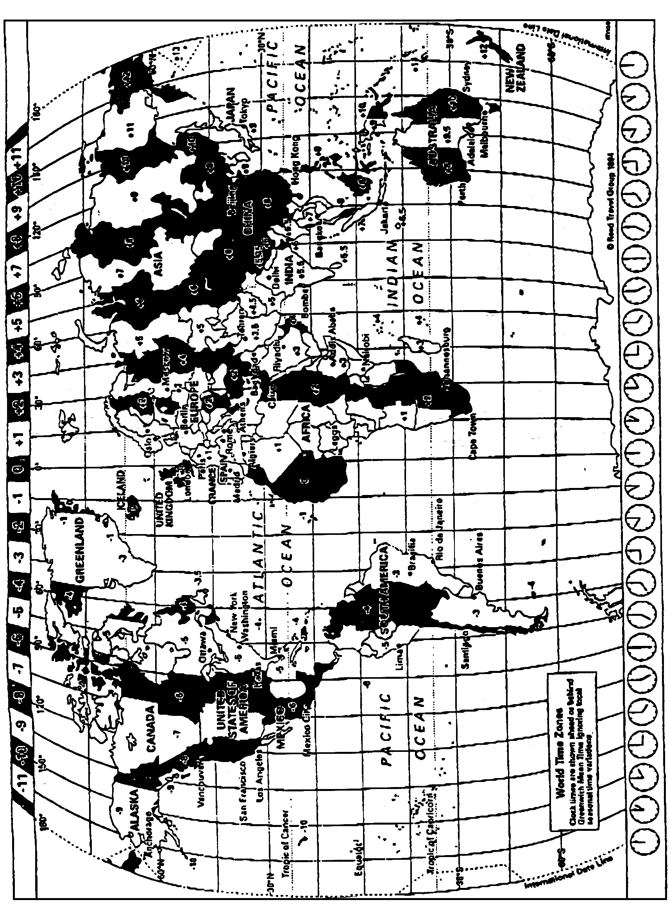
World Time Zone Map
This map provides only a general guide to Time zones through out the world. For individual country details, please refer to the information under local time in the main section of the guide.

