GAUTENG DEPARTMENT OF EDUCATION

SENIOR CERTIFICATE EXAMINATION

TRAVEL AND TOURISM SG

TIME: 3 hours

MARKS: 150
INSTRUCTIONS:

- The paper consists of TWO sections.
- Section A (Questions 1 and 2) is COMPULSORY.
- Answer any THREE questions from Section B. (Questions 3 to 7.)
- Start each question on a new page.`
- The Addendum (pages 11 to 13) contains information which pertains to various questions in this paper. You are advised to detach the Addendum and place it alongside the relevant questions for easy reference.

SECTION A

COMPULSORY

QUESTION 1

1.1 Complete the table below. Write only the question number in your answer book, with the missing information next to it. E.g. 1.1.1 Great Wall of China.

 | ICON | CITY | COUNTRY
 | 1.1.1 | Cape Town | 1.1.2
 | 1.1.3 | 1.1.4 | France
 | Big Ben | 1.1.5 | 1.1.6
 | 1.1.7 | New York | 1.1.8
 | Sydney Opera House | 1.1.9 | 1.1.10
 | The Leaning Tower | 1.1.11 | 1.1.12
 | 1.1.13 | 1.1.14 | Brazil
 | 1.1.15 | Agra | 1.1.16
 | 1.1.17 | San Francisco | 1.1.18
 | 1.1.19 | 1.1.20 | Egypt
 |  |  |  |  | (20)

Identify each of the International Tourist Destinations depicted below, and briefly explain why each is so popular and famous.

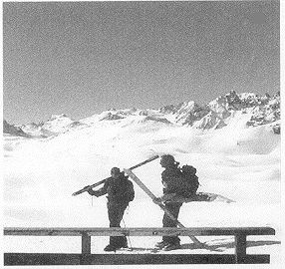
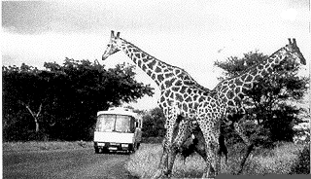
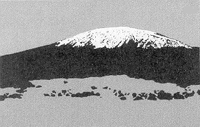
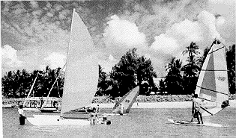
1.2.1 1.2.2
1.2.3
1.2.4 1.2.5

5x2=(10)

Answer the following questions based on information in the Satour Fact Files.  - Name any FIVE advantages of tourism.  - Name any THREE of South Africa’s unique marketing points.  - What event “opened doors internationally” for South Africa?  - From which country in Europe do most of South Africa’s foreign tourists come? | (5)  (3)  (1)  (1)

Choose the correct answer from the choices given. Write only the correct letter next to the number of the question in your answer book. E.g. 1.4.1. B.

1.4.1 Who is the current Minister of Environmental Affairs and Tourism?
- Mavuso Msimang
- Pallo Jordan
- Valli Moosa
- Sibusiso Bhengu

This is South Africa’s top tourist destination:
- Victoria and Alfred Waterfront
- Kruger National Park
- Sun City
- Gold Reef City

Which activity is an example of an urban adventure?
- Hunting
- White water rafting
- Cultural villages
- Game viewing

This former township is now one of Gauteng’s major tourist attractions.
- Sun City
- Soweto
- Mdantsane
- Kayalitsha

In which two provinces is the Kruger National Park located?
- Northern and Western Cape
- Gauteng and Mpumalanga
- Northern and Eastern Province
- Northern Province and Mpumalanga

The Union Buildings are located in this city.
- Pretoria
- Cape Town
- Johannesburg
- Durban

This vibrant city is known for its Golden Mile of hotels, beaches and attractions.
- Cape Town
- Durban
- Port Elizabeth
- East London

Which province in South Africa has the highest number of guest beds?
- Mpumalanga
- Northern Cape
- Western Cape
- Gauteng

Which one of the following icons, located in South Africa, is considered to be world famous?
- Kruger National Park
- Gold Reef City
- Table Mountain
D. Sun City

This is a historic mining town in Mpumalanga.  - Nelspruit  - Delmas  - Pilgrim’s Rest  - Hazyview | 10x1=(10)  [50]

QUESTION 2

Use the information in the Addendum on pages 11 and 12 to answer this question.

Read the information, background and instructions very carefully before answering this question.

Background

A wealthy young couple from England are in Cape Town for the weekend. They arrive on the Friday afternoon and will leave on Monday morning. For calculation purposes, this means they are spending 3 days in Cape Town.

While in Cape Town they want to visit the Victoria and Alfred Waterfront on their first evening. They would like to go up Table Mountain in a cable car. A boat trip out to Robben Island is definitely on their itinerary. They would like to walk around in the Kirstenbosch Botanical Gardens on their last afternoon in Cape Town. An afternoon at leisure to do some souvenir shopping is planned for. For the Saturday evening they have bought tickets to see a live concert and they will be spending Sunday evening with friends.

The couple will take advantage of Holiday Inn’s Weekender Plus special for their accommodation. They will use Hertz Car Rental to hire a Toyota Camry 200SI for the weekend, taking advantage of the Weekend Wheels option. They will collect the car on Friday evening and return it first thing on Monday morning. They will be charged for two days, at the special rates. They take out 100% Collision Damage Waiver and 90% Theft Protection.

They have budgeted R200.00 each per day for meals, R200,00 each per day for entertainment and each one will have R500,00 per day to spend on shopping.

Instructions  Plan a tour and budget for them, by answering the questions below and using the information provided. Wherever possible show all your calculations.  2.1 How much will the 100% Collision Damage Waiver cost them for the two days? Calculate. | (2)

How much will the 90% Theft Protection cost them per day?  - How much will the total car hire cost be? Show your calculations  - What will the hotel cost be for each one, per night?  - Copy the table below into your answer book and use it to show what they will be doing or where they will be going during the weekend. | (1)  (5)  (1)  (6)

Friday evening

Saturday morning

Saturday afternoon

Saturday evening

Sunday morning

Sunday afternoon

Sunday evening

2.6 Copy the table below into your answer book and use it to compile a travel budget for the tourists.

 | Accommodation
 | Travelling expenses
 | Entertainment
 | Shopping and gifts
 | Meals
 | TOTAL | R
TOTAL FOR SECTION A: |  |  |  | (10)  [25]  [75]

SECTION B

Choose any THREE of the following questions.

QUESTION 3
ESSAY

Tourism in South Africa is nearly impossible if one tries to separate it from nature. South Africa is rich in natural beauty, and wildlife, therefore ecotourism forms an integral part of tourism in South Africa.

Write an essay on ecotourism, using the following aspects to help you:

  - The term ecotourism
  - The value of ecotourism
  - The status of ecotourism in South Africa
  - The mission regarding ecotourism

Your essay should be at least 250 words in length. Your answer will be assessed according to the following criteria:  - Your overall knowledge of facts associated with the topic  - Your logical reasoning in discussing the topic  Your ability to express your thoughts clearly and fluently | [25]

QUESTION 4
COMPREHENSION AND TERMINOLOGY

Study the table below, taken from “Cape St. Francis Resort” and answer the questions that follow.

 | PRICE LIST  1997 | RATES FOR 1997  Effective from 12 Jan. 1997 to 10 Jan. 1998  self catering rate per 2 guests |  | HIGH SEASON – XMAS  Period 12 Dec. 1997 to 10 Jan. 1998  self catering rate per UNIT |  |  | HIGH SEASON – EASTER  Period 27 March to 30 April  self catering rate per UNIT
 | CHALETS | 140.00 | XTRA @ R20 PP | 225.00 | sleeps 4 |  | 180.00 | sleeps 4
 | APARTMENTS | 120.00 | XTRA @ R20 PP | 245.00 | sleeps 4 |  | 210.00 | sleeps 4
 | APARTMENTS BUDGET | 100.00 | XTRA @ R20 PP | 195.00 | sleeps 4 |  | 175.00 | sleeps 4
 | COTTAGES SMALL | 170.00 | XTRA @ R35 PP | 380.00 | sleeps 5 |  | 325.00 | sleeps 5
 | COTTAGES STANDARD | 170.00 | XTRA @ R35 PP | 460.00 | sleeps 6 |  | 380.00 | sleeps 6
 | COTTAGES LARGE | 170.00 | XTRA @ R35 PP | 590.00 | sleeps 8 |  | 470.00 | sleeps 8
 | COTTAGES SUPERIOR | 220.00 | XTRA @ R35 PP | 725.00 | sleeps 8 |  | 550.00 | sleeps 8
 | SITE(NO ELECTRICITY) | 35.00 (No Electricity) | XTRA @ R7 PP | 100.00 | For 4 People | XTRA @ R25 PP | 50.00 | For 2 People | XTRA @ R15 PP
 | SITE(ELECTRICITY) | 40.00 (10 amp elect.) | XTRA @ R7 PP | 120.00 | For 4 People | XTRA @ R25 PP | 60.00 | For 2 People | XTRA @ R15 PP
 | BEACHFRONT SITE |  |  | 150.00 | For 4 People | XTRA @ R25 PP | 75.00 | For 2 People | XTRA @ R15 PP
PRICES MAY CHANGE WITHOUT PRIOR NOTICE
CAMPERS BOOKED ONTO A SITE WITHOUT AN ELECTRICAL POINT WILL GET A REDUCTION OF R5.00 PER DAY OUT OF SEASON & R10 PER DAY IN SEASON

What do you understand by:  - P/P  - Chalet  - Apartment  - Site  - Explain the term cottages superior.  - What type of tourist would make use of a camping site without electricity?  - What type of tourist would make use of a camping site with electricity?  - Explain what you understand by the term beachfront site.  - Calculate how much it would cost a group of four hikers, using the resort and staying on a site without electricity during Easter from 28 March until 3 April. Show all calculations.  - A wealthy family of four (two adults and two children) want to visit Cape St. Francis for seven days in February. They do not want to hire a caravan. What type of accommodation would you recommend? Motivate your answer. Calculate the costs for the week. Show all calculations.  - A group of 24 students want to go to Cape St. Francis for the weekend from  12 to 15 December. Which accommodation would you suggest? Work out a quotation showing all your calculations. | (2)  (2)  (2)  (2)  (2)  (1)  (1)  (2)  (3)  (5)  (3)
 | [25]

QUESTION 5  JARGON AND ADVERTISEMENTS  - Every industry, profession and sport develops its own jargon. Jargon means words, phrases and sometimes slang that belong specifically to the industry concerned. The Travel and Tourism industry has its own jargon, which you should be familiar with. In your own words explain what the following words or phrases mean:  - Pax  - Boarding pass  - Cabin crew  - Cockpit crew  5.1.5 Carousel | (1)  (2)  (2)  (2)  (2)

Make a careful study of the advertisements in the Addendum on page 13 and then answer the following questions:  - In advert number one (No. 1): explain what the abbreviation p/p p/d means.  - Explain the term self catering.  - Which types of tourists would make use of the facilities offered at the Private Reserve in advert number two (No. 2)?  - The Sesetse and Timbavati Chalets are described as having en suite facilities. In your own words, explain what this means.  - Discuss what you understand by the concept game drives in open vehicles.  - Tshukudu Game Lodge would greatly appeal to a certain type of tourist. Who do you think would visit the lodge in advert number four (No. 4) and why?  - Consider the rates in advert number four (No. 4). A South African family of three adults and one child took advantage of the Tshukudu Game Lodge’s winter special. Calculate how much it cost the family to stay at Tshukudu for 3 days.  - Bel-Rose is described as being “a lovely restored National Monument”. What does it mean? | (1)  (2)  (2)  (2)  (2)  (2)  (4)  (1)  [25]

QUESTION 6

Read the extract below which comes from a letter to Tourism Reports of February 1999.

I have never been so offended and embarassed in my whole life!

There I was, with my husband and our overseas guest, standing at the reception counter of a country hotel at 7 o’clock on a Monday evening. My husband told the receptionist who we were and informed her that we had reservations for the night. The receptionist glanced at her computer, pushed a few buttons, turned to us and said: “There is no record of your reservation, and besides we have no more rooms available. There are no cancellations and we aren’t likely to get any. In any case it wouldn’t help, because in fact we are overbooked.”

We stood there, stunned by this display of arrogance and disregard for our well being. My husband took a deep breath, put on his best smile and said to the little lady “It’s late, we were expecting to sleep here tonight and now we can’t. What can you suggest?”

The little lady looked up with a sarcastic smile on her face and said: “What would you like me to say, that I’ll make room here for you? I can’t do that. We’re overbooked and we have no rooms available.” With that she went back to working on her computer and completely ignored us.

My husband exploded. “Young lady!” he said. “I demand to speak to the manager!”

The young lady in question slowly took her eyes away from the computer, focused on my husband and said “The manager’s gone home. I’m in charge now. And when I say there are no rooms available, I mean there are no rooms available”.

What should the receptionist’s first response have been, if she was really trying to assist the travellers and provide excellent service?  - Discuss the likely effect this encounter would have had on the overseas guest who was listening to this conversation.  - State a reasoned opinion about the manager, who has left this receptionist in charge of the hotel on a night when the hotel is overbooked.  - What can the three people who experienced this bad service do to ensure that something like this does not happen again?  - What does the fact that the hotel is overbooked, tell you about the management of the hotel?  - Name and briefly discuss FIVE fundamentals of excellent service. | (5)  (3)  (5)  (4)  (3)  (5)  [25]

QUESTION 7  TIME ZONES AND FOREIGN CURRENCY  7.1 Study the World Time Zone Map in the Addendum on page 14. Answer the questions that follow.  - The South African cricket team is playing a series in Delhi, India. A player wants to phone his wife in Port Elizabeth at 21:30 local time. At what time in Delhi would he have to phone? Show all your calculations.  - A South African tourist flies from Cape Town to Los Angeles in July. The flight leaves at 04:50 and lasts 19 hours. At what time will he land? Show all your calculations.  - From Los Angeles he travels by car to New York and flies from there to Beijing, China to attend to some business. His flight leaves at 21:40 from New York and lasts 13 hours. What time will it be in Beijing when he lands? What day will it be (previous day/same day/next day)? Show all your calculations. | (2)  (3)  (4)

7.1.4 How many hours, in total, would the South African tourist spend on aeroplanes from the time he leaves Cape Town until he arrives back in Johannesburg? His flight from Beijing to Johannesburg lasted 9 hours. Show all calculations. | (2)

7.2 Study the Foreign Exchange rates below and answer the questions that follow.

1 US Dollar  1 British Pound  1 German Mark  1 Euro  1 Japanese Yen  1 Zimbabwe Dollar  1 Botswana Pula | R7,96  R11,84  R4,63  R6,88  R0,42  R0,31  R0,45

Show all calculations to two decimal points.  - A German tourist visits South Africa. His travelling expenses (airline ticket and car rental) add up to R9 883,37. Convert this amount to German Mark. Show all calculations.  - What will an American tourist pay in his own currency if his travelling expenses add up to R9 883,37? Show all calculations.  - A South African flies to Japan. He needs the following amounts:  - ¥ 3 915,00 for return tickets  - ¥ 5 727,34 for accommodation  Convert the above amounts into South African Rand. Show all calculations.  - A South African tourist visits Zimbabwe. He spends 7 149,53 Zimbabwe Dollars. How much money did he spend in Rand? Show all calculations.  - At the All African Games Penny Heyns won R10 000,00 per record. She set two new records. She now lives in England. How much did she win in English Pounds? Show all calculations.  - A businessman from Botswana visits South Africa. He brings 2 010,00 Botswana Pula with him. How much is this in Rand? Show all calculations.  TOTAL FOR SECTION B:  TOTAL: | (2)  (2)  (4)  (2)  (2)  (2)  [25]  [75]  150

ADDENDUM (pages/ bladsye 11 – 14)

HOLIDAY INN

WEEKENDER PLUS
 | Valid to 31/8/98
 | SGL | DBL
Cape Town - Waterfront (opening July 98) | 318.00 | 159.00


Valid

1/2/98 – 31/8/98
 | SGL | DBL
Johannesburg - Sandton | 318.00 | 159.00
Durban | 318.00 | 159.00
Pretoria | 318.00 | 159.00
Johannesburg - Sunnyside Park | 318.00 | 159.00

Per room
(Includes 2 breakfasts)
express | Per room  (Includes 2 breakfasts)
Pretoria Valid to 31/12/98 | 209.00
Eastgate Valid to 31/12/98 | 219.00

Kids  stay & eat  free! | Children under 18 (max 2) stay free when sharing parents’ room (when family room available) and eat free when accompanied by their parents at all Holiday Inn hotels. You receive our special “Weekender Extender” booklet of discount vouchers.

GENERAL CONDITIONS

- Rates include VAT.
- Special offer is for room only, and is per person sharing.
- Weekender Plus is only valid for a Friday, Saturday, and Sunday night.
- Unfortunately, the offer only applies to individuals and not conferences or groups.
- Weekender Plus bookings must be prepaid.
- Rates are commissionable to travel agents.
- Surcharge 9 – 13 April at certain hotels.

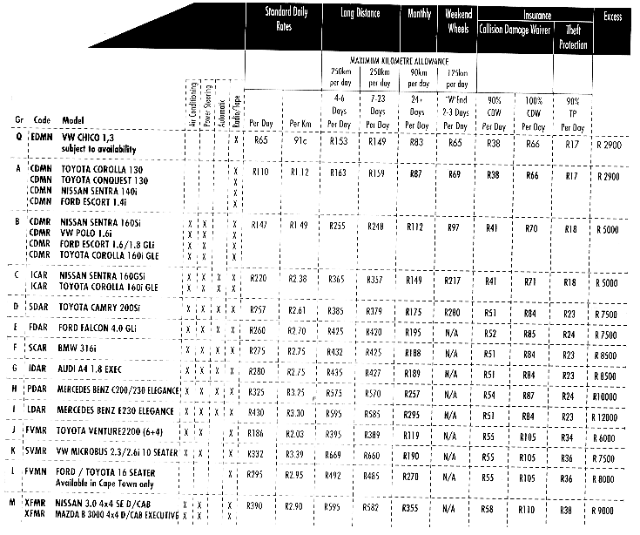
Hertz



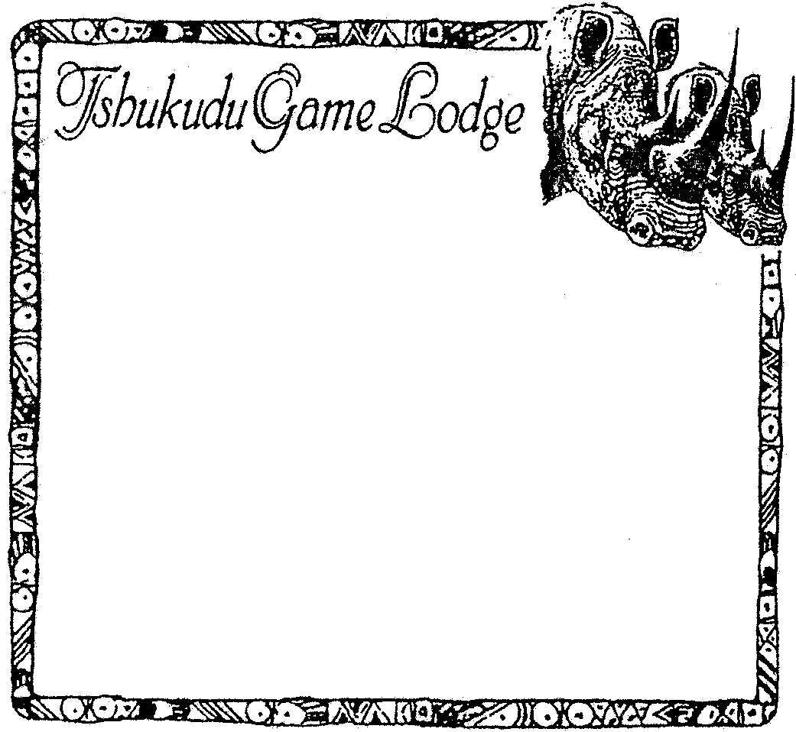

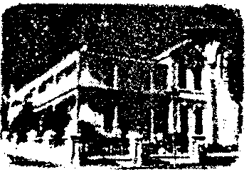

SWELLENDAM
In the heart of Swellendam lie these two charming historical homes. 3 fully
self-catering cottages, or breakfast is
provided. Sleeps 4, or sleeps 5, or sleeps 2 in each. Each unit is very comfortable & private, with a pool & a braai. Approved
by Satour. Close to the shops &
restaurants. Lovely walks, Bontebok
National Park 5km, drives to coast.

Rates R95 p/p (self catering) or
R105 p/p p/d (bed & breakfast).

Rupert & Alida Erskine.
Tel: (0291) 43053 Fax: (0291) 42084
Cel: 082 4922 334
Box 430, Swellendam
KADIE COTTAGE
THE KOORNLANDS
CONFERENCE VENUE
Majuba Private Reserve – Heidelberg

Specializing in school groups and team building.

Exclusive – only one group at a time!
Only 30 minutes – South of Johannesburg – 5km off N3 JHB – DBN.
Day conferences R135,00 (excl. VAT) p.p.p.d. (Lunch + 2 teas)
Overnight conferences R245,00 (excl. VAT) p.p.p.d. (Full fare)

Full obstacle course – volley ball – swimming pool – game drives -mountain hiking – river – game in abundance.

Bookings: 083 274 6050 / 083 302 2585 ·
Fax: (0151) 6876
COME AND ENJOY A
UNIQUE GAME LODGE
Tshukudu is well known for its:
 Excellent food  Good game viewing  Night & day game drives
in open vehicles  Accommodation in comfortable en-suite cottages
 Orphaned animals re-introduction project  Lion breeding project
 Excellent birdviewing  5000 ha  R750 p/p sharing & R900 p/p
single, children under 12 half price fully inclusive  Bushcamp

WINTER SPECIALI
For South African Citizens Only: 01.05.98 to 30.09.98
3 day special – per adult sharing….
R1350,00 fully inclusive. Children under 12 half price.

FOR BOOKINGS OR FURTHER INFORMATION CONTACT:
ALA OR DES. TEL: (015) 793 2476 and (015) 793 1886
or 2010 A/H FAX: (015) 793 2078 CELL: 083 626 4916
OR WRITE TO PO BOX 289, HOEDSPRUIT, 1380
E-MAIL: tshukudu@iafrika.com
SESETSE
&
TIMBAVATI
BUSH LODGESRELAX AND ENJOY THE AFRICAN BUSH AT OUR
INTIMATE CAMPS CATERING FOR 8-10 GUESTS Thatched chalets
with en suite
facilities
 Game drives in
open vehicles
 Guided walks
 Big 5 sightings Borders the
Kruger National
Park
 Night drives with
spot lights
 Own airfield
 Meals providedEXCELLENT BUSH CUISINE

Monday – Wednesday R 490 p/p per night
Thursday – Sunday R 590 p/p per night

RESERVATIONS & BROCHURE:
TEL: (031) 213-815 FAX (031) 212-857
TIMBAVATI WILDERNESS TRAILS CC
P O BOX 51140 MUSGRAVE 4062
ORANJEZICHT - CAPE TOWN

el- rose
guest lodgeThis beautiful Victorian house
situated on the slopes of Table Mountain
with magnificent views of the harbour,
Signal Hill and Devils Peak is a lovingly
restored National Monument. Our
en-suite rooms boast all the comforts of
home and our conference facilities are
ideal for the smaller group.
Rates from R220,00 p/p B&B.

Tel; (021) 461 0635
Fax: (021) 461 0617
B
5
4
3
1
2

