GAUTENG DEPARTMENT OF EDUCATION
SENIOR CERTIFICATE EXAMINATION

TECHNIKA (MECHANICAL) HG

TIME: 3 hours

MARKS: 300

REQUIREMENTS:

- A calculator and drawing instruments.

INSTRUCTIONS:

- Answer ALL the questions.

- An information sheet is provided on pages 10 to 13 of this question paper. Please detach it for ease of reference.

QUESTION 1

1.1 Study the diagram below and name the labelled components of the carbon-iron equilibrium diagram. Also determine, with the aid of the diagram, the temperature to which steel with a carbon content of 1% must be heated to reach its upper critical temperature (AC₃). Write down only the letters (a – h) underneath each other and the correct answer next to the numbers. | (10)

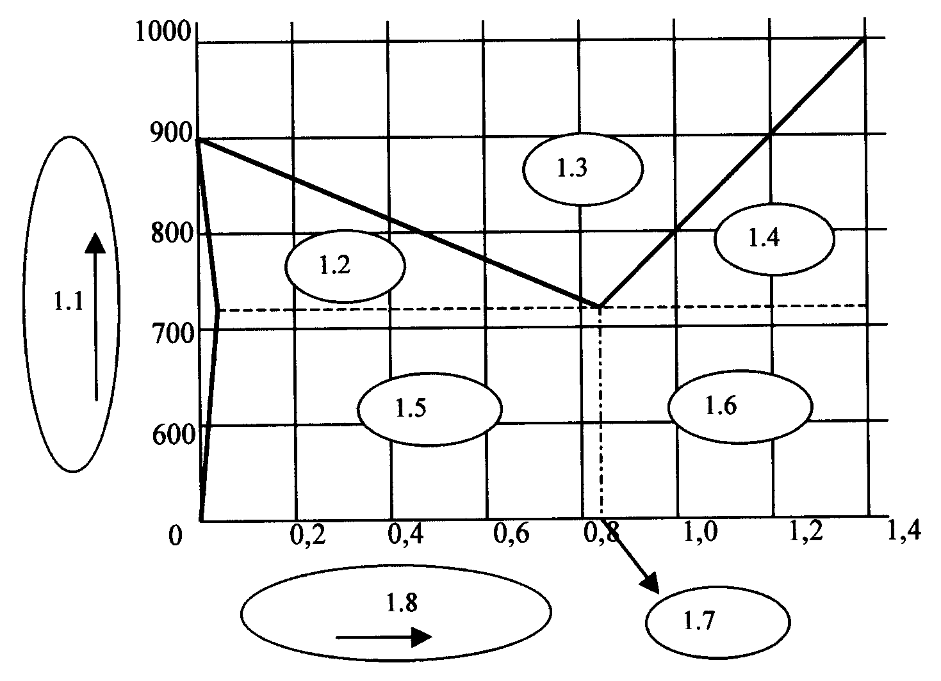

c
d
b
a

e
f

h
g

1.2 Name THREE basic crystal structures of steel. | (3)

1.3 Calculate the size of the rivet hole that must be drilled on the centre line if the pull bar can withstand a pull stress of 80MPa. The load on the pull bar is 150kN. | (8)

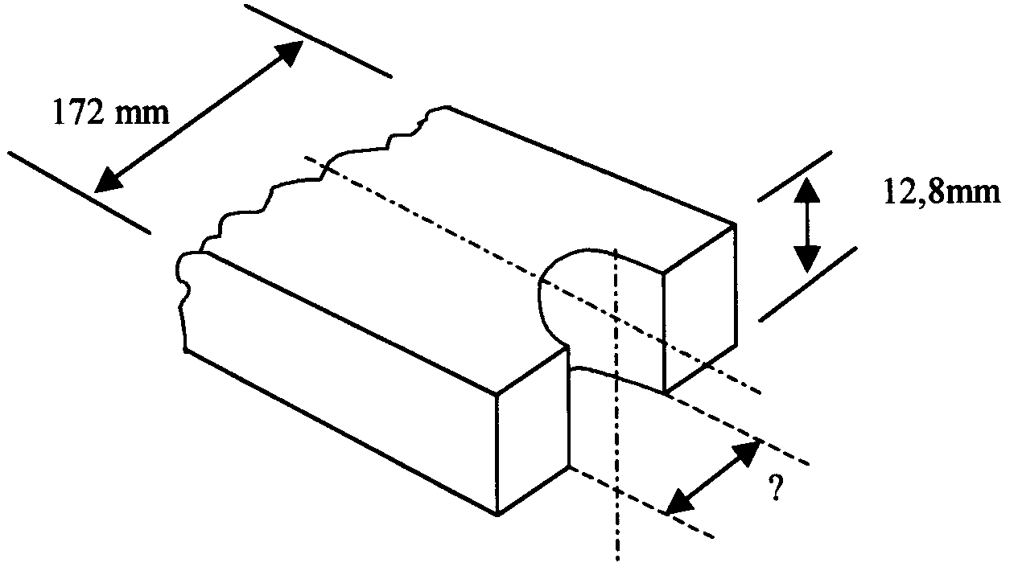

1.4 Name FOUR characteristics of a good works leader (manager). | (4)

1.5 Name FIVE important safety features which should be taken into consideration when designing a factory building. | (5)

1.6 Why do we make use of a chosen number with differential indexing? | (2)

1.7 Explain the following occurrences briefly according to the kinetic molecular theory of gases:  - The increase in pressure when the temperature increases  - The compressibility of gases | (3)  (3)

1.8 Explain the concept ergonomics. | (4)

1.9 Describe the following tests briefly and illustrate your answer with the aid of simple sketches:  - The Brinell hardness test  - The Rockwell hardness test | (8)  (8)

1.10 Explain the concept of thermodynamics as a branch of Physics. | (2)  [60]

QUESTION 2

2.1 One hundred and twenty-seven (127) teeth must be milled on a spur gear. The dividing head ratio is 40:1.  - Calculate the indexing required. (Choose 125 divisions.)  - Calculate the change wheels required.  - Determine the direction of rotation of the index plate.  - Make a simple sketch to indicate the position and arrangement of the change wheels. | (2)  (5)  (2)  (4)

2.2 Study the diagram below and name the components numbered 2.2.1 – 2.2.6 of the Prony brake that is used to test brake power. Write down only the numbers (2.2.1 – 2.2.6) underneath each other and the correct answer next to it. | (6)

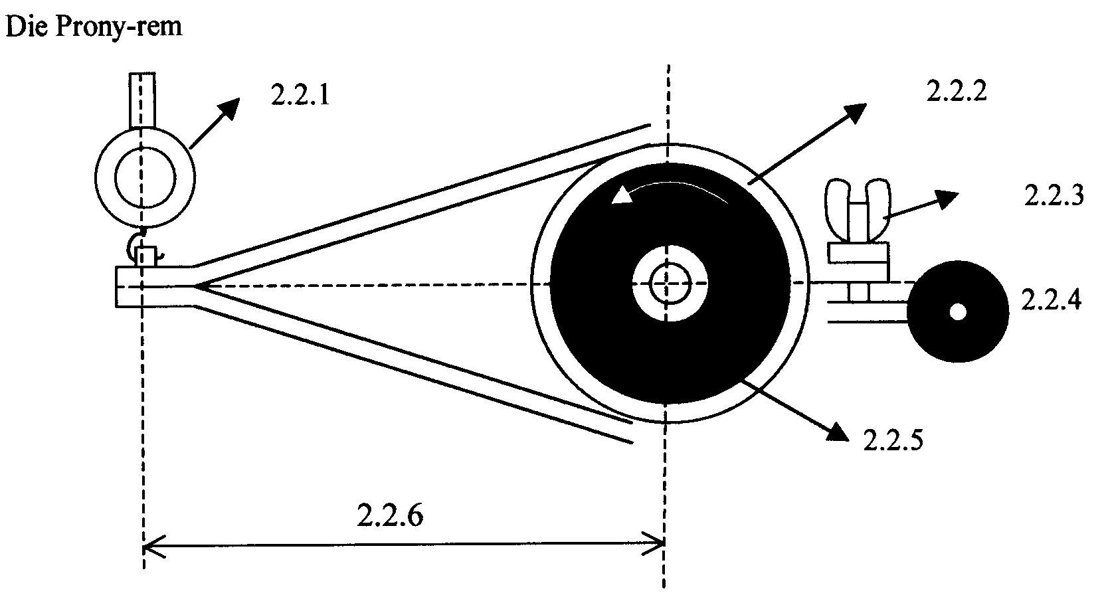
The Prony brake

2.3 Describe the operation of a helical-spring, single-plate dry clutch during disengagement of the input shaft from the output shaft. | (8)

2.4 The two-wire method of screw-thread measurement is used to test the angle of a M50 x 5 I.S.O. screw thread. The measurements across the two sets of wires shows a difference of 7,03mm. The diameters of the two sets of wires are  1,01P and 0,505P respectively.  Calculate the  - size of the screw-thread angle.  - error, if any, in the screw angle. | (8)  (2)

2.5 The volume of a certain gas is 2,4m³ at a pressure of 125kPA and a temperature of 20ºC. Calculate the final temperature in ºC of the gas if the volume is reduced to 1,1m³ by a pressure of 600kPa. | (7)

2.6 Define Boyle’s law. | (4)  [48]

QUESTION 3

3.1 The following components were used in the design of a hydraulic system for a car hoist:  - Electric motor  - Hydraulic gear pump  - Ventilated reservoir  - Non-adjustable pressure relief valve  - Adjustable pressure relief valve  - Shut-off valves  - Check valve (one-way)  - Two-way control valve (spring-loaded)  - Measuring vessel  - Single-acting power cylinder  - Pressure gauge  - Filter  Use I.S.O 1219 symbols and design a flow diagram for the hoist. | (12)

3.2 The graph below indicates the pressure-volume diagram for a four-stroke compression-ignition engine to illustrate the pressure-volume relationship for a complete cycle. Study the graph and name the numbered parts. Write only the numbers 3.2.1 – 3.2.7 underneath each other and the correct answer next to it. | (7)
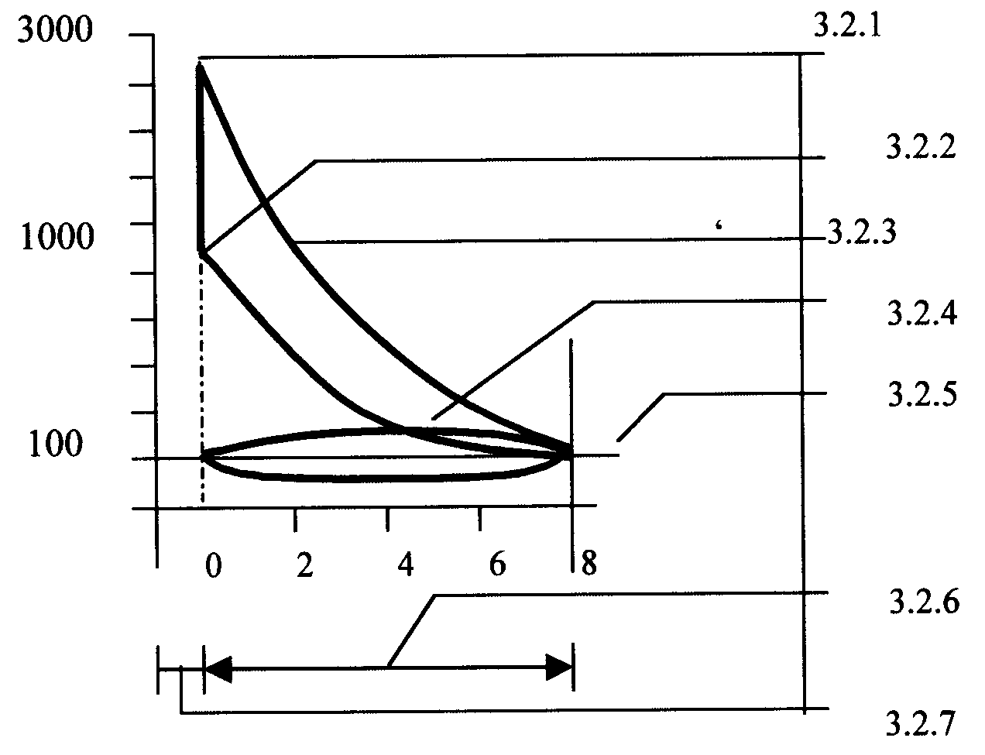
3.2.1

3.2.3

3.3 Describe how the following gear ratios are obtained by means of a single epicyclic gear train:  - Reduction gear ratio  - Overdrive gear ratio  - Direct drive (1:1 ratio) | (4)  (4)  (2)

3.4 Why is control important in terms of workstream planning? | (6)

3.5 A vehicle, with a mass of 800kg, accelerates uniformly from rest to 60km/h during 5s up an incline of 1:20. The frictional resistance is 250N.  Calculate the  - work done against the frictional force when the velocity of 60 km/h has been reached.  - work done against the gravitational component parallel to the plane.  - total force exerted by the vehicle. | (5)  (3)  (5)  [48]

QUESTION 4

4.1 A motor vehicle engine has a mass of 540kg and is lifted from ground level to a height of 1,2m by means of a crane.  Calculate the  - gain in potential energy.  - force required to lift the engine without acceleration.  - work done to lift the engine to a height of 1,2m. | (3)  (3)  (3)

4.2 Study the diagram below and calculate the distance C and D of the dovetail, which is tested for accuracy. | (8)

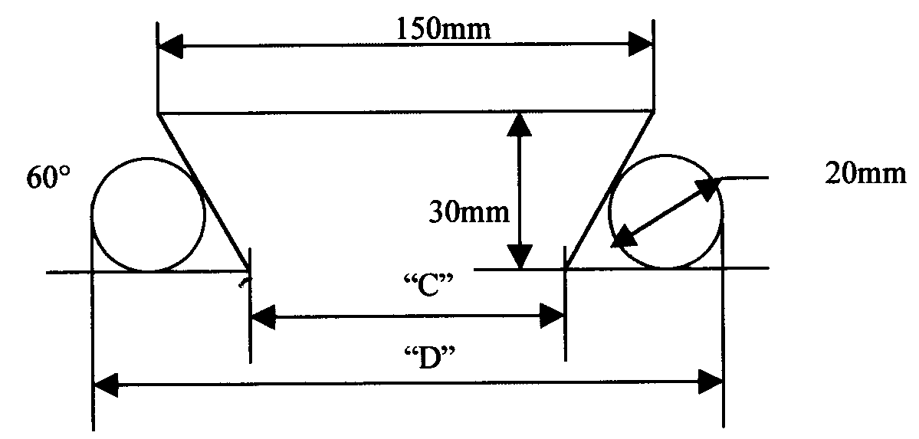

4.3 Briefly describe the chemical combustion process of petrol in the presence of sufficient oxygen. Name the products of this combustion. | (6)

4.4 Two V-belts are used on a pulley which rotates at 1 440r/min. The tractive force in the tight side is 150N and the ratio of the tractive force in the tight side to the slack side is 6:1.  If TI = 150N calculate the  - power transmitted in kilowatt if the driving pulley has a diameter of 0,2m.  - belt speed in metres per second. | (10)  (3)

4.5 Briefly describe the method of using the index driving plate of a lathe to cut a three-start thread. | (6)

4.6 Define the following concepts:  - Potential energy  - Kinetic energy | (3)  (3)  [48]

QUESTION 5

5.1 A lift has a steel cable of 17,3mm diameter and an elasticity modulus E of  200 x GPa. The cable is 25m long when the lift is at ground level. Calculate the distance the lift will lower below ground level due to the extension of the cable when a mass of 700kg is loaded into the lift. | (12)

5.2 Define isothermal compression of gases. | (4)

5.3 Name THREE properties of an ideal gas. | (3)

5.4 What is the purpose of a key in a transmission system? | (2)

- Choose the correct answer. Write down only the question number and the letter (A – E) of your choice next to it. The term dragging refers to the clutch’s inability to  - engage smoothly.  - disengage fully.  - engage fully.  - engage gradually.  - exert pressure. | (2)

- Define the following concepts:  5.6.1 The mean effective pressure on the piston of an internal combustion engine  5.6.2 Indicated power | (4)  (4)

  - The following data is provided for a six-cylinder, four-stroke internal combustion engine:

Cylinder diameter 90mm
Stroke length 110mm
Mean effective pressure on piston 928kPa
Revolutions per minute 3 500rpm r/min
Effective brake arm length 1 200mm
Reading on scale 4,5kg

Calculate the following:  5.7.1 The indicated power in kW  5.7.2 The work done during one power stroke if the piston moves from the TDC to the BDC  5.7.3 The brake power in kW  3.7.4 The mechanical efficiency of the engine | (7)  (3)  (4)  (3)  [48]

QUESTION 6

6.1 Describe the colour penetrating test used to test steel for defects.  6.2 The diagram below shows four forces acting at a point. Calculate the magnitude and direction of the equilibrium force. | (8)  (15)

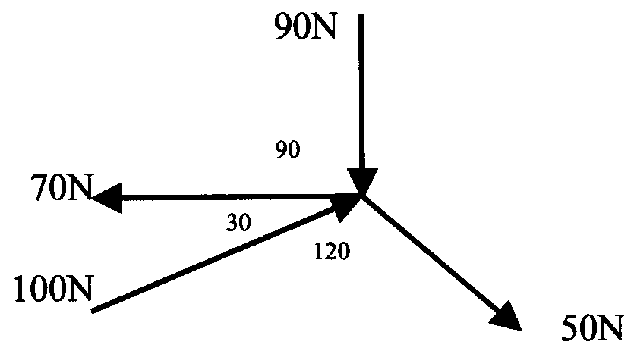

6.3 Study the following diagram. Calculate the magnitude and direction of the reaction at pivot O of the lever. (The lever is in equilibrium.) | (15)

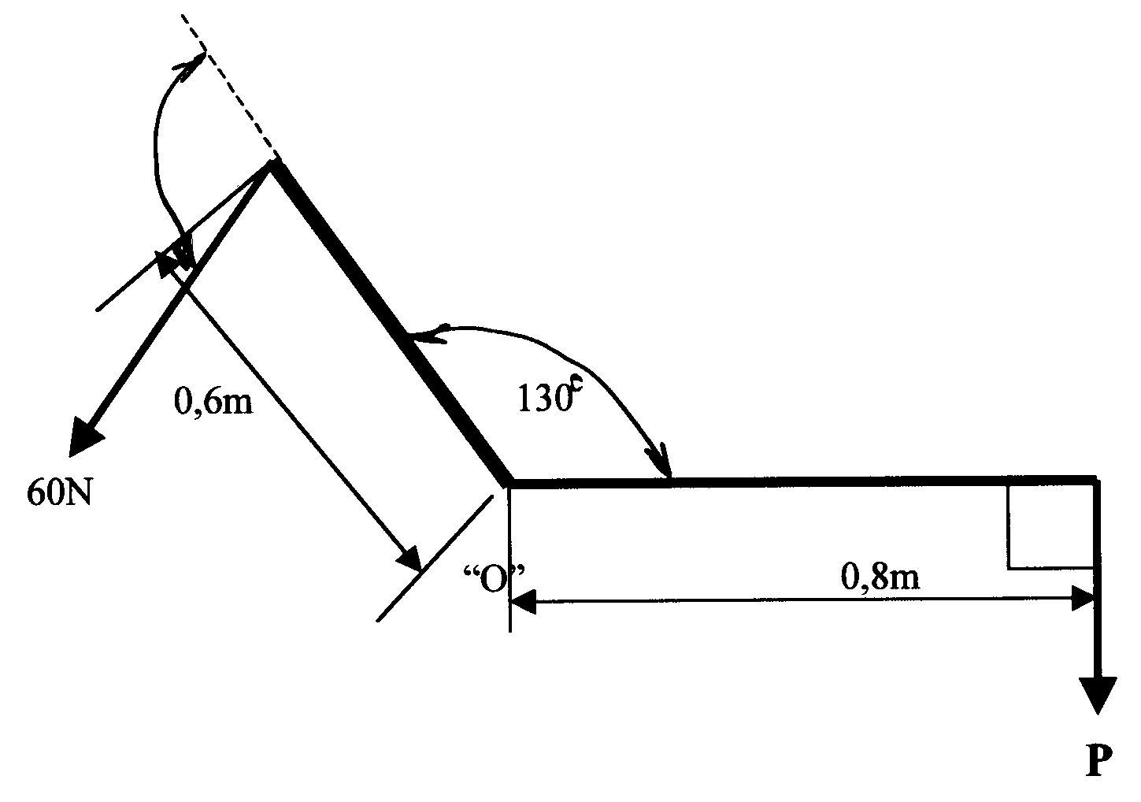

100º

6.4 Define Hooke’s law. | (3)

6.5 Name THREE ways in which you can make your employees aware of the growing AIDS crisis in our country. | (3)

6.6 The mass of a flywheel is 60kg and the radius of inertia is 175mm. The flywheel accelerates from 350r/min to 850r/min within 8 seconds.  6.6.1 Calculate the angular acceleration in radians per second. | (4)  [48]

TOTAL: | 300

